Unit R081 – Pre-production skills

Shot types used in storyboarding

Task 1

Read the Shot name and Use columns below. Match up the correct picture with the type of shot by inserting the corresponding letter into the Image column.

Shot name | Use | Image
Low Angle | Creates the feeling that the viewer is small and vulnerable and the character here is powerful.
Extreme Wide Angle | Establishing shot – shows where action takes place and sets the scene at the start of an episode or event. Often pans or zooms in slowly as the scene is set.
Two-shot | Used for conversation between equals where what both characters say or do is equally important.
Wide Angle | Puts one character in context in his or her surroundings, shows the whole person.
Over the Shoulder Shot | Used for conversation where one person’s speech is more important than the other.
Extreme Close Up | Unreal viewpoint, focusing on a single feature of a person such as the nose, mouth, a hand etc, for effect or to draw attention to it.
Close Up | Focuses in on what one person has to say or shows reaction in facial expression.
Medium Close Up | Concentrates attention on single character.
Wide Shot | Puts characters in context to show their location and how they relate to it.
High Angle | Creates the feeling that the character here is being viewed by a more powerful presence positioned near the ceiling. Used in thriller films to show someone being watched.

Task 1 Images
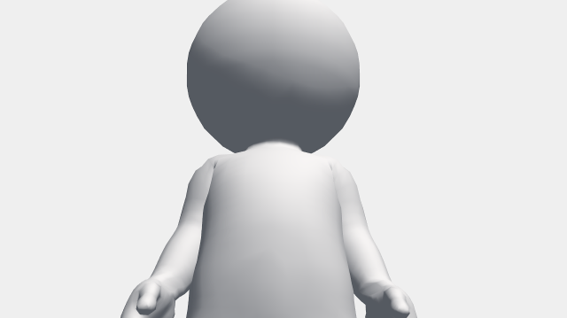
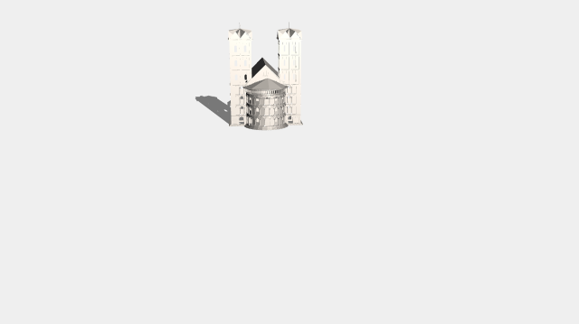
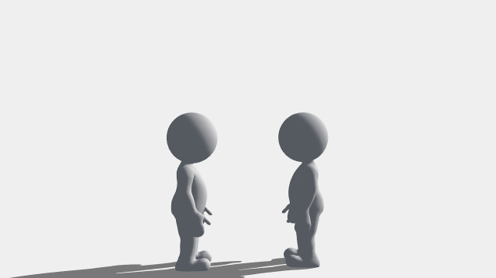
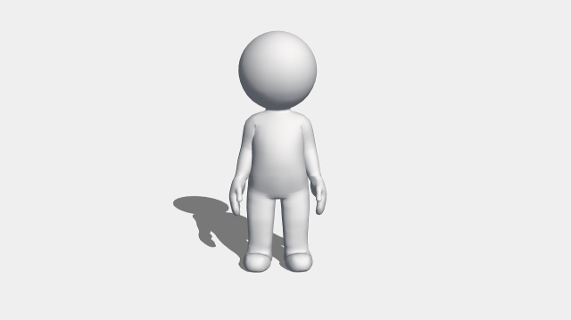
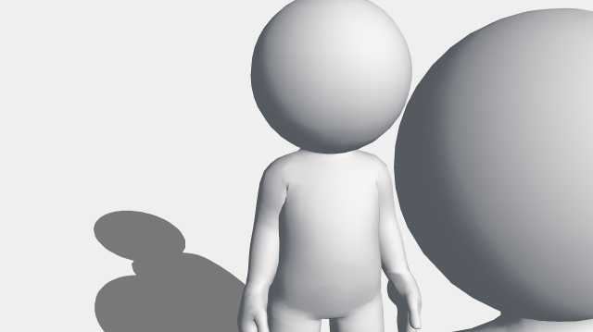
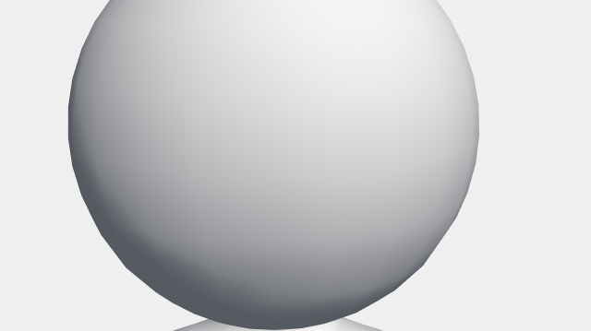
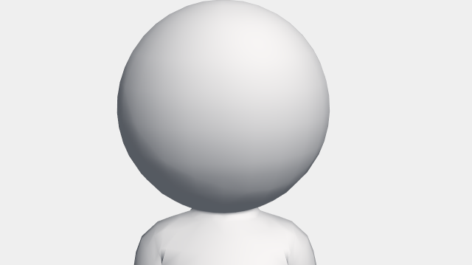
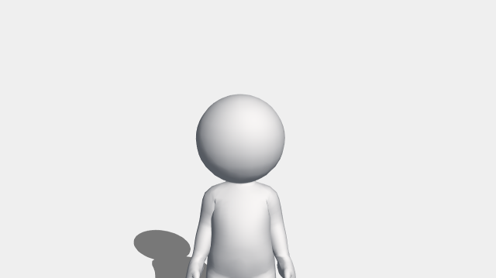
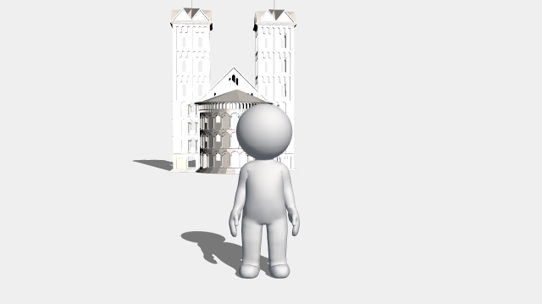
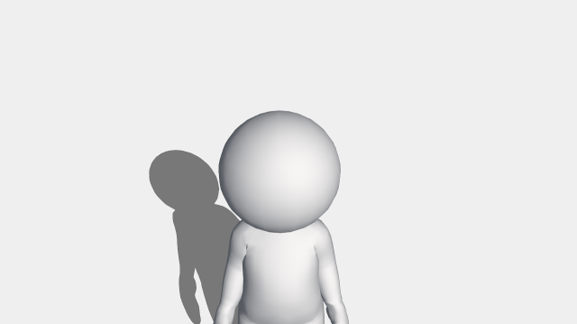

a
c
e
g
i
j
h
f
d
b

Task 2

Read the Shot name and Use columns below. Match up the correct picture with the type of shot by inserting the corresponding letter into the Image column.

Shot name | Use | Image
Low Angle | Creates the feeling that the viewer is small and vulnerable and the character here is powerful.
Extreme Wide Angle | Establishing shot – shows where action takes place and sets the scene at the start of an episode or event. Often pans or zooms in slowly as the scene is set.
Two-shot | Used for conversation between equals where what both characters say or do is equally important.
Wide Angle | Puts one character in context in his or her surroundings, shows the whole person.
Over the Shoulder Shot | Used for conversation where one person’s speech is more important than the other.
Extreme Close Up | Unreal viewpoint, focusing on a single feature of a person such as the nose, mouth, a hand etc, for effect or to draw attention to it.
Close Up | Focuses in on what one person has to say or shows reaction in facial expression.
Medium Close Up | Concentrates attention on single character.
Wide Shot | Puts characters in context to show their location and how they relate to it.
High Angle | Creates the feeling that the character here is being viewed by a more powerful presence positioned near the ceiling. Used in thriller films to show someone being watched.

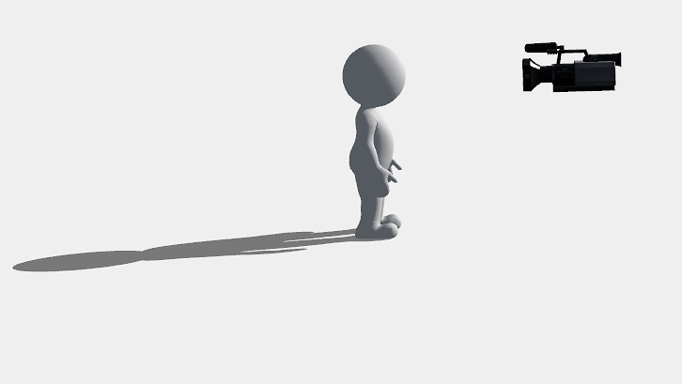
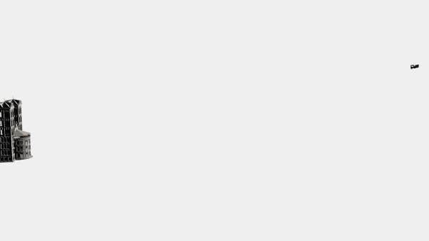
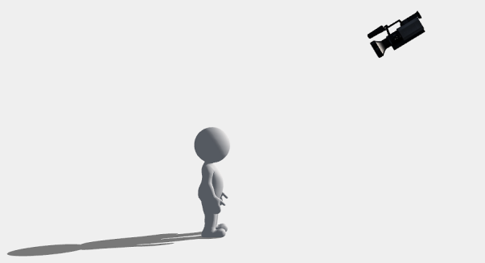
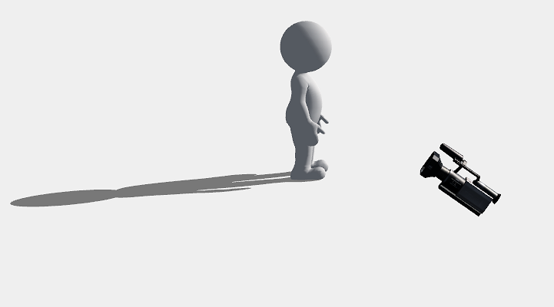
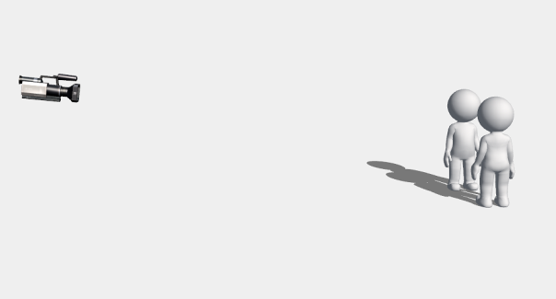
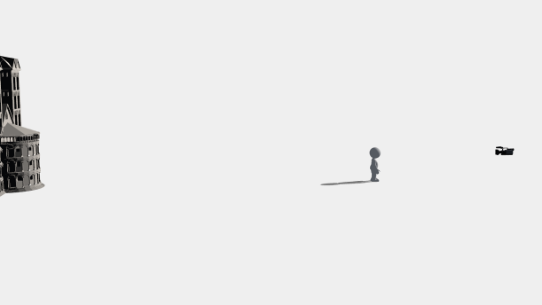
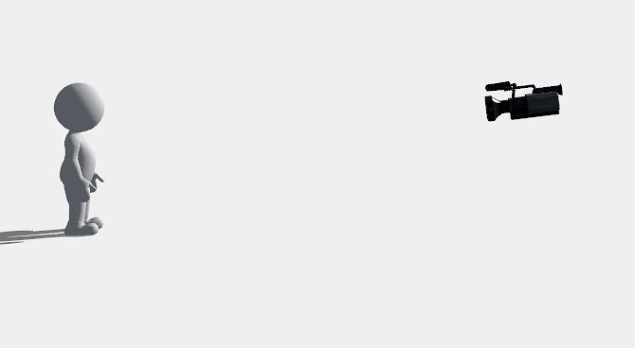
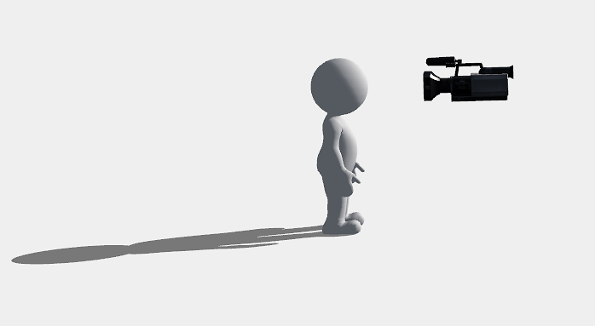
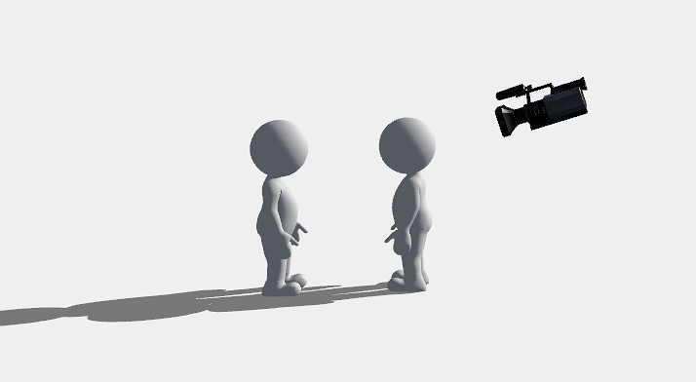
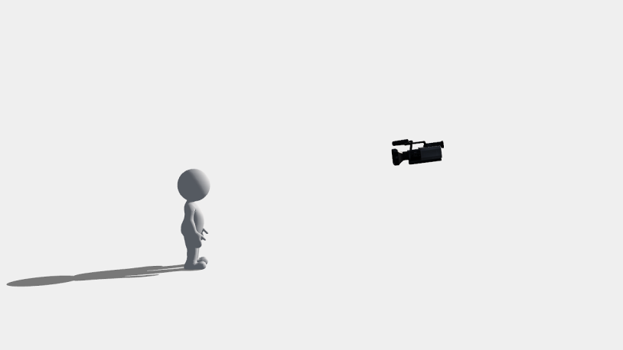
Task 2 Images
a
c
e
g
i
j
h
f
d
b

