Checkpoint Task

Cash Flow

Research
Using a textbook or other resource, find a definition of cash flow and write it down below.
Cash flow is…

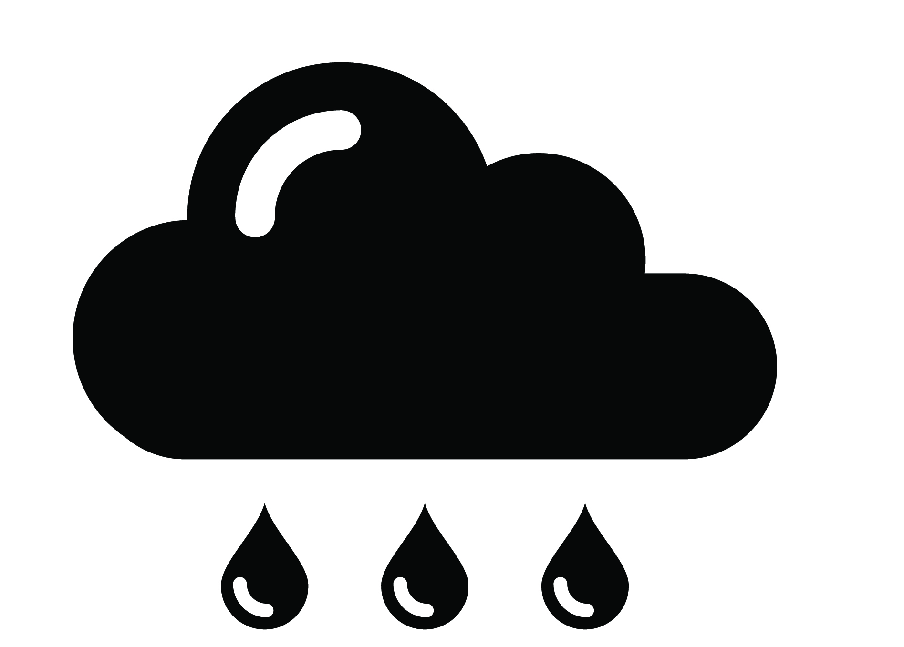
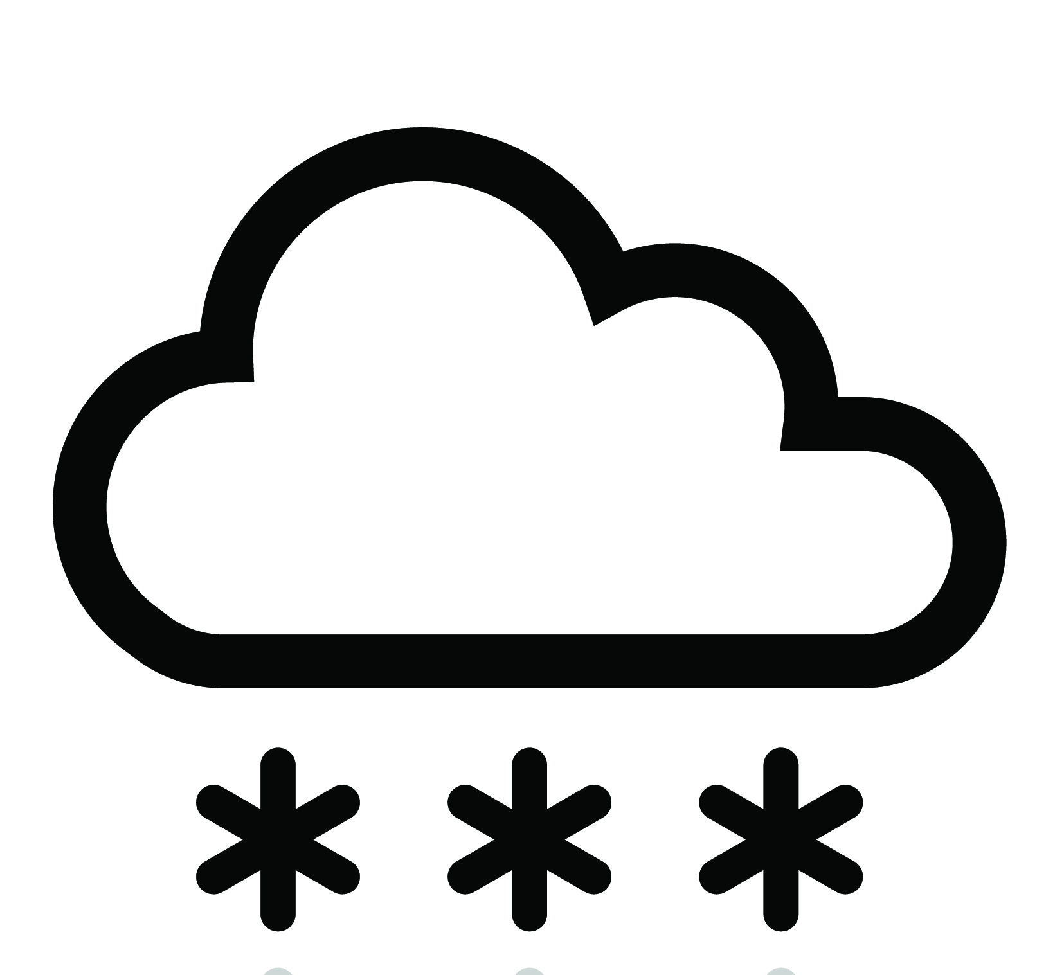
A forecast is a prediction of what could happen in the future.
Try to come up with a definition of a cash flow forecast using the information that you have found out and the definition of a forecast.

A cash flow forecast is…

Have a go

Joyce has a weekend job and earns £25 per week.
She has tried to forecast the cash that she will be spending this week:
- £5 on bus fares
- £7 on snacks
- £3 on apps for her phone

How much money does Joyce forecast that she will have left at the end of the week?
If Joyce saves all of her 'spare' cash each week, how long would it take her to afford a new phone costing £55?

Extension
How would your answers to the questions above change if the bus fare went up by 10%?

