Lesson Element

Characteristic Curves

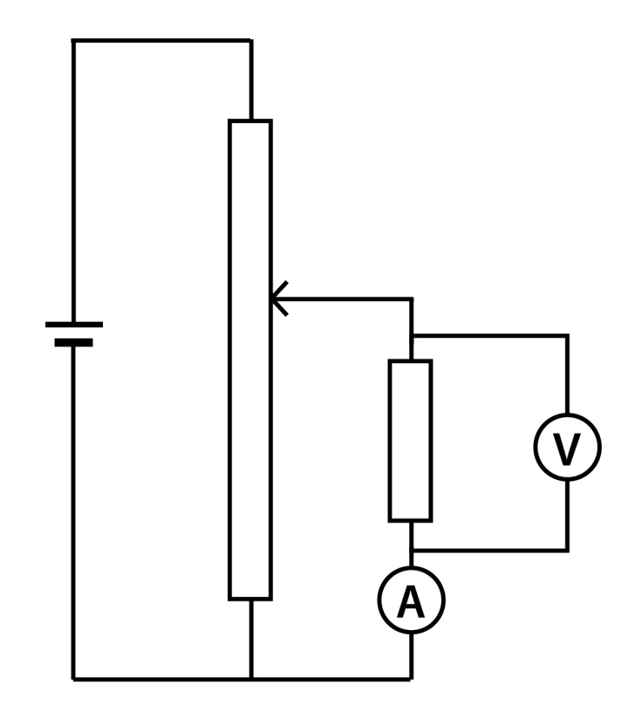
Equipment: Smooth power supply; rheostat/potentiometer; ammeter; voltmeter; connecting wires; range of components (ohmic resistor; diode; LED; thermistor; LDR)

Set up the circuit as shown in the diagram. Make sure that the ammeter is initially set at the highest value to reduce chances of blowing the fuse.

Task

- To measure the characteristic curve for a component you must change the voltage and measure the current.
- Find the maximum and minimum values of voltage that give appropriate readings, and then select the steps needed to give the required number of values.
- Measure the current as the voltage is changed across a component.
- Repeat the previous two steps with each of the components.
- Draw the current – voltage curves for each component.
- Calculate the resistance of the components.

