Lesson Element

Resistivity
You will see that your text book shows the equation: R=ρl/A, where R is resistance; ρ is the constant called resistivity; l is the length and A is the cross-sectional area of the conductor.
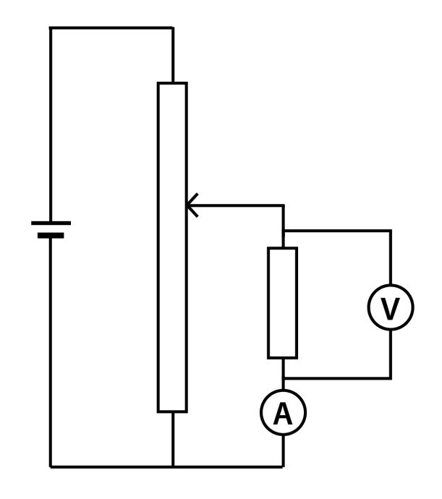
R=ρl/A becomes ρ=RA/l

Ensure that the fuse wire is placed on a heat resistant mat and do not touch it when the current is flowing.

Task
- Use a standard length of wire, say 1m long. Measure the thickness with a micrometer and then calculate the cross sectional area, A. Measure the current as the voltage is changed, as with the characteristic curve worksheet, and then find the resistance from the gradient of the line.
- Use the equation to calculate the resistivity of the material. Check the result with the value from the datasheet for the material, or in a data book.
- Using a thin wire, repeat the above experiment and check whether the results give a straight line. Explain the shape of the graph using your knowledge from previous work and experiments.
- When a wire gets too hot it will melt and thus prevent the current flowing. Using the given fuse wire, increase the current steadily until the wire melts and record the maximum current that will pass through the wire. Try changing the length and thickness of the wire and record the results.

- Explain the variation in the current when the wire melts.
- What are the errors in conducting this experiment?
- How can the experimental technique be changed to give more accurate data?

