Unit R102 – The Engineered Business World

Careers in the Rail Engineering Sector

Learning Outcome 3: Know about employment in engineering
Rail engineering is one of the fastest growing sectors with advances in technology and infrastructure.
The rail engineering sector is a made up of a diverse range of products and services internationally, and includes a wide variety of roles.

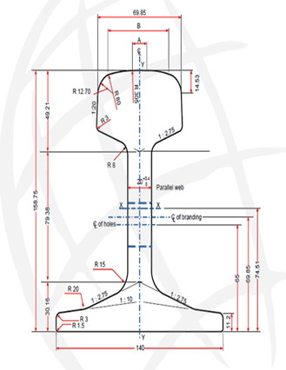
Source: http://www.enablerailacademy.co.uk/

Task 1:
Research 3 different career paths in the rail engineering sector and give a description of the role each career plays.

Task 2:
Having identified a range of engineering career paths within rail engineering, carry out further research to identify the entry routes into rail engineering.
- Research 3 companies that recruit Engineering Apprentices and state which engineering disciplines are offered.

- Research at least two different companies that offer opportunities for graduates, and the types of opportunities available.

Task 3:
The rail sector is supported by a range of professional body organisations.
- Identify two membership institutions linked to the rail engineering sector.

- Research and state the role of National Skills Academy for Rail Engineering.

