Unit R105 – Design briefs, designs specifications and user requirements

Production Costs

Task 1:
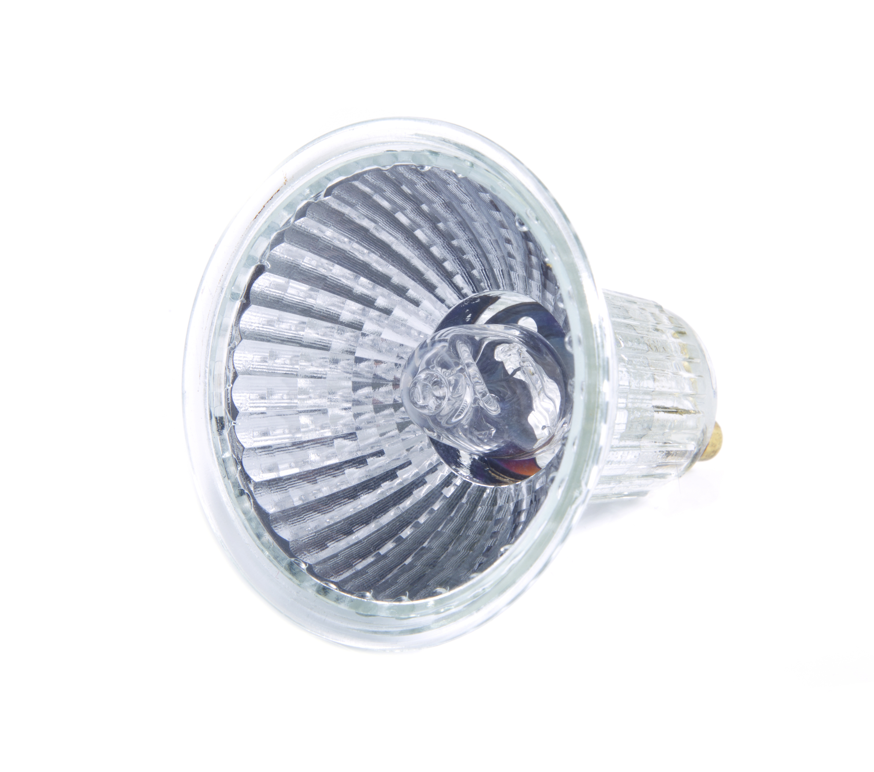
After undertaking market research OCR Electrical has decided to design and manufacture an energy-efficient halogen lamp. They have commissioned the design work and the resulting lamp is shown below.

The design work cost £1000 which OCR Electrical would like to recover over the first 10,000 lamps manufactured and sold.
They have decided to manufacture the lamps using batch production in batches of 1000. The manufacturer has advised them that there will be a cost for electricity of £200 per batch and another £200 to rent their factory.

Each lamp also uses materials and labour in its manufacture which is shown below:
Materials/Labour | Cost per Lamp
Metal (for reflector) | £0.20
Tungsten Filament | £0.10
Copper | £0.10
Glass | £0.20
Halogen gas | £0.20
Labour | £0.20

Answer the following questions:
- Which of the costs are direct production costs and which are indirect production costs?

- How much does it cost OCR Electrical to produce each lamp?

- If OCR Electrical can sell each lamp for £1.95, how much profit do they make for each lamp they sell?

You are advised to present your work on a spreadsheet.

