Unit R103 – Sustainable engineering

Types of materials used in engineered products

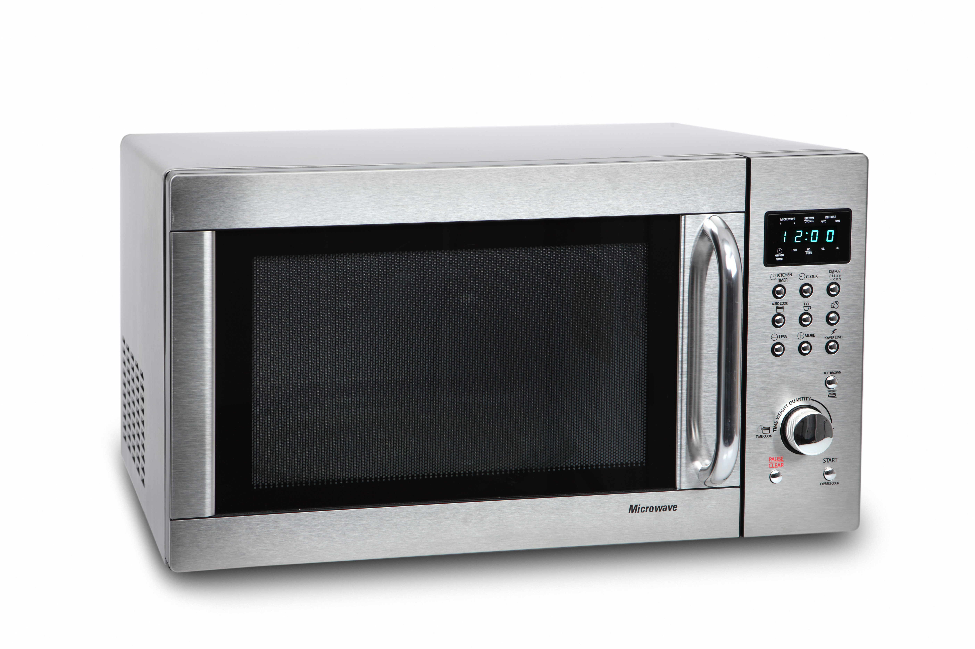
Modern engineered products often use a range materials and component types to make up the complete product.

Consider the modern microwave oven and how it is manufactured and what materials are used for different parts of the product.

Task 1
List the specific materials that could be used in the following parts and the assembly of the microwave:

Outer casing, rear and bottom panels

Door and mechanism

Controls and moving parts

Polymer materials used for the packaging

Task 2
Some of the materials used in the product help contribute to the sustainability of resources. Pick one of the materials that you have identified in Task 1 and write about the sustainability of this material and the environmental impact.

You may need to use online resources to research material to complete the activities. You could choose a different product to carry out the activities.

