Extreme Ecosystems

Task 1 – How are climate, soil and plants interdependent in the Arctic?
- Sort the statements into the Venn diagram under the correct headings of ‘soil’ and ‘climate’.
- Put statements related to plants in the overlapping section of the diagram

- The Tundra biome has fewer plant species than any other biome. | - Tundra plants have short roots.
- There is only a thin humus layer as only a small amount of leaf litter is produced. | - Plants in the Arctic grow very slowly.
- The ground is permanently frozen below 50cm. This is called permafrost. | - Tundra plants have small leaves to reduce transpiration.
- Plants are low and compact, reaching a maximum of 30cm high. | - The average annual temperature range is -28ºC (winter) to 3ºC (summer).
- Where the ground isn’t frozen, the soil is often waterlogged from snow meltwaters or melting permafrost

Soil conditions
Climate

Task 2 – Summarising Arctic Flora
Using the statements write a summary of the characteristics of Arctic Flora. This must be exactly 50 words! You will need to choose carefully what to include and what to edit to make it exactly 50 words.

Task 3 – Who lives in the tundra biome?
- Look at the table of Tundra-dwellers. How could they be grouped? You could use dictionaries/ encyclopaedias/ internet searches to find out more information about some of the things in the table.
- To get started you could think about flora (plant) and fauna (animals). Colour code as appropriate.
- Can you make any links between the tundra dwellers in your table? Cut out the table a re-arrange to create a food web or simply join with pencil lines to create one.

Stretch and challenge: can you add to the grid to fill in the blank gaps?
Tundra-dwellers
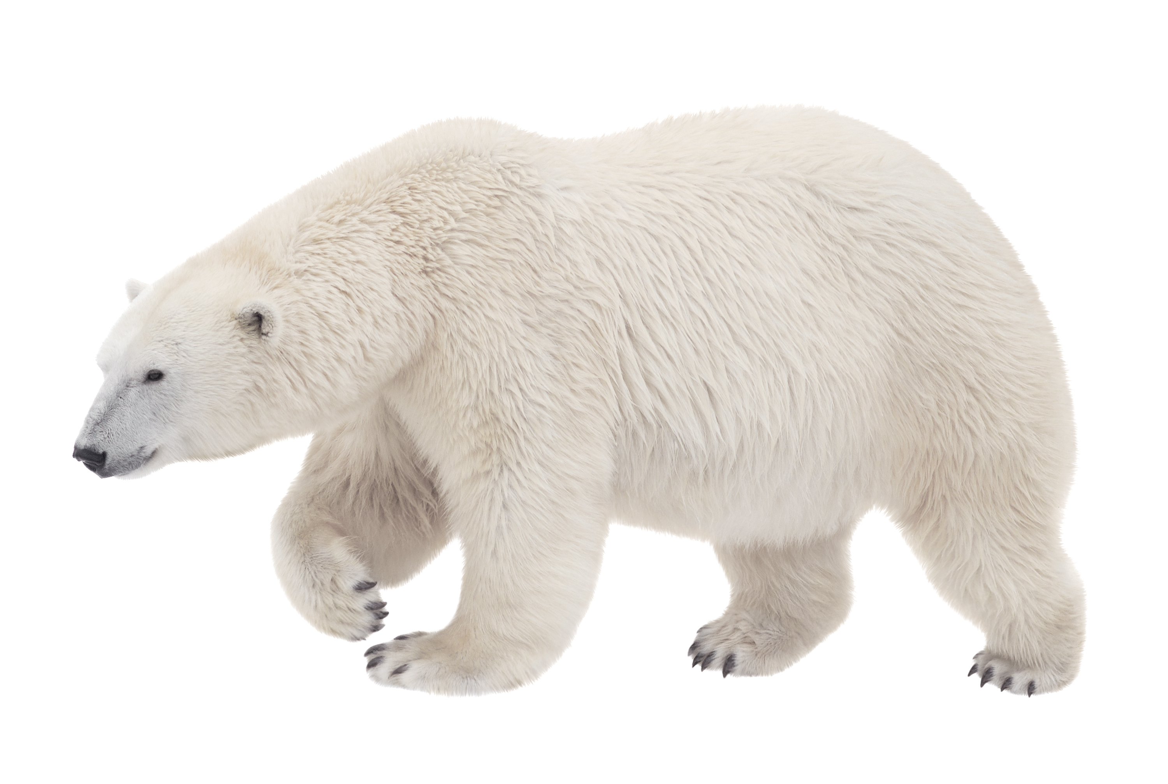  Polar bear | 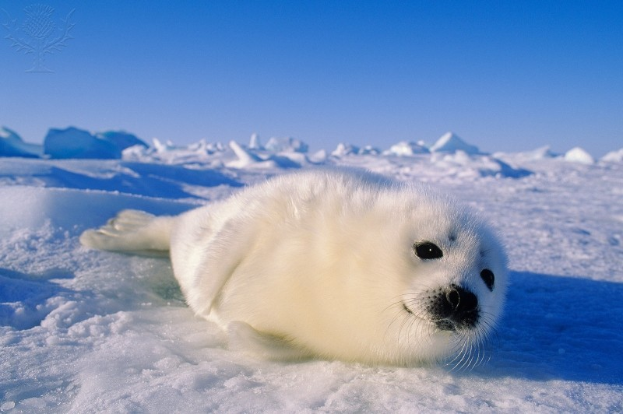  Harp seal | 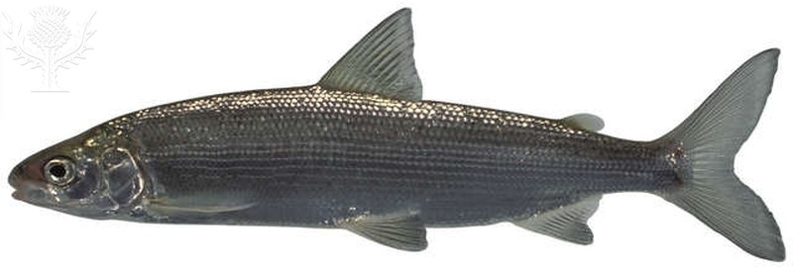  Whitefish | 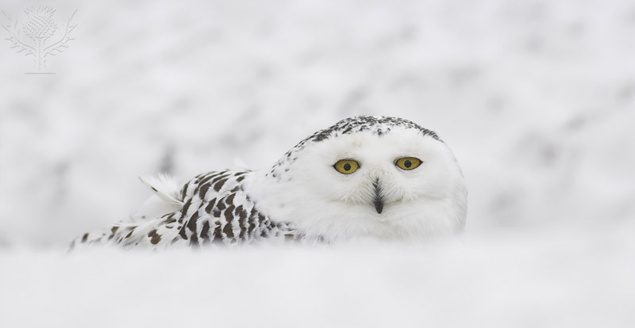  Snowy owl | 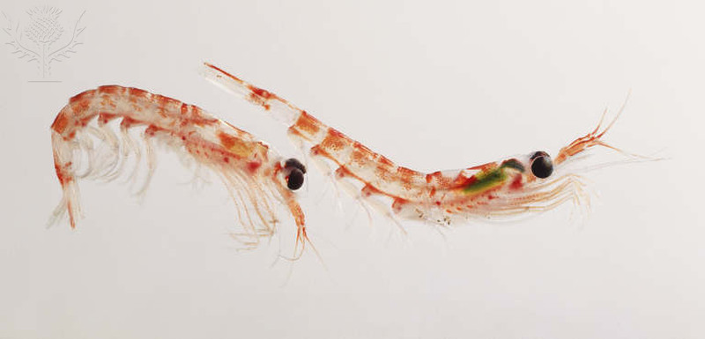  Krill
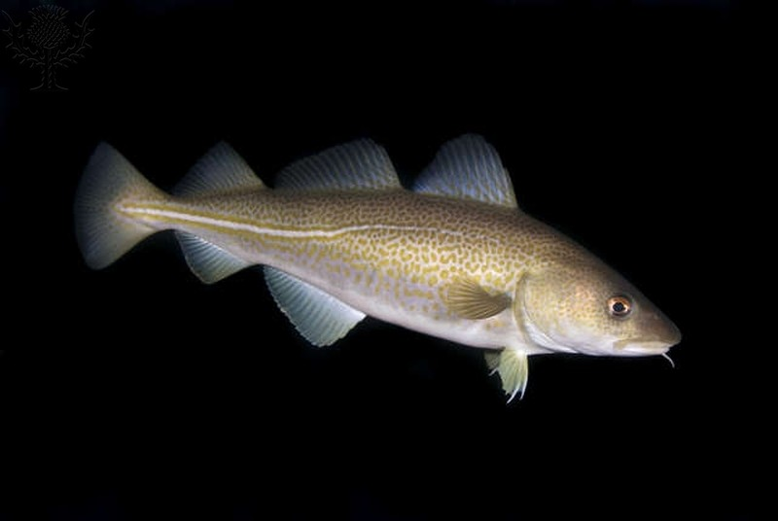  Arctic cod | 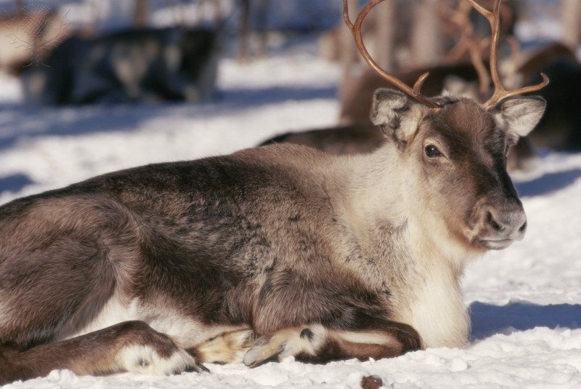  Reindeer | 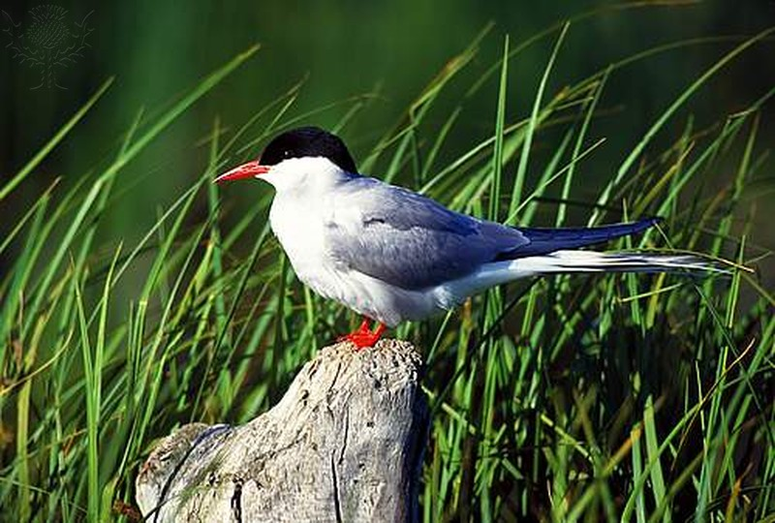  Arctic tern | 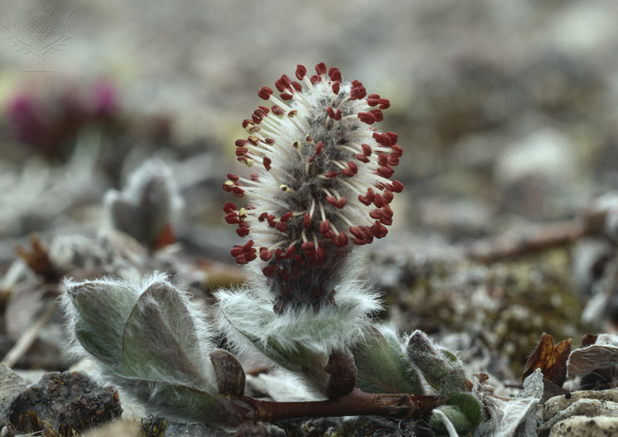  Arctic willow | 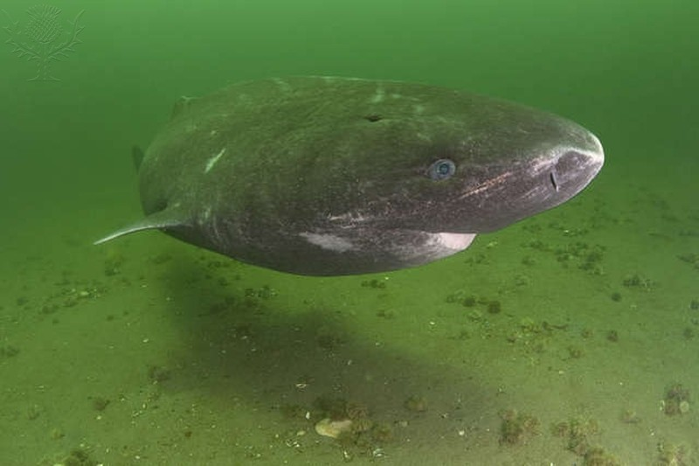  Greenland shark
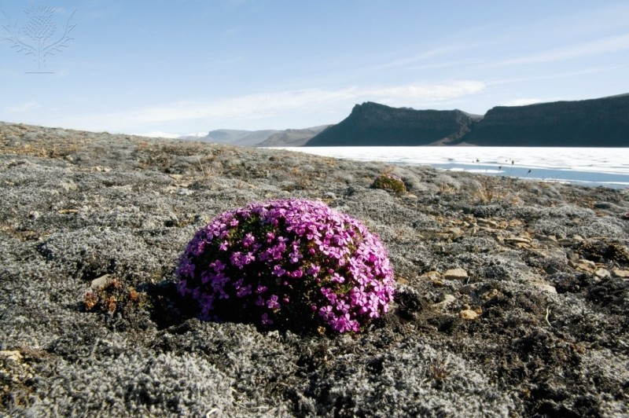  Arctic moss | 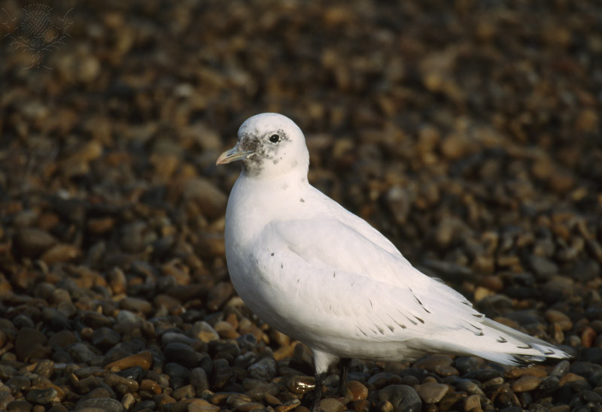  Ivory gull | 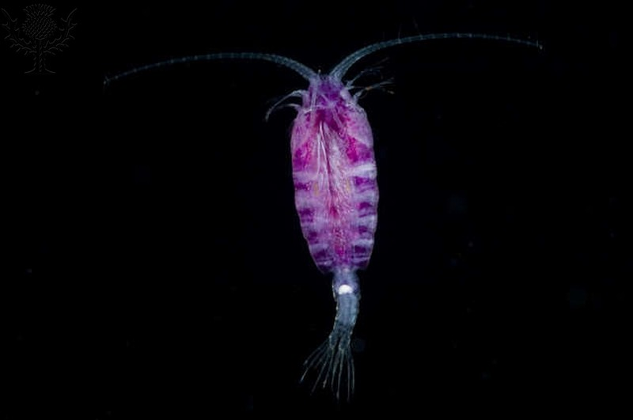  Copepod | 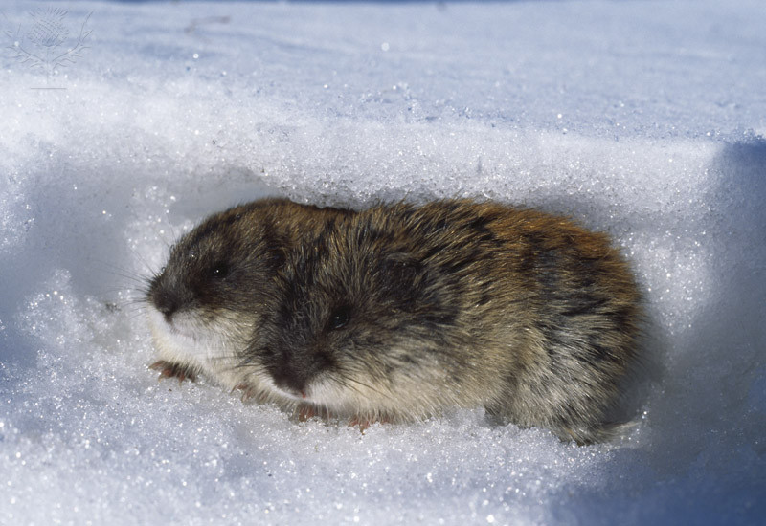  Lemming | 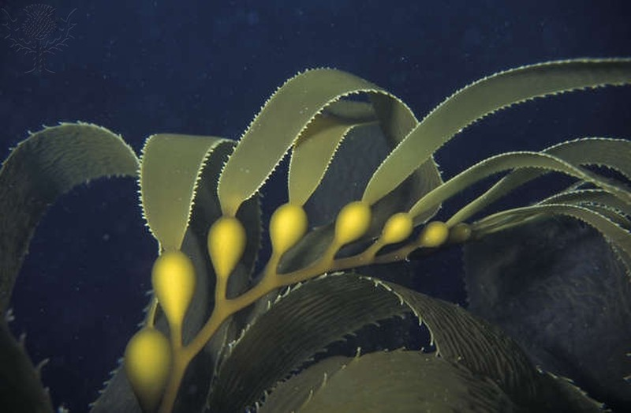  Kelp
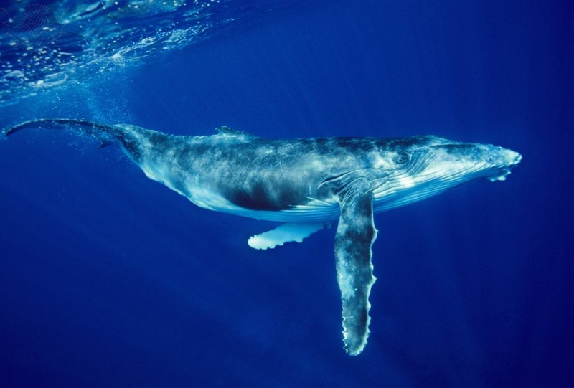  Humpback whale | 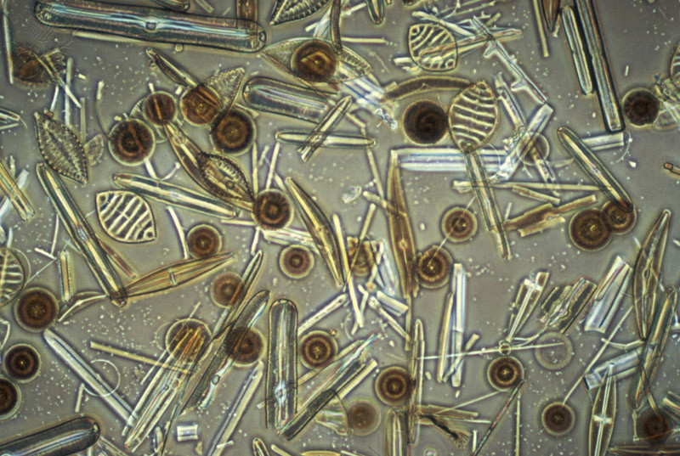  Phytoplankton | 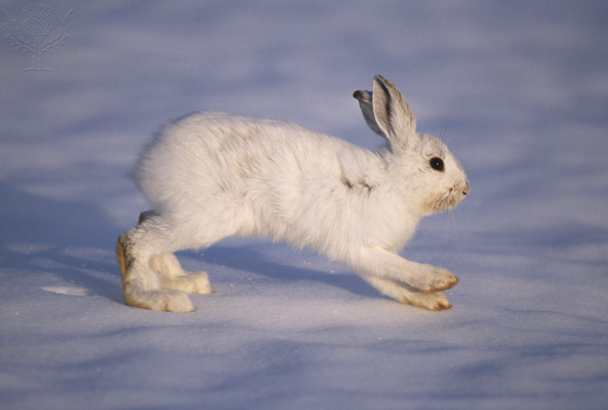  Snowshoe hare | 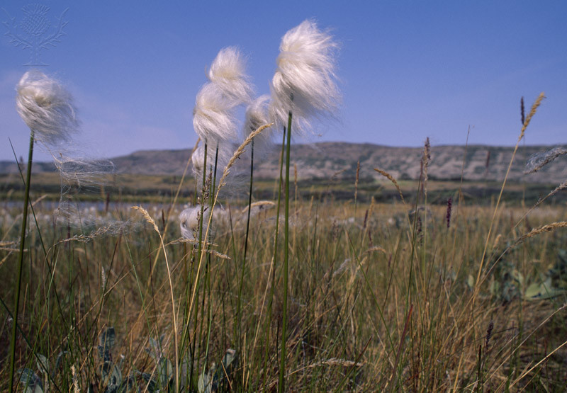  Cotton grass | 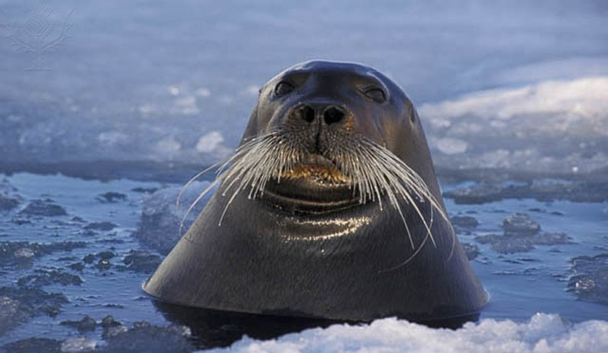  Bearded Seal
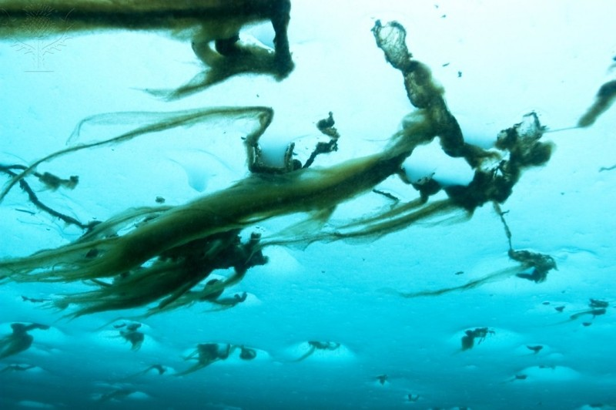  Ice algae | 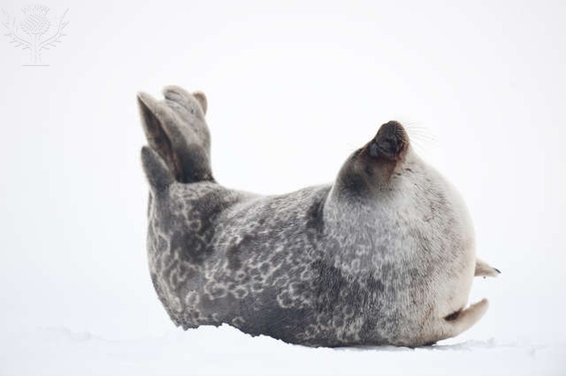  Ringed seal | 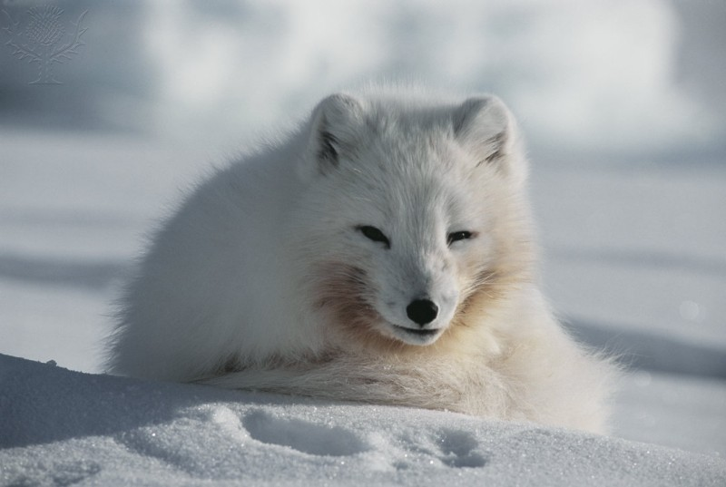  Arctic Fox | 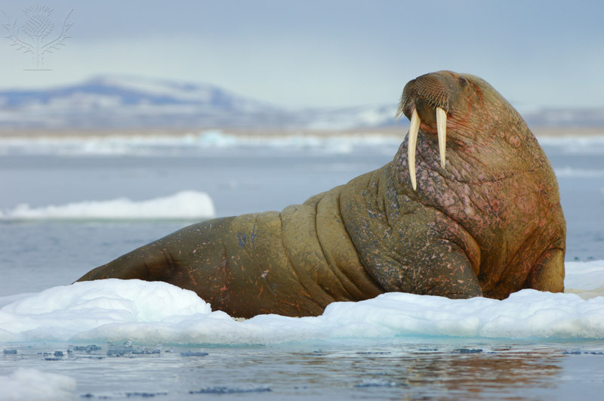  Walrus | 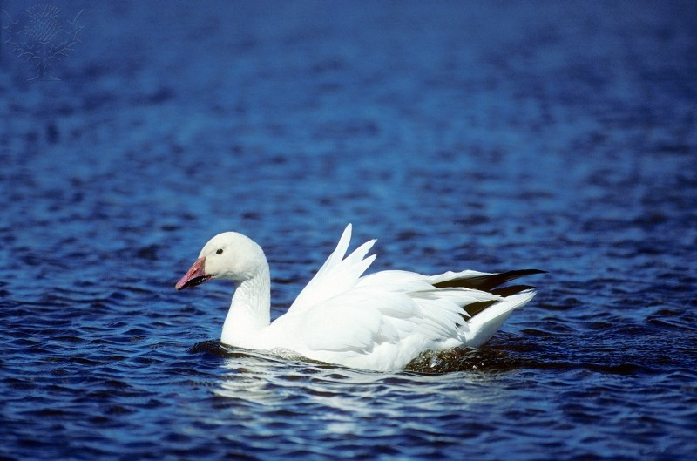  Arctic goose
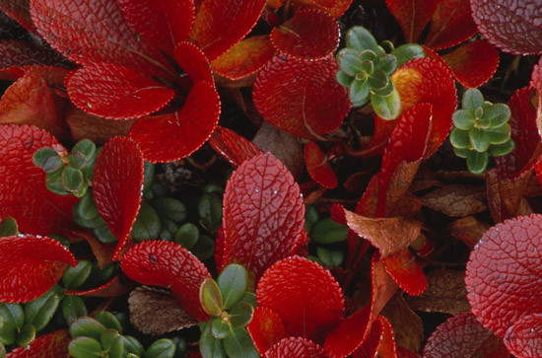  Bearberry | 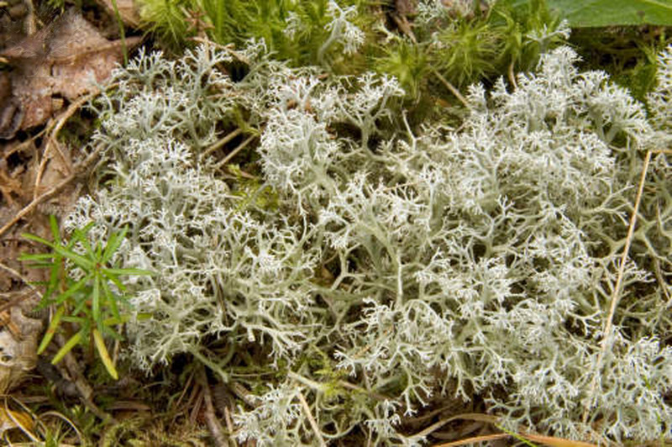  Caribou moss | ? | ? | ?

Task 4 – Making connections
Watch the following short clip from Frozen Planet ‘bottom of the food chain’. http://www.bbc.co.uk/nature/life/Malacostraca#p00l7sgp

It is about krill in the Southern Ocean, however this species is also of vital importance in the Arctic.

Answer the following:
What do krill look like?

What do krill eat?

What do krill thrive from?

What happens to algae as ice melts?

Who depends on krill?

Task 5 – How do humans impact the tundra ecosystem?
The table below shows some additional Tundra-dwellers. How might these groups affect the ecosystem or web that you produced in Task 3. Add these indigenous people to your food web and give detail on the possible effects.

Sami | Inuit | Koryak
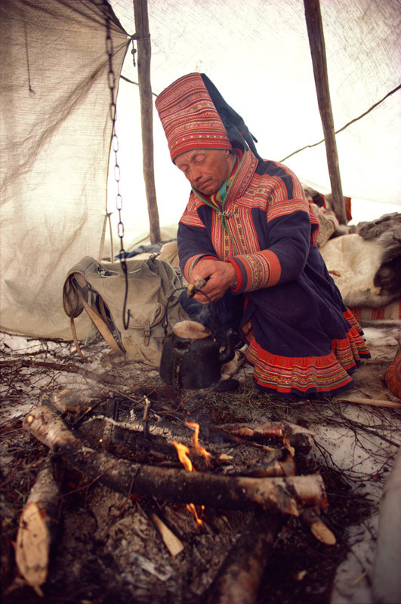  The Sami are indigenous people of northern Europe (northern Norway, Sweden, Finland and part of Russia). Their traditional livelihoods include coastal fishing and nomadic reindeer herding. | 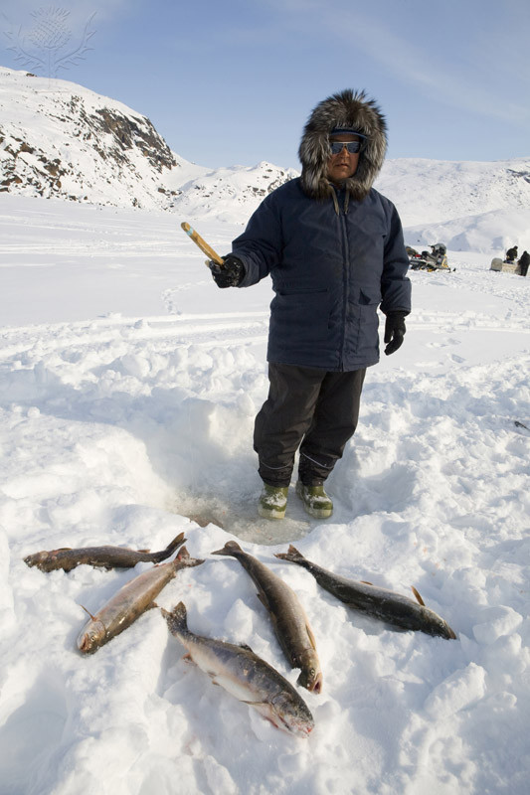  The Inuit are indigenous people of Arctic Greenland, Canada and the USA. Their traditional way of life includes hunting and fishing. | 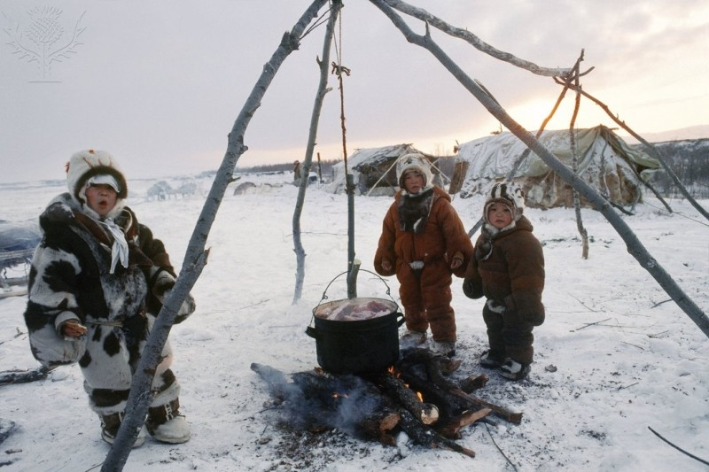  The Koryak are indigenous people of north eastern Russia. Their traditional way of life is coastal fishing and nomadic reindeer herding.

Task 6 – Summarising Arctic Flora and Fauna
Create a ‘Tweet’ (maximum 140 characters) summarising what you have learnt about the flora and fauna of the Arctic.

