Testing, Analysing and Evaluating

Worksheet 1
Rating test
Testers give their opinion on whether they extremely like or dislike a food.
SAMPLE | 1.  Dislike very much | 2.  Dislike | 3.  Neither Like or dislike | 4.  Like | 5.  Like a lot | Comments

Difference Testing
These are used to see if people can tell the difference between samples.
Triangle Test
Two samples are the same and one is different.

Circle the odd one out.
SAMPLE

How many people in your class could tell the difference?
Ranking Test
This is used to sort foods out into the order in which they are preferred.
Taste the samples and put them into the order you like best.
SAMPLE | Order | Comments

It can also be used to rank different attributes of a product e.g. creaminess of yogurt. Put the characteristic of the product in the blank box
SAMPLE
SAMPLE | Order

Profiling Test
This is when a variety of different aspects of a food product are assessed for example a particular, flavour, texture, aroma. These can be presented in a chart or as a star profile.
Testers rate the attributes by giving a score from 5=excellent, 1=poor.
Attribute | Scores |  |  |  |  | Total | Average
1
2
3
4
5

6

The chart could be done on a spread sheet and then presented as either a chart or star profile.

Having completed the different sensory analysis tests answer the questions below.
- State one sensory analysis test that could be used to see if consumers could tell the difference between diet cola and a cola containing sugar.

Name of test
Reason for choosing that test

- The diagram below shows the ingredients in a lemon cheese cake and the results from the tasting panel.
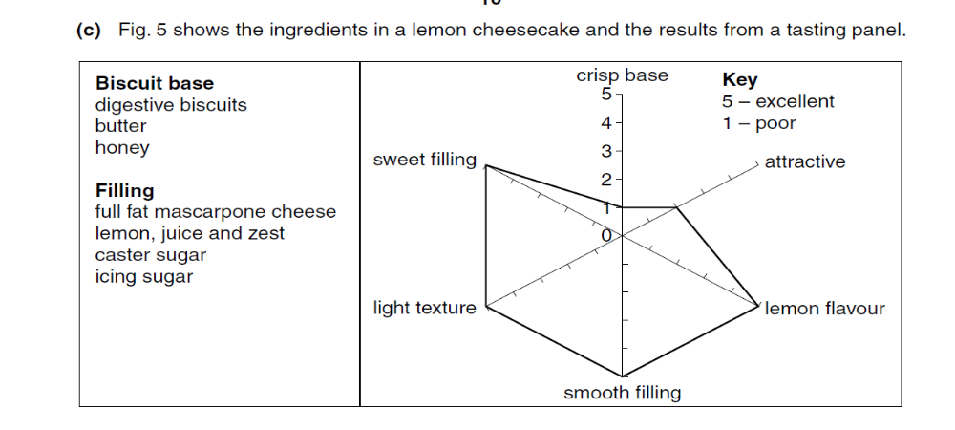

Complete the chart below to show two areas which need improving and suggest one different way of doing this for each.
Area to be improved | How it could be improved
1

2

- Give clear instructions how on how to set up and carry out sensory analysis tests.

Worksheet 2 – Soup Product Analysis
The design brief for this task was:
To design and make a new soup which is interesting for teenagers to eat.
Having carried out a survey of the intended users the identified needs of the product are:-
- To be aimed at teenagers.
- To be able to be eaten as a quick snack.
- To be able to be reheated in under 8 minutes.
- The soup should contain a variety of nutrients but not be too high in fat.
- It should have a good flavour.
- The appearance of the soup should be attractive / colourful.
- The flavour of the soup should reflect the main ingredients.
- It should contain a variety of textures

Criteria to be Evaluated Against | Products to be Evaluated
To be aimed at teenagers.
To be able to be eaten as a quick snack.
To be able to be reheated and served in under 8 minutes.
Contains protein and but not be too high in fat.
Appearance of the soup should be attractive / colourful
Flavour of the soup should reflect the ingredients.
It should contain a variety of textures.

Worksheet 3

Worksheet 4
Criteria to be Evaluated Against | Products to be Evaluated

Worksheet 5
Creativity – A Grade work
Evaluation of existing products
Key: ☺ = suitable for the requirement ☹ = not suitable for the requirement
Identified needs used

4 products in the chart
Product | Suitable for teenagers | Lower in fat (no more than 5g per 100g) | Tasty | Suitable to be frozen | Serves 1 person | Suitable to be microwaved
Tomato and mozzarella pasta bake | ☺ | ☺  (3.0g) | ☺ | ☺ | ☺ | ☺
Sharwood’s sweet and sour chicken with rice | ☹ | ☺  (1.6g) | ☺ | ☺ | ☹ | ☺
Minced beef and onion pie | ☹ | ☹  (178g) | ☹ | ☺ | ☺ | ☺
Broccoli quiche | ☹ | ☹  (??g) | ☺ | ☺ | ☹ | ☹
Conclusion
After looking at the four products that I found only one product met all the needs that I identified. This shows that there is a gap in the market for a new ready meal which serves one person. The Tomato mozzarella pasta bake has met all of the required needs that I have specified and is therefore the best product which I found. The sweet and sour chicken with rice has met all but one of the areas. The sweet and sour chicken did not reach the requirement of it only serving one person, this is because it was very large and on the packaging it stated suitable for four people. The minced beef and onion pie only met the specification in one place; this was the suitable to be frozen area. I know that this is true because on the packaging it states suitable to be frozen. In the other areas the pies were not suitable because the pies were far too big for one person to eat and also most teenagers would not want to eat these pies. The pies contained 17.8g fat per 100g which tells us this is not lower in fat. We also know that the pies can’t be microwaved at is says so on the packaging. The broccoli quiche met the requirements of tasty and suitable to be frozen, I know that it is suitable to be frozen because it tells us on the packaging. I think that it is tasty because the flavours complement each other. It didn’t meet the requirement suitable for teenagers, lower in fat, and serves one and suitable to be microwaved.

Worksheet 6
Creativity
Design brief – design and make a low fat product made for teenagers.
Identified needs
Lower in fat no more than 5g fat per 100g
Tasty
Oven cooked
Freezer
Teenagers
Evaluation of existing products
Identified needs used

4 products in the chart
Product | Target group | Method of heating | Healthy lifestyle promotion lower in fat no more than 5g/100g | Servings of people | Storage method freezer/cool dry place | Food quality
Somerfield fish and chips | Adults | Oven | No 6.1g | 1 | Freezer | Tasty
Co-op chilli con carne with rice | Adults | Oven | Yes 3.5g | 1 or 2 | Freezer | Tasty  colourful
Chicken in a Chinese style mushroom sauce and rice | Adults | Oven | Yes 2.1g | 1 | Freezer | Tasty  colourful  texture
Birds eye captains cod pie | Teenager or younger | Oven | No 7.1g | 1 | Freezer | Colourful
No conclusion on the chart
No detailed evaluation of 1 product
C/D Grade work

Worksheet 7
Choose one of the soup products and evaluate it in detail. This needs to include:-
  - A photograph of the product
  - Detailed recording and evaluation of the tasting (you could include a star chart or a tasting chart)
  - A detailed analysis of the product paying particular attention to the identified needs of the intended user.
Put photograph of product here | 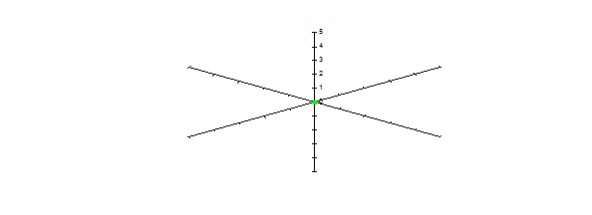
Identified needs | Evaluation against identified needs
To be aimed at teenagers.
To be able to be eaten as a quick snack.
To be able to be reheated and served in under 8 minutes.
The price per portion should be no more than 50p.
Contains protein and but not be too high in fat.
Appearance of the soup should be attractive / colourful
Flavour of the soup should reflect the ingredients.
It should contain a variety of textures.

Worksheet 8
Creativity – A Grade work
Activity 3 Exemplar Grade A evaluation of product against identified needs. Note the candidate has put the identified needs in a different colour so they can clearly be seen.

Evaluating Existing Products
Evaluation of 1 product in detail
Broccoli Quiche
The broccoli quiche is a ready meal but in my opinion, it isn’t suitable for teenagers. Therefore it did not reach the requirement for my identified target audience. I don’t think it is suitable for teenagers because many teenagers do not like broccoli so they would not like to eat this product. The quiche contains 18.6g of fat per 100g, so it is not lower in fat. In order for the quiche to be lower in fat it needs to have 5g or less per 100g. The quiche is suitable to be frozen because it states on the packaging it can be frozen so it meets the requirement in this area. I would also say that it is tasty because the flavours of the broccoli and pastry together complement each other. I thought that the quiche was far too big for 1 person to eat. I think it would serve 4 people and so would not be a suitable meal for one person to eat on their own, so it does not meet the requirement of being suitable as a one portion size product either. The product is not suitable to be microwaved as it states on the packaging that you can only bake it in the oven which means that teenagers might not want to eat it because it will take longer to heat or cook it in the oven, and they will probably want a product that is reheated or cooked quickly. The product has not met the requirements in most of the specified areas.

Worksheet 9
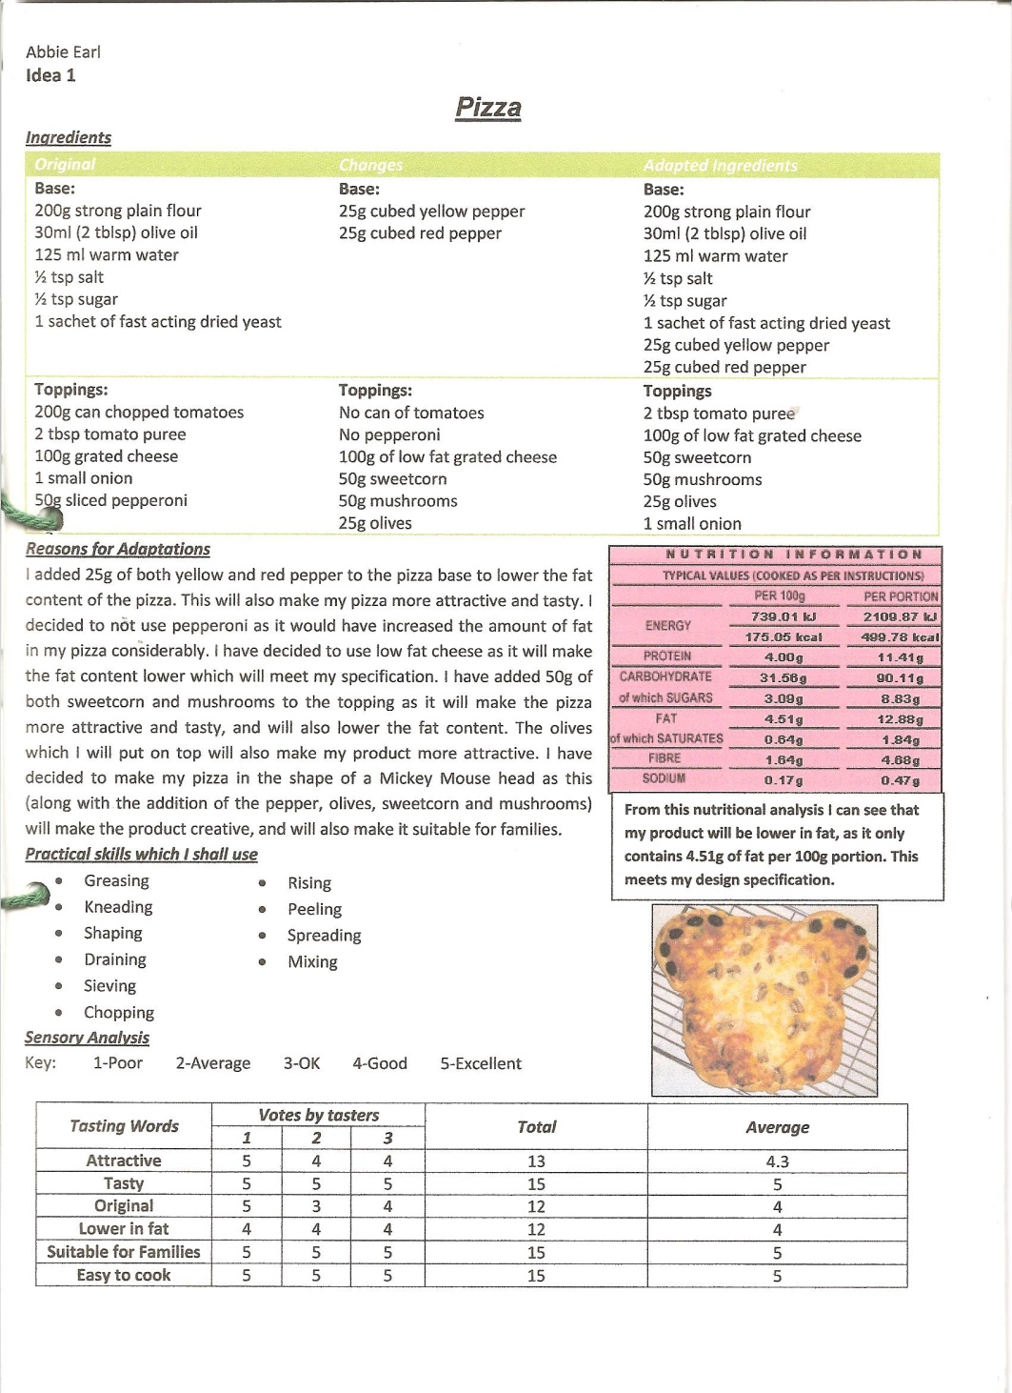

Worksheet 10
Name
Dish
Original Recipe | Adapted Recipe | Skills
Reasons for making the changes
I have chosen to make these changes to the recipe because

Nutritional information on my soup

Evaluation of the finished product
Tasting Characteristic | Taster |  |  | Total | Average
Tasting Characteristic | 1 | 2 | 3 | Total | Average
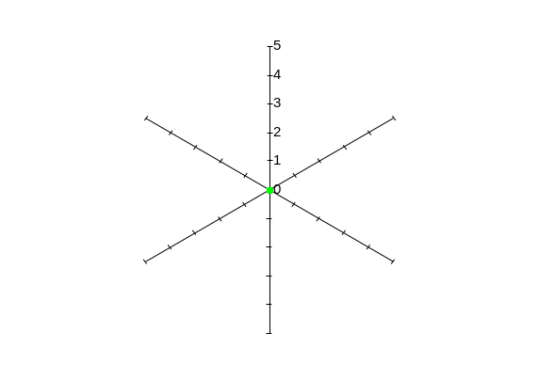
Comments on my soup by tasters

The good things about my soup were:

If I was to make my soup again the things I would improve are:

Evaluation Against Specification
Specification point | Score | Comment on Specification Point
Photograph of finished product

Worksheet 11
Texture |  | Appearance | Taste | Smell
Airy  Bouncy  Brittle  Bubbly  Cellular  Chewy  Coarse  Cold  Crisp  Crumbly  Crunchy  Crystalline  Dry  Elastic  Fibrous  Fine  Firm  Fizzy  Flaky  Foamy  Gooey  Greasy  Gritty  Hard  Hot  Juicy  Lumpy  Moist  Mushy  Powdery  Pulpy  Rubbery  Slimy  Smooth  Soft  Soggy  Spongy  Springy  Sticky  Stiff  Stretchy | Stringy  Syrupy  Tacky  Tender  Thick  Thin  Tough  Warm  Watery | Appetising  Attractive  Bubbly  Clear  Cloudy  Cold  Colourful  Colourless  Crumbly  Dry  Dull  Fattening  Flat  Foamy  Fresh  Greasy  Healthy  Hot  Moist  Opaque  Powdery  Shiny  Smooth  Soggy  Solid  Syrupy  Tasty  Translucent | Acid  Bitter  Bland  Burnt  Creamy  Dry  Fatty  Old  Raw  Salty  Sharp  Sickly  Soggy  Sour  Spicy  Stale  Sweet  Tangy  Tasteless  Tasty  Watery  Wet  Salty  Undercooked | Appetising  Burnt  Fatty  Fresh  Fruity  Greasy  Minty  Nutty  Piquant  Pungent  Rancid  Sour  Spicy  Sweet

