Foundation Check In - 12.02 Interpreting and representing data

- The pictogram shows the number of fish caught by five friends.
How many fish did they catch in total?
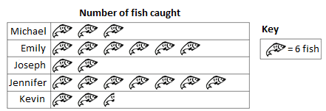

- The pie chart below represents the responses from 120 students asked to choose their favourite sport.
How many students chose Football?

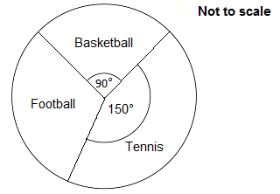

- How many more students are in Year 8 than in Year 10?

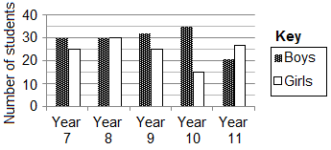

- Zaria has 20 music CDs. The frequency table gives some information of the number of tracks on each CD.
Complete the table and then use this information to complete the bar chart below.

 | Number of Tracks | Frequency
 | 11 | 3
 | 12 | 2
 | 13
 | 14 | 4
 | 15 | 6

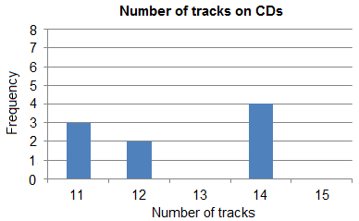

- The table shows the quarterly sales in a high street shop.

Year | Q1 | Q2 | Q3 | Q4
2013 | 25 | 75 | 105 | 45
2014 | 30 | 85 | 110 | 50
2015 | 40 | 80 | 115

Use the sales data to complete the graph below.

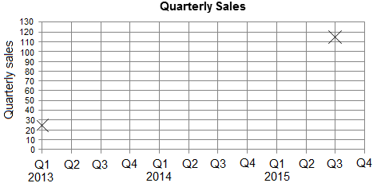

- Describe any patterns you can see on the completed graph in Question 5.

- 160 children go on a school trip either to the amusement park or the zoo.
84 children go to the amusement park, of which 38 are boys. 28 girls go to the zoo. Represent this information in a two-way table.

- Freda wants to represent the following data in a pie chart.

 | Favourite Colour | Frequency
 | Red | 40
 | Blue | 60
 | Yellow | 40
 | Green | 70

Show that the angle of the sector representing Green is 120°.

- The vertical line chart shows the score from rolling a single regular dice 200 times.
Calculate the sum of all 200 scores.

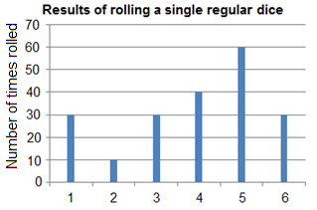

- The composite bar chart shows the membership of a sports club.
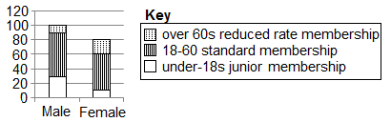

The cost of standard membership is £20.
How much revenue does the club generate from standard memberships?

Extension

Carmel asked 100 students how they travelled to school one day. Each student either walked, cycled or came by bus.

46 of the 100 students are boys.
13 of the boys came by bus.
18 girls cycled.
22 of the 38 students who walked are girls.

(a) Work out the total number of students who cycled to school that day.

(b) If a girl is chosen at random, what is the probability that she came by bus that day?

Answers

- 123 fish

- 40 students

- 10 students

- 5 CDs have 13 tracks. See graph below.

- See graph below

- Possible answers include: repeating pattern each year, maximum quarterly sales in middle of each year, peaks in Quarter 3 and troughs in Quarter 1, gradual increase in quarterly sales over time, etc.

 | Amusement park | Zoo | Total
Girls | 46 | 28 | 74
Boys | 38 | 48 | 86
Total | 84 | 76 | 160
- Angle for Green

- 780

- 110 × £20 = £2200

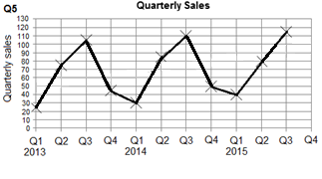
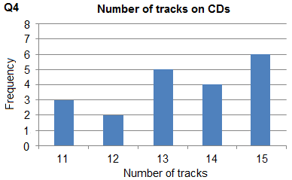

Extension
(a) 35 (b)

We’d like to know your view on the resources we produce. By clicking on ‘Like’ or ‘Dislike’ you can help us to ensure that our resources work for you. When the email template pops up please add additional comments if you wish and then just click ‘Send’. Thank you.
If you do not currently offer this OCR qualification but would like to do so, please complete the Expression of Interest Form which can be found here: www.ocr.org.uk/expression-of-interest

OCR Resources: the small print
OCR’s resources are provided to support the teaching of OCR specifications, but in no way constitute an endorsed teaching method that is required by the Board, and the decision to use them lies with the individual teacher. Whilst every effort is made to ensure the accuracy of the content, OCR cannot be held responsible for any errors or omissions within these resources. We update our resources on a regular basis, so please check the OCR website to ensure you have the most up to date version.
© OCR 2015 - This resource may be freely copied and distributed, as long as the OCR logo and this message remain intact and OCR is acknowledged as the originator of this work.

OCR acknowledges the use of the following content: Maths and English icons: Air0ne/Shutterstock.com

To give us feedback on, or ideas about the OCR resources you have used, email resourcesfeedback@ocr.org.uk
To give us feedback on, or ideas about the OCR resources you have used, email resourcesfeedback@ocr.org.uk
To give us feedback on, or ideas about the OCR resources you have used, email resourcesfeedback@ocr.org.uk
To give us feedback on, or ideas about the OCR resources you have used, email resourcesfeedback@ocr.org.uk
To give us feedback on, or ideas about the OCR resources you have used, email resourcesfeedback@ocr.org.uk
To give us feedback on, or ideas about the OCR resources you have used, email resourcesfeedback@ocr.org.uk
OCR Resources: the small print
OCR’s resources are provided to support the teaching of OCR specifications, but in no way constitute an endorsed teaching method that is required by the Board, and the decision to use them lies with the individual teacher. Whilst every effort is made to ensure the accuracy of the content, OCR cannot be held responsible for any errors or omissions within these resources.
© OCR 2014 - This resource may be freely copied and distributed, as long as the OCR logo and this message remain intact and OCR is acknowledged as the originator of this work.

OCR Resources: the small print
OCR’s resources are provided to support the teaching of OCR specifications, but in no way constitute an endorsed teaching method that is required by the Board, and the decision to use them lies with the individual teacher. Whilst every effort is made to ensure the accuracy of the content, OCR cannot be held responsible for any errors or omissions within these resources.
© OCR 2014 - This resource may be freely copied and distributed, as long as the OCR logo and this message remain intact and OCR is acknowledged as the originator of this work.
OCR acknowledges the use of the following content::
Garden: Elen Eliseeva/Shutterstock.com Flag: Pixel Europe/Shutterstock.com

To give us feedback on, or ideas about the OCR resources you have used, email resourcesfeedback@ocr.org.uk
Assessment Objective | Qu. | Topic | R | A | G |  | Assessment Objective | Qu. | Topic | R | A | G
AO1 | 1 | Interpret a pictogram |  |  |  |  | AO1 | 1 | Interpret a pictogram
AO1 | 2 | Interpret a pie chart |  |  |  |  | AO1 | 2 | Interpret a pie chart
AO1 | 3 | Interpret a multiple bar chart |  |  |  |  | AO1 | 3 | Interpret a multiple bar chart
AO1 | 4 | Interpret a frequency table and construct a bar chart |  |  |  |  | AO1 | 4 | Interpret a frequency table and construct a bar chart
AO1 | 5 | Plot a time series graph |  |  |  |  | AO1 | 5 | Plot a time series graph
AO2 | 6 | Identify patterns in a time series graph |  |  |  |  | AO2 | 6 | Identify patterns in a time series graph
AO2 | 7 | Design a two-way table |  |  |  |  | AO2 | 7 | Design a two-way table
AO2 | 8 | Calculate an angle in a pie chart |  |  |  |  | AO2 | 8 | Calculate an angle in a pie chart
AO3 | 9 | Use graphical data to solve a problem |  |  |  |  | AO3 | 9 | Use graphical data to solve a problem
AO3 | 10 | Interpret and use data from a composite bar chart |  |  |  |  | AO3 | 10 | Interpret and use data from a composite bar chart
Assessment Objective | Qu. | Topic | R | A | G |  | Assessment Objective | Qu. | Topic | R | A | G
AO1 | 1 | Interpret a pictogram |  |  |  |  | AO1 | 1 | Interpret a pictogram
AO1 | 2 | Interpret a pie chart |  |  |  |  | AO1 | 2 | Interpret a pie chart
AO1 | 3 | Interpret a multiple bar chart |  |  |  |  | AO1 | 3 | Interpret a multiple bar chart
AO1 | 4 | Interpret a frequency table and construct a bar chart |  |  |  |  | AO1 | 4 | Interpret a frequency table and construct a bar chart
AO1 | 5 | Plot a time series graph |  |  |  |  | AO1 | 5 | Plot a time series graph
AO2 | 6 | Identify patterns in a time series graph |  |  |  |  | AO2 | 6 | Identify patterns in a time series graph
AO2 | 7 | Design a two-way table |  |  |  |  | AO2 | 7 | Design a two-way table
AO2 | 8 | Calculate an angle in a pie chart |  |  |  |  | AO2 | 8 | Calculate an angle in a pie chart
AO3 | 9 | Use graphical data to solve a problem |  |  |  |  | AO3 | 9 | Use graphical data to solve a problem
AO3 | 10 | Interpret and use data from a composite bar chart |  |  |  |  | AO3 | 10 | Interpret and use data from a composite bar chart

