Lesson Element

Mrs Dalloway

Instructions and answers for teachers

These instructions cover the student activity section which can be found on page 5. This Lesson Element supports the teaching of Mrs Dalloway for OCR AS Level English Literature, Component 02.
When distributing the activity section to the students either as a printed copy or as a Word file you will need to remove the teacher instructions section.
- Learners are required to communicate fluently, accurately and effectively their knowledge, understanding and judgement of their set text.
- Learners are required to understand the significance of cultural and contextual influences on readers and writers.
- Learners are required to identify and consider how attitudes and values are expressed in their chosen texts.
- Learners are required to explore connections between their set text and thematically linked unseen extracts.

Introduction
OCR recognises that the teaching of this qualification will vary greatly from school to school and from teacher to teacher. With that in mind this lesson plan is offered as a possible approach but will be subject to modifications by the individual teacher.
Lesson length is assumed to be one hour.
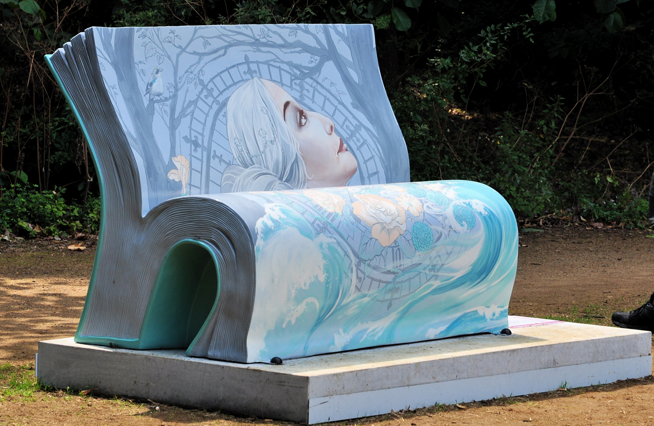

Learning Objectives for the Lesson
Objective 1  (AO3) | Students will be able to demonstrate understanding of the significance and influence of the contexts in which Mrs Dalloway was written and has been received.
Objective 2  (AO4) | Students will be able to explore connections and comparisons between Mrs Dalloway and other works by Virginia Woolf.
Objective 3  (AO1) | Students will be able to articulate informed, personal and creative responses to Mrs Dalloway, using associated concepts and terminology, and coherent, accurate written (or spoken) expression.

Recap of previous experience and prior knowledge
Remind students of the Specification Aims, Assessment Objectives and text requirements for this component (especially AO3 – ‘contexts’).
Direct students to explanation of Reader-response theory in Doing English (Eaglestone/Routledge/978 0415346344).

Prepare
Create a handout or PowerPoint presentation listing: major events in Woolf’s life; simultaneous historical events of contextual importance; Woolf’s major literary works; themes and concerns in her literary works.
- Introductory film work (5 minutes)
Show students brief sections about Virginia Woolf from the film The Hours (Daldry, 2002) and ask them to write down their initial impressions; brief feedback and discussion.
- Biography and Context (10 minutes)
Present students with a hand out/PowerPoint presentation listing: major events in Woolf’s life; simultaneous historical events of contextual importance; Woolf’s major literary works; themes and concerns in literary works. Ask students to select what they consider to be the most important events and aspects. Lead discussion and encourage justification of ideas.
- Presentation (5 minutes)
Present students with brief information about Woolf’s relationship with close male figures (father; brothers; husband) and lead discussion about the place of women (and women writers) in society: both in the early twentieth-century and today.
- Research and feedback (25 minutes)
Divide students into small groups. Ask groups to go away and research briefly (books and internet) in the context of Woolf’s life:
- Major works (with brief summaries)
- Mental illness
- London and its literary life
- Social structure, class and the role of women.
[one topic per group]
Students give brief presentations to the rest of class (and lead discussions). Notes distributed and taken; PowerPoints electronically distributed.
- Reading (5 minutes)
Distribute copies of To the Lighthouse; students take turns to read aloud from the opening; brief discussion of initial impressions (especially in the context of biographical information already explored).

Consolidation/Next steps
- Plenary task (10 minutes)
Show scenes from film versions of Orlando (Potter, 1992) and Mrs Dalloway (Gorris, 1997). Tell students to note down impressions from each film of significance in the context of the biographical information about Virginia Woolf already covered.
- Homework Tasks
Begin (or continue) reading Mrs Dalloway in preparation for class study.
Essay: ‘Which aspects of the opening section of Mrs Dalloway appear to have echoes in the events and concerns of Virginia Woolf’s own life?’
- Further reading or extension activity
Read/research To the Lighthouse as an extension activity/optional extra reading.
- Preparation for next lesson (Virginia Woolf: Mrs Dalloway – Lesson Plan: Literary Context)
Introduction to Free Indirect Discourse/ Stream of Consciousness technique:
Write down impressions of this lesson in an ‘ad hoc’/unstructured format and bring to the next lesson.

Supporting/further information
Films:
The Hours (Daldry, 2002)
Orlando (Potter, 1992)
Books:
Doing English (Eaglestone/Routledge/978 0415346344)

OCR Resources: the small print
OCR’s resources are provided to support the teaching of OCR specifications, but in no way constitute an endorsed teaching method that is required by the Board, and the decision to use them lies with the individual teacher. Whilst every effort is made to ensure the accuracy of the content, OCR cannot be held responsible for any errors or omissions within these resources.
© OCR 2015 - This resource may be freely copied and distributed, as long as the OCR logo and this message remain intact and OCR is acknowledged as the originator of this work.
OCR acknowledges the use of the following content: Page 1: Photo of the Mrs Dalloway Book Bench, Ron Ellis/Shutterstock.com
Please get in touch if you want to discuss the accessibility of resources we offer to support delivery of our qualifications: resources.feedback@ocr.org.uk
We’d like to know your view on the resources we produce. By clicking on ‘Like’ or ‘Dislike’ you can help us to ensure that our resources work for you. When the email template pops up please add additional comments if you wish and then just click ‘Send’. Thank you.
If you do not currently offer this OCR qualification but would like to do so, please complete the Expression of Interest Form which can be found here: www.ocr.org.uk/expression-of-interest

Lesson Element

Mrs Dalloway

Student Activity

Introduction
This lesson will introduce you to Virginia Woolf and Mrs Dalloway.

Task 1: Introductory Film
Write down your initial impressions of The Hours:

Task 2: Biography and Context
Review the presentation on Woolf’s life then complete the table below listing each event or aspect of her life in order of importance. Provide a justification for each event.
Order of importance | Significant event | Justification
1
2
3
4
5

Task 3: Context ‒ Research and presentation
Research in your pair/group:
- Major works (with brief summaries)
- Mental illness
- London and its literary life
- Social structure, class and the role of women.
[The teacher will allocate one topic per group]
Prepare a two minute presentation for the rest of class.

Extension task
Read: To The Lighthouse by Virginia Woolf

