THE OLYMPIANS GUIDE TO SUCCESS

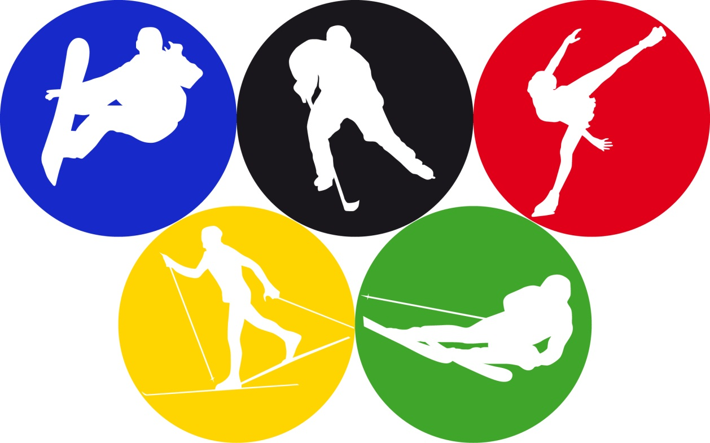

SCIENTIFIC REPORT BY __________________

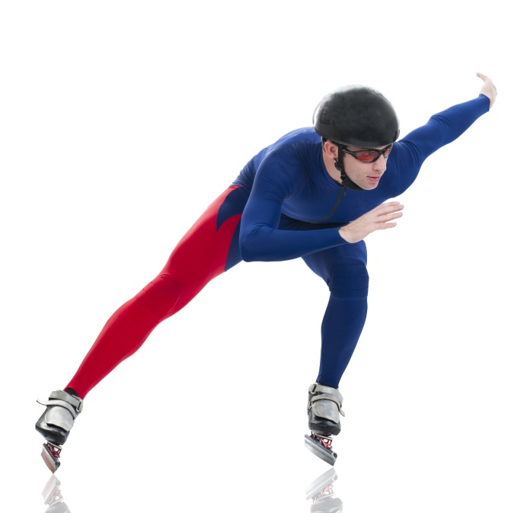
SPEED
WHAT IS SPEED?

CURLING
HOW DO YOU CALCULATE SPEED?

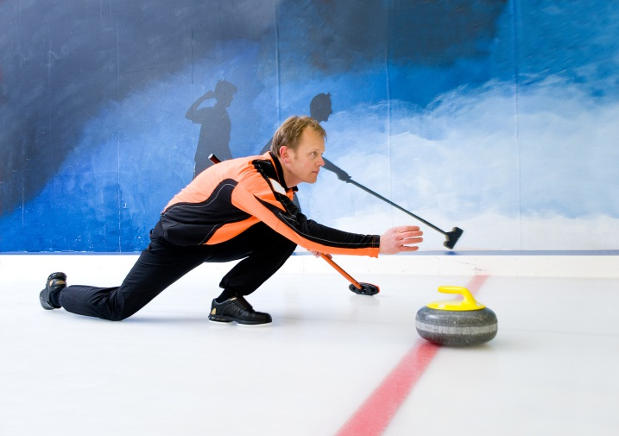
HOW DOES FRICTION REDUCE SPEED?

SHOULD WE USE BRUSHING DURING CURLING?

DRAW AN ILLUSTRATION OF HOW WE SHOULD BE CURLING.

SKI JUMPING
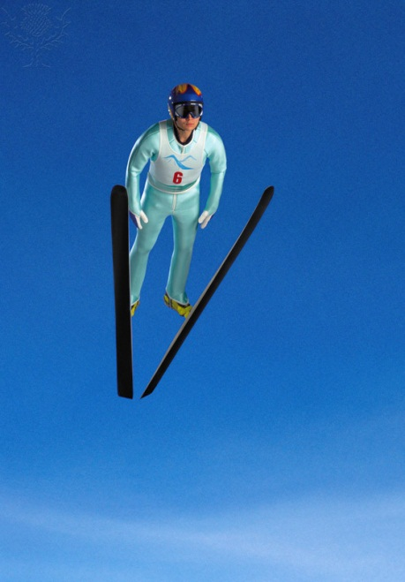
HOW DOES AIR RESISTANCE CAUSE THE ATHLETE TO JUMP A SMALLER DISTANCE?

DRAW AN ILLUSTRATION OF HOW ATHLETES CAN REDUCE AIR RESISTANCE WHEN JUMPING.

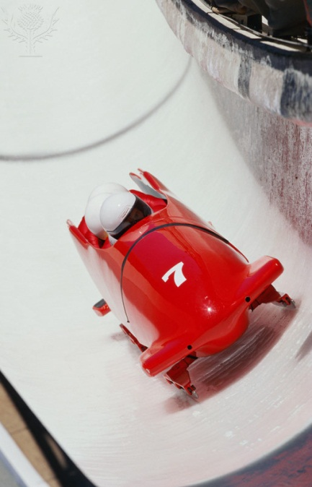
BOBSLEIGH
DESIGN US A BOBSLEIGH MAKING IT STREAMLINED

MP ROWING
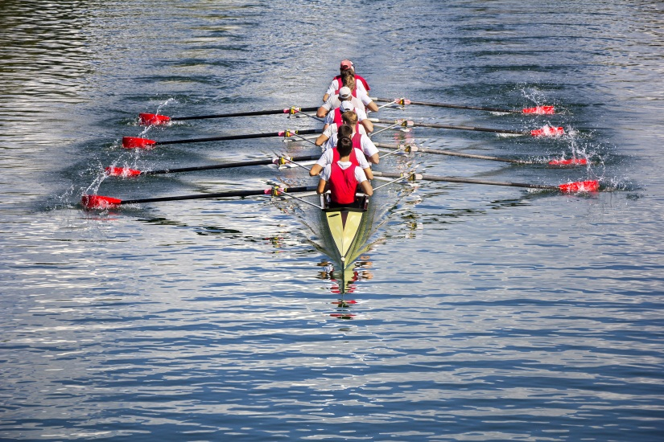
HOW DOES A BOAT FLOAT?

DESIGN US A BOAT WHICH COULD BE USED FOR ROWING

Thank you for completing the report. We will check your report and put all the changes you suggested in to our sports. We will give you feedback soon.
FEEDBACK:

