Learner Resource 2

Describing and explaining graphs

Activity 1
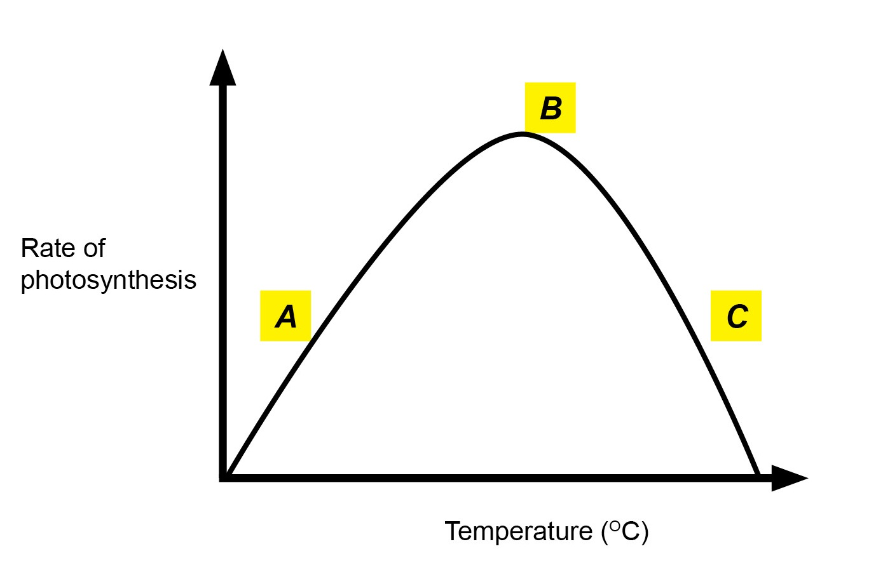

Describe and explain the shape of the graph

Describe | Connective | Explain
higher/greater/faster  lower/slower  increases/decreases  increasing/decreasing  use of figures with units  goes up/down  peaks at  highest/lowest rate | because  as a result of  due to | more/less kinetic energy  more/less collisions  more/less enzyme substrate complexes  optimum temperature  balance  active site changes shape  denatures  more/less product
Using statements from the table below, describe and explain the graph above.

Activity 2
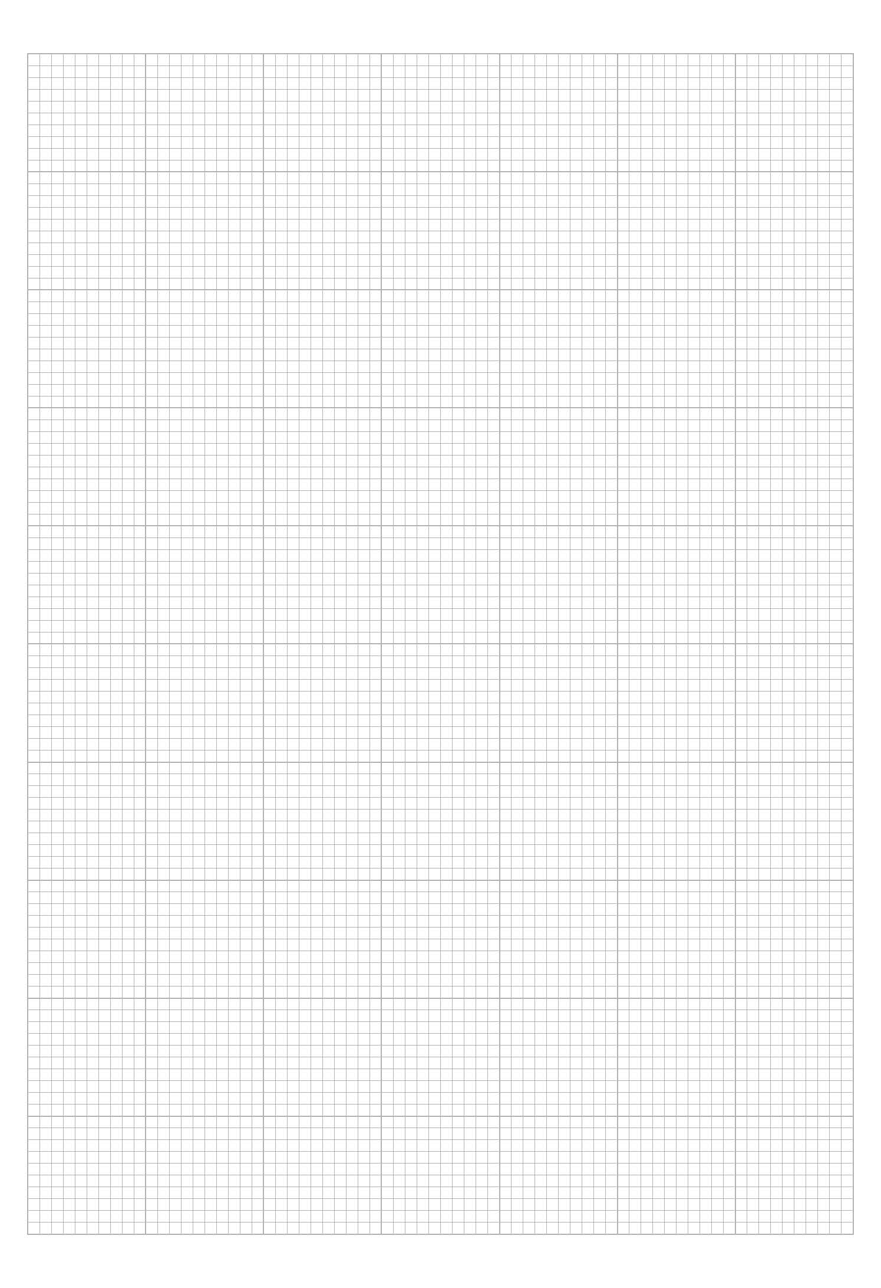
Work in pairs for this activity. One person from the pair draws a graph on the graph paper below.
The second person in the pair describes and explains the graph using words from the table below to help.
Describe | Connective | Explain
higher/greater/faster  lower/slower  increases/decreases  increasing/decreasing  use of figures with units  goes up/down  peaks at  highest/lowest rate | because  as a result of  due to | more/less kinetic energy  more/less collisions  more/less enzyme substrate complexes  optimum temperature  balance  active site changes shape  denatures  more/less product

OCR Resources: the small print
OCR’s resources are provided to support the teaching of OCR specifications, but in no way constitute an endorsed teaching method that is required by the Board, and the decision to use them lies with the individual teacher. Whilst every effort is made to ensure the accuracy of the content, OCR cannot be held responsible for any errors or omissions within these resources.
© OCR 2016 - This resource may be freely copied and distributed, as long as the OCR logo and this message remain intact and OCR is acknowledged as the originator of this work.
OCR acknowledges the use of the following content:
Please get in touch if you want to discuss the accessibility of resources we offer to support delivery of our qualifications: resources.feedback@ocr.org.uk
OCR Resources: the small print
OCR’s resources are provided to support the teaching of OCR specifications, but in no way constitute an endorsed teaching method that is required by the Board, and the decision to use them lies with the individual teacher. Whilst every effort is made to ensure the accuracy of the content, OCR cannot be held responsible for any errors or omissions within these resources.
© OCR 2016 - This resource may be freely copied and distributed, as long as the OCR logo and this message remain intact and OCR is acknowledged as the originator of this work.
OCR acknowledges the use of the following content:
Please get in touch if you want to discuss the accessibility of resources we offer to support delivery of our qualifications: resources.feedback@ocr.org.uk

