Topic Exploration Pack

Global challenges Part 3

Instructions and answers for teachers 1
Introduction 2
Suggested activities 3
Learner Activity 7

Instructions and answers for teachers

These instructions cover the student activity section which can be found on page 7. This Topic Exploration Pack supports OCR GCSE (9–1) Gateway Science Physics A.
When distributing the activity section to the learners either as a printed copy or as a Word file you will need to remove the teacher instructions section.

Mapping to spec level (Learning outcome)
P8.3a - explain the red-shift of light as seen from galaxies which are receding (qualitative only). The change with distance of each galaxy’s speed is evidence of an expanding universe
P8.3b - explain how red shift and other evidence can be linked to the Big Bang model
P8.3c - recall that our Sun was formed from dust and gas drawn together by gravity and explain how this caused fusion reactions, leading to equilibrium between gravitational collapse and expansion due to the energy released during fusion
P8.3d - explain that all bodies emit radiation, and that the intensity and wavelength distribution of any emission depends on their temperatures
P8.3e - recall the main features of our solar system, including the similarities and distinctions between the planets, their moons, and artificial satellites
P8.3f - explain for circular orbits, how the force of gravity can lead to changing velocity of a planet but unchanged speed (qualitative only)

P8.3g - explain how, for a stable orbit, the radius must change if this speed changes (qualitative only)
P8.3h - explain how the temperature of a body is related to the balance between incoming radiation absorbed and radiation emitted; illustrate this balance using everyday examples and the example of the factors which determine the temperature of the Earth
P8.3i - explain, in qualitative terms, how the differences in velocity, absorption and reflection between different types of waves in solids and liquids can be used both for detection and for exploration of structures which are hidden from direct observation, notably in the Earth’s core and in deep water

Introduction
In topic P8.3 global challenges learners take their prior knowledge of stars, planets and satellites and apply it to how the galaxy remains in perfect order. Learners will look at the life of a star, the solar system, what holds them in position and the theories of the creation of the universe with its evidence (red shift and cosmic microwave background radiation).
Learners were first introduced to the topic of space in Key Stage 3 where they would have learned about gravity and how it differs on different planets as well as a brief introduction to the gravitational force between Earth and the Moon and the Sun. They should be familiar with the Sun being a star and a few more stars in the galaxy. They would have been introduced to the light year as a unit of astronomical distance.
Learners may have the following misconceptions or difficulties about this topic:
- Learners may think that the Earth changes distance from the Sun and that this is why we get seasons. For example the closer to the sun then we are in summer and vice versa for winter.
- Learners may think that the Moon does not rotate on its axis.
- Learners may think all stars are the same size, so its brightness determines only by its distance from Earth.
There are many good videos which can help learners to grasp a better understanding of each point.
http://youtu.be/i4m4UW03wgs
http://youtu.be/CEQouX5U0fc
http://youtu.be/xp-8HysWkxw

Suggested activities

Task 1 – Red shift and cosmic microwave background radiation
This task looks at red shift and cosmic microwave background and how they are used to show the Universe is expanding. It is a task that can be done as a starter activity or part of the main. Learners are to read the statements and decide if they are related to red shift or cosmic microwave background radiation. You may wish to cut the statements out into cards and have learners work in groups and then feeding back to the class. Learners are then to write a brief explanation as to how the evidence shows that the Universe is expanding.
Read the statements below and place them into one of the two columns depending on which they relate to.
Red shift | Cosmic rays
This tells us that distant galaxies are moving away from us | Radiation created at the beginning of the universe
When an object moves away from is, its light waves are stretched into lower frequencies or longer wavelengths. | There are microwaves coming from every direction in space
In the spectrum of light from the sun there are black lines where helium has absorbed light.
With a distant star the absorption spectrum has moved to the red end.

Explain how red shift and cosmic microwave background radiation are evidence for expansion of the Universe.
Learners may have different answers but as long as it agrees with the points above then it show evidence that the Universe is expanding.

Task 2 – Lifecycle of a star
This task focuses on the life cycle of a star (P8.3c). Learners are to use the layout provided and are to explain what is happening in each stage.

Useful links:
http://www.schoolsobservatory.org.uk/astro/stars/lifecycle
https://www.youtube.com/watch?v=PM9CQDlQI0A
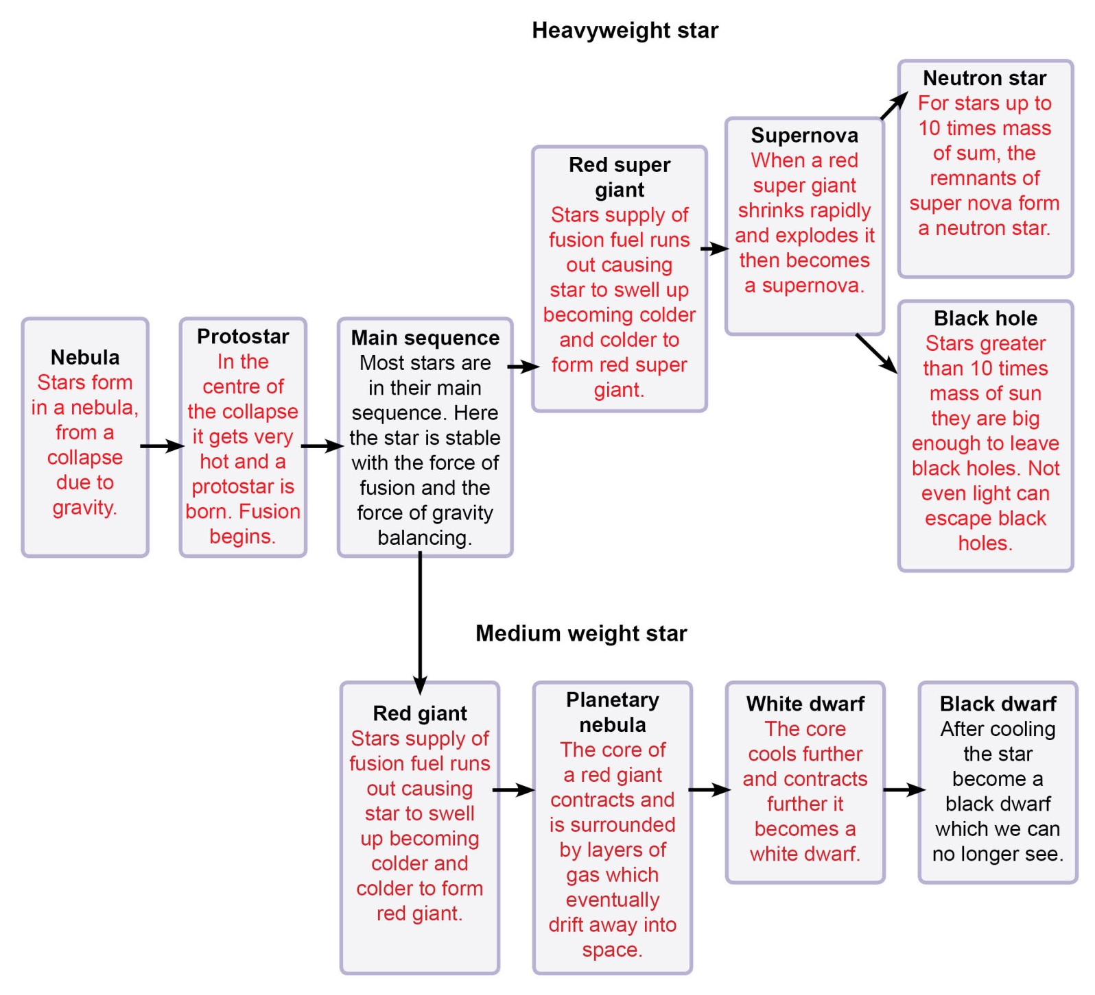

Task 3 – Planets
A quick starter activity to test Key Stage 3 knowledge. Learners are to place the planets in correct order starting with the one closest to the sun.
Useful links:
http://solarsystem.nasa.gov/planets/
Task order:
Saturn, Mercury, Neptune, Earth, Uranus, Venus, Jupiter, Mars
Correct order:
Mercury, Venus, Earth, Mars, Jupiter, Saturn, Uranus, Neptune

Task 4 – Creativity with the solar system
This task focuses on P8.3e. Learners are to be given a choice in this task to choose the one they wish to complete. It can be done as a 15 minute task at the start of a lesson or could be done after learning about the solar system. Complete one of the three tasks individually or in small groups:
1. Write a poem about the solar system.
2. Write a song/rap about the solar system.
3. Write a story about travelling to the different planets in the solar system.
Learners then present what they have done to the rest of the class.
Useful links:
http://solarsystem.nasa.gov/planets/

Task 5 – Planets mnemonic
A quick starter activity is to get learners to develop a mnemonic to remember the order of the planets.

Task 6 – Planets similarities and differences
This task can be done as a group task in which learners must research and possibly present the similarities and differences between planets of the solar system. Learners would require the use of a laptop.

Useful links:
http://space-facts.com/planets/

Task 7 – Orbits
This task focuses on P8.3f and could be done as a plenary task to test learners’ knowledge from the lesson. Learners must first find the mistakes in the passage and then correct them in the space provided.
In our solar system there are 8 planets and a dwarf planet known as Pluto. The Hubble telescope is the Earth’s natural satellite. All planets orbit around the Sun. It takes Earth 365 days to orbit the Sun on its axis. Planets stay in their orbits and do not fly off because smaller objects exert an inward force (gravitational force) on them. An example of this is the Sun on the planets. This inward pull force is due to gravity and is called ellipses.
In the space provided below correct the passages that were incorrect above.
- Hubble telescope is not Earths natural satellite but the Moon is.
- Larger object exert inward pull force.
- This is not called ellipses but centripetal force.

OCR Resources: the small print
OCR’s resources are provided to support the teaching of OCR specifications, but in no way constitute an endorsed teaching method that is required by the Board, and the decision to use them lies with the individual teacher. Whilst every effort is made to ensure the accuracy of the content, OCR cannot be held responsible for any errors or omissions within these resources.
© OCR 2016 - This resource may be freely copied and distributed, as long as the OCR logo and this message remain intact and OCR is acknowledged as the originator of this work.
OCR acknowledges the use of the following content: Page 11: Planets, La Gorda/Shutterstock.com
Please get in touch if you want to discuss the accessibility of resources we offer to support delivery of our qualifications: resources.feedback@ocr.org.uk
We’d like to know your view on the resources we produce. By clicking on ‘Like’ or ‘Dislike’ you can help us to ensure that our resources work for you. When the email template pops up please add additional comments if you wish and then just click ‘Send’. Thank you.
If you do not currently offer this OCR qualification but would like to do so, please complete the Expression of Interest Form which can be found here: www.ocr.org.uk/expression-of-interest

Topic Exploration Pack

Learner Activity

Task 1 – Red shift and cosmic microwave background radiation
Task 1 allows you to look at phenomenon within space that allow scientists to show that the Universe is expanding and provide the Big Bang theory. Read the statements and place them into one of the two columns depending on which they relate to. Secondly using the statements explain how red shift and cosmic microwave background radiation are evidence for expansion of the Universe.
Radiation created at the beginning of the universe. | There are microwaves coming from every direction in space. | When an object moves away from us, its light waves are stretched into lower frequencies or longer wavelengths. | With a distant star the absorption spectrum has moved to the red end. | In the spectrum of light from the sun there are black lines where helium has absorbed light. | This tells us that distant galaxies are moving away from us.

Red shift | Cosmic microwave background radiation

Extension activity
Explain how red shift and cosmic microwave background radiation are evidence for expansion of the Universe.

Task 2 – Lifecycle of a star
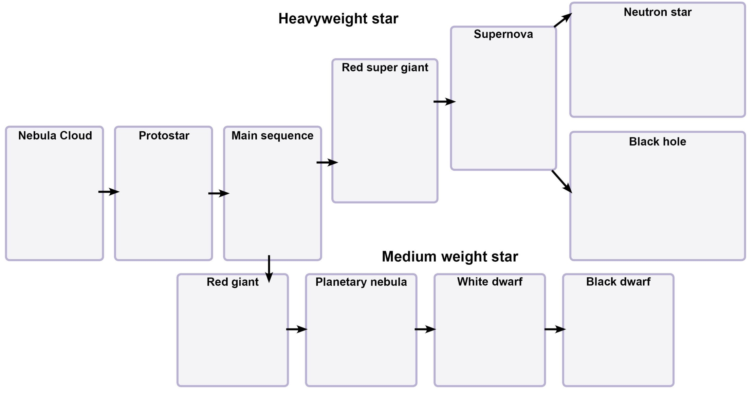
Task 2 allows you to explore not only our own star the sun but look at the life cycle of stars in detail. It may require a bit of research or group work. Use the worksheet and explain what is happening at each stage in the stars lifecycle. Look at both medium weight and heavy weight stars and complete the relevant sections.

Task 3 – Planets
A quick starter activity to test Key Stage 3 knowledge. Learners are to place the planets in correct order starting with the one closest to the sun.
Useful links:
http://solarsystem.nasa.gov/planets/

Task 4 – Creativity with the solar system
Working individually or in small groups, choose one of the three tasks below. You have 15 minutes to complete the task.
- Write a poem about the solar system.
- Write a song/rap about the solar system.
- Write a story about travelling to the different planets of the solar system.
Present what you have come up with to the rest of the class.
Useful links:
http://solarsystem.nasa.gov/planets/

Task 5 – Planets mnemonic
Develop a mnemonic to remember the order of the planets.

Task 6 – Planets similarities and differences
As a group research and present the similarities and differences between planets of the solar system.

Task 7 – Orbits
Task 7 allows you look at our solar system and think about what holds it all together.
Read the passage below about the solar system and its orbits. There are 3 mistakes in the passage. Underline the 3 mistakes.
In our solar system there are 8 planets and a dwarf planet known as Pluto. The Hubble telescope is the Earth’s natural satellite. All planets orbit around the Sun. It takes earth 365 days to orbit the Sun on its axis. Planets stay in their orbits and do not fly off because smaller objects exert an inward force (gravitational force) on them. An example of this is the Sun on the planets. This inward pull force is due to gravity and is called ellipses.

In the space provided below correct the passages that were incorrect above.

