Lesson Element

Using and Manipulating Surds

Instructions and answers for teachers

These instructions cover the student activity section which can be found on page 8. This Lesson Element supports OCR AS and A Level Mathematics A.
When distributing the activity section to the students either as a printed copy or as a Word file you will need to remove the teacher instructions section.

Rationale
AS and A level Mathematics learners are expected to be able to use and manipulate surds, including rationalising the denominator. In addition, learners should understand and use the equivalence of surd and index notation.
Assumed Knowledge
Learners that have studied the Higher tier GCSE should have already met surds but this will be new content for Foundation tier GCSE learners. These activities assume that learners have been taught:
- Simplifying expression with surds
- Rationalising denominators
Possible Misconceptions
Some learners find the concept 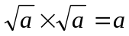 very challenging.
The most common misconception is 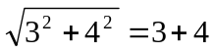.
Teaching Notes
This lesson element consists of three tasks of increasing difficulty. All three tasks have been devised to promote discussion amongst learners. The tasks can all be done in pairs, and pairs could then join to form small groups. It should be very straightforward for learners to devise their own extra questions for tasks two and three.

Task 1 – Matching Pairs
Learners link an expression in column one to an expression in column two, (sometimes several column one expressions link to a single expression in column two).
The aim of this task is to practise the basics of manipulating surds, including the special case when a rational answer is obtained from 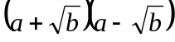 (which is important for rationalising the denominator as required in task two).

Suggested approach
Before learners start the task they may need to be reminded about the basics of multiplying out brackets and about the special case of the difference of two squares.
It can also be helpful to have look at square numbers and a few of their multiples,
e.g. , so .
The task is not a simple case of one to one correspondence of expressions from the two columns, so learners do need to continue to think carefully as they approach the end of the task.
Learners can work in pairs and then discuss their answers with another pair for self-checking, which should make them aware of the different ways of answering the same question,
e.g. 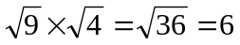 or 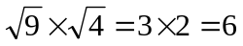.
Learners should be encouraged to identify for themselves any types of questions requiring further practice.

Answers
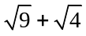 |  | 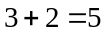
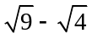 |  | 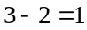
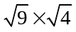 |  | 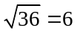 or 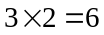
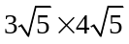 |  | 
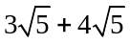 |  | 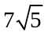
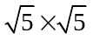
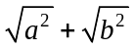 |  | 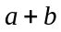
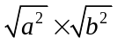 |  | 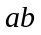
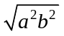
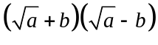 |  | 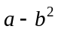
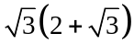 |  | 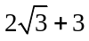
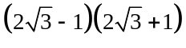 |  | 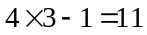
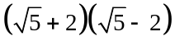 |  | 
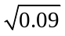 |  | 
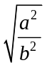
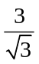 |  | 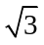
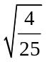 |  | 
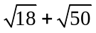 |  | 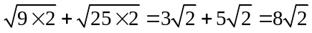
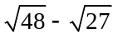 |  | 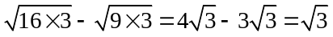
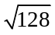 |  | 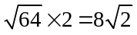

Task 2 – Card Sorting
Learners have eight expressions to rationalise, in increasing order of difficulty. Each expression has a set of cards showing the steps needed and learners need to put the cards into the correct order.
The aim of this task is to consolidate knowledge of rationalising the denominator.

Suggested approach
Learners can work in pairs and decide the order of the steps needed to rationalise the denominator for each question. They need to be familiar with the fact that 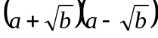 will produce a rational number whereas 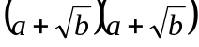 will not, along with being comfortable with the fact that multiplying by 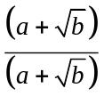 does not change the value of the expression (as it is equivalent to multiplying by 1). Exploring rationalisation is developed further in task three.
The task can be developed by asking pairs of learners to devise expressions to rationalise and give to another pair, or to write out a series of steps with an error in and ask another pair to spot the error.
Answers
1. | 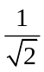 | 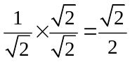
2. |  | 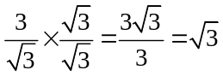
3. | 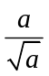 | 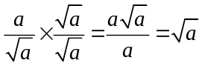
4. | 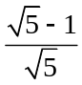 | 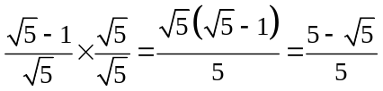
5. | 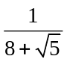 | 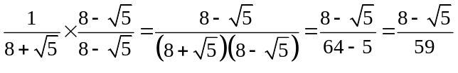
6. | 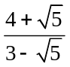 | 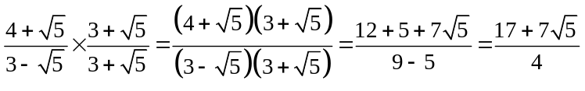
7. | 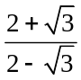 | 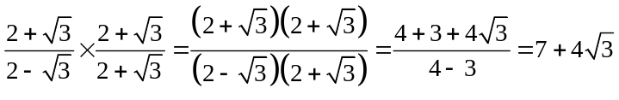
8. | 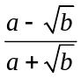 | 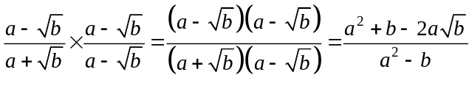

Task 3 – What is the question?
Learners are given an irrational expression and have to think of six ways of obtaining this expression using addition, subtraction, multiplication, division, equivalent fractions and rationalising the denominator.
The aim of this task is to consolidate and extend understanding of surd manipulation. It could be used as a tool for assessment for learning.

Suggested approach
Learners may need some help getting into this task and may need reminding that in task one several expressions in column one linked to the same expression in column two.
The answer in the centre can be changed and be made progressively harder, starting with answers of the form 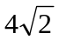and then progressing to answers of the form 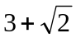.
A more graduated approach could be to find as many ways as possible to make using the operations addition and subtraction first, and then introduce multiplication, division and equivalent fractions. This open ended task lends itself to pairs sharing their work with other pairs or the whole class. Learners can give a whole range of answers for this task so further discussion will be generated during the review process.

Rationalise the denominator
Equivalent expression

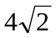

Rationalising the denominator is harder and needs some trial and error.

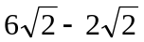
e.g.

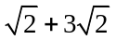

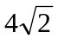
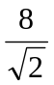
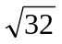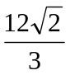
OCR Resources: the small print
OCR’s resources are provided to support the teaching of OCR specifications, but in no way constitute an endorsed teaching method that is required by the Board, and the decision to use them lies with the individual teacher. Whilst every effort is made to ensure the accuracy of the content, OCR cannot be held responsible for any errors or omissions within these resources.
© OCR 2016 - This resource may be freely copied and distributed, as long as the OCR logo and this message remain intact and OCR is acknowledged as the originator of this work.
OCR acknowledges the use of the following content: n/a
Please get in touch if you want to discuss the accessibility of resources we offer to support delivery of our qualifications: resources.feedback@ocr.org.uk
We’d like to know your view on the resources we produce. By clicking on ‘Like’ or ‘Dislike’ you can help us to ensure that our resources work for you. When the email template pops up please add additional comments if you wish and then just click ‘Send’. Thank you.
If you do not currently offer this OCR qualification but would like to do so, please complete the Expression of Interest Form which can be found here: www.ocr.org.uk/expression-of-interest

Lesson Element

Using and Manipulating Surds

Student Activity

Task 1 – Matching Pairs
Look at the two columns of expressions below. Draw a line from each of the expressions in Column A to its matching pair in Column B. Sometimes more than one expression from Column A will match to a single expression in Column B.
Column A |  |  |  | Column B
Column A |  |  |  | Column B
Column A |  |  | 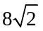 | Column B
Column A | 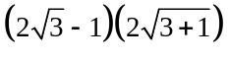 |  |  | Column B
Column A |  |  |  | Column B

Task 2 – Card Sorting
Print and cut out one set of cards for each group in the class.
The cards represent the steps needed to rationalise 8 different expressions. Lay out the cards in 8 lines from the most complex representation of the expression, to the simplest representation of the expression. Some rationalisation sequences have 4 cards, and some 5 cards.

 | 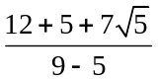 | 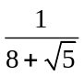
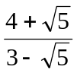 | 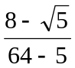 | 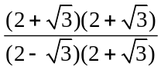
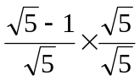 | 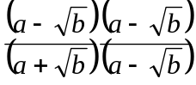 | 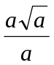
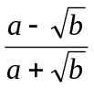 | 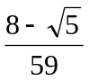 | 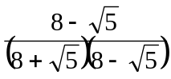
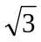 | 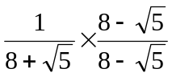 | 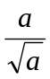
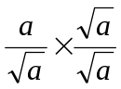 | 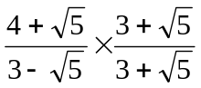 | 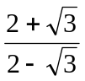
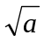 | 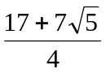 | 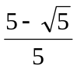
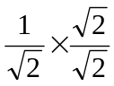 | 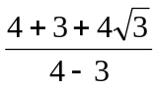 | 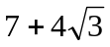
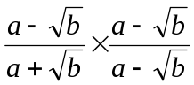 | 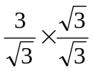 | 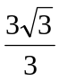
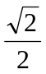 | 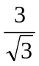 | 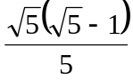
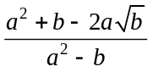 | 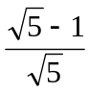 | 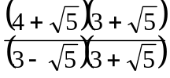
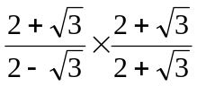

Task 3 – What is the Question?
Come up with 6 expressions which represent the answer shown in the centre oval, in this case 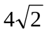. One expression should use addition, one subtraction, one multiplication, one division, one an equivalent expression and one rationalisation of the denominator.

Rationalise the denominator
Equivalent expression

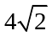

Now try: (i) 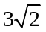.
(ii) 

