Biology PAG 1: Microscopy

Combined Science PAG B1: Microscopy

Suggested Activity 1: Examining human cheek cells

Instructions and answers for teachers & technicians
These instructions cover the learner activity section which can be found on page 7. This Practical activity supports OCR GCSE Biology.
When distributing the activity section to the learners either as a printed copy or as a Word file you will need to remove the teacher instructions section.
This is a suggested practical activity that can be used as part of teaching the GCSE (9-1) Gateway Science (A) and Twenty First Century Science (B) specifications.
These are not controlled assessment tasks, and there is no requirement to use these particular activities.
You may modify these activities to suit your learners and centre. Alternative activities are available from, for example, Royal Society of Biology, Royal Society of Chemistry, Institute of Physics, CLEAPSS and publishing companies, or of your own devising.
Further details are available in the specifications (Practical Skills Topics), and in these videos.

OCR recommendations:
Before carrying out any experiment or demonstration based on this guidance, it is the responsibility of teachers to ensure that they have undertaken a risk assessment in accordance with their employer’s requirements, making use of up-to-date information and taking account of their own particular circumstances. Any local rules or restrictions issued by the employer must always be followed.
CLEAPSS resources are useful for carrying out risk-assessments: (http://science.cleapss.org.uk).
Centres should trial experiments in advance of giving them to learners. Centres may choose to make adaptations to this practical activity, but should be aware that this may affect the Apparatus and Techniques covered by the learner.

Introduction
In this practical activity, learners will be preparing a microscope slide of their own cheek cells and examining them using a light microscope.

DfE Apparatus and Techniques covered
The codes used below match the OCR Practical Activity Learner Record Sheet (Biology / Combined Science) and Trackers (Biology / Combined Science) available online. There is no requirement to use these resources.
1 [1]: Use of appropriate apparatus to make and record a range of measurements accurately, including: i [i]) length
7 [7]: Use of appropriate apparatus, techniques and magnification, including microscopes, to: i) make observations of biological specimens; ii) produce labelled scientific drawings

Aims
To use apparatus to measure length.
To use apparatus and techniques to observe cheek cells and produce labelled scientific drawings.

Intended class time
20-30 minutes

Links to Specifications:

Twenty First Century
B1.1.1b describe how to use a light microscope to observe a variety of plant and animal cells

Gateway
B1.1a describe how light microscopes and staining can be used to view cells

Mathematical Skills covered
M1b Recognise and use expression in standard form
M2a Use an appropriate number of significant figures
M3b Change the subject of an equation

Twenty First Century IaS references covered
IaS2.1 present observations and other data using appropriate formats
IaS2.2 when processing data use SI units where appropriate
IaS2.3 when processing data use prefixes and powers of ten for orders of magnitude
IaS2.5 when processing data interconverts units
IaS2.6 when processing data use an appropriate number of significant figures

Gateway Working scientifically references covered
WS1.4c use SI units
WS1.4d use prefixes and powers of ten for orders of magnitude
WS1.4e interconvert units
WS1.4f use an appropriate number of significant figures in a calculation
WS2a carry out experiments
WS2b make and record observations and measurements using a range of apparatus and methods
WS2c presenting observations using appropriate methods

Equipment
- Light microscope
- Microscope slides (one per person)
- Cover slip (one per person)
- Cotton bud (per person)
- Mounted needle
- Filter paper
- Methylene blue stain
Disinfectant should be available – place used cotton buds and slides in this after use.

Health and Safety
Methylene blue is a low hazard substance but will stain skin and clothing so care should be taken when using it.
The inside of the cheek is delicate tissue so the cotton bud just needs to be rubbed gently once down the surface to pick up some cells. The cotton bud should then be immediately placed in disinfectant.

Method
It is probably a good idea to demonstrate the lowering of the cover slip onto the microscope slide using the mounted needle in order to maximise chances of learners getting this right. Learners also need to be reminded to focus all the way down (to the point that the objective lens is almost touching the slide) without their eye to the eyepiece lens and then to focus up in order to avoid broken cover slips. If used cotton buds and slides are placed in disinfectant when they are no longer needed, there should be no contamination issue.

Notes
This practical exercise needs to be accompanied by some teaching and learning about magnification calculations in order for learners to be able to answer one of the quiz questions that supports the practical and the associated skills.

Technician Notes
For this practical the teacher will require for a class of 30, working in pairs:
- 15 × light microscopes
- 30 × microscope slides
- 30 × cover slips
- 30 × cotton buds
- 15 × mounted needles
- 30 × small pieces of filter paper (optional)
- 15 × Methylene blue stain

For class use: disinfectant e.g. 1% Virkon solution in which to place used cotton buds and microscope slides.

Answers for quiz questions
- Name one structure that would be present in an animal cell such as a cheek cell but is not visible using a light microscope. [ 1 mark]
Mitochondria

- A student measured a drawing of a nucleus in a muscle cell to be 9 mm. The magnification of the drawing was ×1500.
What was the actual size of the nucleus? Use the appropriate unit for your answer.
[2 marks]
actual size = measured size
magnification

9 ÷ 1 500 = 0.006 mm

6 μm

- The diagram below shows a drawing done by a student from a light microscope image of onion epidermis (skin).
Suggest three improvements to the drawing. [3 marks]
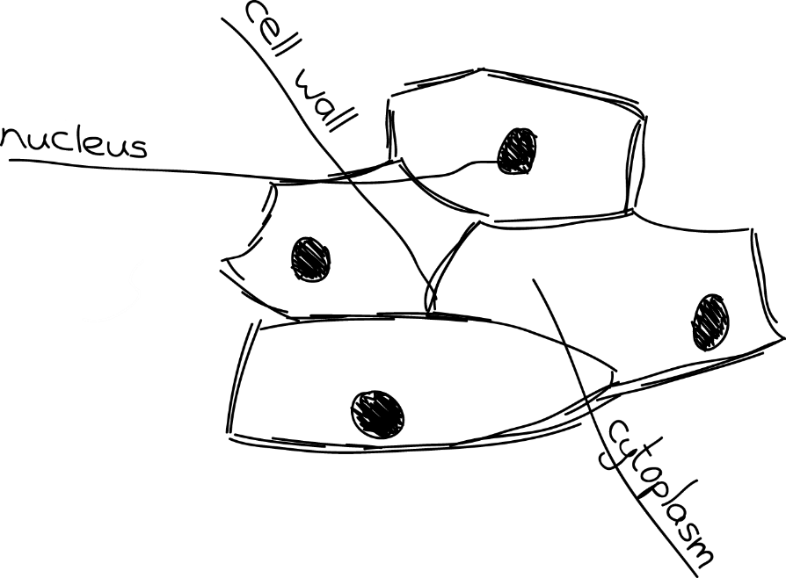

Any three from:
Lines should be solid, not sketched
There shouldn’t be any shading e.g. of nuclei
Label lines should be drawn with a ruler
Label lines should not overlap
Label lines should not have labels written on them, the labels should be written horizontally, next to the line

Document updates
v1 Published on the qualification pages
v1.1 January 2017 Consolidated labelling of activities

We’d like to know your view on the resources we produce. Click ‘Like’ or ‘Dislike’ to send us an auto generated email about this resource. Add comments if you want to. Let us know how we can improve this resource or what else you need. Your email will not be used or shared for any marketing purposes.
Looking for another resource? There is now a quick and easy search tool to help find free resources for your qualification.
OCR is part of Cambridge Assessment, a department of the University of Cambridge.
For staff training purposes and as part of our quality assurance programme your call may be recorded or monitored.
Oxford Cambridge and RSA Examinations is a Company Limited by Guarantee. Registered in England. Registered office
The Triangle Building, Shaftesbury Road, Cambridge, CB2 8EA. Registered company number 3484466. OCR is an exempt charity.
OCR operates academic and vocational qualifications regulated by Ofqual, Qualifications Wales and CCEA as listed
in their qualifications registers including A Levels, GCSEs, Cambridge Technicals and Cambridge Nationals.
OCR provides resources to help you deliver our qualifications. These resources do not represent any particular teaching method we expect you to use. We update our resources regularly and aim to make sure content is accurate but please check the OCR website so that you have the most up to date version. OCR cannot be held responsible for any errors or omissions in these resources.
Though we make every effort to check our resources, there may be contradictions between published support and the specification, so it is important that you always use information in the latest specification. We indicate any specification changes within the document itself, change the version number and provide a summary of the changes. If you do notice a discrepancy between the specification and a resource, please contact us.
© OCR 2021 - You can copy and distribute this resource freely if you keep the OCR logo and this small print intact and you acknowledge OCR as the originator of the resource.
OCR acknowledges the use of the following content: N/A
Whether you already offer OCR qualifications, are new to OCR or are thinking about switching, you can request more information using our Expression of Interest form.
Please get in touch if you want to discuss the accessibility of resources we offer to support you in delivering our qualifications.
v1.2 June 2021 Update to meet digital accessibility standards

We’d like to know your view on the resources we produce. Click ‘Like’ or ‘Dislike’ to send us an auto generated email about this resource. Add comments if you want to. Let us know how we can improve this resource or what else you need. Your email will not be used or shared for any marketing purposes.
Looking for another resource? There is now a quick and easy search tool to help find free resources for your qualification.
OCR is part of Cambridge Assessment, a department of the University of Cambridge.
For staff training purposes and as part of our quality assurance programme your call may be recorded or monitored.
Oxford Cambridge and RSA Examinations is a Company Limited by Guarantee. Registered in England. Registered office
The Triangle Building, Shaftesbury Road, Cambridge, CB2 8EA. Registered company number 3484466. OCR is an exempt charity.
OCR operates academic and vocational qualifications regulated by Ofqual, Qualifications Wales and CCEA as listed
in their qualifications registers including A Levels, GCSEs, Cambridge Technicals and Cambridge Nationals.
OCR provides resources to help you deliver our qualifications. These resources do not represent any particular teaching method we expect you to use. We update our resources regularly and aim to make sure content is accurate but please check the OCR website so that you have the most up to date version. OCR cannot be held responsible for any errors or omissions in these resources.
Though we make every effort to check our resources, there may be contradictions between published support and the specification, so it is important that you always use information in the latest specification. We indicate any specification changes within the document itself, change the version number and provide a summary of the changes. If you do notice a discrepancy between the specification and a resource, please contact us.
© OCR 2021 - You can copy and distribute this resource freely if you keep the OCR logo and this small print intact and you acknowledge OCR as the originator of the resource.
OCR acknowledges the use of the following content: N/A
Whether you already offer OCR qualifications, are new to OCR or are thinking about switching, you can request more information using our Expression of Interest form.
Please get in touch if you want to discuss the accessibility of resources we offer to support you in delivering our qualifications.

Biology PAG 1: Microscopy

Combined Science PAG B1: Microscopy

Suggested Activity 1: Examining human cheek cells

Learner Activity

Introduction
In this practical activity you will have the chance to prepare a microscope slide of cells from your own cheek, stain them and examine them using a light microscope.

Aims
To use apparatus to measure length.
To use apparatus and techniques to observe cheek cells and produce labelled scientific drawings.

Intended class time

20-30 minutes

Equipment (per group)

- Light microscope
- Microscope slides (one per person)
- Cover slip (one per person)
- Cotton bud (per person)
- Mounted needle
- Filter paper (optional)
- Methylene blue stain.

Disinfectant should be available – place used cotton buds and slides in this after use.

Health and Safety

Methylene blue is a low hazard substance but will stain skin and clothing so care should be taken when using it.

The inside of the cheek is delicate tissue so the cotton bud just needs to be rubbed gently once down the surface to pick up some cells. The cotton bud should then be immediately placed in disinfectant.

Method
- Set up the microscope ready with the lowest power objective lens e.g. ×4.
- Rub one side of the cotton bud down the inside of one side of your cheek once. This is enough to pick up some cells without damaging the delicate tissue of your inner cheek.
- Rub the side of the cotton bud with the cells on it once on the centre of the microscope slide.
- Place one drop of methylene blue on top of where the cells are on the slide.
- Take the cover slip and carefully place one side into the methylene blue using the mounted needle, as shown below.

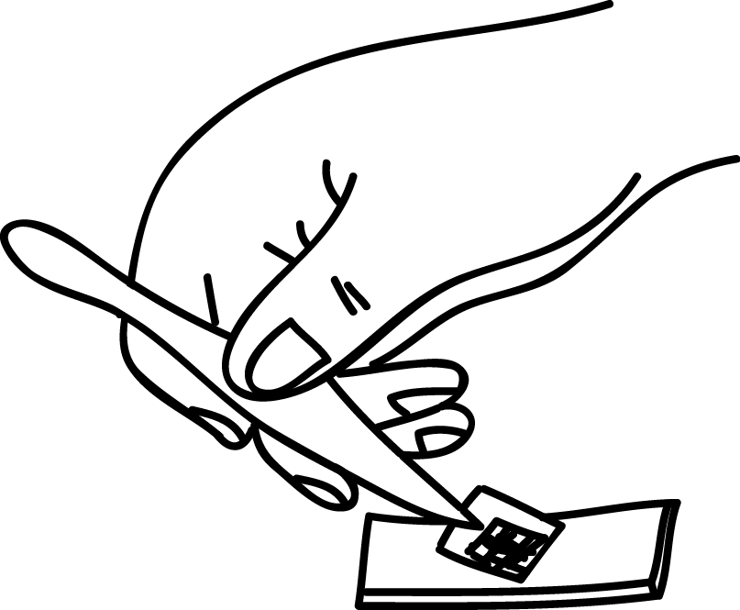

- Slowly lower the other side of the cover slip into the methylene blue, taking care not to trap any air bubbles.
- Examine the slide under the microscope using low power first. Move up to high power.
- Once you have done your drawing, place the slide and cover slip into disinfectant as directed by your teacher.

Results
Draw two or three typical cheek cells from your slide. Remember only to draw what you can see and to make sure you use a sharp pencil to draw a large drawing. Use solid lines and don’t shade. If you are labelling, use a ruler to draw the label line and make sure they don’t overlap. Don’t forget to add the magnification of your drawing.

Quiz - test your knowledge and understanding
- Name one structure that would be present in an animal cell such as a cheek cell but is not visible using a light microscope. [1 mark]

- A student measured a drawing of a nucleus in a muscle cell to be 9 mm. The magnification of the drawing was ×1500.
What was the actual size of the nucleus? Use the appropriate unit for your answer.
[2 marks]

- The diagram below shows a drawing done by a student from a light microscope image of onion epidermis (skin).
Suggest three improvements to the drawing. [3 marks]

1.

2.
3.

DfE Apparatus and Techniques covered
If you are using the OCR Practical Activity Learner Record Sheet (Biology / Combined Science) you may be able to tick off the following skills:

Biology |  |  | Combined Science
1i |  |  | 1i
7i | 7ii |  | 7i | 7ii

