Set Text Guide for students

Prose Literature A – Herodotus

General Introduction

Herodotus
Herodotus was born at Halicarnassus in Ionia, on the west coast of modern day Turkey. The traditional date of his birth is 484 BC. Most of what we know about his life comes from the Suda, a medieval encyclopaedia of the ancient world. His parents were from the upper class of the city and he had aristocratic connections. When the Persians conquered Halicarnassus in 545 BC they installed a series of tyrants. In his mid-20s, Herodotus took part in a failed revolt against one of these tyrants, Lygdamis II.
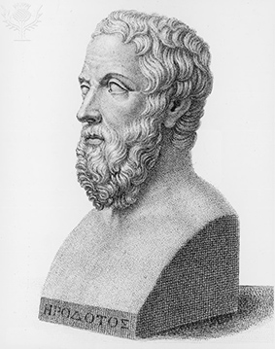
The revolt failed and Herodotus went into exile on the island of Samos. Although Lygdamis was eventually overthrown a few years later, Herodotus never returned home. Instead, inspired by earlier travel-writers, he spent the next ten years of his life travelling around the ancient world. He visited places as far apart as Egypt, Scythia, the Italian peninsula and mainland Greece, writing down the local stories and traditions which he heard. He settled for a time in Athens, where he was paid well for reciting parts of his work-in-progress.
In 443 BC Herodotus settled in the Athenian colony of Thurii in southern Italy. For the next 20 years he continued to give readings of his work and editing it. He may have revisited Athens, but probably died at Thurii in the late 420s BC. The work that he left us, the Histories, is a valuable source for the wars between Greece and Persia which took place in the first part of the 5th century BC. It also provides us with a rich account of the traditions and folklore of the ancient world.

The Histories
Before Herodotus there had been a tradition of travel writing by educated Ionians. Mostly, they would record the local legends and myths of the places they visited. This might have been the aim of Herodotus at the start of his career, but his finished work developed into something so novel that it gave birth to a new genre of literature: history. The term ‘history’ comes from the first words of his book:
‘Ἡροδότου Ἁλικαρνησσέος ἱστορίης ἀπόδεξις ἥδε’
‘This is the publication of the enquiry of Herodotus of Halicarnassus’
Herodotus’ work was ground-breaking because, like a modern historian, he tried to link cause and effect. The earlier writers had merely listed events without looking for any links between them.
Despite his pioneering achievements, Herodotus has been criticised since antiquity for his methods: he displays a clear bias towards his dear Athens whenever the Athenians feature in his stories; he often explains world events through the actions of one or two individuals, ignoring the complex nature of politics; he has a conservative view of religion and is often happy to credit the gods with having a direct hand in human affairs. These criticisms do not detract from the size of his accomplishment.
The Histories was at some point divided into nine sections, or books. Book I starts in the realms of Greek myth and Book 9 ends after the Battle of Plataea in 479 BC. Herodotus starts out seeking to explain the causes of Greece’s hostility with Persia, and then records the actual conflicts between them. While doing so, he includes a great deal of colourful stories, or digressions, which enrich his work. The prescribed material for this topic comes from Book I, and concerns Croesus, king of Lydia, who was defeated by the Persian king Cyrus the Great in 547 BC.

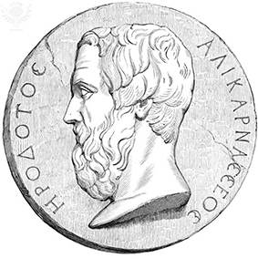

Talking Points
Talking Point | Notes
What are the methods and sources used by modern historians? Which of these would have been available to Herodotus?
Herodotus is often criticised for portraying individuals as the cause of global events. Can you think of any figures in more recent history who are claimed to have changed the world?
Does it matter that Herodotus had links to the aristocracy? How might that shape his view and recording of historical events?

Context

Greece, Lydia and Persia
Ancient Greece was not a country but a collection of city states (poleis), each with its own army, laws and government. These cities shared similar religious beliefs and spoke a common language. This civilisation was centred in and around the Aegean Sea. In the 8th century BC, migrants from mainland Greece had settled the eastern shore of the Aegean in an area subsequently known as Ionia, establishing Greek city states similar to the ones they had left behind.
To the east of Ionia lay the ancient kingdom of Lydia, established some 500 years earlier. The Lydians had their own language and religion and, according to Herodotus, invented coinage. Through the military exploits of Alyattes (619–560 BC), Lydia obtained an empire which stretched across the whole of western Anatolia (the Turkish peninsula). Alyattes was succeeded by his son Croesus.
To the east of Lydia, Cyrus the Great established the Persian Empire in the mid-6th century BC. The growth of this empire was rapid, as a succession of other powers, such as the Medes and the Babylonians, were conquered by the Persians. In 547 BC, following the Battle of Thymbra, Lydia itself came under Persian rule. In 499 BC, with military support from Athens and Eretria, the Greek cities of Ionia revolted against the tyrants which had been installed by Persia. It took the Persian king, Darius I, six years to subdue this and the various other Greek rebellions in western Anatolia.
When a peace had been drawn up, Darius decided to deal decisively with the threat posed by Greece by launching a huge invasion of the Greek mainland in 492 BC. He was finally defeated by an outnumbered Athenian army at the Battle of Marathon in 490 BC. His son Xerxes I also invaded mainland Greece, in 480 BC. Despite occupying and devastating Athens twice, the Persians’ campaign was ended by the Greeks at the Battle of Salamis and the Battle of Mycale in 479 BC. After this, Greece, especially Athens, flourished for the next 50 years.
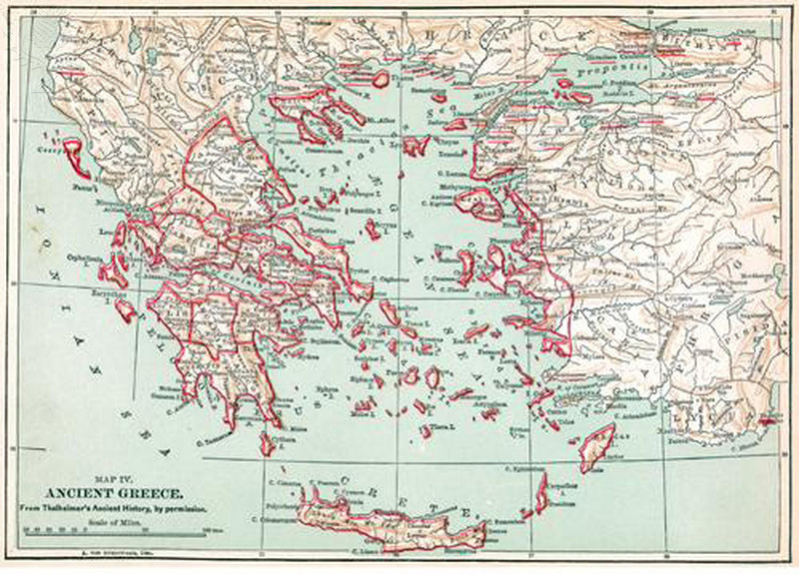

The legend of Croesus
Croesus was the king of Lydia from c.560-47 BC. He succeeded his father, Alyattes, to the throne and was a member of the powerful Mermnad dynasty. He conquered the Greek cities along the coast and collected tribute (a form of tax) from them. He is said to have created the world’s first system of coinage. Most of what we know about him comes from Herodotus
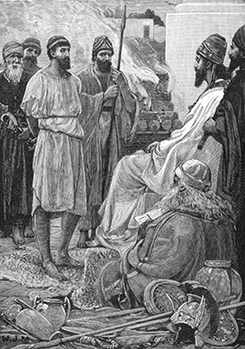
In the wars between Persia and Greece, which are the focus of Herodotus’ work, Croesus should probably have little more than a passing mention. However, Herodotus uses the character of Croesus as a parallel for Xerxes, the Persian king who invaded Greece in 480 BC. Both men enjoy extraordinary wealth and power, only to experience subsequent great loss.
Despite his fabulous wealth, which became proverbial in English (‘the riches of Croesus’), Croesus is a tragic figure. He spends a good deal of his time and money on oracles, only to be deceived by them. He is inadvertently responsible for his son’s death and oversees the collapse of the Lydian empire.
Croesus probably burned himself to death after the Lydian capital, Sardis, fell to the Persians in c.546 BC. In the prescribed text, we see that Herodotus relates a more optimistic outcome. According to other sources, Croesus either went to Egypt or became an adviser at Cyrus’ royal court after the flames of his pyre (a fire for burning dead bodies) were extinguished.
Figure 2

Solon and Alcmaeon
Solon became archon of Athens in c.594 BC. It was the highest political office a person could hold at the time. A member of the ruling elite, the Eupatrids, he introduced a series of economic and political reforms which brought greater freedom to ordinary Athenians.
By the time Solon came to power, the inequality gap between rich and poor had widened so much that many Athenians found themselves being ushered into slavery by a small number of very wealthy landowners. Solon cancelled a large number of existing debts and prevented any future borrowing which risked a person’s freedom.
Furthermore, his political reforms meant the ruling class were not simply chosen according to who their parents were. This laid the foundations for the famous democracy which Cleisthenes would introduce at the end of the century.
After his reforms, Solon is said to have travelled the ancient world for ten years, visiting places such as Egypt and Cyprus. He is unlikely to have met Croesus (who did not come to power until c.560 BC), but Herodotus is perhaps focusing on the tradition of Solon as one of the Seven Wise Men of Greece.
The second part of the prescribed text tells a story about Alcmaeon, son of Megacles. His family, the Alcmaeonids, were a powerful aristocratic family from ancient Athens. Herodotus says that the Alcmaeonids freed Athens from tyranny, and the founder of democracy, Cleisthenes, was one of their most famous sons. The story of Alcmaeon is a digression in Book 6 of the Histories, by which Herodotus seeks to explain how his family became rich. Alcmaeon is portrayed as dutiful, helpful, greedy and clever; but perhaps more interesting is the reappearance of Croesus and the other sides to his character which Herodotus shows here.
Augustus reigned for thirty years, during which time Rome was rebuilt and recovered from the damage of civil war. In order to reinforce his own position and the era of peace, Augustus used traditional myths and legends as a way of uniting the Roman people. The Trojan hero Aeneas was well known before Virgil’s epic; he was believed to be a member of the Julian family and therefore an ancestor of Augustus and his great-uncle Julius Caesar. Because the Aeneid’s content chimes so closely with the cultural programme promoted by Augustus, it has sometimes unfairly been described as Augustan propaganda.
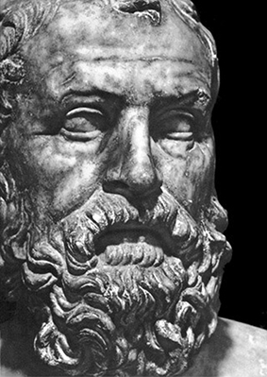

Talking points
Talking Point | Notes
Ancient Greece was not a country, but groups of peoples united by a common language and religious views. Can you think of any other modern or historical parallels to such an identity?

Although Croesus probably committed suicide after the capture of Sardis, legends quickly sprung up about how he survived the fire. Can you think of any other stories where a character lives on after their supposed death?
Bearing in mind his own life story, why might Herodotus be particularly interested in writing about the travels of Solon?

The Text

Passage 1: Solon and Croesus
Having laid down his laws for the Athenians, Solon is travelling the Aegean region. He arrives at Sardis, the capital of the Lydian Empire and the seat of the king Croesus. Croesus shows off his wealth before asking Solon who is the most blessed man in the world. Solon’s answers frustrate the proud king.

Stylistic Features
Polyptoton (a6-15): ὄλβια...ὀλβιώτατον...ὀλβιώτατος...ὀλβιώτατον

Contrast (a10-12): ὁ μὲν ἐλπίζων...Σόλων δὲ, οὐδὲν ὑποθωπεύσας

Superlatives (a18, 21): τελευτὴ...λαμπροτάτη...ἀπέθανε κάλλιστα

Irony (c15): ὁ Κροῖσος, κάρτα δόξας ἀμαθῆ εἶναι

Glossary of Key Terms
Key terms regarding content and literary techniques. | Now over to you.  Now find your own examples of these techniques and list them in the boxes below.
καλοί τε κἀγαθοί (a.16) – literally ‘fine and good’, but in practice the qualities requisite in a gentleman, and thus referred to members of the upper classes.
Νέμεσις (d.1) – Nemesis, the personification of divine retribution. The Greeks believed Nemesis fell upon men who had become overly proud or presumptuous due to their prosperity. Much like Croesus in this passage.
Sophrosyne (σωφροσύνη) – while this word is not directly mentioned in the passage, its essence permeates the philosophy of Solon. It means something like ‘self-control and prudence’ and is perhaps best embodied in Solon’s description of Cleobis and Biton when he says their life was ἀρχῶν (‘sufficient’). It is the opposite of Croesus’ hubris.

Talking points
Talking Point | Notes
Why do you think Croesus reacts to Solon’s words in the way he does? What does this tell us about him?
To what extent do you agree with Solon’s criterion for happiness?

The Text

Passage 2: How Alcmaeon was enriched by Croesus
In a digression about the origins of the Alcmaeonid family, Herodotus tells how their forefather Alcmaeon was rewarded by Croesus for assisting Lydians abroad, and for his love of gold.

Stylistic Features
Contrast (1-2): μέν καὶ πάλαι λαμπροὶ...καὶ κάρτα λαμπροί

Like many of Herodotus’ stories, the narrative of this tale is unelaborate and straightforward, with plenty of repetition. It is important for Herodotus to get across the main points of the story, particularly when his audience might have trouble hearing the performance in a busy town centre.

Glossary of Key Terms
Key terms regarding content and literary techniques. | Now over to you.  Now find your own examples of these techniques and list them in the boxes below.
Ἀλκμαιωνίδαι – the Alcmaeonids were a very distinguished Athenian family who played a big part in Athenian politics throughout the 6th and 5th centuries BC.

Talking points
Talking Point | Notes
What do you think of Alcmaeon’s behaviour? Why reasons might he have had to act in a more restrained way than he did?
How does Croesus’ character here compare to the Croesus we saw interviewing Solon? Can you account for any differences?

Activities and tasks
Gold coin of Croesus
BBC
http://www.bbc.co.uk/ahistoryoftheworld/objects/7cEz771FSeOLptGIElaquA
A webpage with details on a gold coin which might have been minted by Croesus. As part of the BBC’s History of the World in 100 Objects series, there is an accompanying podcast.
In Our Time: History of History
BBC
http://www.bbc.co.uk/programmes/b00gryrx
Melvyn Bragg hosts a discussion about the history of history writing with some of Britain’s leading classicists and historians. The programme helps to link the work of Herodotus to the modern method.
Herodotus on the Perseus website
Tufts University
http://www.perseus.tufts.edu/hopper/text?doc=Perseus%3Atext%3A1999.01.0126%3Abook%3D1%3Achapter%3D30
The original, unabridged, version of the Greek text, along with an English translation. This may help the more diligent student, but beware the differences between this and the prescribed text. Useful for looking up words quickly.

Task 1: Create a synopsis
Subject | Verb

Task 2: Creating a storyboard

Task 3: Create a practice question
Question

Answer | Marks | Guidance

We’d like to know your view on the resources we produce. By clicking on ‘Like’ or ‘Dislike’ you can help us to ensure that our resources work for you. When the email template pops up please add additional comments if you wish and then just click ‘Send’. Thank you.
If you do not currently offer this OCR qualification but would like to do so, please complete the Expression of Interest Form which can be found here: www.ocr.org.uk/expression-of-interest
OCR Resources: the small print
OCR’s resources are provided to support the teaching of OCR specifications, but in no way constitute an endorsed teaching method that is required by the Board, and the decision to use them lies with the individual teacher. Whilst every effort is made to ensure the accuracy of the content, OCR cannot be held responsible for any errors or omissions within these resources.
© OCR 2016 - This resource may be freely copied and distributed, as long as the OCR logo and this message remain intact and OCR is acknowledged as the originator of this work.
OCR acknowledges the use of the following content: Britannica.com/The Granger Collection, Britannica.com/akg-images, Britannica.com/Archive Photos, Britannica.com/Universal history archive.
Please get in touch if you want to discuss the accessibility of resources we offer to support delivery of our qualifications: resources.feedback@ocr.org.uk

