Checkpoint Task

Monitoring and controlling chemical reactions

Instructions and answers for teachers

These instructions cover the student activity section which can be found on page 10. This Checkpoint Task should be used in conjunction with the KS3–4 GCSE (9-1) Gateway Science Chemistry A Transition Guide: Monitoring and controlling chemical reactions, which supports OCR GCSE (9-1) Gateway Science Chemistry A.
When distributing the activity section to the students either as a printed copy or as a Word file you will need to remove the teacher instructions section.
ABC – This activity offers an opportunity for English skills development.
123 – This activity offers an opportunity for maths skills development.

Introduction
The first checkpoint task (Particles and Collisions) has two sections. The first (Heating Particles) checks that learners have an understanding of the particle theory that will support an extension of the ideas into the collision theory. It focuses on getting learners to explain how particle movement changes as heating occurs before a change of state. They then need to apply these ideas to explain a practical situation. Learners could attempt this part of the task individually as homework, then compare answers in pairs or small groups. The debated answers could then be shared with the class, before deciding on the answers that best fit the theory.
The second part (Particles and Dissolving) checks whether learners can use collisions of a liquid into a solid to explain ways to speed up dissolving. This could be used both before and after practical work on a similar theme, to see how the learners’ ideas have changed. It is important that learners have been encouraged to discuss why their chosen method worked so well with reference to collisions, as misconceptions are common with ideas about particles which cannot be seen.
The second checkpoint task (Neutralisation) checks that learners can use the pH scale to classify chemicals as acids, alkalis or neutral and compare their strength. This then leads on to see if learners can interpret results of a neutralisation experiment and use their mathematical skills to compare the strength and cost-effectiveness of the cure. This is preparation for titration calculations at Key Stage 4.

Teacher preparation
Diagrams of particles in a liquid should not have gaps between the particles as this would suggest that liquids can be compressed, so it is important to check that any diagrams used do show the correct arrangement. Some learners have a simplistic view of the particle model, with ideas such as ‘particles expand when heated’, so it is important to challenge these ideas with a variety of situations and questions wherever possible. The Royal Society of Chemistry produces many resources to address misconceptions, such as ‘Chemical Misconceptions – prevention, diagnosis and cure’. All of the chapters are available for free via the RSC’s Learn Chemistry site http://www.rsc.org/learn-chemistry.
What’s the fastest way to dissolve a jelly/sugar cube? is a motivating practical. Many learners will know what to do, but not be able to explain why it works. Explain that water is more attracted to the solid particle than the water is to itself, or the solid is to itself and so the collision pulls it out of the solid and into the liquid to become a solution. Learners should then be able to produce an explanation for each method of speeding up dissolving following a group discussion.
Resources:
sugar or jelly cubes,
beakers,
spatulas for stirring,
kettle for heating water,
thermometers,
pestles and mortars or scissors for increasing surface area of cube,
measuring cylinders,
water,
stopwatches.
Allow learners to plan their own fair test to find out the best method. Groups could be given a different variable to investigate (following class discussion) to produce enough data to allow graphs or bar charts to be plotted.
It is important that learners are confident with classifying acids and alkalis using the pH scale before neutralisation experiments can be carried out. Learners should have carried out their own neutralisation experiments before attempting the second checkpoint task. A range of different strength sodium hydrogencarbonate solutions are convenient to use as different indigestion cures.
Confusion can arise with the use of the word base as alkali is most commonly used up to GCSE. A base neutralises an acid, a soluble base is called an alkali. Many learners think that acids burn but don’t know that alkalis such as sodium hydroxide are in fact more corrosive than acids. This can be demonstrated by adding laboratory acids and alkalis to solids such as paper and compared at the end of the lesson. This should encourage suitable care when using both acids and alkalis. Molecular models can be used to illustrate the reaction in particle terms, showing that a salt and water are formed.

Learner Task 1 Particles and Collisions
- Heating particles
Learning outcomes:
- To describe particle movement and arrangement in solids, liquids and gases before and after heating
- To explain some uses of solids, liquids and gases in terms of particle movement and arrangement
In this section learners need to think about how particles behave when they are heated and how this affects their uses.
Heating particles
- If a solid such as a metal is heated gently, how does the behaviour of the particles change before it melts?
The particles vibrate faster, so the average distance apart increases very slightly - expansion; still in a regular pattern but the bonds are weaker.

- Why do railway tracks need a small gap between each end?
So that when heated by the sun they do not expand and buckle – the gap just decreases in size.

- If a liquid is heated gently, how does the behaviour of the particles change before it boils?
Faster random movement of particles within the liquid, so the average distance apart increases very slightly - expansion is greater than in solids; the number of particles with sufficient energy to escape at the surface and become a gas increases (rate of evaporation increases); more collisions with the side of the container.

- Why are liquids used in thermometers?
The liquid expands quickly as the particle movement increases and so the liquid rises up the thermometer as it is heated, or contracts and goes down as cooled.

- If a gas is heated gently in a sealed container, how does the behaviour of the particles change?
Faster random movement of particles throughout the container, more energetic collisions with the side of the container, so the pressure inside rises.

- What will happen to the sealed container of gas if it continues to be heated?
The container will explode.

  - Particles and Dissolving
Learning outcomes:
- Explain how liquid temperature and amount, solid size and stirring affect the speed of dissolving of a sugar cube by referring to collisions between the water and the sugar.
In the second part you need to use your knowledge of particles to explain the results of dissolving experiments.
Particles and dissolving
Sam wanted to find the best way to dissolve sugar cubes. He stirred 1 sugar cube with 100ml of water.
- First he changed the temperature of the water and found that as the temperature increased, the dissolving time decreased. Explain this by referring to collisions between sugar and water.
As the water temperature increases, the water particles move faster, so hit the sugar cube harder and more often. Because the water and sugar are attracted to each other more than sugar-sugar or water-water, the sugar breaks away from the cube, becomes weakly bonded to the water and hence becomes a solution.

- Next he changed the size of the sugar cube. He found that as the cube was broken into smaller pieces, the dissolving time decreased. Explain this by referring to collisions between sugar and water.
As the pieces get smaller, there are more sides that can be attacked by the water, so more successful collisions happen at the same time, and the sugar breaks away from the cube’s pieces and becomes part of the solution.

- When Sam increased the amount of water, he found that the more water there was, the faster the sugar dissolved. Why was this?
There were more water particles to collide with the sugar cube at the same time, so the cube was broken up more quickly.

- When Sam did not stir the water, he found the cube did not dissolve before the end of the lesson. Why was this?
Only the water molecules near the sugar cube can collide with it. As liquid particles do not move very quickly, the time for a particle near the surface to reach the bottom of the beaker where the cube is, is greater than the time available for the experiment; slow diffusion of dissolved sugar particles.

Neutralisation
Kerry tested the pH of some liquids using universal indicator. These are her results:
liquid | pH
Lemon juice | 2
Vinegar | 3
Rain water | 6
Pure water | 7
Bicarbonate of soda | 8

- Which is the strongest acid?
Lemon juice

- Which is the weakest acid?
Rain water

- Which is the neutral liquid?
Pure water

- Which liquid could be used to neutralise an acidic bee sting?
Bicarbonate of soda

- Which liquid would cause the most damage to teeth?
Lemon juice

- Kerry added an indigestion tablet to lemon juice and universal indicator. Describe the colour changes she would see if the lemon juice was slowly neutralised.
Red, orange, yellow and finally green.

Abdul tested some different indigestion remedies by adding 5 g of cure to a mixture of lemon juice and water. These are his results:
Indigestion remedy | Time taken to neutralise the lemon juice solution | Cost
Bicarbonate of soda | 70 s | £1.29 for 200 g
Biso-settler | 45 s | £2.80 for 100 g
Gavis-cure | 30 s | £3 for 16 g

- Which is the strongest alkali?
Gavis-cure

- Work out the cost of 1 g of each cure to 3 decimal places.
Bicarbonate of soda = £1.29/200g = £0.006/g
biso-settler = £2.80/100g = £0.028/g Gavis-cure = £3/16g = £0.188/g

- Which is the most cost-effective cure?
Bicarbonate of soda as only £0.006/g even though it takes the longest time to neutralise the acid.
Extension task
In 1827 Robert Brown observed pollen grains in water and saw that they moved. Why was this?
Pollen grains are bombarded by the random movement of the water molecules.

Task 2
- If fruit squash has 1/10th of the acid that lemon juice has, how much cure would be needed to neutralise the acid in it?
5g cure neutralises lemon juice solution
If squash is 1/10th of the amount of acid, cure = 5/10 = 0.5 g

- Which ion do all acids contain? How does the concentration of these ions affect the pH of the solution?
H⁺ hydrogen ions
the greater the concentration of hydrogen ions, the lower the pH

- Which ion do all alkalis contain? Write the word and symbol equation for the reaction between these 2 types of ion during a neutralisation reaction.
OH⁻ hydroxide ions,
H⁺ + OH⁻ → H₂O ,
hydrogen ions + hydroxide ions → water

Supporting/further information
http://www.rsc.org/learn-chemistry/resource/res00000421/particles-in-motion-experiment
This experiment provides evidence that particles in a gas are in motion.
http://www.rsc.org/learn-chemistry/resource/res00000420/experiments-with-particles
When a solid and a liquid are mixed, the solid may or may not dissolve. When two liquids are mixed they may become one liquid or stay separate. These experiments provide an opportunity to predict and then observe what happens.
http://www.rsc.org/learn-chemistry/resource/res00001182/the-yellow-clock
Mix 2 solutions so that a colour change occurs after 1 minute by applying knowledge of factors that affect the rate of a reaction.
http://www.bgfl.org/bgfl/custom/resources_ftp/client_ftp/ks3/science/acids/neutralisation.htm
A colourful simulation that allows learners to predict and test: the effect of adding litmus to common liquids, the pH of common liquids and how much of different strength acids will be needed to neutralise different strength alkalis.
http://www.rsc.org/learn-chemistry/resource/res00001756/neutralisation-curing-acidity?cmpid=CMP00005266
This simple experiment allows learners to follow the pH and temperature changes when an acidic solution is gradually neutralised. The experiment can be used to explore the issues involved in the control of soil pH in agriculture.

OCR Resources: the small print
OCR’s resources are provided to support the teaching of OCR specifications, but in no way constitute an endorsed teaching method that is required by the Board, and the decision to use them lies with the individual teacher. Whilst every effort is made to ensure the accuracy of the content, OCR cannot be held responsible for any errors or omissions within these resources.
© OCR 2016 - This resource may be freely copied and distributed, as long as the OCR logo and this message remain intact and OCR is acknowledged as the originator of this work.
OCR acknowledges the use of the following content: Railway Track; Gayvoronskaya_Yana/Shutterstock.com: Thermometer; Eugene Sergeev/Shutterstock.com: Sugar cube; Szasz-Fabian Ilka Erika/Shutterstock.com: Testing pH; N.Melanjina/Shutterstock.com: Indigestion tablet in water; jcjgphotography/Shutterstock.com
Please get in touch if you want to discuss the accessibility of resources we offer to support delivery of our qualifications: resources.feedback@ocr.org.uk
We’d like to know your view on the resources we produce. By clicking on ‘Like’ or ‘Dislike’ you can help us to ensure that our resources work for you. When the email template pops up please add additional comments if you wish and then just click ‘Send’. Thank you.
If you do not currently offer this OCR qualification but would like to do so, please complete the Expression of Interest Form which can be found here: www.ocr.org.uk/expression-of-interest

Checkpoint Task

Monitoring and controlling chemical reactions

Learner Activity

Introduction
In the first part of task 1 you will need to think about how particles behave when they are heated and how this affects their uses. In the second part you need to use your knowledge of particles to explain the results of dissolving experiments.
In task 1.2 you will need to interpret results of pH tests and neutralisation experiments. You will also need to use your mathematical skills to find the most cost-effective indigestion remedy.

Learner task 1
1.1 Heating particles
- If a solid such as a metal is heated gently, how does the behaviour of the particles change before it melts?

- Why do railway tracks need a small gap between each end?


- If a liquid is heated gently, how does the behaviour of the particles change before it boils?

- Why are liquids used in thermometers?
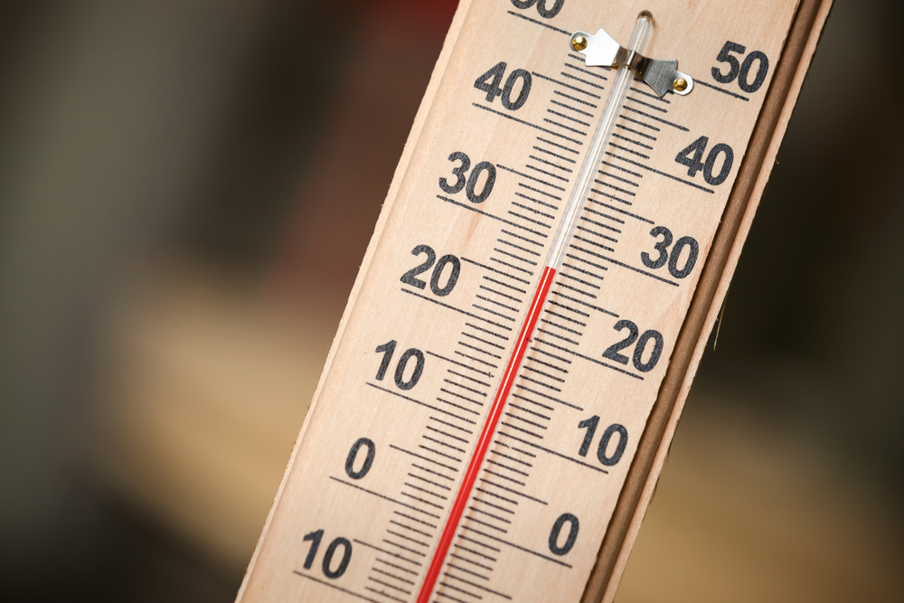

- If a gas is heated gently in a sealed container, how does the behaviour of the particles change?

- What will happen to the sealed container of gas if it continues to be heated?

1. 2 Particles and collisions
Sam wanted to find the best way to dissolve sugar cubes. He stirred 1 sugar cube with 100ml of water.

- First he changed the temperature of the water and found that as the temperature increased, the dissolving time decreased. Explain this by referring to collisions between sugar and water.
- Next he changed the size of the sugar cube. He found that as the cube was broken into smaller pieces, the dissolving time decreased. Explain this by referring to collisions between sugar and water.
- When Sam increased the amount of water, he found that the more water there was, the faster the sugar dissolved. Why was this?
When Sam did not stir the water, he found the cube did not dissolve before the end of the lesson. Why was this?

Neutralisation

Kerry tested the pH of some liquids using universal indicator. These are her results:
liquid | pH
Lemon juice | 2
Vinegar | 3
Rain water | 6
Pure water | 7
Bicarbonate of soda | 8

- Which is the strongest acid?

- Which is the weakest acid?

- Which is the neutral liquid?

- Which liquid could be used to neutralise an acidic bee sting?

- Which liquid would cause the most damage to teeth?

- Kerry added an indigestion tablet to lemon juice and universal indicator. Describe the colour changes she would see if the lemon juice was slowly neutralised.

Abdul tested some different indigestion remedies by adding 5g of cure to a mixture of lemon juice and water.
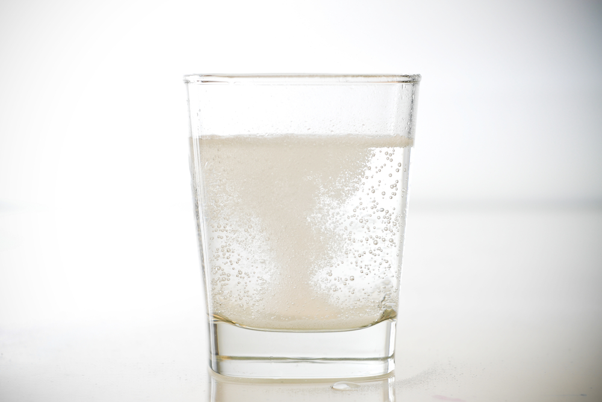
These are his results:
Indigestion remedy | Time taken to neutralise the lemon juice solution | Cost
Bicarbonate of soda | 70 s | £1.29 for 200 g
Biso-settler | 45 s | £2.80 for 100 g
Gavis-cure | 30 s | £3 for 16 g

- Which is the strongest alkali?

- Work out the cost of 1 g of each cure to 3 decimal places.

Which is the most cost-effective cure?

Extension task
- In 1827 Robert Brown observed pollen grains in water and saw that they moved. Why was this?

Task 2

- If fruit squash has 1/10th of the acid that lemon juice has, how much of each indigestion cure would be needed to neutralise the acid in it?

- Which ions do all acids contain? How does the concentration of these ions affect the pH of the solution?

- Which ion do all alkalis contain? Write the word and symbol equation for the reaction between these 2 types of ion during a neutralisation reaction.

