Chemistry PAG 6: Titration

Suggested Activity 2: The vinegar dilemma

Instructions and answers for teachers & technicians
These instructions cover the learner activity section which can be found on page 14. This Practical activity supports OCR GCSE Chemistry and Combined Science.
When distributing the activity section to the learners, either as a printed copy or as a Word file, you will need to remove the teacher instructions section.
This is a suggested practical activity that can be used as part of teaching the GCSE (9-1) Gateway Science (A) and Twenty First Century Science (B) specifications.
These are not controlled assessment tasks, and there is no requirement to use these particular activities.
You may modify these activities to suit your learners and centre. Alternative activities are available from, for example, Royal Society of Biology, Royal Society of Chemistry, Institute of Physics, CLEAPSS and publishing companies, or of your own devising.
Further details are available in the specifications (Practical Skills Topics), and in these videos.
OCR recommendations:
Before carrying out any experiment or demonstration based on this guidance, it is the responsibility of teachers to ensure that they have undertaken a risk assessment in accordance with their employer’s requirements, making use of up-to-date information and taking account of their own particular circumstances. Any local rules or restrictions issued by the employer must always be followed.
CLEAPSS resources are useful for carrying out risk-assessments: (http://science.cleapss.org.uk).
Centres should trial experiments in advance of giving them to learners. Centres may choose to make adaptations to this practical activity, but should be aware that this may affect the Apparatus and Techniques covered by the learner.

Introduction
Learning the techniques and procedures of titration can be complex for leaners as there are a wide range of conceptual and practical aspects to be mastered. This activity can be used as part of a staged introduction to titration, by not requiring the use of burettes and volumetric pipettes, and simplifying the resultant calculations.
After this activity, learners can then progress to learning to use the more accurate volumetric apparatus, and then the more involved resultant calculations, for example with a standard hydrochloric acid – sodium hydroxide titration (see OCR PAG Titration, Suggested activity 1, or RSC: http://www.rsc.org/learn-chemistry/resource/res00000536/a-microscale-acid-base-titration).
This method is based on the CLEAPSS activity PP019: http://science.cleapss.org.uk/Resource-Info/PP019-Analysis-of-vinegar-small-scale.aspx.
Further thoughts on developing titration practical work can be found at: http://www.ocr.org.uk/qualifications/by-subject/science/science-news/practical-work-and-cognitive-load/

DfE Apparatus and Techniques covered
The codes used below match the OCR Practical Activity Learner Record Sheet (Chemistry / Combined Science) and Trackers (Chemistry / Combined Science) available online. There is no requirement to use these resources.
By doing this experiment, learners have an opportunity to develop the following skills:
1 [1]: Use of appropriate apparatus to make and record a range of measurements accurately, including: i [iii]) mass
3 [8]: Use of appropriate apparatus and techniques for: i) conducting and monitoring chemical reactions; ii) conducting and monitoring chemical reactions, including appropriate reagents and/or techniques for the measurement of pH in different situations
6 [11]: Safe use and careful handling of gases, liquids and solids, including: i) careful mixing of reagents under controlled conditions; ii) using appropriate apparatus to explore chemical changes and/or products
NOTE: This practical does not cover ‘8: The determination of concentrations of strong acids and strong alkalis”.

Aims
To experimentally determine the concentration of ethanoic acid in a range of vinegar samples.

Intended class time
30-40 minutes

Links to Specifications:

Gateway Science (Suite A) – including Working Scientifically (WS)
C3.3g use and explain the terms dilute and concentrated (amount of substance) and weak and strong (degree of ionisation) in relation to acids [to include ratio of amount of acid to volume of solution]
C3.3h recall that relative acidity and alkalinity are measured by pH
C3.3i describe neutrality and relative acidity and alkalinity in terms of the effect of the concentration of hydrogen ions on the numerical value of pH (whole numbers only)
C3.3j recall that as hydrogen ion concentration increases by a factor of ten the pH value of a solution decreases by a factor of one.
C3.3k describe techniques and apparatus used to measure pH
C5.1a explain how the concentration of a solution in mol/dm³ is related to the mass of the solute and the volume of the solution
C5.1b describe the technique of titration
C5.1c explain the relationship between the volume of a solution of known concentration of a substance and the volume or concentration of another substance that react completely together
C5.1f explain how the mass of a solute and the volume of the solution is related to the concentration of the solution
WS1.2d recognise when to apply knowledge of sampling techniques to ensure any samples collected are representative
WS1.2e evaluate methods and suggest possible improvements and further investigations
WS1.3a presenting observations and other data using appropriate methods
WS1.3e interpreting observations and other data
WS1.3f presenting reasoned explanations relating data to hypotheses
WS1.3g evaluating data in terms of accuracy, precision, repeatability and reproducibility
WS1.3h identifying potential sources of random and systematic error
WS1.3i communicating the scientific rationale for investigations, methods used, findings and reasoned conclusions
WS1.4a use scientific vocabulary, terminology and definitions
WS1.4b recognise the importance of scientific quantities and understand how they are determined
WS1.4c use SI units and IUPAC chemical nomenclature unless inappropriate
WS1.4d use prefixes and powers of ten for orders of magnitude
WS1.4e interconvert units
WS1.4f use an appropriate number of significant figures in calculation
WS2a carry out experiments
WS2b make and record observations and measurements using a range of apparatus and methods
WS2c presenting observations using appropriate methods to include descriptive, tabular diagrammatic and graphically

Twenty First Century Science (Suite B) – including Ideas about Science (IaS)
C6.1.4 recall that relative acidity and alkalinity are measured by pH including the use of universal indicator and pH meters
C6.1.5 use and explain the terms dilute and concentrated (amount of substance) and weak and strong (degree of ionisation) in relation to acids including differences in reactivity with metals and carbonates
C6.1.6 use the idea that as hydrogen ion concentration increases by a factor of ten the pH value of a solution decreases by one
C6.1.7 describe neutrality and relative acidity and alkalinity in terms of the effect of the concentration of hydrogen ions on the numerical value of pH (whole numbers only)
C5.4.2 explain how the mass of a solute and the volume of the solution are related to the concentration of the solution and calculate concentration using the formula: 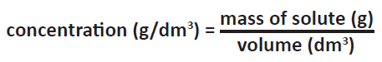
C5.4.3 explain how the concentration of a solution in mol/dm³ is related to the mass of the solute and the volume of the solution and calculate the molar concentration using the formula 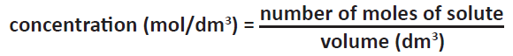
C5.4.4 describe neutralisation as acid reacting with alkali to form a salt plus water including the common laboratory acids hydrochloric acid, nitric acid and sulfuric acid and the common alkalis, the hydroxides of sodium, potassium and calcium
C5.4.5 recall that acids form hydrogen ions when they dissolve in water and solutions of alkalis contain hydroxide ions
C5.4.6 recognise that aqueous neutralisation reactions can be generalised to hydrogen ions reacting with hydroxide ions to form water
C5.4.7 describe and explain the procedure for a titration to give precise, accurate, valid and repeatable results
C5.4.8 evaluate the quality of data from titrations
C5.4.9 explain the relationship between the volume of a solution of known concentration of a substance and the volume or concentration of another substance that react completely together (separate science only)
IaS1.3 recognise the importance of scientific quantities and understand how they are determined
IaS1.8 use appropriate scientific vocabulary, terminology and definitions to communicate the rationale for an investigation and the methods used using diagrammatic, graphical, numerical and symbolic forms
IaS2.1 present observations and other data using appropriate formats
IaS2.2 when processing data use SI units where appropriate (e.g. kg, g, mg; km, m, mm; kJ, J) and IUPAC chemical nomenclature unless inappropriate
IaS2.3 when processing data use prefixes (e.g. tera, giga, mega, kilo, centi, milli, micro and nano) and powers of ten for orders of magnitude
IaS2.5 when processing data interconvert units
IaS2.6 when processing data use an appropriate number of significant figures
IaS2.8 when analysing data identify patterns/trends, use statistics (range and mean) and obtain values from a line on a graph (including gradient, interpolation and extrapolation),
IaS2.9 in a given context evaluate data in terms of accuracy, precision, repeatability and reproducibility, identify potential sources of random and systematic error, and discuss the decision to discard or retain an outlier
IaS2.10 evaluate an experimental strategy, suggest improvements and explain why they would increase the quality (accuracy, precision, repeatability and reproducibility) of the data collected, and suggest further investigations
IaS2.11 in a given context interpret observations and other data (presented in diagrammatic, graphical, symbolic or numerical form) to make inferences and to draw reasoned conclusions, using appropriate scientific vocabulary and terminology to communicate the scientific rationale for findings and conclusions
IaS2.12 explain the extent to which data increase or decrease confidence in a prediction or hypothesis

Mathematical Skills covered
M1a recognise and use expressions in decimal form
M1b recognise and use expressions in standard form
M1c use ratios, fractions and percentages
M2a use an appropriate number of significant figures
M2f understand the terms mean
M3a understand and use the symbols: =, <, ≪, ≫, >, ∝, ∼
M3b change the subject of an equation
M3c substitute numerical values into algebraic equations using appropriate units for physical quantities

Technical Requirements – PER GROUP

Chemicals
Identity | Approximate quantity required or produced PER GROUP | Hazard information |  | Risk information
labelled vinegar samples (see Notes) | c. 1 cm³ each (see notes) | Currently not classified as hazardous at this concentration
0.2 mol dm^{–3} sodium hydroxide solution | c. 10 cm³ |  | WARNING  Causes skin and serious eye irritation | Ensure learners are wearing eye protection and all spills are promptly cleared up.
0.1% phenolphthalein solution | a few drops |  | WARNING  Highly flammable  See CLEAPSS Recipe Book 46 | Ensure learners are wearing eye protection and all spills are promptly cleared up.

Equipment
- retort stand, boss and clamp
- 1 × pastettes (extended fine tip pastettes / fine tipped plastic Pasteur pipettes)
- dropping pipette with volume markings OR measuring cylinder (10 cm³) and pipette
- white tile
- small beaker or small glass vial (c. 14 cm³), e.g. Timstar VI16982 (162 reusable vials for about £40)
- access to a 2 decimal place mass balance – if you only have access to a 3 d.p. balance, place masking tape over the last decimal place.

Notes
Shop-brought vinegar samples can be used in this practical, and will need diluting down 1:4, e.g. 25 cm³ vinegar made up to 100 cm³ with deionised water.
Alternatively, sample vinegars can be made up at different concentrations, with appropriate labels. The vinegars used in the trial were made up as follows:
Vinegar sample | Volume of 1 mol/dm³ ethanoic acid solution required / cm³
Trading standards stock vinegar | 21
Supermarket vinegar | 20
Farm shop vinegar | 26
Fred's Chip Shop vinegar | 14
Make up these volumes of ethanoic acid separately to 100 cm³ with deionised water.

Health and Safety
Eye protection should be worn at all times.

Method
As the method of titration here is simplified, learners can focus on developing their observational skills to accurately identify the end-point of the titration. The method also minimises the use of reagents and allows rapid collection of quality data.

Images from trials
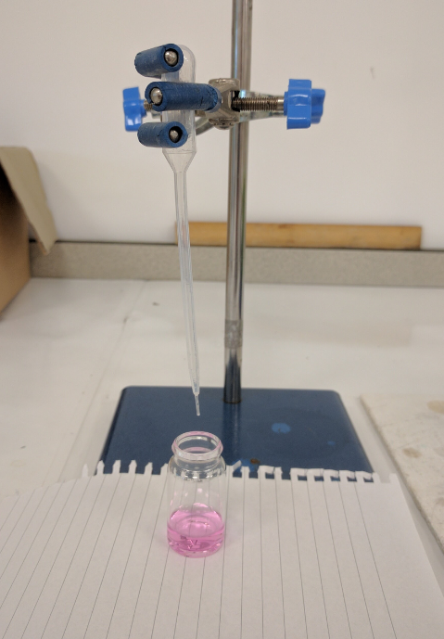
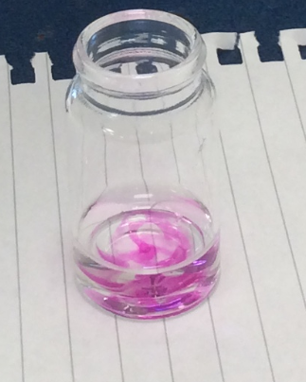
Figure 1 – Images from the trial

Analysis of results – Trial results
Data and calculations | Example data | Trading standards stock vinegar | Supermarket vinegar | Farm shop vinegar | Fred’s Chip Shop vinegar
M1 / g | 10.40 | 10.10 | 10.41 | 10.30 | 10.36
M2 / g | 11.51 | 10.97 | 11.51 | 11.59 | 11.05
M3 / g | 12.80 | 11.88 | 12.64 | 13.28 | 11.56
percentage concentration / %  = | 5.6 | 5.0 | 4.9 | 6.3 | 3.5

The questions you set your learners will depend on the focus of the experiment.
1. | Based on your results, write a short report to Trading Standards on whether further investigation is required. [3 marks]
The percentage concentration of Fred’s Chip shop vinegar is 3.5% and therefore less than the required 5.0%.

As only one sample and one repeat was used, a firm conclusion cannot be made.

Therefore, further investigation should be carried out.

2. | Discuss ways to improve the design of the analysis to give you more confidence in your data:
 | (a) | Repeatability [3 marks]
At least three repeats should be carried out

A mean average of the results can then be calculated,

which minimises random errors/increases accuracy.

 | (b) | Reproducibility [1 mark]
Either:

Another scientist should carry out the analysis using the same method.

or

The same scientist should carry out the analysis using a different method.

 | (c) | Sampling [2 marks]
Samples should be taken from several bottles of vinegar from Fred’s Chip Shop and analysed.

This will help to decide whether there was just one bad bottle of vinegar, or whether there is a wider problem.

Extension opportunities
1. | A chemist works in the quality assurance laboratory of a vinegar manufacturer.  Her job is to check that all the vinegar is at least 5.0% (w/v) acidity.  She tests 10 cm³ samples with 0.40 mol/dm³ potassium hydroxide and phenolphthalein indicator.
 | (a) | Calculate the minimum mass of ethanoic acid that must be in a 10 cm³ sample: [2 marks]
(mass = volume × percentage concentration)

10 x (5.0 / 100) =

0.50 g

 | (b) | Therefore calculate the minimum amount (in moles) of ethanoic acid in the 10 cm³ sample.  Relative molecular mass of ethanoic acid is 60.0 g/mol. [2 marks]
(amount = mass / relative molecular mass)

0.5 / 60.0 =

8.333 × 10^{–3} mol

 | (c) | Therefore, calculate the minimum volume (in cm³) of 0.40 mol/dm³ potassium hydroxide that will need to be added to the sample to neutralise it.  Ethanoic acid and potassium hydroxide react in a 1:1 ratio. [3 marks]
(volume = amount / concentration)

8.333 × 10^{–3} mol / 0.40 mol/dm³ =

0.02083 dm³

21 cm³ (to 2 sig fig)

2. | Describe the similarities and differences between the acidic nature of a hydrochloric acid and ethanoic acid. [6 marks]
Both substances are acidic because they contain hydrogen,

and dissociate in water to produce hydrogen ions (H⁺).

Hydrochloric acid is a strong acid as it fully ionises in solution.

Ethanoic acid is a weak acid as it partially ionises in solution.

3. | Find out about phenolphthalein in a book or through an internet search. Discuss why it is a better indicator than universal indicator for titration of vinegar with a strong base such as potassium hydroxide. [4 marks]
Phenolphthalein is an acid-base indicator which is colourless in acidic solutions

and pink in alkali solutions.

This gives a clear colour change when the solution is neutralised,

unlike universal indicator where a subjective judgement needs to be made about which colour indicates the solution is neutralised.

Document updates
v1 August 2016 Published on qualification pages
v1.1 January 2017 Consolidated labelling and formatting of activities; removed ‘accurate measurement of volume’ from Apparatus and Techniques list.
v1.2 July 2017 Details of making up sample vinegars added. Updated equipment list.
We’d like to know your view on the resources we produce. By clicking on ‘Like’ or ‘Dislike’ you can help us to ensure that our resources work for you. When the email template pops up please add additional comments if you wish and then just click ‘Send’. Thank you.
If you do not currently offer this OCR qualification but would like to do so, please complete the Expression of Interest Form which can be found here: www.ocr.org.uk/expression-of-interest
Looking for a resource? There is now a quick and easy search tool to help find free resources for your qualification:
www.ocr.org.uk/i-want-to/find-resources/
OCR Resources: the small print
This formative assessment resource has been produced as part of our free GCSE teaching and learning support package. All the GCSE teaching and learning resources, including delivery guides, topic exploration packs, lesson elements and more are available on the qualification webpages.
If you are looking for examination practice materials, you can find Sample Assessment Materials (SAMs) on the qualification webpages: here

OCR’s resources are provided to support the teaching of OCR qualifications, but in no way constitute an endorsed teaching method that is required by the Board, and the decision to use them lies with the individual teacher. Whilst every effort is made to ensure the accuracy of the content, OCR cannot be held responsible for any errors or omissions within these resources.
© OCR 2017 - This resource may be freely copied and distributed, as long as the OCR logo and this message remain intact and OCR is acknowledged as the originator of this work.
OCR acknowledges the use of the following content: n/a
Please get in touch if you want to discuss the accessibility of resources we offer to support delivery of our qualifications: resources.feedback@ocr.org.uk

Chemistry PAG 6: Titration

Suggested Activity 2: The vinegar dilemma

Learner Activity

Introduction
A new local fish-and-chip shop has been accused of watering down its vinegar. Your task is to provide preliminary evidence to trading standards to help them decide whether to investigate further.
Vinegar should have an ethanoic acid concentration of at least 5.0% (w/v) − this means for every 100 cm³ of vinegar there should be at least 5.0 g of ethanoic acid present (w/v means weight per volume).
You will be provided with a sample of stock vinegar from the Trading Standards laboratory, and two other well established sources, along with the vinegar from Fred’s Chip Shop.
This method is based on the CLEAPSS activity PP019: http://science.cleapss.org.uk/Resource-Info/PP019-Analysis-of-vinegar-small-scale.aspx.

Aims
To experimentally determine the concentration of ethanoic acid in a range on vinegar samples.

Intended class time
30-40 minutes

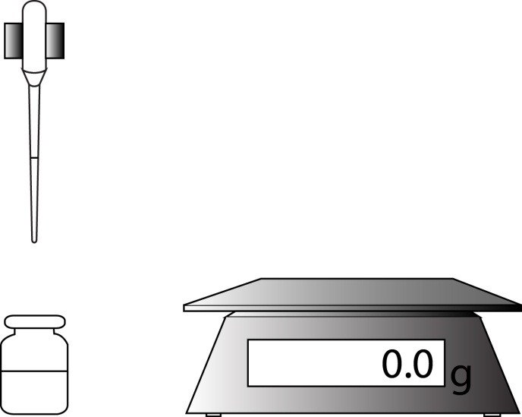
glass vial
vinegar and phenolphthalein
clamp
sodium hydroxide
pipette
mass balance
Figure 1 – The experimental setup

Chemicals and equipment (per group)
- 0.2 mol dm^{–3} sodium hydroxide solution (WARNING: Irritant)
- four vinegar samples labelled
  - Trading standards stock vinegar
  - Supermarket vinegar
  - Farm shop vinegar
  - Fred’s Chip Shop vinegar
- fine-tipped dropping pipette
- dropping pipette with volume markings OR measuring cylinder (10 cm³) and pipette
- phenolphthalein solution
- white tile
- small beaker or small glass vial (c. 14 cm³)
- retort stand, boss and clamp
- access to a 2 decimal place mass balance

Health and Safety
- Eye protection should be worn at all times.

Method
STAGE 1: Preparing your titration setup
- Squeeze the pipette bulb of the fine–tipped dropping pipette as tightly as possible, and suck up as much 0.2 mol dm^{–3} sodium hydroxide as possible.
- Carefully clamp the bulb of the pipette in clamp, attached to a retort stand with a boss.
- Add one drop of phenolphthalein indicator to a clean glass vial (or small beaker). Weigh and record the mass of the vial and its contents (this mass is called M1).
- Add about 1 cm³ of the vinegar sample to the vial. Reweigh and record the mass of the vial and its contents (M2)
The solution should be colourless at this stage.

STAGE 2: Carrying out the titration
- Place the vial under the end of the sodium hydroxide pipette.
- Slowly turn the clamp screw to add a drop of sodium hydroxide to the vial. Agitate/swirl the vial to ensure thorough mixing.
The pink indicator colour may appear then disappear on mixing.
- Continue to add drops with mixing until the pink colour remains throughout the liquid for at least 10 seconds.
- Reweigh and record the mass of the vial and its contents (M3)
- Calculate the percentage composition (weight by volume) of ethanoic acid in each vinegar using the equation in the last row of the results table.

STAGE 3: Clearing up
- Rinse all solutions down the sink with plenty of water.

Analysis of results
Use the table below to collect your data:
Data and calculations | Example data | Trading standards stock vinegar | Supermarket vinegar | Farm shop vinegar | Fred’s Chip Shop vinegar
M1 / g | 10.40
M2 / g | 11.51
M3 / g | 12.80
percentage concentration / %  = | 5.6
Take care with your BIDMAS in the last row – ((M3 – M2) × 4.8) ÷ (M2 – M1) – check you get 5.6% with the example data before analysing your results.

Your ability to analyse your observations may depend on how much of the GCSE Chemistry/Combined Science course you have studied. Your teacher will let you know which questions you should focus on:
1. | Based on your results, write a short report to Trading Standards on whether further investigation is required. [3 marks]

2. | Discuss ways of improving the design of the analysis to give you more confidence in your data:
 | (a) | Repeatability [3 marks]

 | (b) | Reproducibility [1 mark]

 | (c) | Sampling [2 marks]

Extension opportunities
1. | A chemist works in the quality assurance laboratory of a vinegar manufacturer.  Her job is to check that all the vinegar is at least 5.0% (w/v) acidity.  She tests 10 cm³ samples with 0.40 mol/dm³ potassium hydroxide and phenolphthalein indicator.
 | (a) | Calculate the minimum mass of ethanoic acid that must be in a 10 cm³ sample: [2 marks]

 | (b) | Therefore calculate the minimum amount (in moles) of ethanoic acid in the 10 cm³ sample. Relative molecular mass of ethanoic acid is 60.0 g/mol. [2 marks]

 | (c) | Therefore, calculate the minimum volume (in cm³) of 0.40 mol/dm³ potassium hydroxide that will need to be added to the sample to neutralise it. Vinegar and potassium hydroxide react in a 1:1 ratio. [3 marks]

2. | Describe the similarities and differences between the acidic nature of a hydrochloric acid and ethanoic acid. [6 marks]
3. | Find out about phenolphthalein in a book or through an internet search. Discuss why it is a better indicator than universal indicator for titration of vinegar with a strong base such as potassium hydroxide. [4 marks]

DfE Apparatus and Techniques covered
If you are using the OCR Practical Activity Learner Record Sheet (Chemistry / Combined Science) you may be able to tick off the following skills:

Chemistry |  |  |  |  | Combined Science
1-i | 3-i | 3-ii | 6-i |  | 1-iii | 8-i | 8-ii | 11-i
6-ii |  |  |  |  | 11-ii

