Maths skills – M0 Arithmetic and numerical computation

M0.1 – Recognise and make use of appropriate units in calculations
Section M0.1 explains the importance of using appropriate units in calculations and being able to convert between them. If your measurement is getting larger, for example from nm to mm, then you need to divide by the appropriate factor. If your measurement is getting smaller, for example from cm to mm then you need to multiply. There are many typical measures including distance (or length), mass, time etc. each with multiple units to convert between, and it is important for learners to choose the most appropriate unit to use.
Rates of change show a quantity per a unit of time, with the unit of time always expressed as “to the minus 1”. Other examples have rate of change measured as quantity per length, again with the unit of length being made into negative powers. In some cases learners will need to combine two or more units.

M0.2 – Recognise and use expressions in decimal and standard form
You are usually expected to record raw data to the same number of decimal places, which is simply how many digits come after the decimal point. When adding and subtracting decimals the answer should be given using the lowest number of decimal places used in the calculation. This involves rounding off the number to a certain point depending on how many decimal places you are recording, with rounding up being required if the next number is 5 or above.
Many numbers in biology, particularly with calculations involving large or small numbers, will be written in standard form, in the format:
a × 10^{n}
where n is a whole number (also known as an integer)
and a is between the values of 1 and 10.
You need to remember the “power laws” in order to deal with the value of n.
You are expected to be able to express results in standard form and to also convert between standard and decimal forms.

M0.3 – Use ratios, fractions and percentage
Section M0.3 explains the use of ratios, fractions and percentages in calculating percentage yields and percentage change, surface area to volume ratios and phenotypic ratios as well as using scales for measuring.
A percentage is simply a fraction out of 100 and is used to calculate what quantity a “part” is out of a “whole”. By dividing the “part” by the “whole” and multiplying by 100, it is converted into a percentage. Percentages can be used to determine how much a quantity has increased or decreased by (percentage change) as well as calculating the efficiency of reactions using how much product is formed (percentage yield).
Ratios are used to describe the relationship between values and is reported as “x : 1”. Ratios are most commonly used to describe the relationship between surface area and volume (surface area to volume ratios) or in genetics in comparing offspring (phenotypic ratios).

M0.4 – Estimate results
Estimating allows you to see whether the answer you’ve calculated makes sense or whether you may have made a mistake. Sometimes this may involve working out an answer based on an already known quantity, such as the average weight of a human being 70 kg. Other times you need to round a value up or down to create nicer numbers to work with. Estimating is very useful for spotting mistakes made with units, decimal points or general mistakes with putting in the wrong number.

M0.5 – Use calculators to find and use power, exponential and logarithm functions
Different models of calculators have different buttons to enter powers and logarithms. Some examples of different calculator symbols for powers include: ‘x^{y}’, ‘10^{x}’, ‘^’ and ‘exp’.
The two most useful logarithm bases are base-10 (common logs) or base-e (natural logs). Common logs are written as “log(x)” and have the calculator button “log”. Natural logs are written as “ln(x)” and have the calculator button “ln”.
You will be expected to be able to estimate the number of bacteria grown over a certain length of time. Bacterial cells multiply exponentially. The formula to find the number of cells after $n$ generations is:
$$N=N_{0}×2^{n}$$
where N₀ = initial number and n = division number.

Questions:
- Convert each of the following into mm.
(a) 100 nm
(b) 2 µm
(c) 3 m
(d) 20 km

2. Volumes.
(a) | How many nm³ in a mm³?
(b) | How many nm³ in a μm³?

3. Use correct notation to express the following:
(a) | 20 m per second
(b) | 14 breaths per minute
(c) | 360 dm³ per hour
(d) | 10³ bacteria per hour

4. Convert these into standard form, to one decimal place.
(a) | 0.3
(b) | 0.0056
(c) | 0.000000000000056
(d) | 0.0000016

5. Convert each of the following into nm.
(a) | 24 m
(b) | 70 µm
(c) | 0.03 µm
(d) | 18 mm

6. Calculate the following giving answers in standard form.
(a) | (2 x 10⁵) x (3 x 10⁵)
(b) | (5 x 10²) x (3 x 10³)
(c) | (4 x 10⁻⁶) x (1 x 10⁵)
(d) | (5 x 10⁻³) x (5 x 10⁻³)

7. A 10 ml starter culture of bacteria was incubated overnight. A serial dilution was then used to make a 1 x 10⁻³ dilution of the resulting culture. A 10 μl sample of this dilution was spread on an agar plate to identify individual colonies.
The resulting spread plate looked like this:
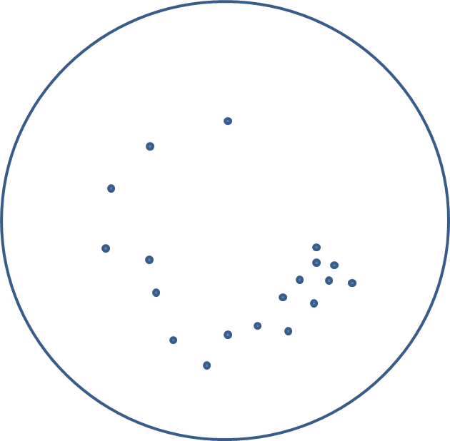
Calculate approximately how many bacteria were in the original culture:

8. Linoleic acid has the formula C₁₈H₃₂O₂. What percentage of atoms in linoleic acid are:
(a) | Carbon?
(b) | Hydrogen?
(c) | Oxygen?

9. In an experiment using catalase to catalyse the release of oxygen gas from a solution of hydrogen peroxide, the theoretical yield is 15.4 cm³. The actual yield was 9.8 cm³. What was the percentage yield for this enzymatic reaction?

10. Convert the following to sensible units:
(a) | 85000 g
(b) | 0.0000008 l
(c) | 9000 μm
(d) | 5000000000 mg

11. In one year a population of 80 rabbits had decreased by 10%, what is the total number of rabbits at the end of the year?

12. Areas.
(a) | How many nm² in a mm²?
(b) | How many nm² in a μm²?

13. Fill in the correct values for volume to 1 decimal place and calculate the mean
Measurement | Volume (ml)  X | Volume (ml)
1 | 4.85
2 | 7.0
3 | 7.14
4 | 5.99
 | Mean:

14. 30 kittens were classified according to their coat colour:
Coat colour | Number of kittens
Black | 17
White | 4
Ginger | 9

What was the ratio of black to white to ginger kittens?
  - : ___ : ___

15. In an experiment, initial and final mass readings were taken. What is the change in mass?
Initial mass = 27.6g | Final mass = 22.25g | Change in mass =

16. Estimate answers, then check your estimates with a calculator:
a) 11.2 x 14.9 =
b) 5.9 x 13.2 =
c) 49.7/6.3 =

17. At the start of an experiment there are 100 bacterial cells in a culture. This bacterium divides (doubles) about every 20 minutes under standard conditions. How many cells will there be after 3 hours?

Answers:
- Convert each of the following into mm. (M0.1)
(a) | 100 nm | 100 nm = 1 x 10⁻⁴ mm
(b) | 2 µm | 2 µm = 2 x 10⁻³ mm
(c) | 3 m | 3 m = 3 x 10³ mm
(d) | 20 km | 20 km = 2 x 10⁷ mm

2. Volumes. (M0.1)
(a) | How many nm³ in a mm³? | 10¹⁸
(b) | How many nm³ in a μm³? | 10⁹

3. Use correct notation to express the following: (M0.1)
(a) | 20 m per second | 20 m s⁻¹
(b) | 14 breaths per minute | 14 breaths min⁻¹
(c) | 360 dm³ per hour | 360 dm³ h⁻¹ or 3.6 x 10² dm³ h⁻¹
(d) | 10³ bacteria per hour | 10³ bacteria h⁻¹

4. Convert these into standard form, to one decimal place. (M0.2)
(a) | 0.3 | 3.0 x 10⁻¹
(b) | 0.0056 | 5.6 x 10⁻³
(c) | 0.000000000000056 | 5.6 x 10⁻¹⁴
(d) | 0.0000016 | 1.6 x 10⁻⁶

5. Convert each of the following into nm. (M0.1)
(a) | 24 m | 24 m = 2.4 x 10¹⁰ nm
(b) | 70 µm | 70 µm = 7 x 10⁴ nm
(c) | 0.03 µm | 0.03 µm = 3 x 10¹ nm
(d) | 18 mm | 18 mm = 1.8 x 10⁷ nm

6. Calculate the following giving answers in standard form. (M0.2)
(a) | (2 x 10⁵) x (3 x 10⁵) | 6 x10¹⁰
(b) | (5 x 10²) x (3 x 10³) | 1.5 x 10⁶
(c) | (4 x 10⁻⁶) x (1 x 10⁵) | 4 x 10⁻¹
(d) | (5 x 10⁻³) x (5 x 10⁻³) | 2.5 x 10⁻⁵

7. A 10 ml starter culture of bacteria was incubated overnight. A serial dilution was then used to make a 1 x 10⁻³ dilution of the resulting culture. A 10 μl sample of this dilution was spread on an agar plate to identify individual colonies. (M0.4)
The resulting spread plate looked like this:
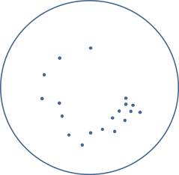
Calculate approximately how many bacteria were in the original culture:
19 bacteria in 10 μl spread plate
Dilution factor = 1 in 1000
19 x 1000 = 19,000 in 10 μl of the original culture
Total volume of original culture = 10 ml
19000 x 1000 = 19,000,000 bacteria in the 10 ml starter culture

8. Linoleic acid has the formula C₁₈H₃₂O₂. What percentage of atoms in linoleic acid are:
(a) | Carbon? | 35% (18 of 52)
(b) | Hydrogen? | 62% (32 of 52)
(c) | Oxygen? | 4% (2 of 52)
(M0.3)
9. In an experiment using catalase to catalyse the release of oxygen gas from a solution of hydrogen peroxide, the theoretical yield is 15.4 cm³. The actual yield was 9.8 cm³. What was the percentage yield for this enzymatic reaction? (M0.3)
100 x 9.8 / 15.4 = 64%

10. Convert the following to sensible units: (M0.1)
(a) | 85000 g | 85 kg
(b) | 0.0000008 l | 0.8 μl or 8 x 10⁻¹ μl
(c) | 9000 μm | 9 mm
(d) | 5000000000 mg | 5000 kg or 5 x 10³ kg

11. In one year a population of 80 rabbits had decreased by 10%, what is the total number of rabbits at the end of the year? (M0.3)
80 x 0.9 = 72 rabbits

12. Areas. (M0.1)
(a) | How many nm² in a mm²? | 10¹²
(b) | How many nm² in a μm²? | 10⁶

13. Fill in the correct values for volume to 1 decimal place and calculate the mean.
Measurement | Volume (ml)  X | Volume (ml)
1 | 4.85 | 4.9
2 | 7.0 | 7.0
3 | 7.14 | 7.1
4 | 5.99 | 6.0
 | Mean: | 6.25

14. 30 kittens were classified according to their coat colour:
Coat colour | Number of kittens
Black | 17
White | 4
Ginger | 9

What was the ratio of black to white to ginger kittens? (M0.3)
  - : 0.4 : 1

15. In an experiment, initial and final mass readings were taken. What is the change in mass? (M0.2)
Initial mass = 27.6g | Final mass = 22.25g | Change in mass = 5.35 g = 5.4 g

16. Estimate answers, then check your estimates with a calculator: (M0.4)
a) 11.2 x 14.9 estimate 11 x 15 = 165 calculator 166.9
b) 5.9 x 13.2 estimate 6 x 13 = 78 calculator 77.9
c) 49.7/6.3 estimate 48 / 6 = 8 calculator 7.9

17. At the start of an experiment there are 100 bacterial cells in a culture. This bacterium divides (doubles) about every 20 minutes under standard conditions. How many cells will there be after 3 hours? (M0.5)
60 min /20 min = 3 divisions per hour

3 x 3 = 9 divisions in 3 hours
$N=N_{0}×2^{n}$ = 100 x 2⁹ = 51200 bacterial cells = 5.12 x 10⁴ bacterial cells
We’d like to know your view on the resources we produce. By clicking on ‘Like’ or ‘Dislike’ you can help us to ensure that our resources work for you. When the email template pops up please add additional comments if you wish and then just click ‘Send’. Thank you.
If you do not currently offer this OCR qualification but would like to do so, please complete the Expression of Interest Form which can be found here: www.ocr.org.uk/expression-of-interest
Looking for a resource? There is now a quick and easy search tool to help find free resources for your qualification:
www.ocr.org.uk/i-want-to/find-resources/

Produced in collaboration with the University of East Anglia
OCR Resources: the small print
OCR’s resources are provided to support the delivery of OCR qualifications, but in no way constitute an endorsed teaching method that is required by the Board, and the decision to use them lies with the individual teacher. Whilst every effort is made to ensure the accuracy of the content, OCR cannot be held responsible for any errors or omissions within these resources.
© OCR 2017 - This resource may be freely copied and distributed, as long as the OCR logo and this message remain intact and OCR is acknowledged as the originator of this work.
OCR acknowledges the use of the following content: n/a
Please get in touch if you want to discuss the accessibility of resources we offer to support delivery of our qualifications: resources.feedback@ocr.org.uk

