# Checkpoint Task: Equations

# Starter Activity: How many ways can you rewrite this equation?

Work with your partner to find different ways of writing this equation.

7*x* + 5 = 23

# Activity 2: Using Number Pyramids

**Remember, the numbers in the bricks are found by adding the 2 bricks immediately below together.**

1. Complete this number pyramid.

5

11

3

7

1. Place the numbers 1 to 5 in the bottom row of the pyramid in any order.

What is the largest possible number that can be made in the top brick? Explain why.

1. Complete these 2 pyramids.

2*x*

7

*x* + 3

*x*

5

3

1. Complete these pyramids. For each one, form an equation and solve it to find *x*.

Here is an example.

20

2*x* + 3

9

2*x*

3

6

20

2*x*

3

6

So 2*x* + 3 + 9 = 20

2*x* + 12 = 20 and now you can solve the equation to find the value of *x*, in this case *x* = 4.

Now try these.

25

*x*

6

5

12

3

*p*

5

30

5

*y*

3

7

1. For each of these pyramids, form an equation and solve it to find *x*.

*x* + 25

3*x*

8

3

2*x* + 2

*x*

1

5

4*x* + 30

5

*2x*

7

5

3*x* – 3

*x*

4

3

6

1. Now try to create some pyramids of your own and solve the equations yourself or give them to your partner to solve.

# Activity 3: Generalising Equations

**A: Solving simple equations**

Solve the equations showing all steps clearly.

1. 3*x* + 7 = 13
2. 5*x* – 4 = 11
3. 2*x* + 5 = 3
4. 6*x* – 2 = 1
5. 7*x* + 5 = 3

*Do you need some more examples to work on?*

**Extension task 1**

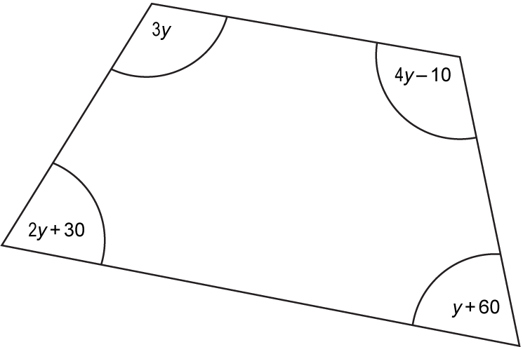

Use the diagram to form an equation and then find the size of each angle of the quadrilateral.

**B: Solving equations with the unknown on both sides**

How do we solve the following equation?

5*x* + 3 = 2*x* + 18

Show your steps clearly.

What happens if we change the numerical values of this equation? Can we still solve it?

Try these 3 examples.

1. 7*x* + 5 = 9*x* – 5
2. 4*x* – 4 = 3*x* – 3
3. 5*x* + 0.6 = 3*x* + 1

*Do you need some more examples to work on?*

Write 3 equations with the unknown on both sides for your partner to solve. Make use of negatives and decimals if you would like to increase the difficulty.

**Extension task 2**

The diagram shows a rectangle. All of the sides are measured in centimetres.



1. Explain why 4*x* + 17 = 7*x* + 5.
2. Solve the equation 4*x* + 17 = 7*x* + 5.
3. Calculate the perimeter of the rectangle.

**C: Generalising**

We can write a general solution for **all** equations of this form using just letter terms.

For example, the most simple equation can be generalised here.

*x* + *a* = *b*

*x* = *b* – *a*

Can you use your working to deduce a general solution for these equations?

1. *x* – *a* = *b*
2. *ax* = *b*
3. 
4. *ax* – *b* = *c*
5. *ax* + *b* = *cx* + *d*

Show all steps in your working. Can you explain your working to your partner and justify each step?

To give us feedback on, or ideas about the OCR resources you have used, email [resourcesfeedback@ocr.org.uk](mailto:resourcesfeedback@ocr.org.uk)

To give us feedback on, or ideas about the OCR resources you have used, email [resourcesfeedback@ocr.org.uk](mailto:resourcesfeedback@ocr.org.uk)

To give us feedback on, or ideas about the OCR resources you have used, email [resourcesfeedback@ocr.org.uk](mailto:resourcesfeedback@ocr.org.uk)

To give us feedback on, or ideas about the OCR resources you have used, email [resourcesfeedback@ocr.org.uk](mailto:resourcesfeedback@ocr.org.uk)

To give us feedback on, or ideas about the OCR resources you have used, email [resourcesfeedback@ocr.org.uk](mailto:resourcesfeedback@ocr.org.uk)

To give us feedback on, or ideas about the OCR resources you have used, email [resourcesfeedback@ocr.org.uk](mailto:resourcesfeedback@ocr.org.uk)

**OCR Resources**: *the small print*OCR’s resources are provided to support the teaching of OCR specifications, but in no way constitute an endorsed teaching method that is required by the Board, and the decision to use them lies with the individual teacher. Whilst every effort is made to ensure the accuracy of the content, OCR cannot be held responsible for any errors or omissions within these resources.   
© OCR 2014 - This resource may be freely copied and distributed, as long as the OCR logo and this message remain intact and OCR is acknowledged as the originator of this work.

**OCR Resources**: *the small print*OCR’s resources are provided to support the teaching of OCR specifications, but in no way constitute an endorsed teaching method that is required by the Board, and the decision to use them lies with the individual teacher. Whilst every effort is made to ensure the accuracy of the content, OCR cannot be held responsible for any errors or omissions within these resources.   
© OCR 2014 - This resource may be freely copied and distributed, as long as the OCR logo and this message remain intact and OCR is acknowledged as the originator of this work.

OCR acknowledges the use of the following content::  
⚫ Garden: Elen Eliseeva/Shutterstock.com ⚫ Flag: Pixel Europe/Shutterstock.com

To give us feedback on, or ideas about the OCR resources you have used, email resourcesfeedback@ocr.org.uk

**OCR Resources**: *the small print*OCR’s resources are provided to support the teaching of OCR specifications, but in no way constitute an endorsed teaching method that is required by the Board, and the decision to use them lies with the individual teacher. Whilst every effort is made to ensure the accuracy of the content, OCR cannot be held responsible for any errors or omissions within these resources. We update our resources on a regular basis, so please check the OCR website to ensure you have the most up to date version.  
© OCR 2016 - This resource may be freely copied and distributed, as long as the OCR logo and this message remain intact and OCR is acknowledged as the originator of this work.

OCR acknowledges the use of the following content: Maths and English icons: Air0ne/Shutterstock.com

We’d like to know your view on the resources we produce. By clicking on the ‘Like’ or ‘Dislike’ button you can help us to ensure that our resources work for you. When the email template pops up please add additional comments if you wish and then just click ‘Send’. Thank you.

