Topic Exploration Pack

Creative ideas for exploring context in 19th century texts

Introduction 2
Suggested activities 4
Student Activity 24
Resource 1 (Jane Eyre) 24
Resource 2 (The War of the Worlds) 32
Resource 3 (The Strange case of Dr Jekyll and Mr Hyde) 38

Instructions and answers for teachers

These instructions cover the student activity section which can be found on page 24. This Topic Exploration Pack supports OCR GCSE (9–1) English Literature J352.
When distributing the activity section to students either as a printed copy or as a Word file you will need to remove the teacher instructions section.

ABC – This activity offers an opportunity for English skills development.

Introduction
Using context as a way in to studying 19th century literature offers plenty of creative scope. For OCR’s GCSE (9-1) English Literature 19th century prose question there is a 20% weighting for showing an understanding of the relationships between texts and the contexts in which they were written (AO3).
Context can also be used by writers to provoke the reader. Therefore it also relates to AO2, which requires students to analyse the language used by writers to create meanings and effects.
This Topic exploration pack offers an approach to considering context in the 19th century set texts in the light of non-fiction texts from the time. It begins with activities that encourage students to consider how ideas and issues that were around at the time might have inspired 19th century writers. This gives students a way in to understanding and appreciating context, and how it can inform their reading. Students move on to consider how writers use context (and language and structure) to evoke emotional responses in their readers. Another key activity strand aims to show how key themes have developed in the 21st century. The aim here is to show students that the themes and genres of the 19th century text still provoke reaction and thought today.
In many ways, preoccupations and developments in the 19th century mirror the 21st. Breathless reviews of Edison’s latest inventions filled the newspapers back then, and resembled those that attend the launch of each new iPhone revamp today.
Think about how the ideas that were around in the 19th century gave rise to the set texts. You could start by considering with students the dual identity of the 19th century: science v superstition. Alongside the technological leaps came a belief in the fantastic – séances, spiritual photography, sea monsters. There was an insistence that energies existed that we could not harness or fathom. A backlash to the advances in technology, possibly. Could this explain the resurgence of interest in the Gothic genre at that time? Double identity is a key motif, Jekyll and Hyde being a prime example.
Point out to students that the news stories of the day gave rise to the themes, events and characters in the stories they are studying. Jane Eyre longs for freedom and finally marries Rochester when she’s his financial equal. Was Brontë inspired by Elizabeth Cady Stanton’s fight for women’s rights in America? The Martians’ attempt to colonise us in The War of the Worlds echoes Britain’s colonization of countries during Queen Victoria’s reign.
The final step: ask your students if they feel strongly about the topics in the news today. People in the 19th century did too, tell them. By alluding to feminism or imperialism Brontë and Wells triggered readers’ emotions.
By understanding that context can be used to create effects, students will be able to explain and illustrate how choice of language shapes meaning. Jekyll and Hyde taps into fears that Darwin’s On the Origin of Species had awakened: if we’re descended from apes, we could regress. A Victorian reader would shudder at Hyde’s ‘ape like fury’.
Genre is another kind of context writers can tap into for its emotive effect. It is comprised of tried and tested elements that are designed to unsettle the reader: for example, key elements of the Gothic tradition - mysterious settings (Thornfield, Satis House), doubt over whether events are supernatural (Bertha’s laugh), power and constraint (Bertha is locked away but Rochester is at her mercy), an innocent out of their depth in a strange place (Pip at Satis House, Jane at Thornfield).
This technique of using context to trigger reader reactions still works today, because the issues and ideas haven’t gone away. The elements of Gothic still unsettle us. If anything, we’re more reliant on technology than we were in the 19th century so HG Wells’s message that technology can’t save us, only nature can, is more chilling.
The books’ themes, then, have retained their emotive capital, and this is why 19th century literature remains relevant for students.

Suggested activities
Activity 1: students read a series of non-fiction texts from the 19th century and match them with their set text. The aim is for students to start gaining an understanding of different 19th century contexts.
Learning objective:
- Students gain an understanding of 19th century historical and social context.
Give students a series of 19th century non-fiction extracts. Ask them if they can identify the ones that relate to their set text.
The extracts here relate to The Strange Case of Dr Jekyll and Mr Hyde, Jane Eyre and The War of the Worlds. Some of these extracts (and others) can be found in the ”Approaching 19th Century novels at GCSE” teacher guide on the OCR GCSE (9-1) English Literature J352 web page.
Links to the texts are below. Some need to be cut and pasted into a browser:
The War of the Worlds by HG Wells
1) Spoof cartoon of Edison’s latest ‘invention’, anti-gravity underwear. Punch magazine, 1879, Page 12/650
Internet Archive: https://archive.org/stream/punch76a77lemouoft#page/n11/mode/2up
2) An excerpt from Charles Darwin’s Beagle Diary, September 17, 1835 darwin-online.org website, Cambridge University Press:
http://darwin-online.org.uk/content/frameset?itemID=F1925&viewtype=text&pageseq=1
3) An 1882 memo from Lord Wolseley opposing the construction of a channel tunnel, Page 32
https://archive.org/details/shallwehavechann00forb
4) Punch cartoon relating to Empire, 1896, page 67/670
Internet Archive: https://archive.org/stream/punchvol110a111lemouoft#page/n65/mode/2up
5) Punch cartoon ‘A Friendly Word with the War Wizard’, 1896, page 69/670
Internet Archive: https://archive.org/stream/punchvol110a111lemouoft#page/n67/mode/2up
6) Article about excitement generated by new invention, the Telemachon. The Colonist, Volume XXII, Issue 2496, Page 6, 11 January 1879 paperspast.com website:
http://paperspast.natlib.govt.nz/cgi-bin/paperspast?a=d&d=TC18790111.2.20&cl=&srpos=0&e=-------10--1----0--

Jane Eyre by Charlotte Brontë
1) Eighty Years and More: Reminiscences 1815 - 1897 by Elizabeth Cady Stanton; Chapter IV; Views on Marriage and Divorce. Students read from ‘The discussion on the question of marriage…’
University of Pennsylvania website: http://digital.library.upenn.edu/women/stanton/years/years.html#XIV
2) Governesses, an article in The Penny Satirist. June 10, 1843.
British Library website: http://www.bl.uk/collection-items/newspaper-article-about-the-private-governess-from-the-penny-satirist
3) An excerpt from The Night Side of Nature by Catherine Crow; Page 100.
Internet Archive: https://archive.org/details/nightsideofnatur01crowiala
4) An excerpt from The Richardson-McFarland Tragedy; Page 13/101. From ‘Now we approach THE SEPULCHRAL BRIDAL SERVICE PROPER…’
Internet Archive: https://archive.org/details/richardsonmcfar00mcfagoog
5) Front page article about Spiritual Photography in Harper’s Weekly. A Journal of Civilisation; May 8, 1869 Mocavo website:
http://www.mocavo.com/Harpers-Weekly-a-Journal-of-Civilization-Volume-13/758088/298#294
6) From A Shilling’s Worth of Magic, a collection of JH Anderson’s writings (Slide 10. Page 72, from ‘They were Americans…’)
British Library website:
http://www.bl.uk/collection-items/the-fashionable-science-of-parlour-magic
7) A drawing of a 19th century séance.
All Posters website:
http://www.allposters.com/-sp/Table-Turning-Seance-Gets-out-of-Hand-in-Lyon-France-Posters_i1872285_.htm
8) Illustrative Studies in Criminal Anthropology by Cesare Lombroso
This article by the Italian criminal psychologist and physician appeared in the quarterly US philosophical journal The Monist at the beginning of the 1890s. Page 186.
https://archive.org/details/monistquart01hegeuoft
9) An excerpt from On the Mode of Communication of Cholera by John Snow, M.D., Member of the Royal College of Physicians, Fellow of the Royal Med. and Chir. Society, Fellow and Vice-President of the Medical Society of London (Second edition: 1854)
Snow’s book is most notable for its description of the cholera outbreak around Broad Street in London. He traced the outbreak to a water pump in the street.
From p23 of the PDF of the book. Students read from ‘The most terrible outbreak of cholera…’
Delta Omega, the honorary society in public health: http://www.deltaomega.org/documents/snowfin.pdf

The Strange Case of Dr Jekyll and Mr Hyde by Robert Louis Stevenson
1) Illustrative Studies in Criminal Anthropology by Cesare Lombroso
This article by the Italian criminal psychologist and physician appeared in the quarterly US philosophical journal The Monist at the beginning of the 1890s. Page 186.
https://archive.org/details/monistquart01hegeuoft
2) A letter to Conrad Martens from Charles Darwin
Darwin Correspondence Project: http://www.darwinproject.ac.uk/entry-3398
3) A Diary of a Resurrectionist 1811-1812, Chapter IV; August 13 1812; October 9 1812
Project Gutenberg: http://www.gutenberg.org/files/32614/32614-h/32614-h.htm
4) A hoax headline from The Daily Graphic, New York relating to a supposed Edison invention
Hoaxes.org website: http://hoaxes.org/af_database/year/category/1870aprilfools/
5) The Criminal Law Amendment Act, 1885 (slide 2, gross indecency law)
British Library website: http://www.bl.uk/collection-items/the-criminal-law-amendment-act-1885
6) ‘A Miraculous Circumstance’ from The Diary of a Resurrectionist, Chapter II, Page 66
Project Gutenberg: http://www.gutenberg.org/files/32614/32614-h/32614-h.htm
Resources:
Activity 1 Jane Eyre
Activity 1 The War of the Worlds
Activity 1 Jekyll and Hyde
Activity 2: students link specific quotations from their set text with 19th century non-fiction texts. The aim is for them to see how understanding of a 19th century context can inform their reading.
Learning objectives:
- Reflect critically and evaluatively on a text, using an understanding of context to inform reading
- Read at a literal level and also explore deeper implications.
Students find links between their set texts and the non-fiction extracts from Activity 1.
Before they start, model the following example from The War of the Worlds by HG Wells:
‘With infinite complacency men went to and fro over this globe about their little affairs, serene in their assurance of their empire over matter.’
The word ‘empire’ might allude to the British Empire. See the Punch cartoon below, which satirises the expense of maintaining the British Empire:
https://archive.org/stream/punchvol110a111lemouoft#page/n137/mode/2up
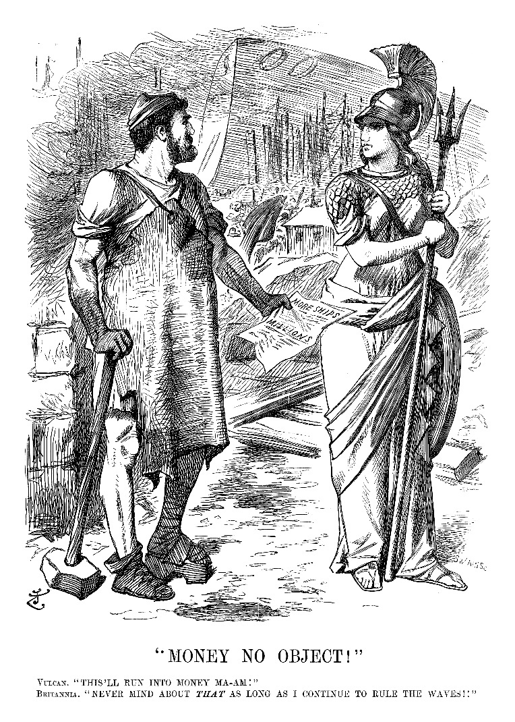
Punch cartoon - 'Money no Object' - Reproduced with permission from Punch Ltd., www.punch.co.uk
And when added to the phrase ‘empire over matter’, the word acquires new connotations. Thanks to Edison’s inventions, people felt that our control over matter was becoming absolute. Punch satirised Edison’s inventions in the cartoon below, saying he’d invented anti-gravity underwear!
https://archive.org/stream/punch76a77lemouoft#page/n11/mode/2up
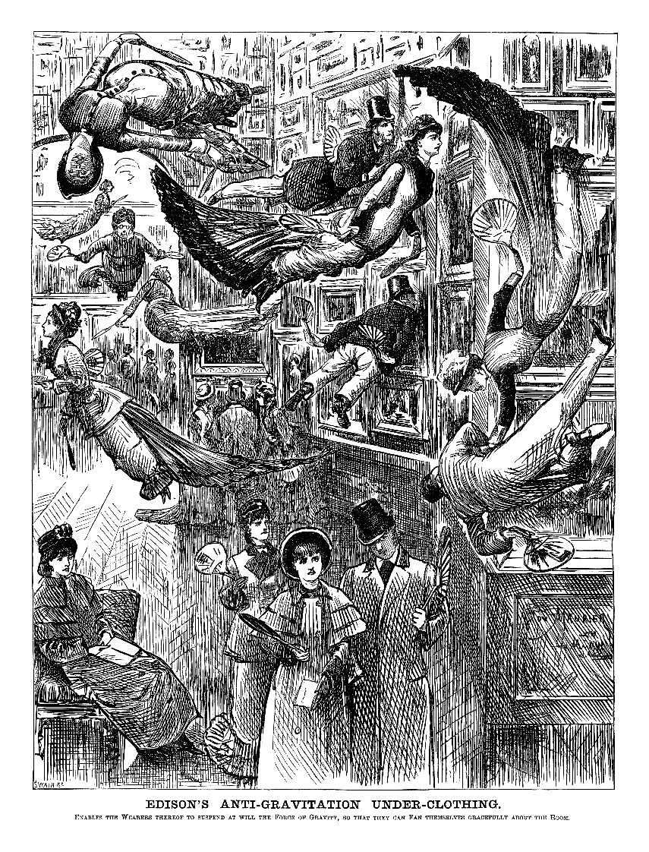
Edison's Anti-Gravitation Under-Clothing - Reproduced with permission from Punch Ltd., www.punch.co.uk
Hand out the quotations below, and see if students can match them to the non-fiction texts.
Ask students how knowledge of 19th century contexts changes how they read the lines in the books? Does it give the line emotive impact?
Linked activities:
Students make a broadsheet or magazine from the articles. They can find more non-fiction texts themselves. The Strand magazine is a good source, and can be found on the Internet Archive website:
https://archive.org/details/TheStrandMagazineAnIllustratedMonthly
Role-play their set text author reading the broadsheet and coming up with ideas for their book.
Students match the quotations below with the extracts from Activity 1.
Quotations:
The War of the Worlds by HG Wells
1) ‘And before we judge of them too harshly we must remember what ruthless and utter destruction our own species has wrought, not only upon animals, such as the vanished bison and the dodo, but upon its own inferior races.’
2) ‘It is still a matter of wonder how the Martians are able to slay men so swiftly and so silently. Many think that in some way they are able to generate an intense heat in a chamber or practically absolute non-conductivity.’
3) ‘With infinite complacency men went to and fro over this globe about their little affairs, serene in their assurance of their empire over matter.’
4) ‘…Slain, after all man’s devices had failed, by the humblest things that God, in his wisdom, has put upon this earth. ‘
5) ‘That night another invisible missile started on its way to earth from Mars.’
6) ‘But by virtue of this natural selection of our kind we have developed resisting power; to no germs do we succumb without a struggle…’
Quotation | Non-fiction text
1 | 4
2 | 5
3 | 1, 4, 6
4 | 6
5 | 3
6 | 2

Jane Eyre by Charlotte Brontë
1) ‘What do I want? A new place, in a new house, among new faces, under new circumstances: I want this because it is of no use wanting anything better…’
2) ‘I cannot think of leaving you, sir, at so late an hour, in this solitary lane, till I see you are fit to mount your horse.’
3) ‘…no firmness in that aquiline nose, and small, cherry mouth; there was no thought on the low, even forehead; no command in that blank, brown eye.’
4) ‘I saw nothing: but I heard a voice somewhere cry –
‘Jane! Jane! Jane’ nothing more’
5) ‘When the typhus fever had fulfilled its mission of devastation at Lowood, it gradually disappeared from thence; but not till its virulence and the number of its victims had drawn public attention on the school.’
6) ‘I know not what dress she had on: it was white and straight; but whether gown, sheet or shroud, I cannot tell.’
7) ‘This was a demoniac laugh – low, suppressed, and deep –’
Quotation | Non-fiction text
1 | 1, 2
2 | 1
3 | 8
4 | 3
5 | 9
6 | 4
7 | 5, 6, 7

The Strange Case of Dr Jekyll and Mr Hyde by Robert Louis Stevenson
1) ‘…the older man bowed and accosted the other with a very pretty manner of politeness…’
2) ‘with ape-like fury, he was trampling his victim underfoot’
3) ‘…new avenues to fame and power shall be laid open to you…’
4) ‘Evil… had left on that body an imprint of deformity and decay.’
5) ‘…had I risked the experiment while under the empire of generous… aspirations… from these agonies of birth and death I had come forth an angel instead of a fiend’
Quotation | Non-fiction text
1 | 5
2 | 2
3 | 3, 4
4 | 1
5 | 3, 4, 6
Activity 3
Learning objectives:
- Reflect critically and evaluatively on a text, using an understanding of context to inform reading
- Read at a literal level and also explore deeper implications.
The learning objectives are the same as for Activity 2, but this time the context is the students’ own 21st century context.
Warm up: Students think about how we access news stories in a 21st century context: blogs, forums, wikis, articles, Twitter.
Activity 3a: students consider how the themes in their set text have evolved by the 21st century. They find articles/images relating to the set text’s themes in the 21st century. The aim is for them to understand how their own 21st century context can inform their reading too.
Students create an alternative to their 19th century broadsheet showing how the key themes and ideas in the set texts have updated in the 21st century.
As an example. show them an image of Jane Eyre helping Mr Rochester after he’s fallen from his horse in a Radio Times cover advertising the 1973 BBC adaptation of the novel:
http://photos1.blogger.com/blogger/1266/1285/1600/cover.gif
And then show them an image from Mad Max: Fury Road where Charlize Theron’s Imperator Furiosa is protecting Tom Hardy’s Max.
An article from The Independent newspaper website.
http://www.independent.co.uk/arts-entertainment/films/reviews/mad-max-fury-road-cannes-film-festival-2015-movie-review-charlize-therons-furiosa-is-every-bit-as-mad-and-bad-as-max-10242492.html
And/or show them this picture of Edison from an 1879 edition of Punch from the Internet Archive, looking at the day’s modern conveniences that are already outdated and in a museum thanks to the inventor’s creations:
https://archive.org/stream/punch76a77lemouoft#page/n15/mode/2up
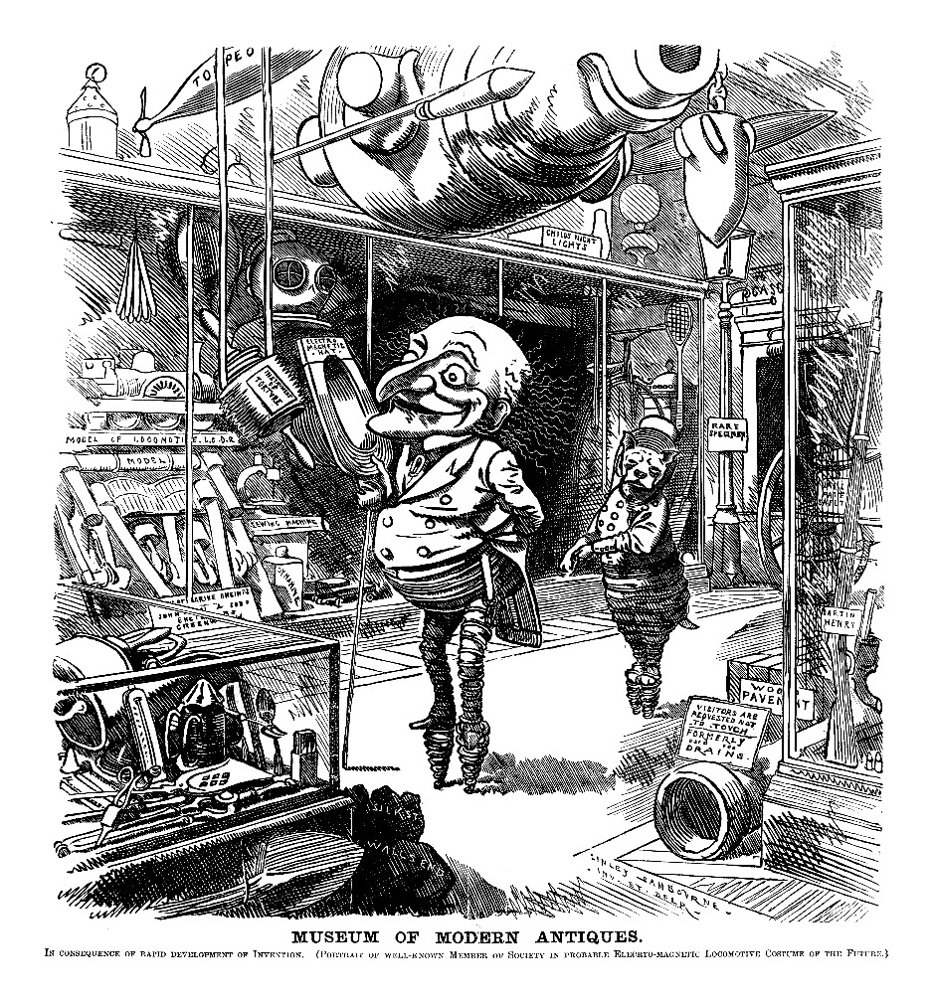
Museum of Modern Antiques; Reproduced with permission from Punch Ltd., www.punch.co.uk
Compare it to these images from Digital Spy website of the iPhone 6 launch day:
http://www.digitalspy.co.uk/tech/news/a597732/iphone-6--6-plus-on-sale-16-of-the-best-pictures-from-launch-day.html#~pgp3ghyf78kZiT
Extension activities:
Class discussion on how their 21st century context can influence how they read a 19th century text; students write a sequel or summarise a modern day adaptation of their set text based on how the themes have developed in the 21st century.
There are some links below to images that show how the themes have updated:
Jane Eyre by Charlotte Brontë
Extension activity: the article from the Return of Kings website could be compared with GH Lewes review of Shirley by Charlotte Brontë (archived at Cornell University Library website) Links below:
http://www.returnofkings.com/63711/our-call-to-boycott-mad-max-movie-spurs-avalanche-of-mainstream-media-anger
http://digital.library.cornell.edu/cgi/t/text/pageviewer-idx?c=livn;cc=livn;rgn=full%20text;idno=livn0024-11;didno=volume;view=image;seq=487;node=livn0024-11%3A1;page=root;size=100
This article by Melissa Burkley, Ph.D can be linked to the premonitions Jane Eyre has about Rochester when she is staying with the Rivers’:
http://www.imagesco.com/articles/psi/burkley.html
This YouTube video of Kate Moss as a hologram in an Alexander McQueen show is inspired by the Gothic and can be linked to the moment Bertha Mason rips Jane’s wedding veil and to Mrs Havisham in Great Expectations:
https://www.youtube.com/watch?v=R7z4Kkh7duI
An image of an MBA graduate holding a cardboard placard with ‘MBA WILL WORK FOR FOOD!’ on it can be linked to the plight of governesses. In the 19th century governesses were said not to fit in to any class, and were often the recipients of charity.
To see the image, students type ‘MBA will work for food’ into Google image search.
The Strange Case of Dr Jekyll and Mr Hyde by Robert Louis Stevenson
This interview with actor Adam Pearson in The Guardian could be linked to how Hyde’s deformed appearance signifies his evil nature. Pearson criticizes film directors for doing just this, saying it stigmatises disfigured people.
A discussion point could be that the Bond franchise is subverting some stereotypes it is associated with, but a bond villain still ends up scarred in a recent Bond film, Spectre.
http://www.theguardian.com/film/2014/apr/13/scarlett-johansson-screen-stigma-disfigurement
Students could also consider how this is not always the case, and villains are sometimes portrayed as attractive. Wickham (14th down on Emily Temple’s list of best looking literary villains for Flavorwire) in Pride and Prejudice proves this is not a recent development.
http://flavorwire.com/496215/the-50-sexiest-literary-villains/view-all
Below is a link to the Victoria and Albert Museum’s Savage Beauty exhibition. McQueen was inspired by the Gothic genre generally.
http://www.vam.ac.uk/content/exhibitions/exhibition-alexander-mcqueen-savage-beauty/about-the-exhibition/
The War of the Worlds by HG Wells
Our hunger for new technology is satirized in the articles below from the technology website Hongkiat and The Guardian newspaper website:
http://www.hongkiat.com/blog/wacky-apple-products/
http://www.theguardian.com/science/shortcuts/2015/may/26/cyborgs-how-humans-will-become-gods-yuval-harari
And the alleged downside of it is mentioned here on the website for the multimedia news organisation NPR:
http://www.npr.org/sections/alltechconsidered/2015/05/18/407648886/attention-white-collar-workers-the-robots-are-coming-for-your-jobs
Invasion scare stories continue in reality. On the BBC news website here:
http://news.bbc.co.uk/2/hi/uk_politics/3466005.stm
and in fiction (Invasion of the Body Snatchers):
http://www.jhalpe.com/items/index/page:13/search:category;Posters
Below is a story related to advances made in medical science from the NLCATP website:
http://nlcatp.org/4-key-pros-and-cons-of-embryonic-stem-cell-research/
and space exploration in this article from The International Journal of Mars Science and Exploration:
http://marsjournal.org/contents/2013/0002/

Activity 3b: students create a collage of images related to a line or phrase from their set text. The images relate to the 19th century context that the writer was reflecting on. And they also relate to the 21st century context that the line relates to. The aim is to show students that 19th century texts are doubly resonant for them.
The objective now is to consolidate students’ understanding that 19th century literature is doubly resonant today. It has endured because it still resonates in a 21st century social context.
Tell students that context can be used by writers to create emotive effects: then and now.
Remind them of The War of the Worlds quote they considered in Activity 2:
‘With infinite complacency men went to and fro over this globe about their little affairs, serene in their assurance of their empire over matter.’
Look at this sentence again. Zoom in on the key words EMPIRE and MATTER.
Split the class into four groups.
1) Find pictures associated with empire in the 19th century
2) Find pictures associated with empire over matter in the 19th century.
3) Find pictures associated with empire in the 21st century
4) Find pictures associated with empire over matter in the 21st century.
The first group sticks their pictures on the whiteboard or a large sheet of paper.
Tell them these are the kinds of images that would have risen in a 19th century reader’s mind as they read the word ‘empire’. Discuss the kinds of emotions they would have triggered. For instance, pride in the extent of the empire, shame at the treatment of native populations, annoyance at the cost.
The second group adds their pictures to the collage. Tell them more images are now coming into play for the 19th century reader, and consequently more emotions. Fear that technology was moving too fast, awe at the inventions, hope that the world would become a better place.
Tell students that 21st century readers (i.e. them) imagine even more images/emotions than a 19th century reader.
The third group then adds their pictures to the collage, and then the fourth group. Discuss which associations have the most impact on today’s reader.

Extension activity:
Students write a story which includes themes that people have strong opinions on. As a first step, students could write a sentence that contains trigger words, like the example from The War of the Worlds.
Alternatively, model the above example. There are some links below to images for empire and empire over matter in the 19th and 21st centuries. Then tell students to choose a line from their set text, and repeat the activity using that particular line.
Empire – 19th century
‘From the Cape to Cairo’ Puck, 1902
History Today website:
http://www.historytoday.com/bernard-porter/cutting-british-empire-down-size
Am I not a Man and a Brother
Josiah Wedgwood’s Wikipedia page:
https://en.wikipedia.org/wiki/Josiah_Wedgwood
To Be Sold & Let
The Sheffield College website:
http://www.online.sheffcol.ac.uk/index.cfm?ParentID=6aa08aed-346b-49c6-bd75-e06e28328d7c
Lion and Union Jack image (No. 5)
The Listverse website:
http://listverse.com/2010/06/22/top-10-greatest-empires-in-history/
Empire over matter – 19th century
Darwin – The Origin of Species
Prezi website:
https://prezi.com/v6v0890srdtb/charles-darwin/
Thomas Edison behind light bulb
TMAC website:
http://www.tmac.org/blog/
Diary of a Resurrectionist
Digi-Media-Apps website:
http://www.digimediaapps.com/books.aspx?id=798
Empire – 21st century
Photo of soldiers in Iraq
The Socialist Worker website:
http://socialistworker.org/2009/07/13/colonialism-in-the-21st-century
Empire over matter – 21st century
Robotic hand and globe
The Technological Citizen website:
http://thetechnologicalcitizen.com/
Activity 4: students create graphs showing the different kinds of emotive effects lines from their set texts have due to context. The aim is to consolidate understanding of how writers use context to create effects.
Learning objectives at GCSE:
- Reflect critically and evaluatively on a text, using an understanding of context to inform reading
- Read at a literal level and also explore deeper implications
- Explain how choice of language shapes meaning.
Students use spreadsheet software to map the emotional impact particular lines from their set text create due to context.
There are four examples below. Students could invent more of their own.
The ‘Boomerang’ effect
The boomerang effect is when contextual impact stays the same.
Model the below example from The War of the Worlds when HG Wells highlights that the Martians were killed not by technology but by the most humble of things, nature.
“Slain, after all man’s devices had failed, by the humblest things…”
Explain to students that we’re still in awe of technology. We wonder where it’s taking us. This reminder that technology can fail had the same impact then as it does now.
As a class, discuss which words have impact and why? Why is this statement provocative? For instance, people were saying that we could achieve anything; Edison’s inventions were going to change the manufacturing industry. Students can re-read the article from The Telemachon. Then discuss why it is still provocative today.
Students then imagine a 19th century and 21st century reader’s response to the line and map it on a table, giving each word a mark out of ten. Zero is the lowest, ten the highest. They give the words the same mark out of 10 for the 19th and 21st century reader.
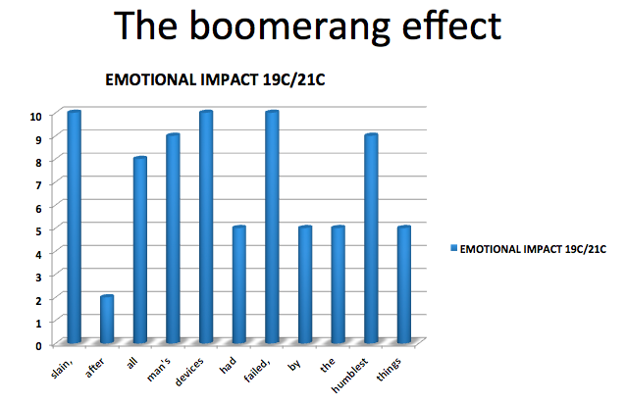
Students then find examples of the ‘Boomerang effect’ from their set text, i.e. lines that they think have the same emotional impact in the 19th century as they do now.
The ‘Double Whammy’ effect
The ‘Double Whammy’ effect is when two contexts come into play in one sentence.
Model using the example sentence from The War of the Worlds used in Activity 3b. As we read the phrase “…serene in their assurance of their empire over matter” the context of imperialism is alluded to. As we read to the end of the line another context comes into play: harnessing of power, Edison’s inventions.
The second half of the sentence has more emotional resonance because two contexts are coming into play.

You can see this visually below: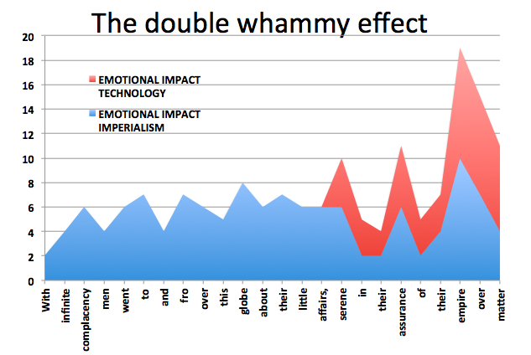
Ask students to find examples of the ‘Double Whammy’ in their set text, i.e. lines where more than one context comes into play, and map them on graphs.
Extension: can they find single words where more than one context comes into play?

The ‘Lucky Break’ effect
The ‘Lucky Break’ effect is when a line in a novel becomes emotive in a modern context by chance.
Model this example from The War of the Worlds:
‘as men busied themselves about their various tasks they were scrutinised and studied’
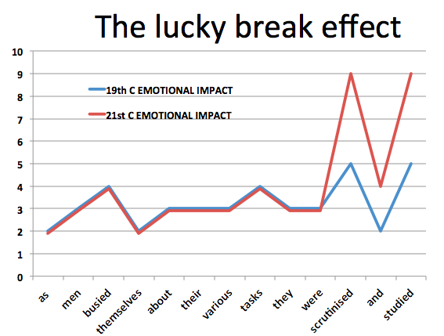
19th century resonance: elicit from students that this line tapped into 19th century paranoia about invasion from the French; an idea to build a channel tunnel, for instance, was scrapped. It could also be referring to imperialism from the oppressed’s point of view.
21st century resonance: elicit that we still have a fear of invasion today, so some resonance remains.
But now there is a new layer of meaning that wouldn’t have been imagined by HG Wells, relating to increased surveillance and monitoring of our movements by government agencies. Hence the red line (21st century impact) on the graph above is higher.
Ask students to find their own examples of the ‘Lucky Break’ effect in their texts, i.e. lines that have accidentally acquired impact today, and map them.

The ‘Here and Now’ effect
The ‘Here and Now’ effect is when a line is more emotive today than it was in HG Wells’s day.
Model the example below from The War of the Worlds. This line might trigger thoughts about climate change in today’s reader:
“When the slow cooling of the sun makes this earth uninhabitable…”
Show students this picture of an Alaskan glacier in 1891 and photographed again in 2005 to illustrate how climate change is a more alarming idea in the 21st century: it’s not a whacky theory like it was in Wells’s day.
thisisclaimatechange.com website: http://www.thisisclimatechange.org/glacial-retreat/
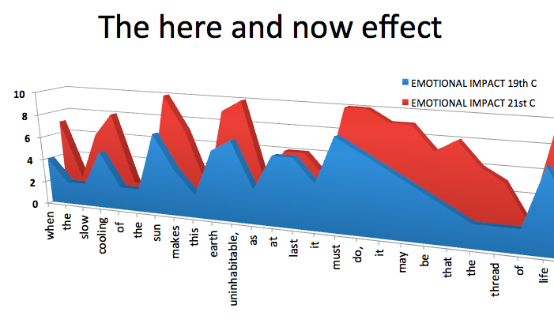
Ask students to find their own examples of the ‘Here and Now’ effect in their texts, i.e. lines that have more emotional impact today than then, and map them.
Activity 5: students look at how writers use language, structure and context to create effects.
Learning objectives at GCSE:
- Reflect critically and evaluatively on a text, using an understanding of context to inform reading
- Read at a literal level and also explore deeper implications
- Explain how choice of language shapes meaning
- Analyse how the writer uses language and structure to create effects and impact.

Hand out crime scene tape and evidence markers. These can be found on the OCR GCSE (9-1) English Literature J352 webpage, under Teaching and Learning Resources, Exploring context – Delivery guide – teacher and learner resources (item 08).
Learners find extracts from their set text, and use the crime scene tape to ‘cordon’ them off. They then use the evidence markers to identify how writers use a combination of context, language and structure to create effects.
Students split into two teams:
Each team is divided into a ‘Crime Scene Investigation Team’ and a ‘Forensic Lab Team’. The CSI Team cordons off sections of the text. They then place evidence markers next to potential clues. These ‘clues’ are submitted to the ‘forensic scientists’ in the lab. They examine them and determine what kind of clue they are (language, structure or context) and write them on the white board.
A student in each team could be in charge of ‘perimeter security’. They make sure the other team does not enter their ‘crime scene’ (i.e.use their quotations).
Model the example below, and then set students off on the task:
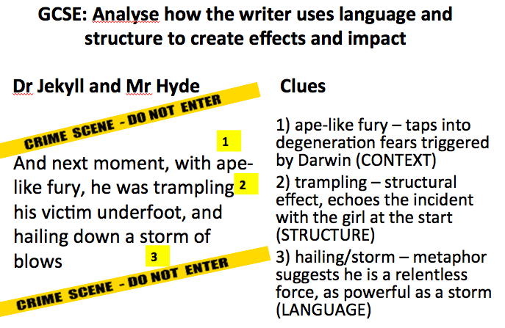
Take the CSI idea a step further, using the idea of case linkage. This is when similarities are spotted between crime scenes that suggest the same criminal is responsible.
Adapt the activity for GCSE students by asking them to identify different parts within their set text when a particular genre is in evidence, e.g. the Gothic in Jane Eyre and Great Expectations, Science Fiction in The War of the Worlds.

OCR Resources: the small print
OCR’s resources are provided to support the delivery of OCR qualifications, but in no way constitute an endorsed teaching method that is required by the Board, and the decision to use them lies with the individual teacher. Whilst every effort is made to ensure the accuracy of the content, OCR cannot be held responsible for any errors or omissions within these resources.
© OCR 2016 - This resource may be freely copied and distributed, as long as the OCR logo and this message remain intact and OCR is acknowledged as the originator of this work.
OCR acknowledges the use of the content as outlined within the body of the document.
Please get in touch if you want to discuss the accessibility of resources we offer to support delivery of our qualifications: resources.feedback@ocr.org.uk

We’d like to know your view on the resources we produce. By clicking on ‘Like’ or ‘Dislike’ you can help us to ensure that our resources work for you. When the email template pops up please add additional comments if you wish and then just click ‘Send’. Thank you.
Whether you already offer OCR qualifications, are new to OCR, or are considering switching from your current provider/awarding organisation, you can request more information by completing the Expression of Interest form which can be found here: www.ocr.org.uk/expression-of-interest
Looking for a resource? There is now a quick and easy search tool to help find free resources for your qualification:
www.ocr.org.uk/i-want-to/find-resources/

Topic Exploration Pack

Student Activity

Resource 1 (Jane Eyre)
Eighty Years and More: Reminiscences 1815 – 1897 by Elizabeth Cady Stanton
Elizabeth Cady Stanton called for reform of the marriage laws in the US at the National Women’s Rights convention in Albany, New York, 1860. She had argued that women should be allowed to divorce husbands who were cruel, drunken, insane or who deserted their wives.
The discussion on the question of marriage and divorce occupied one entire session of the convention, and called down on us severe criticisms from the metropolitan system. Enemies were unsparing in their denunciations, and friends ridiculed the whole proceeding. I was constantly called on for a definition of marriage and asked to describe home life as it would be when men changed their wives every Christmas. Letters and newspapers poured in upon me, asking all manner of absurd questions, until I often wept with vexation. So many things, that I had neither thought nor said, were attributed to me that, at times, I really doubted my own identity.
However, in the progress of events the excitement died away, the earth seemed to turn on its axis as usual, women were given in marriage, children were born, fires burned as brightly as ever at the domestic altars, and family life, to all appearances, was as stable as usual.
Public attention was again roused to this subject by the McFarland-Richardson trial, in which the former shot the latter, being jealous of his attentions to his wife. McFarland was a brutal, improvident husband, who had completely alienated his wife's affections, while Mr. Richardson, who had long been a cherished acquaintance of the family, befriended the wife in the darkest days of her misery. She was a very refined, attractive woman, and a large circle of warm friends stood by her through the fierce ordeal of her husband's trial.
Though McFarland did not deny that he killed Richardson, yet he was acquitted on the plea of insanity, and was, at the same time, made the legal guardian of his child, a boy, then, twelve years of age, and walked out of the court with him, hand in hand. What a travesty on justice and common sense that, while a man is declared too insane to be held responsible for taking the life of another, he might still be capable of directing the life and education of a child! And what an insult to that intelligent mother, who had devoted twelve years of her life to his care, while his worthless father had not provided for them the necessaries of life!
She married Mr. Richardson on his deathbed. The ceremony was performed by Henry Ward Beecher and Rev. O. B. Frothingham, while such men as Horace Greeley and Joshua Leavitt witnessed the solemn service. Though no shadow had ever dimmed Mrs. Richardson's fair fame, yet she was rudely treated in the court and robbed of her child, though by far the most fitting parent to be intrusted with his care.
As the indignation among women was general and at white heat with regard to her treatment, Miss Anthony suggested to me, one day, that it would be a golden opportunity to give women a lesson on their helplessness under the law–wholly in the power of man as to their domestic relations, as well as to their civil and political rights. Accordingly we decided to hold some meetings, for women alone, to protest against the decision of this trial, the general conduct of the case, the tone of the press, and the laws that made it possible to rob a mother of her child.

An excerpt from an article in The Penny Satirist, June 10 1843, available from http://www.bl.uk/collection-items/newspaper-article-about-the-private-governess-from-the-penny-satirist
Governesses
I know not what planet ruled in full malignity when the invention of private Governesses took place, an invention purely diabolical. The private governess is an innovation in society, belonging to no class or station, identifying herself with no human creature, a being without the pale of public or private sympathies, a something beyond our humanities, an excrescence growing on what she does not belong to, an anomaly above and below those around her. She resembles the mistletoe - she is alone - and the sun never shineth on her - she is winterly and cold - she refesheth not our ideas with gaiety - she has no root nor standing - she is sad and comfortless. She has no opinions, no judgements, no flights of thoughts; she wastes her youth away; she has no household gods... She is without accomplishments, though all accomplished, the child of ten is preferred before her; she has no friend in the house, nor out; she sits by herself - she watches the embers of her lonely fire - she wonders for what she is destined - she sighs and wonders on, and grows old a-sighing. She is proud and discontented - the very elements of discontent surround her - cultivation of mind without the natural sympathies and charities of life, neglected, cheerless, unsought for, uncared for, hopeless. She has the virtue of endurance, she endures on; she inwardly rebels; she hates her occupation, for it is thankless, but still she endures. She is blighted; the kindly feelings of her heart expand not, for she is a governess! She is glad of the waste of life, that the day is gone, yet she knoweth not why, for to-morrow, and to-morrow, and to-morrow, bringeth the same dullness, the same monotony. She looketh back, her recollections are sad, for her occupation betokeneth want of means; the past is made up of sorrow and endurance; she looketh forward, but the view is prospectless. She has passed the summer of her existence - she shall see no home protected by the loving and the loved - she shall embrace no babes, no second types of youth, their prattle shall ne’er divert her thoughts like the music of creation, making her a still firmer believer in Immortality! She rises not to Virtue, she hath not the inducement to do so, she simply endures and murmurs. She is sickly, she suffers silently; she is like a flower on which the sun shines not, it is pale, colourless, sapless, scentless; so she is, without life’s best elixir, Hope, therefore she droops. She hath no spirits - her ruminations are dull, prosaic, common-place, matter-of-fact, comfortless, petty. She hath no bright hallucinations to distract her ennui, guiding her, like a guardian angel from mile to mile, from height to height, along the clear horizon of the glorious world, till she blend with it the suns and stars of other systems, and finally loses herself, her sorrows, and her loneliness in Infinity!
An excerpt from The Night Side of Nature by Catherine Crowe (1848), available from https://archive.org/about/terms.php
Crowe has been considering “that strange sensation which most people have experienced, of having witnessed a scene, or heard a conversation, at some indefinite period before, or even in some earlier state of existence.” It’s what we call deja-vu. She has just outlined a theory explaining this sensation; one that a doctor has formulated. It says deja-vu is caused by one side of the brain working faster than the other.
I confess this theory, as regards this latter phenomenon, is to me eminently unsatisfactory, and it is especially defective for one of the most curious particulars connected with it, namely, that on these occasion[s], people not only seem to recognise the circumstances as having been experienced before; but they have, very frequently, an actual foreknowledge of what will be next said or done.
Now, the explanation of this mystery, I incline to think, may possibly lie in the hypothesis I have suggested; namely, that in profound, and what appears to us generally to have been a dreamless sleep, we are clear-seers. The map of coming events lies open before us, the spirit surveys it; but with the awaking of the sensuous organs, this dream-life, with its aerial excursions, passes away; and we are translated into our other sphere of existence. But, occasionally, some flash of recollection, some ray of light, from this visionary world, in which we have been living, breaks in upon our external objective existence, and we recognize the locality, the voice, the very words, as being but a re-acting of some foregone scenes of a drama.
The faculty of presentiment, of which everybody must have heard instances, seems to have some affinity to the phenomenon last referred to. I am acquainted with a lady, in whom this faculty is in some degree developed, who has evinced it be a consciousness of the moment when a death was taking place in her family, or amongst her connexions, although she does not know who it is that has departed. I have heard of several cases of people hurrying home from a presentiment of fire; and Mr. M. of Calderwood was once, when absent from home, siezed (sic) with such an anxiety about his family, that, without being able in any way to account for it, he felt himself impelled to fly to them and remove them from the house they were inhabiting; one wing of which fell down immediately afterwards. No notion of such a misfortune had ever before occurred to him, nor was there any reason whatever to expect it; the accident originating from some defect in the foundations.
…
A young servant girl in this neighbourhood, who had been several years in an excellent situation, where she was much esteemed, was suddenly seized with a presentiment that she was wanted at home; and, in spite of all representations, she resigned her place and set out on her journey thither; where, when she arrived, she found her parents extremely ill, one of them mortally, and in the greatest need of her services. No intelligence of their illness had reached her, nor could she herself in any way account for the impulse.
…
When any exhibitions of this sort of faculty occurs in animals, which is by no means unfrequent, it is termed instinct; and we look upon it, as what it probably is, only another and more rare development of that intuitive knowledge which enables them to seek their food, and perform the other functions necessary to the maintenance of their existence, and the continuance of their race. Now, it is remarkable, that the life of an animal is a sort of dream-life; their ganglionic system is more developed than that of man, and the cerebral, less; and since it is doubtless, from the greater development of the ganglionic system in women, that they exhibit more frequent instances of such abnormal phenomena as I am treating of, than men, we may be, perhaps, justified in considering the faculty of presentiment in a human being as a suddenly awakened instinct, just as in an animal, it is an intensified instinct.
Glossary
Seer: someone who can see into the future Surveys (verb): looks at Aerial: outside the body Foregone: past Faculty: ability Affinity to: connection to Ganglionic: nerves outside the central nervous system
The following extract is taken from a book “containing all the letters and other interesting facts and documents not before published” on the Richardson – McFarland Tragedy. The book is by Daniel McFarland (available from https://archive.org/details/richardsonmcfar00mcfagoog.
On November 25, 1868 Daniel McFarland entered the offices of the New York Tribune newspaper and shot Albert D. Richardson. McFarland had separated from his wife, Abby Sage, and suspected that she was now seeing Richardson.
Richardson died from his wounds a week later. Abby Sage had got her divorce from McFarland in Indiana a little while earlier. They married as Richardson lay on his death bed.
Now we approach the sepulchral bridal service proper, which was administered by the Rev. Henry Ward Beecher, and which we give in full as it occurred :-
Mr Beecher (to Mr. Richardson) – Do you take the woman whom you have by your side now, in this hour, standing near the heavenly land, and renew to her the pledges of your love? Do you give your heart to her, and your name? Is she, before God and before these witnesses, your beloved, your honoured and your lawful wife?
Mr. Richardson (in an audible and clear voice)-Yes.
Mr Beecher (turning to Miss Sage or Mrs. McFarland,) – And do you accept him as your head in the Lord? And are you now to him a wife sacred and honoured, bearing his name? And will you love him to the end of your life?
Miss Sage – I do, and will.
Mr Beecher –Then by the authority given me by the Church of Christ I do pronounce you husband and wife; and may the blessing of Almighty God, the Father, the Son and the Holy Spirit, rest upon you and abide with you. Amen.
The ceremony was impressive in one sense, but sadly suggestive of grim and hallow materialism. Not a word of the softening salve of Christian hope and consolation was spoken, and the voice of the Plymouth pastor is said to have had a strangely religio-theatric tone. One-third of the means which Mr. Richardson left became now the property of his death-bed bride. At five minutes past five o’clock, last Thursday morning, he expired. During the night brandy and other stimulants were given him, but death had then set in and they had no effect. He lay the last two hours of his life perfectly unconscious and then passed quietly away, without being able to recognize those who surrounded his bedside. Among them were his brother, C.A. Richardson, his son, L.P. Richardson, his wife, Mrs. McFarland-Sage, Dr. Swan, Mr. and Mrs. Holder, Mr. and Mrs. Gilbert, and one of two newspaper writers. It was a deeply affecting scene to which the profoundly sorrow-stricken face of the dead man’s son, who though so young, seemed in his thoughtful countenance to realize the intense desolation of his father’s dying moments, and the cruel, wanton glare of vulgar curiosity turned upon him while the breath of life was fluttering in his body.

An extract from an article in Harper’s Weekly. A Journal of Civilisation, available from https://books.google.co.uk/books?id=YqZIAQAAMAAJ&pg=PA303&dq=SPIRITUAL+PHOTOGRAPHY,+Harper%27s+Weekly+13,+May+8,+1869&hl=en&sa=X&ved=0ahUKEwjK0YLmop_LAhVB5RoKHRs7CK0Q6AEIOTAD#v=onepage&q=SPIRITUAL%20PHOTOGRAPHY%2C%20Harper's%20Weekly%2013%2C%20May%208%2C%201869&f=false
New York, Saturday, May 8, 1869
SPIRITUAL PHOTOGRAPHY
The case of the people against WILLIAM H. MUMLER, of 630 Broadway, is one so remarkable and without precedent in the annals of criminal jurisprudence that we devote this page to illustrations bearing upon it. The charge against Mr. MUMLER is that, by means of what he terms spiritual photographs, he has swindled many credulous persons, leading them to believe it possible to photograph the immaterial forms of their departed friends.
The case has excited the profoundest interest, and, strange as it may seem, there are thousands of people who believe that its development will justify the claims made by the spiritual photographer. We shall not attempt to give an expression to our own opinions, but simply to follow the developments of the case through the testimony offered during the first few days of the trial.
It is through the instrumentality of Marshal JOSEPH H. TOOKER that the case has been brought before the courts. He deposes that he was ordered by Mayor HALL to investigate the case, which he did by assuming a false name, and by getting his photograph taken by Mr. MUMLER. After the taking of the picture the negative was shown him, with a dim, indistinct outline of a ghostly face staring out of one corner; and he was told that the picture represented the spirit of his father-in-law. He, however, failed to recognize the worthy old gentleman, and emphatically declared that the picture neither represented his father-in-law, nor any of his relations, nor yet any person whom he had ever seen or known. With this evidence the prosecution rested.

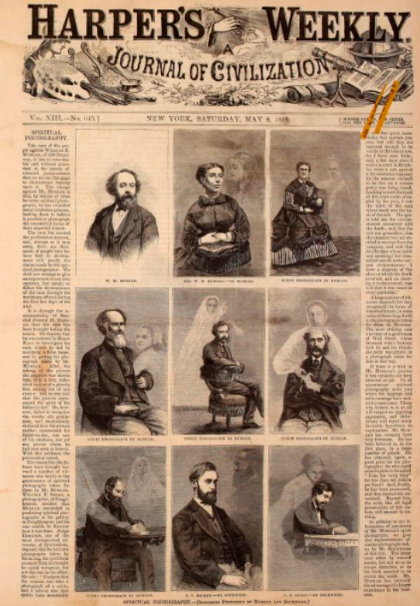
The below excerpt is from A Shilling’s Worth of Magic, a collection of JH Anderson’s writings. In his writing, Anderson (a magician famous for “catching” a bullet in his mouth) denounces Spirit Rappers as fakes.
Here he mentions the three Fox sisters from New York, who played a key role in the development of Spiritualism in the 19th century, after claiming a spirit had communicated with them by rapping on the walls of their house in 1848. They went on to hold public séances. In 1888 they admitted it had been a hoax.
They were Americans. They belonged to a country which has “gone a-head” of us in telegraphs and railways. What were railways and telegraphs to them? - Mere means of conveyance between mortals. It was for them to invent a new telegraph; one station of which should be the visible world - the other, the invisible; and themselves for conducting wires. It was not with them “Messages of twenty words, for any distance not exceeding fifty miles, two shillings;” but “Messages from this world to the people of the other, at ten dollars each.” And they found a public ready to send them - willing and greedy to pay for them.
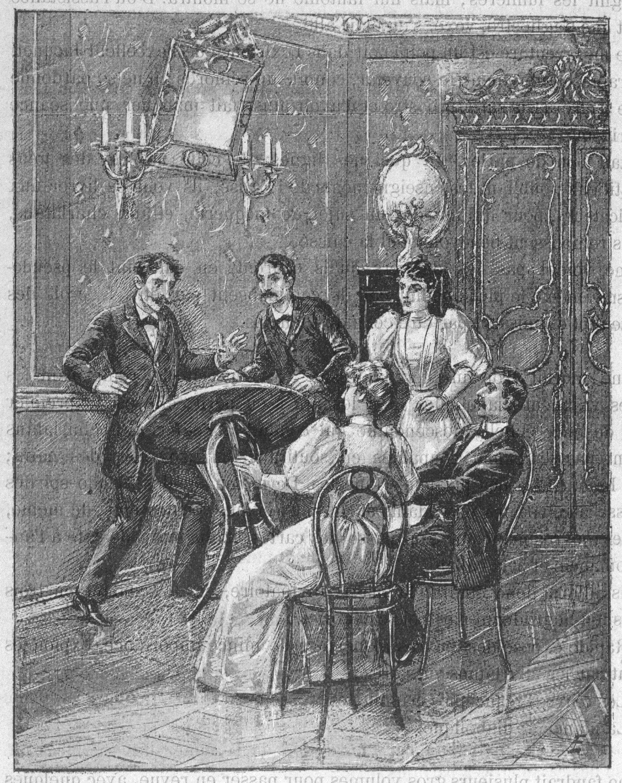
Table Turning Séance gets out of hand in Lyon, France. Image Copyright © Mary Evans Picture Library
in Leo Taxil's Le Diable au XIXeme Siecle page 17

An excerpt from On the Mode of Communication of Cholera by John Snow, M.D., Member of the Royal College of Physicians, Fellow of the Royal Med. and Chir. Society, Fellow and Vice-President of the Medical Society of London (Second edition: 1854), available from (http://www.med.mcgill.ca/epidemiology/hanley/c609/material/SnowCholera/On_the_mode_of_communication_of_cholera.pdf)
Snow’s book is most notable for its description of the cholera outbreak around Broad Street in London. He traced the outbreak to a water pump in the street.
The most terrible outbreak of cholera which ever occurred in this kingdom, is probably that which took place in Broad Street, Golden Square, and the adjoining street, a few weeks ago. Within two hundred and fifty yards of the spot where Cambridge Street joins Broad Street, there were upwards of five hundred fatal attacks of cholera in ten days. The mortality in this limited area probably equals any that was ever caused in this country, even by the plague; and it was much more sudden, as the greater number of cases terminated in a few hours. The mortality would undoubtedly have been much greater had it not been for the flight of the population. Persons in furnished lodgings left first, then other lodgers went away, leaving their furniture to be sent for when they could meet with a place to put it in. Many houses were closed altogether, owing to the death of the proprietors; and, in a great number of instances, the tradesmen who remained had sent away their families: so that in less than six days from the commencement of the outbreak, the most afflicted streets were deserted by more than three-quarters of their inhabitants.
…As soon as I became acquainted with the situation and extent of this irruption of cholera, I suspected some contamination of the water of the much-frequented steer-pump in Broad Street.
…On proceeding to the spot, I found that nearly all the deaths had taken place within a short distance of the pump.
…and as regards the small number of those attacked who were believed not to have drank the water from Broad Street pump, it must be obvious that there are various ways in which the deceased persons may have taken it without the knowledge of their friend. The water was used for mixing with spirits in all the public houses around. It was used likewise at dining-rooms and coffee shops. The keeper of a coffee-shop in the neighbourhood, which was frequented by mechanics, and where the pump-water was supplied at dinner time, informed me (on 6th September) that she was already aware of nine of her customers who were dead. The pump-water was also sold in various little shops, with a teaspoonful of effervescing powder in it, under the name of sherbet; and it may have been distributed in various other ways which I am unacquainted. The pump was frequented much more than is usual, even for a London pump in a populous neighbourhood.
There are certain circumstances bearing on the subject of this outbreak of cholera which require to be mentioned. The Workhouse in Poland Street is more than three-fourths surrounded by houses in which deaths from cholera occurred, yet out of five hundred and thirty-five inmates only five died of cholera, the other deaths which took place being those of persons admitted after in Broad Street, near to the pump, and on perceiving that no brewer’s men were registered as having died of cholera, I called on Mr. Huggins, the proprietor. He informed me that there were above seventy workmen employed in the brewery, and that none of them had suffered from cholera, — at least in a severe form, —- only two having been indisposed, and that not seriously at the time the disease prevailed. The men are allowed a certain quantity of malt liquor, and Mr. Huggins believes they do not drink water at all…

Small print:
Elizabeth Cady Stanton, Eighty Years and More Reminiscences 1815-1897, from Project Gutenberg https://www.gutenberg.org/files/11982/11982-h/11982-h.htm

Resource 2 (The War of the Worlds)
Spoof cartoon of Edison’s latest ‘invention’, anti-gravity underwear. Punch magazine, 1879
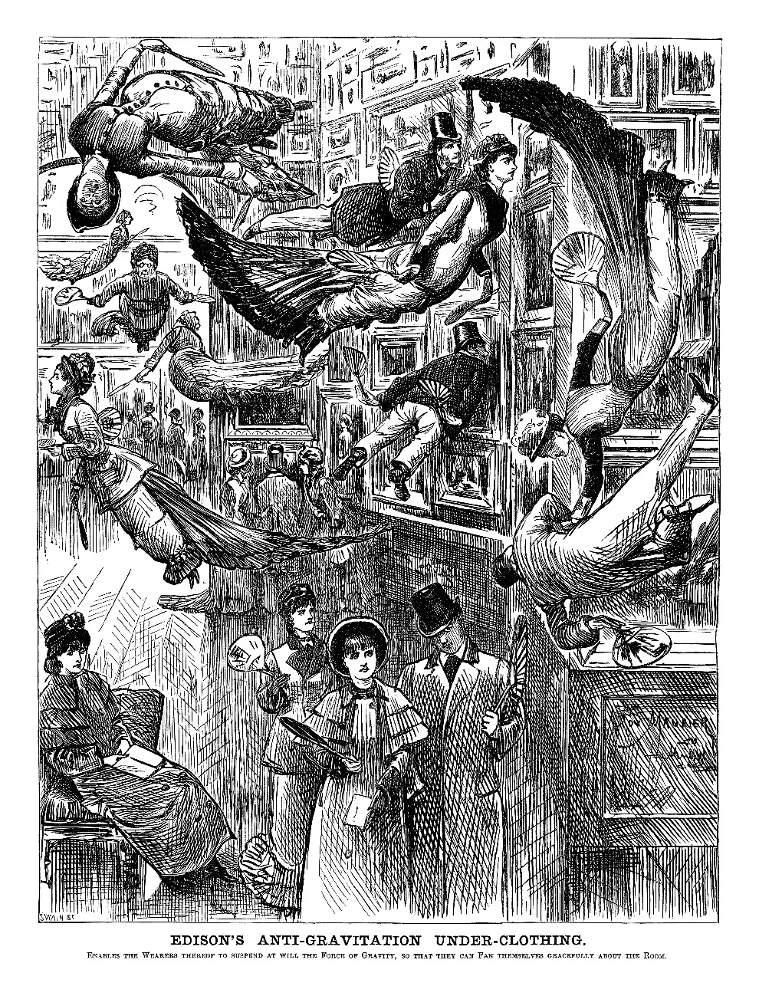
Edison's Anti-Gravitation Under-Clothing - Reproduced with permission from Punch Ltd., www.punch.co.uk

An excerpt from Charles Darwin’s Beagle Diary
September 1835
17th The Beagle was moved into St Stephens harbor. We found there an American Whaler & we previously had seen two at Hoods Island. - The Bay swarmed with animals; Fish, Shark & Turtles were popping their heads up in all parts. Fishing lines were soon put overboard & great numbers of fine fish 2 & even 3 ft long were caught. This sport makes all hands very merry; loud laughter & the heavy flapping of the fish are heard on every side. - After dinner a party went on shore to try to catch Tortoises, but were unsuccessful. - These islands appear paradises for the whole family of Reptiles. Besides three kinds of Turtles, the Tortoise is so abundant; that [a] single Ship’s company here caught from 500-800 in a short time. - The black Lava rocks on the beach are frequented by large (2-3 ft) most disgusting, clumsy Lizards. They are as black as the porous rocks over which they crawl & seek their prey from the Sea. - Somebody calls them “imps of darkness”. - They assuredly well become the land they inhabit. - When on shore I proceeded to botanize & obtained 10 different flowers; but such insignificant, ugly little flowers, as would better become an Arctic, than a Tropical country. - The birds are Strangers to Man & think him as innocent as their countrymen the huge Tortoises. Little birds within 3 & four feet, quietly hopped about the Bushes & were not frightened by stones being thrown at them. Mr King killed one with his hat & I pushed off a branch with the end of my gun a large Hawk.
Charles Darwin's Beagle Diary
Charles Darwin
Edited by R. D. Keynes
9780521003179
Cambridge University Press

In 1875 work began on a sub-marine tunnel linking England and France, but by May 1882 the work was abandoned because the British government had become worried that the tunnel would lead to invasion.
Below is a memo from Lord Wolseley that formed part of the evidence against building the tunnel which led to the scrapping of the project.
Lord Wolseley.
(1).—Memorandum:—"The proposal to make a Tunnel under the Channel, may, I think, be fairly described as a measure intended to annihilate all the advantages we have hitherto enjoyed from the existence of the 'silver streak,' for to join England to the Continent by a permanent highway, will be to place her under the unfortunate condition of having neighbours possessing great standing armies, a state of things which prevents any of the Continental nations from disarming, as long as any one of them refuses to follow suit. The construction of the tunnel would place us under those same conditions that have forced the Powers of Europe to submit to universal service…
"I do not think there is a naval or military man of any experience who does not consider that the construction of a Sub-marine Tunnel between England and France would introduce a new element of danger into the problem involved in the defence of England from invasion, although some may differ as to the extent of that danger. There may be some who will say, 'You can effectually counteract this danger, protect yourself against it, in fact, nullify it;' but that the Tunnel does mean a new danger is virtually undisputed, and I believe that all thoughtful students of war will admit this to be the case. But whilst all will, I think, acknowledge that danger is involved in the scheme, a large number will go further, and will assert that, whatever precautions be taken, and even if it be assumed that more money is spent on fortifications than any British Cabinet is ever likely, in time of peace, to ask from Parliament, it will be impossible completely to provide against the risk. You may, by a very great outlay, of money, in the first instance, and a considerable annual expenditure on the maintenance of fortifications and on other necessary precautions, do a great deal to mitigate the evil; but you cannot remove it altogether, except by the creation of an army fully equal in every respect to that which France can put into the field, and I am sure the people of England have no intention of imposing such a fearful burden upon themselves".
"But the greatest of all dangers to which the construction of this Tunnel will lay us open, is that one end of it may be seized by surprise or treachery, without any warning, and before the machinery designed for its destruction had been put in motion".
"It must be remembered that the works at our end of the Tunnel may be surprised by men sent through the Tunnel itself, without landing a man upon our shores. A couple of thousand armed men might easily come through the Tunnel in a train at night, avoiding all suspicion by being dressed as ordinary passengers" and the fort at our end of the Tunnel might so fall into the hands of an enemy.
Source: Shall We Have a Channel Tunnel? A lecture delivered in Aberdeen, on Tuesday February 6th, 1883.
By Lord Forbes.

Punch 1896
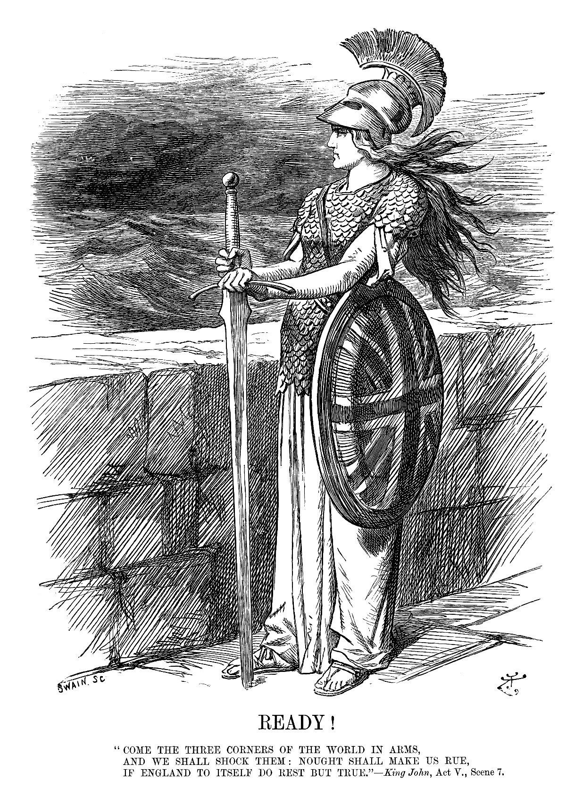
Ready! (Britannia) - Reproduced with permission from Punch Ltd., www.punch.co.uk

Punch 1896
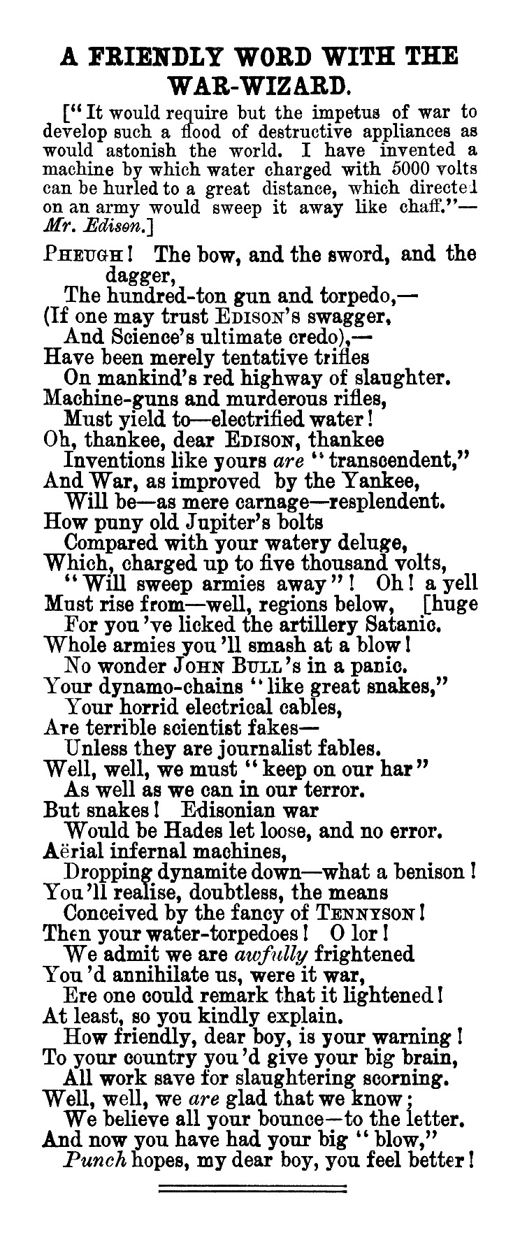
A friendly word with the War-Wizard - Reproduced with permission from Punch Ltd., www.punch.co.uk

1879 article, re-published in The Colonist newspaper

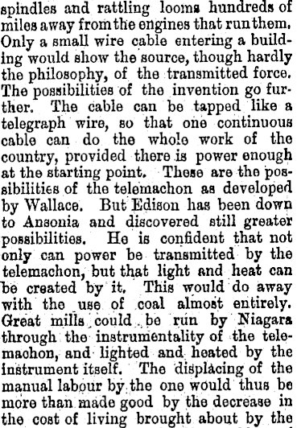
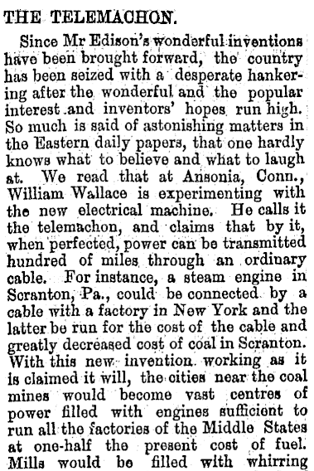

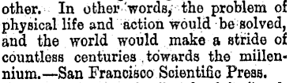

THE TELEMACHON.
Colonist, Volume XXII, Issue 2496, 11 January 1879, Page 6
Reproduced from the National Library of New Zealand, Papers Past. http://paperspast.natlib.govt.nz/cgi-bin/paperspast?a=d&d=TC18790111.2.20

Resource 3 (The Strange case of Dr Jekyll and Mr Hyde)
Illustrative Studies in Criminal Anthropology by Cesare Lombroso
These excerpts from an article by the Italian criminal psychologist and physician Cesare Lombroso appeared in the quarterly US philosophical journal The Monist at the beginning of the 1890s.
Secretions. – Dr. Ottolenghi has made in my laboratory a number of observations with 15 born criminals and 3 occasional criminals, for the purpose of ascertaining the proportional quantities of urea, chlorides, and phosphates eliminated under the same alimentary conditions. Here are the average results:
Urea per 100 grammes of the weight of the body | Born criminals | 0.39 grammes
 | Occasional criminals | 8.53 grammes
Phosphates…..do……. | Born criminals | 0.024 grammes
 | Occasional criminals | 0.0195 grammes
Chlorides…..do……. | Born criminals | 0.28 grammes
 | Occasional criminals | 0.29 grammes
There is therefore amongst the born criminals a diminution in the elimination of urea; and an augmentation in that of phosphates, while the elimination of chlorides does not vary.
Walk. – A study which I have made with Perachia, shows us that, contrary to the case of normal men, the step of the left foot of criminals is generally longer than that of the right; besides they turn off from the line of the axis more to the right than to the left; their left foot, on being placed on the ground, forms with this line an angle of deviation more pronounced than the angle formed by their right foot...
The Skeleton.- Mr. Tenchini, having made studies upon 63 skeletons of criminals, has found in the proportion of 6 out of 100 cases, the perforation of the olecranon (the bony prominence at the back of the elbow); he likewise observed additional ribs and vertebrae in 10 cases out of 100 of them, and also too few, in the same proportion; which reminds us of the great variableness of these bones in the lower vertebrates. Lately he has even found in a criminal 4 sacral vertebræ too few, made up by 4 supplementary cervical vertebræ.
Dr Ottolenghi has studied in my laboratory the wrinkles of 200 criminals and 200 normal persons (workingmen and peasants), and he has found that they occur earlier and much more frequently among the criminals; in fact, two to five times more so than among normal persons, with predominance of the zygomatic wrinkle (situated in the middle of each cheek), which wrinkle may well be called the wrinkle of vice, and is the characteristic wrinkle of criminals.
In criminal women (80) also, wrinkles have been found more frequent than in normal women, although here the difference is not so marked. One calls to mind at once the wrinkle of the sorcerers. It is enough to look at the bust of the celebrated Sicilian woman poisoner, preserved in the National Museum of Palermo, and whose face is one heap of wrinkles.
We shall not terminate this part of our discussion without making mention of the beautiful discovery that we owe – it pleases us to state – to a lawyer, Mr Anfosso. The tachyanthropometer which he has constructed is a real automatic measurer. We might name it, - if the word did not possess a little too much local colour, - an anthropometric guillotine; so quickly and with the precision of a machine, does it give the most important measurements of the body, which makes the practice of anthropometry very easy, even to people who are entire strangers to the science; and it facilitates, moreover, the examination of the description of individual criminals, the perfection of which will always remain one of the most glorious distinctions of M. Bertillon. And at the same time that this instrument renders services to the administration of justice, it permits on a grand scale observations which hitherto were only obtainable by the learned.
Experiments were made a short time ago by Mr. Rossi, who studied the result of these measurements in 100 criminals (nearly all thieves). He found the breadth of the span of the arms to be greater than the height of body in 88; and in 11 to be less. In 30 he found the right foot larger; in 58 he found the left foot larger; in 12 both feet equal. The right arms of 43 per cent. were longer than the left, and the left in 54 per cent. longer than the right. Which confirms to a marvellous degree the gaucherie, mancinism, or structural misproportion, that had before been indicated by dynamometry and the study of the walk of criminals.
The very frequent recurrence of anatomical misproportion and gaucherie could not be better confirmed; and there are in this atavistic symptoms, for Rollet has observed in 42 anthropoids the left humerus to be longer than the right, in proportion of 60 to 100, while among men the proportion is only 7 out of 100.
This anatomical misproportion I have very recently verified with Mr. Ottolenghi by measurements of the two hands, the middle fingers, and the feet, right and left, in 90 normal persons and in 100 born criminals.
Glossary
Gaucherie: awkwardness
Mancinism: left-handed
Humerus: upper arm bone
Atavistic: reverting to something ancient or ancestral
Tachyanthropometer or Tachy Anthropometer: an instrument that measures the human body
Anthropometric: relating to the scientific study of the measurements of the human body
Dynamometry: the science of measuring power. IE human reflex
Anthropoid: ape

Below is a letter to Charles Darwin from Conrad Martens. Martens was the official artist on board the Beagle from December 1833 until August 1834. In 1835 he moved to Sydney, Australia.
St Leonards. I Sydney
Jan 20th./62
To Charles Darwin Esq., &c-.
Many thanks my old Ship.mate for your kind message which I have just recd. by the padre.
I thought you had quite forgotten that I was in existence, and certainly the man who voluntarily sets himself down in such a place as this has no right to grumble if he finds such to be the case.
As it appears however you have still two of my sketches hanging up in your room. I hope you will not refuse to accept another which I shall have much pleasure in preparing and will send to you by the next mail.
Your “book of the season” as the reviewers have it, I must own I have not yet read, altho Mr Clarke offered to lend it me, I am afraid of your eloquence, and I don’t want to think I have an origin in common with toads and tadpoles, for if there is anything in human nature that I hate it is a toady, but of course I know nothing of the subject, and they do make such microscopes now a-days – I suppose yours is one of Ross’s very best, by the by I got him to make two eyepieces for a reflecting telescope just before he died as I had succeeded in casting and polishing two metals of 6 and 7. Feet focus, and so now I shew the good people here the mountains in the moon turned up side down, as of course they ought to be when seen from the antipodes.
But I must apologise, for I suppose you don’t laugh at nonsense now as you used to do in “Beagle” or rather I suppose it does not come in your way.
Well, that was a jolly cruize (sic), and I hope you have been well and happy ever since – and that you may continue so for some time to come is, believe me, the sincere wish of your old shipmate Conrad Martens.
PS. I wonder whether, the Admiral, what is now, I should like to send my kind regards, if you should see him, but don’t if you don’t like – coffee without sugar, you remember.-
Letter, "From Conrad Martens, 20 January 1862", pp. 35-36, in Charles Darwin, Edited by Frederick Burkhardt, Joy Harvey, Duncan M. Porter, Jonathan R. Topham, The Correspondence of Charles Darwin, Volume 10: 1862. (1997). © Cambridge University Press., 1997.
Reproduced with permission from Cambridge University Press.

Excerpts from A Diary of a Resurrectionist 1811-1812
In the 19th century there were not enough dead bodies for surgeons and trainee surgeons to dissect. They needed to do this in order to advance their knowledge of the human body. As a result, gangs of so-called resurrectionists robbed the graves of the recently dead and sold the bodies to medical schools.
Below are two entries from a diary kept by one of these resurrectionists. It was published in 1896 due to public demand and it records “the doings of one gang of the resurrection-men in London”
1812 August
Thursday 13th. Went to St Thomas’s Crib could not succeed came back to the White horse, Bill got arrested, Millard pd. the Debt I got drunk would not go out, Bill & Hollis went to Weigate got 1 adult male, took to the Boro, Recd. £2 0s 0d
1812 October
Friday 9th. Went to look out at different places. At night went to St. Olave, got 2 adults M. & F.M. was opened took them to St. Thomas’s; again met, I got drunk, I miss^{d}. going with the party.
They seperated, part went to Lambeth got 1 adult F. They missed, one took that to the Boro the others (Except Ben who was getting drunk) went to Connolly got 1 adult F., took that to Bartholomew, & removed the other same place.
Diary of a resurrectionist, Joshua Naples, 1811-1812
MS0024/1 Diary of a Resurrectionist, The Archives at the Royal College of Surgeons of England.© 2016 The Royal College of Surgeons of England
Diary of a resurrectionist, Joshua Naples, 1811-1812
Glossary
St Thomas’s: a London hospital
The Boro: a London hospital
£,s,p: pounds, shillings, pence. This was the currency that was used in Britain in the 19th Century
St Olave: a burial ground
Bartholomew: a London hospital
MS0024/1 Diary of a Resurrectionist, The Archives at the Royal College of Surgeons of England.© 2016 The Royal College of Surgeons of England
A spoof headline from The Daily Graphic, New York
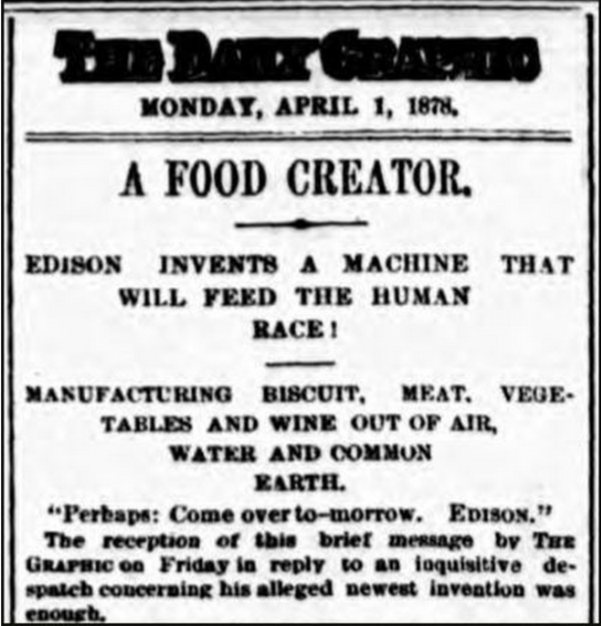
An excerpt from The Criminal Law Amendment Act, 1885
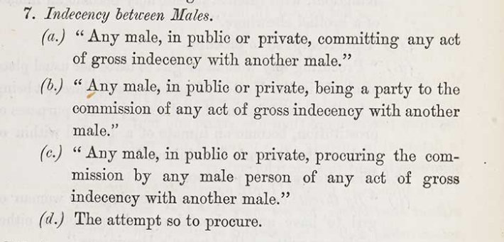
Screen shot from http://www.bl.uk/collection-items/the-criminal-law-amendment-act-1885.
Courtesy of the British Library.

Below is a 19th century broadside, a single sheet of paper with a proclamation or news story printed on it. These were common between the 16th-19th centuries. This was re-printed in the introduction to The Diary of a Resurrectionist 1811-1812.
“MIRACULOUS CIRCUMSTANCE:
“Being a full and particular account of John Macintire, who was buried alive, in Edinburgh, on the 15th day of April, 1824, while in a trance, and who was taken up by the resurrection-men, and sold to the doctors to be dissected, with a full account of the many strange and wonderful things which he saw and felt while he was in that state, the whole being taken from his own words.
“I had been some time ill of a low and lingering fever. My strength gradually wasted, and I could see by the doctor that I had nothing to hope. One day, towards evening, I was seized with strange and indescribable quiverings. I saw around my bed, innumerable strange faces; they were bright and visionary, and without bodies. There was light and solemnity, and I tried to move, but could not; I could recollect, with perfectness, but the power of motion had departed. I heard the sound of weeping at my pillow, and the voice of the nurse say, ‘He is dead.’ I cannot describe what I felt at these words. I exerted my utmost power to stir myself, but I could not move even an eyelid. My father drew his hand over my face and closed my eyelids. The world was then darkened, but I could still hear, and feel and suffer. For three days a number of friends called to see me. I heard them in low accents speak of what I was, and more than one touched me with his finger. The coffin was then procured, and I was laid in it. I felt the coffin lifted and borne away. I heard and felt it placed in the hearse; it halted, and the coffin was taken out. I felt myself carried on the shoulders of men; I heard the cords of the coffin moved. I felt it swing as dependent by them. It was lowered and rested upon the bottom of the grave. Dreadful was the effort I then made to exert the power of action, but my whole frame was immovable. The sound of the rattling mould as it covered me, was far more tremendous than thunder. This also ceased, and all was silent. This is death, thought I, and soon the worms will be crawling about my flesh. In the contemplation of this hideous thought, I heard a low sound in the earth over me, and I fancied that the worms and reptiles were coming. The sound continued to grow louder and nearer. Can it be possible, thought I, that my friends suspect that they have buried me too soon? The hope was truly like bursting through the gloom of death. The sound ceased. They dragged me out of the coffin by the head, and carried me swiftly away. When borne to some distance, I was thrown down like a clod, and by the interchange of one or two brief sentences, I discovered that I was in the hands of two of those robbers, who live by plundering the grave, and selling the bodies of parents, and children, and friends. Being rudely stripped of my shroud, I was placed naked on a table. In a short time I heard by the bustle in the room that the doctors and students were assembling. When all was ready the Demonstrator took his knife, and pierced my bosom. I felt a dreadful crackling, as it were, throughout my whole frame; a convulsive shudder instantly followed, and a shriek of horror rose from all present. The ice of death was broken up; my trance was ended. The utmost exertions were made to restore me, and in the course of an hour I was in full possession of all my faculties.
Diary of a resurrectionist, Joshua Naples, 1811-1812
Royal College of Surgeons of England

