Topic Exploration Pack

Area of Study 6: Innovations in Music 1900 – present day

Mapping to the specification: learning outcomes 2
Introduction 3
Suggested activities overview 6
Listening question 1: Debussy – Gigues from Images for Orchestra - learner sheet with possible answers 9
Listening question 2: Schoenberg – Variations for Orchestra Op. 31 learner sheet with possible answers 11
Listening question 3: Stravinsky - Dumbarton Oaks Concerto for Chamber Orchestra – Learner sheet with possible answers 13
Listening question 4: Philip Glass - Facades - learner sheet with possible answers 17
Listening question 5: Judith Weir - Airs from Another Planet 19
Online resources 21
Student activity section - worksheets 22
Listening question 1: Debussy – Gigues from Images for Orchestra 22
Listening question 2: Schoenberg – Variations for Orchestra 25
Listening question 3: Stravinsky - Dumbarton Oaks Concerto for Chamber Orchestra 27
Listening question 4: Philip Glass - Facades 30
Listening question 5: Judith Weir - Airs from Another Planet 32
These instructions and answers cover the student activity section which can be found on page 22. This Topic Exploration Pack supports OCR AS and A Level Music.
When distributing the activity section to the students either as a printed copy or as a Word file you will need to remove the teacher instructions section.

Mapping to the specification: learning outcomes
Learners should study the continuation, development and innovations in music of the Western tradition from 1900 to the present day:
- study examples in-depth of music from the period of study, using live performances, recordings and scores as appropriate
- use attentive listening and contextual knowledge to analyse, evaluate and make critical judgements about the repertoire
- use technical vocabulary to communicate a sophisticated understanding of twentieth century and contemporary music and its context.

Learners should analyse, explain and compare developments in Twentieth and Twenty first century styles, including:
- late romantic style, e.g. large scale symphonic works
- impressionism
- expressionism, atonality and serialism
- neo-classical developments, e.g. reinterpretation of traditional forms
- national styles, e.g. based on folk traditions
- post-1945 avant-garde, experimental approaches, electronic music, post-modern response e.g. to Eastern or African influence
- minimalism
- contemporary approaches to composition.

Learners should study and understand innovations in the use of musical elements, including:
- irregular rhythm, metre, polyrhythm, polymetre, organisation of time
- pitch, dissonance, harmony, tonality, modality, atonality
- exploration of sonority, timbre, textures, instrumental and vocal techniques and resources, percussion, technology
- dynamics, contrast, extreme range
- structure, form, notation, improvisation, aleatoric.

Learners should study and understand the conditions and context in which music of this period was created and performed, including:
- audience reaction to innovation
- technology and mass media
- the response of composers to political and social events, e.g. revolution, war
- persecution, censorship
- ideas about the function and relevance of music, e.g. Gebrauchsmusik, crossover
- with popular styles, music for films, propaganda
- working conditions for musicians
- challenges and issues for performers and composers working today.

Introduction
As the title suggests, the period of music from 1900 onwards was a time of innovation when composers focused more than ever before on developing new techniques and ideas. A huge variety of different styles was developed in this period ranging of course from impressionism, large scale orchestral music, neo-classical, serialist, avant-garde and minimalist styles.

This Area of Study, with the focus on new developments in music since 1900, is a suitable progression for learners who have studied the programme music of the nineteenth century or the instrumental music of the classical period. It will provide learners with an in-depth understanding of how composers were developing techniques and can build successfully on their knowledge from the work covered in the compulsory Area of Study 1.

Innovations in music gives learners the opportunity to consider how composers wanted to express their creativity as well as the different techniques they used to express feelings and emotion in their music.

Learners will need to develop their understanding of devices used in the music of this period such as the use of harmony and tonality as a composing tool and the developments using dissonance together with the use of chromatic chords at the beginning of the twentieth century. Further composing tools such as the use of atonality and subsequently the development of serialism will need consideration. Learners will need to study the use of different and varied groups of instruments and the use of a varied range of instrumental techniques. More avant-garde approaches to composing will also need to be approached including extended instrumental techniques and the use of minimalist techniques.

There are wide opportunities for study of different aspects of music from the Twentieth and Twenty first centuries, including late romantic style with the large scale symphonic works from the beginning of the twentieth century, Impressionism, Expressionism, including atonality and serialism, neo-classicism, national styles, post 1945 avant-garde such as experimental approaches and electronic approaches, minimalism and contemporary approaches to composition.

Although there are plenty of opportunities for wider listening which will be advantageous, learners will also need to study some pieces in detail to understand the full implications of the composing techniques used. The context of the music will also need consideration and learners will need to understand about the developments in the twentieth century in the arts as well as the conditions under which composers worked in the twentieth century.

The study of structural principles from the classical period will also give learners the relevant background to the further developments in structure from 1900 and how composers made creative use of structures from 1900 in addition to the use of melody and rhythm to provide expressive freedom.

Music at the beginning of the twentieth century was really a development of romantic style. The conventions of musical expression remained in place and still seemed to be an irremovable way of composing music. Composers still made use of the normal conventions of rhythm and metre, harmony, melody and tonality. Deviations from the rules were regarded as mere irregularities. However, chromaticism became more and more developed so that tonality became almost lost in the overwhelming use of chromatic chords.

The beginning of the twentieth century sees further developments in instrumental music with composers often choosing to use an even larger orchestra than previously. Learners study orchestral music from the classical period as part of the compulsory Area of Study 1 and will encounter score reading. The study of instrumental music means that learners must become competent at following an orchestral score and interpreting the musical information being communicated. For this Area of Study they will need to develop their skills of score reading to be able to read and understand larger scores. They will need to develop their skills at reading and aurally identifying larger woodwind and brass sections as well as covering a huge range of percussion. Learners will need to be aware of the chromatic chords used in these large scale pieces as well as the use of different scales and tonalities.

As the century continued new developments included neo-classicism, expressionism and serialism. Learners will be able to make use of their knowledge of structural principles from Area of Study 1 when studying works in the neo-classical style in addition to knowledge of chromaticism as mentioned above.

A further topic of exploration for learners will be a focus on expressionism and the developments of the 12 note system of composing. A basic knowledge of serialism and the rules involved in this approach to composition will be essential before they go on to study a work using this approach.

Other composers chose to focus their composing on national folk styles and a study of the use of folk music and how it was incorporated into twentieth century music should be covered. A revolution in the field of rhythm would also be a focus point, particularly in folk song styles but also in the earlier large orchestral works such as the large scale ballets by Stravinsky.

A further study could focus on the use of timbres in the music since 1900. In the early years of the twentieth century composers such as Schoenberg were also concentrating on using different combinations of instruments and different vocal techniques. Since then, many composers have used extended instrumental techniques such as the prepared piano in works by, for example, John Cage as well as the extended instrumental and vocal techniques in the Sequenzas by Berio.

Avant-garde, aleatoric and electronic music as well as Minimalism would be further topics to cover during this Area of Study.

When studying a piece of music, learners should also be aware of elements such as melody, rhythm and metre and texture. They will need be able to discuss the use of these elements with appropriate language. Revision of each of these features would also be a suitable focus before attempting a study of innovations.

Learners might benefit from studying some shorter pieces of music from the twentieth century as an introduction before progressing to one of the longer works, for example:

- A selection of Preludes by Debussy
- Mikrokosmos by Bartok
- Suite for Klavier by Schoenberg
- One of the sonatas e.g. flute sonata by Hindemith or Poulenc.

Recordings and many examples of live performances are available on: https://www.youtube.com/ Live performances have the advantage of allowing learners to see the instruments that they are hearing, the standard seating positions within an orchestra, many significant performance venues and performances of some of the more creative and individual compositions of the twentieth century. Seeing and hearing a performance makes the experience far more engaging for learners. Some recordings also provide useful illustrations which can help when providing a suitable starting point for learners.

Suggested activities overview

There are plenty of opportunities for composing and performing activities in this Area of Study which will provide an integrated approach.

Each piece of music selected for the following listening questions can be used as a starting point for performing and composing opportunities.

Here are some suggestions for starting points when approaching each of the pieces of music used in the listening questions. Each piece of music has been selected from a different focus of music since 1900.

- Large Orchestral Music and Impressionism
Debussy - Gigues from Images for Orchestra

Debussy’s music has been called impressionistic, although it came much later than the main body of impressionist painting. However, the two are undoubtedly related and an excellent starting point would be some investigation of impressionist art.

Although Debussy himself despised the term impressionism, the link with impressionist art will nevertheless provide some insight into his music.

Debussy’s music is ideal for piano learners and many would be able to perform some of the preludes or Suite Bergamasque.

Flute players could of course attempt syrinx which could also be adapted for other instrumentalists. A task for other instrumentalists could be to arrange a piano piece by Debussy for the group of instruments available in the class.

Composing tasks could focus on the particular features of Debussy’s music such as the use of parallel 7th and 9th chords, the use of whole tone, modal and chromatic scales, ambiguous harmonies and tonal centres with the lack of cadence points and the use of pedal points, free chromaticism and the importance of melody over harmony and rhythm.

- Expressionism and Serialism
Schoenberg: Variations for Orchestra

One way to give learners some familiarity with the rules of 12 note music is to give them a composing task. They can compose their own piece of serial music, preferably for their own instrument. This can be quite challenging as it is rarely sufficient just to follow the rules! It requires just as much skill and judgement as composing in any other style and they will need to make musical decisions just as with any other composing task. Once the choice of the series has been made, a matrix with all versions of the row can be accessed by using www.musictheory.net and selecting tools and matrix generator.

Learners will still have to make decisions in order to produce a musical outcome, with for example, the intervals, the motifs and the rhythms they want to use.
A practical task could develop from this starting point, the outcome being a performance of their composition.

- Neo-classicism
Stravinsky: Dumbarton Oaks Concerto for Chamber Orchestra

As this genre has a focus on music from the Baroque and classical periods, a useful starting point could be the performance of some simple dance suite movements such as Gavotte and Minuet. Learners will therefore be introduced to the features of these dances before analysing a twentieth century piece or trying to compose in that style.

A further starting point would be to study the Baroque concerto grosso focusing on some examples by Bach or Vivaldi. These could even be a starting point for a group performance. Some learners might even be studying a solo concerto as part of their performance studies which will also be useful background before studying neo-classicism. The work covered in Area of Study 1 will obviously be of some benefit here too.

Composing work could focus on writing in neo-classical style, either for their own or for a group of instruments. Some of the chamber works written in this style by either Stravinsky or Poulenc could be used as a starting point for this task.

- Minimalism
Philip Glass: Facades

This topic lends itself well to an integrated approach. Learners will enjoy trying to perform Steve Reich’s Clapping Music, a good demonstration of phasing in action. There are examples of performances on Youtube and a score is available at: http://earreader.nl/wp-content/uploads/2016/01/SteveReich-ClappingMusic.pdf

Another piece which is a good performance piece is Terry Riley’s ‘In C’. This piece can be performed in a variety of ways, dependent on the performers and can lead to useful discussion on aleatoric music. A score is available for this piece at:
http://imslp.org/wiki/In_C_(Riley,_Terry)

Composing tasks could usefully start with a group piece built along the same lines as ‘In C’ with members of the group writing their own motif before combining them and continually making changes to them so the piece develops and changes constantly as it progresses.

- Contemporary approaches to Composition
Judith Weir: Piano Concerto

Learners could try to compose their own piece using some of the techniques of contemporary composers. They could attempt a piece for their own instrument something along the lines of the Berio Sequenzas which could then be performed.

Now ask learners to complete the worksheets that follow. Links are provided where the specific full scores used can be found and downloaded.

Listening question 1: Debussy – Gigues from Images for Orchestra - learner sheet with possible answers

Gigues from Images for Orchestra
You will need a recording of this piece as well as the score and many suitable recordings are available on Youtube. The link below is a recording with a simplified score for two pianos.
https://www.youtube.com/watch?v=TerWx9fe5yo
A full score is also available at http://imslp.org/wiki/Special:ImagefromIndex/15761
The first of the orchestral Images, called Gigues, was originally entitled Gigues Tristes. It was however, the last of the three to be completed, begun in 1909 and completed by 1912. Just as no. 2, Iberia portrays Spain and no. 3, Rondes de Printemps, France, it is thought that Gigues portrays the English landscape and to this end makes use of parts of the traditional Tyneside song, The Keel Row:
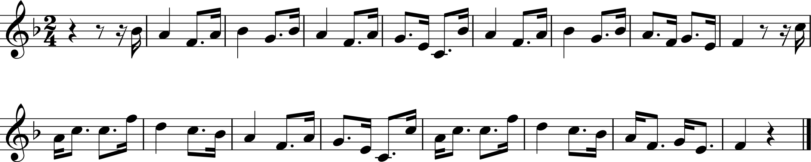

(a) Listen to the first section up to fig 3. How does Debussy create the atmosphere of this piece? You should refer to orchestration, textures, melody and any other features of interest.
Possible answers could include:
Use of muted trumpets and strings at the beginning marked pp.
Entry of flute also quiet dynamic. Plays a whole tone version of the beginning of the Keel Row theme.
Pedal note of C – long held note that gradually builds up through the strings so they are in octaves.
Harp plays glissandos usinbg notes of the whole tone scale giving a feeling of vagueness and lacking sense of key.
A cymbal roll is added. Again pp.
A repeat of this section with the flute melody a tone lower. Still with long held pedal notes on strings.
A new melody on oboe d’amore. Totally unaccompanied. In folk song style with compound time signature with balanced phrases.
The first theme is then superimposed on top. There is superimposition of themes throughout the piece.
A return to the oboe d’amore unaccompanied then a change to a D pedal played pizzicato on divided cellos with off beat chords. Tambourine also plays off beats.
The section has a very quiet dynamic throughout. There is a lack of steady pulse at the beginning due to the long held notes.
An introduction to two of the melodies in a very calm and still, almost mysterious atmosphere created by the use of the pedal notes, the unaccompanied melody and the harp whole tone glissandos as well as the reserved use of percussion.

A new melody on oboe d’amore. Totally unaccompanied. In folk song style with compound time signature with balanced phrases.
The first theme is then superimposed on top. There is superimposition of themes throughout the piece.
A return to the oboe d’amore unaccompanied then a change to a D pedal played pizzicato on divided cellos with off beat chords. Tambourine also plays off beats.
The section has a very quiet dynamic throughout. There is a lack of steady pulse at the beginning due to the long held notes.
An introduction to two of the melodies in a very calm and still, almost mysterious atmosphere created by the use of the pedal notes, the unaccompanied melody and the harp whole tone glissandos as well as the reserved use of percussion.

There are three main melodies used in the music together with another that appears later on the oboe d’amore. These are as follows:

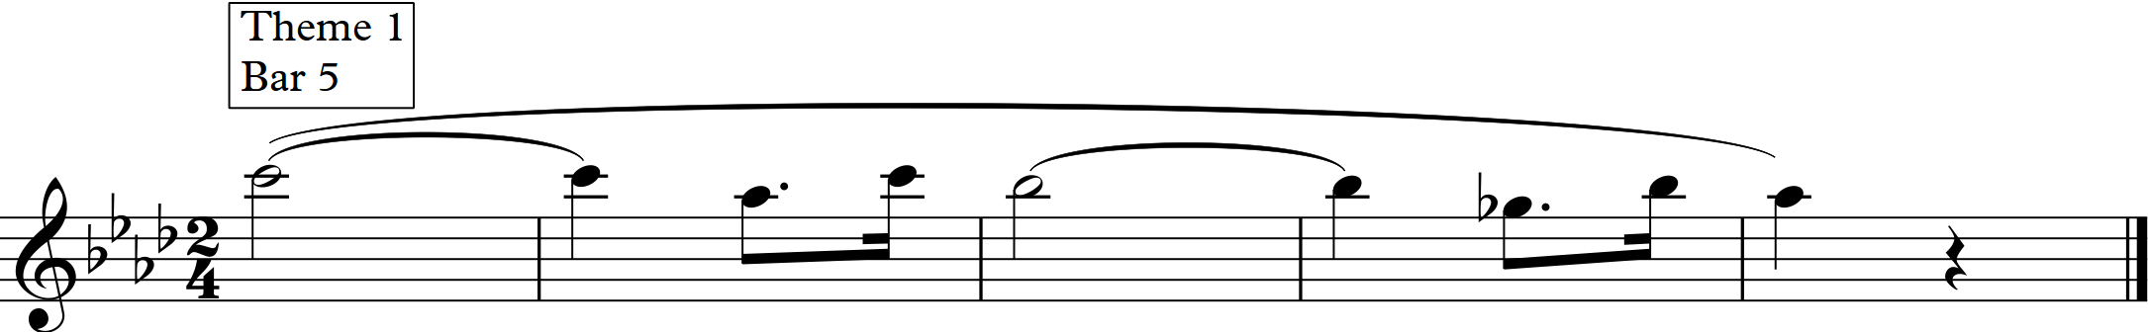

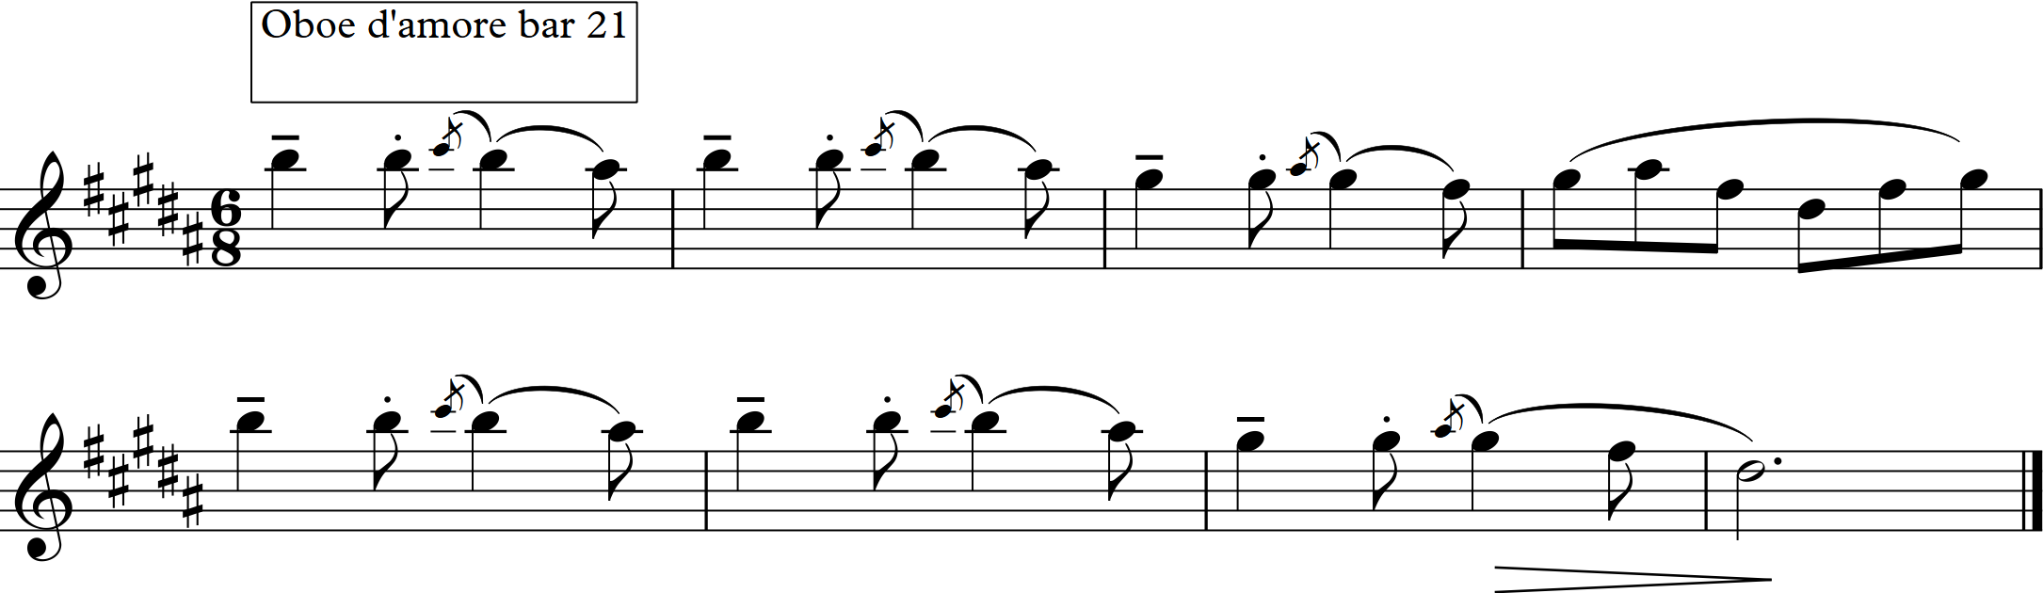
3.
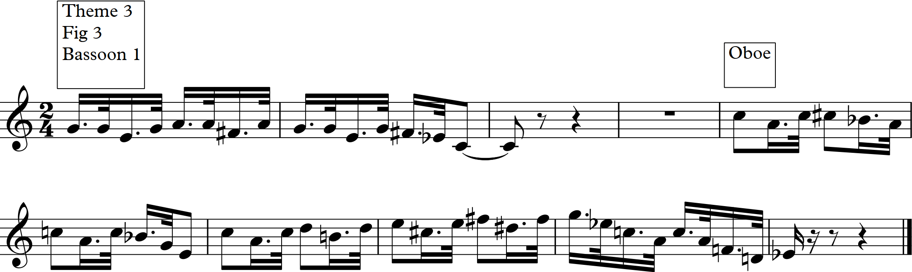
4.
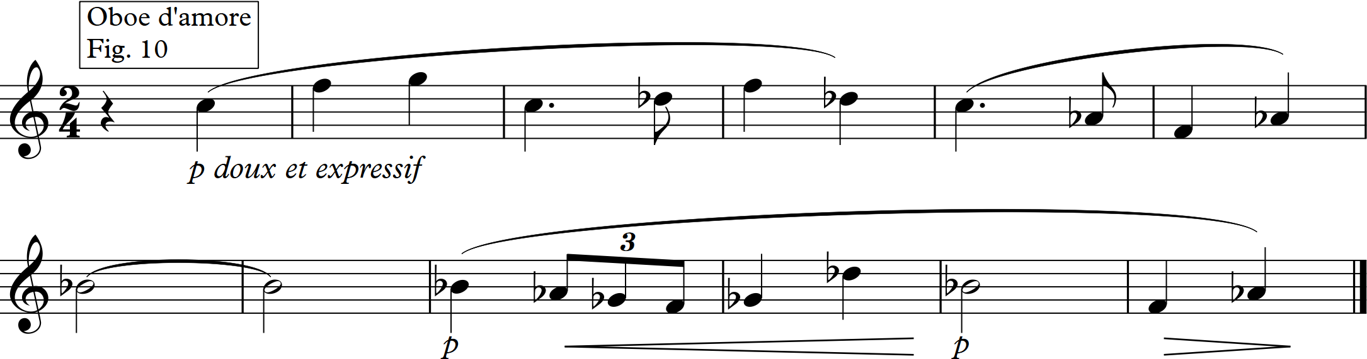

- Listen to the rest of the piece. How does Debussy combine and develop these ideas?
Debussy introduces the new themes and superimposes them on top of each other but the themes are not really developed, just repeated with different orchestrations.
For example: Theme 3 is introduced in a more rhythmic section, then the oboe d’amore adds theme 2 to the texture.
He takes the ‘Keel Row’ and uses its dotted rhythm to energise the textures. The tune is never quite heard in a complete version. The nearset is a xylophone version leading up to the main climax, but stopping short of the last four notes of the final cadence.
The other two tunes, on oboe d’amore provide the material for the climax and have elements in common with the ‘Keel Row’ which makes for some unity.
At fig. 6 there is a mixture of the themes
A new more gentle melody appears on the oboe d’amore at fig. 10. This is accompanied by the Keel Row melody which eventually takes command again.
At the climax from fig 17 there are traces of practically every theme, interweaving in an intricate texture using full orchestra.
From the listener’s viewpoint, we are never sure which theme Debussy is going to bring in next which ultimately makes it sound improvised which of course it isn’t!
At a pause there is a sort of cadenza for piccolos with solo violin harmonics, then flutes, clarinets and lastly bass clarinet.
The tempo is resumed and the oboe d’amore reverts to its 6/8 tune.
Excerpts of the Keel Row tune add interest to the atmospheric ending.

Listening question 2: Schoenberg – Variations for Orchestra Op. 31 with possible answers

Schoenberg variations for Orchestra
The score for this piece can be found here: http://imslp.org/wiki/Variations_for_Orchestra,_Op.31_(Schoenberg,_Arnold)

The tone row for this piece is as follows:
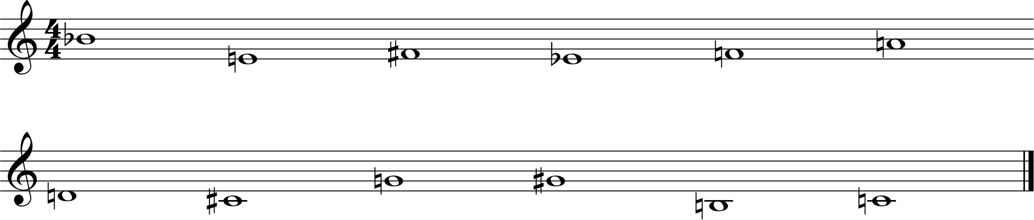
You will now need to produce the matrix for this tone row by using www.musictheory.net then going to the tools and the matrix calculator. This will give you all the 48 rows that could be used in this composition, Prime, Inversion, Retrograde and Retrograde Inversion in all 12 different transpositions.

Recordings of this music are available on Youtube. For example: https://www.youtube.com/watch?v=yHHUxoa1DDs
The theme appears at 2.23 after an introduction.
Variation 1 is at 3.26, Variation 2 at 4.43 and Variation 3 at 6.08

- By looking at the score and listening to the theme establish where the prime row is located.
Cello bars 1-5

- Work out what row is used as an accompaniment in this section.
Row I9 is used with notes on woodwind, horn, harp and Double bass

- What is the next row that Schoenberg uses? What row do the accompanying parts use?
Cello has RI9 in bars 6 – 12.
Accompanying parts have R0 from bar 6 to bar10

4. Look at bar 13 – what row is used here and what row is accompanying?
The cello has R9 from bar 13 to bar 17 while the accompanying parts play RI9

5. Do the same at bar 19 – here there are two different accompaniments, the woodwind chords as before and also a countermelody on the cello.
The violin plays I9 while the accompanying parts play P0. The countermelody on cello is P3.

6. What do you notice about his choices?
For the main melody on cello, then violin at the end he makes use of one each of Prime, Inversion, Retrograde and Retrograde Inversion. Each of these rows apart from the Prime row has been selected in transposition 9. Each accompaniment also uses a different version of the row, alternating between the 9th transposition and the original row – I9, R0, RI9, P0.

7. How has Schoenberg stated the row in the first instance? How does this help the listener?
It is stated on one instrument, the cello, in high register. Other parts accompany with quiet chords so that it is easier to hear the theme.

8. Now listen to the introduction – what sort of atmosphere is Schoenberg creating?
Quiet and mysterious, created by the peaceful yet quick tempo and the use of pedal notes. The function of the introduction is to present the material to be developed in a very free manner.

9. Listen to some of the variations. What features of this piece are similar to a classical set of variations.
The theme is presented in simple form and then each Variation becomes more complicated. For example, the accompaniment becomes more active in Variation 1. Variation 2 is a piece of contrapuntal texture with the theme on muted violin solo followed in canon by the first oboe.

Pierre Boulez wrote ‘We must avoid confusing composition with organisation’ with particular reference to Schoenberg Variations. After listening to some of these variations, how much do you agree with this comment?
Listening question 3: Stravinsky: Dumbarton Oaks Concerto for Chamber Orchestra – Learner Sheet with possible answers

Before you listen to the Stravinsky piece, you should listen to Bach’s Brandenburg Concerto no. 3, first movement. There is a Youtube video with score at:
https://www.youtube.com/watch?v=0BOqMiI0uJ8
You should also find out about the concerto grosso in the Baroque era.

A recording of The Dumbarton Oaks Concerto can be found at:
https://www.youtube.com/watch?v=LDez514_nFA

Listen to Movement 1
- What features of this music suggest it was written in the twentieth century?
Syncopation
Changes of metre
Lack of cadences
Based on one motif
Instrumental techniques such as: pizzicato, double stopping.
Use of full range of instruments e.g. high bassoon
Technically difficult writing for instruments.
Strings often handled very percussively
Instruments as soloists
Large range of dynamics
Lack of balanced phrasing
Fragmented melodies.

- What features of this music suggest that it was written with classical or Baroque ideals in mind?
Use of chamber orchestra.
Each instrument used as a soloist.
Very contrapuntal throughout.
Includes a fugal section
Changes of textures – 2 part, 3 part, full orchestra.
The concerto grosso idea of contrasts of concertino and ripieno.
Use of quick figuration.

- Why do you think that he has called this a concerto for chamber orchestra?
Learner enters own views here.

You might also like to try: listening to the other two movements. In typical Baroque style they follow the pattern of fast, slow, fast. Continue to identify other features of Baroque style as well as twentieth century features in the music.

Dumbarton Oaks is one of Stravinsky’s later examples of neo-classical music, written in 1937-8.
Stravinsky was considered to be the first composer of neo-classical music in the twentieth century, although other composers had been thinking along the same lines before Stravinsky’s first piece in this style. This piece was called Pulcinella, written in 1920 and it really brought neo-classicism to everyone’s attention.

Pulcinella was written as a ballet, based on an 18th century play. It followed his three large scale ballets, The Firebird, Petrouchka and The Rite of Spring and it surprised many people because of the smaller scale and the references to earlier styles. Stravinsky had taken excerpts from Baroque composers such as Pergolesi and Gallo and rewritten them in his own inimitable style.
Listen to some of the work and again identify features of earlier music as well as identifying twentieth century features.

There is a Youtube video with a simplified score.
https://www.youtube.com/watch?v=pVEcJnlHUMM
Note in particular the use of instruments and the features of Concerto Grosso that again appear in this piece.
.

Listening question 4: Philip Glass - Facades learner sheet with possible answers

A recording is available at:
https://www.youtube.com/watch?v=l5rQwfcU70E

- What interval does the composer use at the beginning?
Minor third.

- How many times do you hear that interval before it changes?
24.

- How does the interval change?
It becomes a major third.

- How many times do you hear the next interval before it changes?
9 times.

- We hear another third a semitone higher three times, what happens then?
Return to the original notes for 12 times.

- After 48 bars a soprano sax melody enters. How many different notes does it use?
Only 4 different notes.

- What happens on the repeat of this melody?
It is repeated with decoration, generally in conjunct movement.

- What instrument then joins?
Another soprano saxophone.

- Describe the accompaniment throughout this section.
The repeating thirds continue throughout.

- It has been said of minimalist music that ‘nothing happens and nothing is expressed’. What do you think after listening to this piece?

You might also like to try:
Facades was originally written for a film called ‘Koyaanisquatsi’ from 1982. The film consists primarily of slow motion and time-lapse photography of cities and many natural landscapes across the United States. There is no narration, just the music. Facades was originally composed for one of the scenes but was eventually cut and not used. In the Hopi language, the word Koyaanisqatsi means 'crazy life, life in turmoil, life out of balance, life disintegrating, a state of life that calls for another way of living', and the film implies that modern humanity is living in such a way. The film is the first in the Qatsi trilogy of films: it is followed by Powaqqatsi (1988) and Naqoyqatsi (2002).

Other pieces by Philip Glass follow on from the concerto theme of piece no. 3. These are entitled The Concerto Project nos I – IV. The first volume for example has a concerto for cello and orchestra and a concerto for two timpanists and orchestra.

Listening question 5: Judith Weir: Airs from another planet

Throughout the history of music, but particularly in the twentieth century, composers have striven to develop their own individuality. Developments of musical forms and techniques as well as a new world of unfamiliar sounds have been at the forefront of the music in the twentieth century with other composers following in the footsteps of those who developed new ideas.
Composers working today obviously also strive to develop their own individual style within their music. Judith Weir is a composer, Master of the Queen’s Music and with her own inimitable style.
You can listen to Airs from another planet, subtitled, traditional music from outer space on:
https://www.youtube.com/watch?v=JJIyzDTWmp8
The score can be viewed at: https://issuu.com/scoresondemand/docs/airs_from_another_planet_2723
There are four movements:
- Strathspey Reel
- Traditional Air
- Jig
- Bagpipe Air with drone.
As in other compositions, she has made use of her Scottish roots in a new and creative composition. Listen to the first movement and identify features of this piece that give it the individuality that would suggest it was written by a composer of the present time.
You might also like to try:
You could also listen to the other movements of this piece and again try to assess how the pieces become individual as well as making some judgements about whether the titles do suggest the traditional music of Scotland.
Judith Weir has written a huge variety of music, including opera and traditional forms of instrumental music. Her piano concerto is scored for piano and string ensemble and compresses the large scale orchestral form into a much smaller piece.
There is an interesting presentation on YouTube about this piece, entitled Judith Weir, a unique harmonic language, to which you might like to listen.
You can find this at:
https://www.youtube.com/watch?v=CVTCVDydWYo
You might also like to listen to other music from the late twentieth century. The composer Luciano Berio has written a series of pieces for individual instruments called Sequenza. There are examples for many different orchestral instruments as well as for voice and even for accordion. They were very much intended to be performed in an individual way by the performer. There are several examples on YouTube.

Online resources

http://imslp.org/ provides a huge free library of scores and recordings. However, many of the pieces of music written more recently will not yet be available due to copyright law.

http://www.naxosmusiclibrary.com/ Naxos Music Library. Requires a subscription to be paid.

https://www.youtube.com/
YouTube recordings and live performances. Live performances have the advantage of allowing learners to see the instruments that they are hearing, the standard seating positions within an orchestra, many significant performance venues, some of which date to the time of the period under study. Seeing and hearing a performance makes the experience far more engaging for learners.

http://www.bbc.co.uk/programmes/b006tn54
BBC Radio 3 Discovering Music. A wealth of archived programmes, many of which are about individual works from this topic.

http://www.theguardian.com/music/series/50-greatest-symphonies

Tom Service's series of blogs for The Guardian on the top fifty symphonies includes details on symphonies from the twentieth century.

http://www.philharmonia.co.uk/explore/films/listening_guides
Listening guides include various works from the twentieth century.

http://www.educationscotland.gov.uk/nqmusic/national5/twentiethcentury/index.asp

Useful summary of some styles, including atonal and impressionist music.

OCR Resources: the small print
OCR’s resources are provided to support the teaching of OCR specifications, but in no way constitute an endorsed teaching method that is required by the Board, and the decision to use them lies with the individual teacher. Whilst every effort is made to ensure the accuracy of the content, OCR cannot be held responsible for any errors or omissions within these resources.
© OCR 2017 - This resource may be freely copied and distributed, as long as the OCR logo and this message remain intact and OCR is acknowledged as the originator of this work.
OCR acknowledges the use of the following content: n/a
Please get in touch if you want to discuss the accessibility of resources we offer to support delivery of our qualifications: resources.feedback@ocr.org.uk
We’d like to know your view on the resources we produce. By clicking on ‘Like’ or ‘Dislike’ you can help us to ensure that our resources work for you. When the email template pops up please add additional comments if you wish and then just click ‘Send’. Thank you.
If you do not currently offer this OCR qualification but would like to do so, please complete the Expression of Interest Form which can be found here: www.ocr.org.uk/expression-of-interest
Looking for a resource? There is now a quick and easy search tool to help find free resources for your qualification:
www.ocr.org.uk/i-want-to/find-resources/

Topic Exploration Pack

Area of Study 6: Innovations in Music
1900 – present day

Student activity section

Listening question 1: Debussy – Gigues from Images for Orchestra

You will need a recording of this piece as well as the score and many suitable recordings are available on YouTube. The link below is a recording with a simplified score for two pianos.
https://www.youtube.com/watch?v=TerWx9fe5yo
A full score is also available at http://imslp.org/wiki/Special:ImagefromIndex/15761
The first of the orchestral Images, called Gigues, was originally entitled Gigues Tristes. It was however, the last of the three to be completed, begun in 1909 and completed by 1912. Just as no. 2, Iberia portrays Spain and no. 3, Rondes de Printemps, France, it is thought that Gigues portrays the English landscape and to this end makes use of parts of the traditional Tyneside song, The Keel Row:

(a) Listen to the first section up to fig 3. How does Debussy create the atmosphere of this piece? You should refer to orchestration, textures, melody and any other features of interest.

There are three main melodies used in the music together with another that appears later on the oboe d’amore. These are as follows:

3.

4.

- Listen to the rest of the piece. How does Debussy combine and develop these ideas?

Listening question 2: Schoenberg – Variations for Orchestra Op. 31

The score for this piece can be found here: http://imslp.org/wiki/Variations_for_Orchestra,_Op.31_(Schoenberg,_Arnold)

The tone row for this piece is as follows:
You will now need to produce the matrix for this tone row by using www.musictheory.net then going to the tools and the matrix calculator. This will give you all the 48 rows that could be used in this composition, Prime, Inversion, Retrograde and Retrograde Inversion in all 12 different transpositions.

Recordings of this music are available on YouTube. For example: https://www.youtube.com/watch?v=yHHUxoa1DDs
The theme appears at 2.23 after an introduction.
Variation 1 is at 3.26, Variation 2 at 4.43 and Variation 3 at 6.08

- By looking at the score and listening to the theme, establish where the prime row is located.

- Work out what row is used as an accompaniment in this section.

- What is the next row that Schoenberg uses? What row do the accompanying parts use?

4. Look at bar 13 – what row is used here and what row is accompanying?

5. Do the same at bar 19 – here there are two different accompaniments, the woodwind chords as before and also a countermelody on the cello.

.

6. What do you notice about his choices?

7. How has Schoenberg stated the row in the first instance? How does this help the listener?

8. Now listen to the introduction – what sort of atmosphere is Schoenberg creating?

9. Listen to some of the variations. What features of this piece are similar to a classical set of variations?

Pierre Boulez wrote ‘We must avoid confusing composition with organisation’ with particular reference to Schoenberg Variations. After listening to some of these variations, how much do you agree with this comment?

Listening question 3: Stravinsky - Dumbarton Oaks Concerto for Chamber Orchestra

Before you listen to the Stravinsky piece, you should listen to Bach’s Brandenburg Concerto no. 3, first movement. There is a YouTube video with score at:
https://www.youtube.com/watch?v=0BOqMiI0uJ8
You should also find out about the concerto grosso in the Baroque era.

A recording of The Dumbarton Oaks Concerto can be found at:
https://www.youtube.com/watch?v=LDez514_nFA

Listen to Movement 1
- What features of this music suggest it was written in the twentieth century?

- What features of this music suggest that it was written with classical or Baroque ideals in mind?

- Why do you think that he has called this a concerto for chamber orchestra?

You might also like to try: listening to the other two movements. In typical Baroque style they follow the pattern of fast, slow, fast. Continue to identify other features of Baroque style as well as twentieth century features in the music.

Dumbarton Oaks is one of Stravinsky’s later examples of neo-classical music, written in 1937-8.
Stravinsky was considered to be the first composer of neo-classical music in the twentieth century, although other composers had been thinking along the same lines before Stravinsky’s first piece in this style. This piece was called Pulcinella, written in 1920 and it really brought neo-classicism to everyone’s attention.

Pulcinella was written as a ballet, based on an eighteenth century play. It followed his three large scale ballets, The Firebird, Petrouchka and The Rite of Spring and it surprised many people because of the smaller scale and the references to earlier styles. Stravinsky had taken excerpts from Baroque composers such as Pergolesi and Gallo and rewritten them in his own inimitable style. Listen to some of the work and again identify features of earlier music as well as identifying twentieth century features.

There is a YouTube video with a simplified score: https://www.youtube.com/watch?v=pVEcJnlHUMM Note in particular the use of instruments and the features of Concerto Grosso that again appear in this piece.
.

Listening question 4: Philip Glass - Facades

A recording is available at:
https://www.youtube.com/watch?v=l5rQwfcU70E

- What interval does the composer use at the beginning?

- How many times do you hear that interval before it changes?

- How does the interval change?

- How many times do you hear the next interval before it changes?

- We hear another third a semitone higher three times, what happens then?

- After 48 bars a soprano sax melody enters. How many different notes does it use?

- What happens on the repeat of this melody?

- What instrument then joins?

- Describe the accompaniment throughout this section.

- It has been said of minimalist music that ‘nothing happens and nothing is expressed’. What do you think after listening to this piece?

You might also like to try:
Facades was originally written for a film called ‘Koyaanisquatsi’ from 1982. The film consists primarily of slow motion and time-lapse photography of cities and many natural landscapes across the United States. There is no narration, just the music. Facades was originally composed for one of the scenes but was eventually cut and not used. In the Hopi language, the word Koyaanisqatsi means 'crazy life, life in turmoil, life out of balance, life disintegrating, a state of life that calls for another way of living', and the film implies that modern humanity is living in such a way. The film is the first in the Qatsi trilogy of films: it is followed by Powaqqatsi (1988) and Naqoyqatsi (2002).

Other pieces by Philip Glass follow on from the concerto theme of piece no. 3. These are entitled The Concerto Project nos I – IV. The first volume for example has a concerto for cello and orchestra and a concerto for two timpanists and orchestra.

Listening question 5: Judith Weir - Airs from Another Planet
Throughout the history of music, but particularly in the twentieth century, composers have strived to develop their own individuality. Developments of musical forms and techniques as well as a new world of unfamiliar sounds have been at the forefront of the music in the twentieth century with other composers following in the footsteps of those who developed new ideas.
Composers working today obviously also strive to develop their own individual style within their music. Judith Weir is a composer, Master of the Queen’s Music and with her own inimitable style.
You can listen to Airs from another planet, subtitled, Traditional music from outer space on:
https://www.youtube.com/watch?v=JJIyzDTWmp8
The score can be viewed at:
https://issuu.com/scoresondemand/docs/airs_from_another_planet_2723
There are four movements:
- Strathspey Reel
- Traditional Air
- Jig
- Bagpipe Air with drone.
As in other compositions, she has made use of her Scottish roots in a new and creative composition.
Listen to the first movement and identify features of this piece that give it the individuality that would suggest it was written by a composer of the present time.
You might also like to try:
You could also listen to the other movements of this piece and again try to assess how the pieces become individual as well as making some judgements about whether the titles do suggest the traditional music of Scotland.
Judith Weir has written a huge variety of music, including opera and traditional forms of instrumental music. Her piano concerto is scored for piano and string ensemble and compresses the large scale orchestral form into a much smaller piece.
There is an interesting presentation on YouTube about this piece, entitled Judith Weir, a unique harmonic language, to which you might like to listen.
You can find this at:
https://www.youtube.com/watch?v=CVTCVDydWYo
You might also like to listen to other music from the late twentieth century. The composer Luciano Berio has written a series of pieces for individual instruments called Sequenza. There are examples for many different orchestral instruments as well as for voice and even for accordion. They were very much intended to be performed in an individual way by the performer. There are several examples on YouTube.

