Checkpoint Task

Global Challenges

Instructions and answers for teachers

These instructions cover the student activity section which can be found on page 5. This Checkpoint Task should be used in conjunction with the KS3–4 Biology A Transition Guide: Global Challenges, which supports OCR GCSE (9‒1) Gateway Science Biology A.
When distributing the activity section to the students either as a printed copy or as a Word file you will need to remove the teacher instructions section.

123 – This activity offers an opportunity for maths skills development.
ABC – This activity offers an opportunity for English skills development.

Learner Task 1.1
Parts of a flower
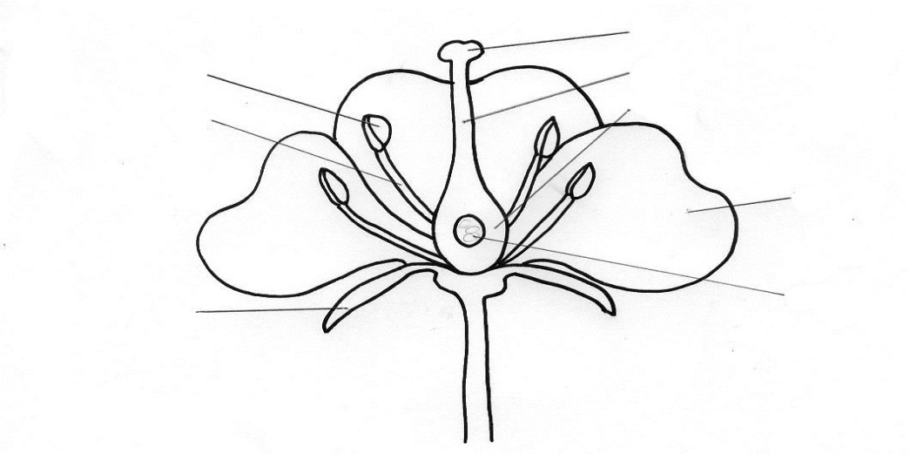
Label the parts of the flower on the diagram below:
4 carpel
2 style
1 stigma
stamen 9
anther 7
3 ovary
filament 8
5 petal

6 ovule
sepal 10

Complete the table with the name of the part of the flower that does each function:
Function | Part of flower
Contains the female sex cells | Ovary
Produces the male sex cells (pollen) | Anther
The female part of the flower that collects the pollen grains | Stigma
Gives protection to the flower when in bud | Sepals

Pollination and Fertilisation
Explain the difference between self-pollination and cross pollination.
Self-pollination - the pollen grain is transferred from the anther to the stigma of the SAME plant.
Cross pollination - the pollen is transferred from the anther of one plant to the stigma of another plant.

In the boxes below, draw a diagram of a typical insect pollinated flower and a wind pollinated flower. Label each feature and explain how each help with successful pollination.
WIND POLLINATED FLOWER INSECT POLLINATED FLOWER
Flower drawn and annotated showing:
Large petals
Brightly coloured
Scented
Short strong anther
Nectar produced
Sticky stigma
Flower drawn and annotated showing:
Small petals
Not coloured/dull
Not scented
Anthers loosely attached
Anthers and stigma hang out of flower
Feathery-like stigma

If bees became extinct or were greatly reduced in number as a result of pesticide overuse, explain what may happen as a result. Include the effect on the ecosystem and the effect to our food security.
Ecosystem - any predators of the bee will likely decrease in number and may have a knock-on effect on its predators/other prey. Other insects in competition with the bee may increase in numbers. If there are fewer pollinators, there may be fewer berries, fruits and future plants for other animals in the habitat to feed on, so they may decrease in number.
Food security - if there are no other insects to take the place of the bees (if they also have been killed by the pesticide) crop yields will be much reduced, therefore less food available both from the crop directly and as food products made from the crop. As a result lower food security.

Pollen grains land on a stigma. A pollen tube grows out of the pollen grain and grows down through the style into the ovary. The nucleus from the pollen moves down the tube to join with the nucleus of the ovule. The ovary turns into a fruit and inside it the ovule grows into a seed.

Learner Task 1.2
Diet, genetics and health
For each statement decide if it is true or false and write T or F next to the statement.
T
T
1. If you take in more energy than you use up, you will put on weight.
F
2. Obesity can lead to high blood pressure, heart disease and lung cancer.
Lung cancer is not linked to obesity.
3. Slow growth, increased risk of infection and irregular periods are symptoms of starvation.
F
4. A deficiency of vitamin C can cause rickets.
Vitamin C deficiency causes scurvy.
T
5. Tar in cigarettes contains carcinogens (substances that cause cancer).
F
6. Smoking does not have an effect on a person’s chance of getting heart disease.
There is evidence that smoking can increase blood pressure as carbon monoxide prevents as much oxygen binding to haemoglobin and nicotine effects elasticity of blood vessels, reducing blood flow. Tobacco smoke also reduces good cholesterol in the blood, increasing the risk of an atheroma.
F
7. All legal drugs are good for your body.
In certain doses they may be, however in large amounts, numerous 'over the counter' and prescribed drugs can have harmful, even deadly, effects.
T
F
8. Alcohol is a depressant.
9. DNA is made up of chromosomes.
Chromosomes are made up of DNA.
T
10. A gene is a short section of DNA.
F
11. A human body cell is made up of 46 pairs of chromosomes.
They are made up of 46 (or 23 pairs) of chromosomes.
F
12. Characteristics such as height and cancer are caused by genes alone.
Both of these characteristics are caused by genes AND environment.
We’d like to know your view on the resources we produce. By clicking on ‘Like’ or ‘Dislike’ you can help us to ensure that our resources work for you. When the email template pops up please add additional comments if you wish and then just click ‘Send’. Thank you.
If you do not currently offer this OCR qualification but would like to do so, please complete the Expression of Interest Form which can be found here: www.ocr.org.uk/expression-of-interest
OCR Resources: the small print
OCR’s resources are provided to support the teaching of OCR specifications, but in no way constitute an endorsed teaching method that is required by the Board, and the decision to use them lies with the individual teacher. Whilst every effort is made to ensure the accuracy of the content, OCR cannot be held responsible for any errors or omissions within these resources.
© OCR 2015 - This resource may be freely copied and distributed, as long as the OCR logo and this message remain intact and OCR is acknowledged as the originator of this work.
OCR acknowledges the use of the following content: n/a
Please get in touch if you want to discuss the accessibility of resources we offer to support delivery of our qualifications: resources.feedback@ocr.org.uk

Checkpoint Task

Global Challenges

Learner Activity (F)

Learner Task 1.1
Parts of a flower
Use the words below to label the parts of the flower on the diagram:
4
6
5
3
2
1
9
7
8

10

ovule anther carpel ovary stamen style
sepal filament stigma petal

Complete the table with the name of the part of the flower that does each function:
Function | Part of flower
Contains the female sex cells
Produces the male sex cells (pollen)
The female part of the flower that collects the pollen grains
Gives protection to the flower when in bud

Pollination and Fertilisation
Explain the difference between self-pollination and cross pollination.

In the boxes below, draw a diagram of a typical insect pollinated flower and a wind pollinated flower. Label each feature and explain how each help with successful pollination.
WIND POLLINATED FLOWER INSECT POLLINATED FLOWER

If bees became extinct or were greatly reduced in number as a result of pesticide overuse, explain what may happen as a result. Include the effect on the ecosystem and the effect to our food security.

Complete the paragraph explaining how fertilisation occurs in a flower:

Pollen grains land on a s____________. A p____________ t_______ grows out of the pollen grain and grows down through the s______________ into the ovary. The n___________ from the pollen moves down the tube to join with the nucleus of the o__________ .The ovary turns into a fruit and inside it the ovule grows into a s_______.

Learner Task 1.2
Diet, genetics and health
For each statement decide if it is true or false and write T or F next to the statement.
Correct any statements that are false.

- If you take in more energy than you use up, you will put on weight.

- Obesity can lead to high blood pressure, heart disease and lung cancer.

- Slow growth, increased risk of infection and irregular periods are symptoms of starvation.

- A deficiency of vitamin C can cause rickets.

- Tar in cigarettes contains carcinogens (substances that cause cancer).

- Smoking does not have an effect on a person’s chance of getting heart disease.

- All legal drugs are good for your body.

- Alcohol is a depressant.

- DNA is made up of chromosomes.

- A gene is a short section of DNA.

- A human body cell is made up of 46 pairs of chromosomes.

- Characteristics such as height and cancer are caused by genes alone.

Checkpoint Task (H)

Global Challenges

Learner Activity

Learner Task 1.1
Parts of a flower
Label the parts of the flower on the diagram below:
1
2
3
5
6
10
8
7
4
9

Complete the table with the function of each of the flower parts named:
Function | Part of flower
 | Ovary
 | Anther
 | Stigma
 | Sepals

Pollination and Fertilisation
Explain the difference between self-pollination and cross pollination.

In the boxes below, draw a diagram of a typical insect pollinated flower and a wind pollinated flower. Label each feature and explain how each help with successful pollination.
WIND POLLINATED FLOWER INSECT POLLINATED FLOWER

If bees became extinct or were greatly reduced in number as a result of pesticide overuse, explain what may happen as a result. Include the effect on the ecosystem and the effect to our food security.

Write a short paragraph explaining the stages of fertilisation in a flower.

Learner task 1.2
Diet, genetics and health
For each statement decide if it is true or false and write T or F next to the statement.
Correct any statements that are false.

- If you take in more energy than you use up, you will put on weight.

- Obesity can lead to high blood pressure, heart disease and lung cancer.

- Slow growth, increased risk of infection and irregular periods are symptoms of starvation.

- A deficiency of vitamin C can cause rickets.

- Tar in cigarettes contains carcinogens (substances that cause cancer).

- Smoking does not have an effect on a person’s chance of getting heart disease.

- All legal drugs are good for your body.

- Alcohol is a depressant.
- DNA is made up of chromosomes.

- A gene is a short section of DNA.

- A human body cell is made up of 46 pairs of chromosomes.

- Characteristics such as height and cancer are caused by genes alone.

