Lesson Element

Space Farm

Instructions and answers for teachers

These instructions cover the learner activity section which can be found on page 6. This Lesson Element supports OCR GCSE (9–1) Gateway Science Biology A and the Twenty First Century Science Biology B qualifications.
When distributing the activity section to the learners either as a printed copy or as a Word file you will need to remove the teacher instructions section.

Mapping to specification level (Learning outcomes)
GCSE (9–1) Gateway Science Biology A/Combined Science A
B1.4a describe photosynthetic organisms as the main producers of food and therefore biomass for life on Earth
B1.4b describe the process of photosynthesis
B1.4c describe photosynthesis as an endothermic reaction
B1.4d describe experiments to investigate photosynthesis
B1.4e e explain the effect of temperature, light intensity and carbon dioxide concentration on the rate of photosynthesis
B1.4f explain the interaction of these factors in limiting the rate of photosynthesis
GCSE (9–1) Twenty First Century Science Biology B/Combined Science B
B3.1.1 a) describe the process of photosynthesis, including the inputs and outputs of the two mains stages and the requirement of light in the first stage, and describe photosynthesis as an endothermic process
b) describe practical investigations into the requirements and products of photosynthesis
B3.1.2 explain how chloroplasts in plant cells are related to photosynthesis
B3.1.4 a) explain the effect of temperature, light intensity and carbon dioxide concentration on the rate of photosynthesis
b) describe practical investigations into the effect of environmental factors on the rate of photosynthesis

B3.1.5 use the inverse square law to explain changes in the rate of photosynthesis with distance from a light source
B3.1.6 . explain the interaction of temperature, light intensity and carbon dioxide concentration in limiting the rate of photosynthesis, and use graphs depicting the effects
B3.1.7 in the context of the rate of photosynthesis:
a) understand and use simple compound measures such as the rate of a reaction M1a, M1c
b) translate information between graphical and numerical form M4a
c) plot and draw appropriate graphs selecting appropriate scales for axes M4a, M4c
d) extract and interpret information from graphs, charts and tables

Introduction
This exercise aims to use class discussion, learner research, creative thinking and practical activities to explore the fundamental concepts of photosynthesis. This topic is linked to respiration, transport in plants, plant growth and nutrition. The activity addresses the difficulty learners have in remembering that plants do not just obtain nutrients from soil and that the process of photosynthesis uses light from the Sun and not heat. There is often confusion with the idea that plants are taking in and releasing gases during photosynthesis, and that this is not respiration or ‘breathing’. It is important to clarify the difference between respiration and photosynthesis with learners before undertaking this activity.

Notes for teachers
Learners will learn how plants make food, how they use glucose and how scientists plan to grow plants on the moon. Learners will use this information to design and build models of a system they would need to grow plants on the moon. These ideas can then be extended to cover intensive production of plants on the moon, how plants could be used to sustain other life forms on the moon and other experiments that could be carried out to further investigate photosynthesis.

Activity
Create a big introduction to the activity by showing learners some pictures of astronauts growing plants on board the space station or a short video clip about growing plants in space.

Suggested short video clips:
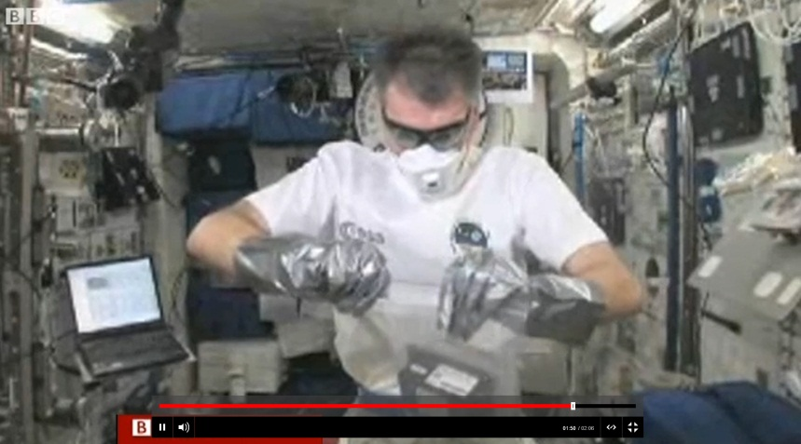
http://www.bbc.co.uk/news/science-environment-13852801
This two minute long clip is from 2011 but gives a good introduction to the activity by talking about the things needed for plants to grow, how they are grown in space and also the reasons for doing this.
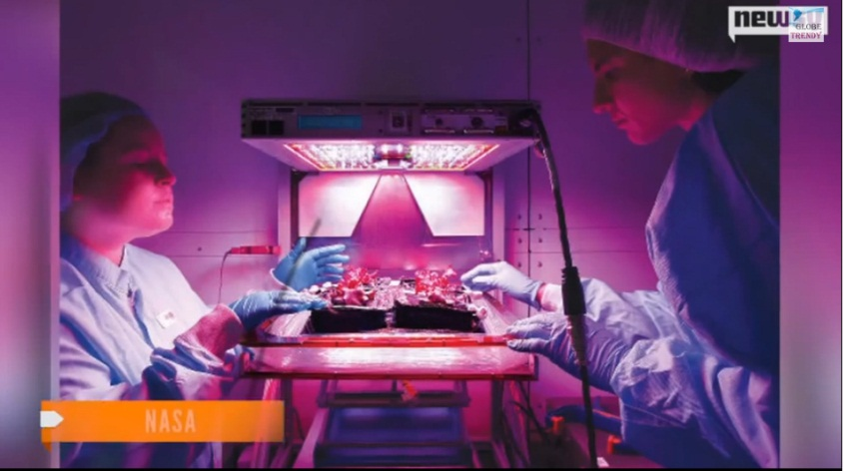
https://www.youtube.com/watch?v=gjr46xOT00A
This short clip contains good information on reasons for growing crops in space and how this is achieved.
- Use the introductory images or video clips to discuss with learners their ideas on why scientists experiment with growing plants in space or on the moon.
- Introduce learners to the aims of the Space Farm activity on the Learner Task Sheet. They need to undertake research in groups and work through the Learner Task Sheet. Working together they should design a moon greenhouse.
- This activity can be a group activity that is then peer assessed on its merits and improvements that can be made.
Provide learners with access to information on photosynthesis including commercial crop production, either through text books, printed articles or access to the internet.

Suggested information for learners:
http://www.independent.co.uk/life-style/gadgets-and-tech/nasa-to-grow-plants-on-the-moon-by-2015-if-they-can-thrive-we-probably-can-too-8972642.html
http://www.dailymail.co.uk/sciencetech/article-2515480/Nasa-grow-PLANTS-moon-Space-agency-sow-seeds-humans-day-live-Earths-neighbour.html
http://www.telegraph.co.uk/science/space/10483133/Nasa-to-send-seeds-to-Moon-to-grow-lunar-salad.html

Suggested items to use to build models:
- Clear plastic empty drinks bottles
- Drinking straws
- Plastic tubing
- small cardboard boxes
- lollipop sticks
- Thin sheets of sponge or cotton wool
- Coloured card and paper
- Yoghurt pots
- Tin foil
- Sticky tape
- Modelling clay

Extension ideas
Learners could undertake further research into the following areas:
Why are insoluble substances such as starch used for storage?
Provide learners with graphs to show limiting factors of photosynthesis. Ask learners to use the graphs to explain the effects of limiting factors on the rate of photosynthesis.
Why do plants take in carbon dioxide and give out oxygen during the day and do the reverse at night, in terms of both photosynthesis and respiration?

Supporting information
Ensure that you have a good understanding of respiration and photosynthesis. The recycling of carbon may come up during discussion with learners.

We’d like to know your view on the resources we produce. By clicking on ‘Like’ or ‘Dislike’ you can help us to ensure that our resources work for you. When the email template pops up please add additional comments if you wish and then just click ‘Send’. Thank you.
Whether you already offer OCR qualifications, are new to OCR, or are considering switching from your current provider/awarding organisation, you can request more information by completing the Expression of Interest form which can be found here: www.ocr.org.uk/expression-of-interest
Looking for a resource? There is now a quick and easy search tool to help find free resources for your qualification:
www.ocr.org.uk/i-want-to/find-resources/

OCR Resources: the small print
OCR’s resources are provided to support the delivery of OCR qualifications, but in no way constitute an endorsed teaching method that is required by the Board, and the decision to use them lies with the individual teacher. Whilst every effort is made to ensure the accuracy of the content, OCR cannot be held responsible for any errors or omissions within these resources.
© OCR 2017 - This resource may be freely copied and distributed, as long as the OCR logo and this message remain intact and OCR is acknowledged as the originator of this work.
OCR acknowledges the use of the following content: n/a
Please get in touch if you want to discuss the accessibility of resources we offer to support delivery of our qualifications: resources.feedback@ocr.org.uk

Lesson Element

Space Farm

Learner Activity
1 Give two reasons why NASA plans to grow plants on the moon?

2 What is needed for plants to photosynthesise and grow on the moon?

3 Give the word and symbol equation for photosynthesis?

4 How do plants use glucose?

5 Temperatures on the surface of the Moon can vary wildly – reaching more than 100°C during the day and growing as cold as -173°C at night. Suggest a reason why plants will need to be kept a stable temperature? Try to include ideas about how temperature affects photosynthesis (remember photosynthesis is a chemical reaction!).

6 Suggest what other two factors affect the rate of photosynthesis.

7 Draw a labelled plan of your moon greenhouse make sure you include details of what your plant will grow in and on. How you will provide the plant with what it needs for photosynthesis?

8 How will you monitor the conditions your plant is in and if it is growing?

9 Make and label your model.
Congratulations your plants are growing on the moon!

Evaluate
1 How could your design be improved?

2 How could you use your knowledge of methods of commercial crop growing to maximise your crop production on the moon?

3 Suggest how your model could be developed to support other life on the moon?

