Lesson Element

Negative Feedback

Instructions and answers for teachers

These instructions cover the learner activity section which can be found on page 11. This Lesson Element supports OCR GCSE (9–1) Gateway Science Biology A and the Twenty First Century Science Biology B qualifications.
When distributing the activity section to the learners either as a printed copy or as a Word file you will need to remove the teacher instructions section.

Mapping to specification level (Learning outcomes)
GCSE (9–1) Gateway Science Biology A/Combined Science A
B3.2b explain the roles of thyroxine and adrenaline in the body
B3.3i describe the effect of ADH on the permeability of the kidney tubules

GCSE (9–1) Twenty First Century Science Biology B/Combined Science B
B5.4.3 explain the response of the body to different temperature challenges, including receptors, processing, responses and negative feedback (separate science only)
B5.4.7 explain the response of the body to different osmotic challenges, including receptors, processing, response, and negative feedback (separate science only)
B5.3.2 explain the roles of thyroxine and adrenaline in the body, including thyroxine as an example of a negative feedback system

Activity 1
Introduces the idea of negative feedback and exemplifies it using temperature control in mammals and birds. It is a literacy based activity where learners have to extract information from text to complete the feedback diagram on Learner Task Sheet 1.

Activity 2
Picture relay, from maps from memory based on water balance in the body. The learners are provided with a blank outline of the human body showing the brain and urinary system such as the one on Learner Task Sheet 2. The teacher has an A3 copy of the full diagram including the annotation. Learners should be in groups of 3 or 4. The first learner from each group looks at the teacher copy for about 1 minute and then goes back to their group and tells them what to add to the outline. After 2 minutes the next learner from each group is allowed to view the teacher copy for 45 seconds and returns to the group to add to the diagram. The final member of the group is allowed to view the teacher copy for 30 seconds and the diagram should be completed. The completed diagram could then be used as the basis for further questioning.

Extension ideas
This is a more challenging worksheet and looks at blood sugar level with reference to diabetes. Prior teaching about the control of blood sugar levels and diabetes is required.

Suggested answers to Learner Task Sheet 1
Negative feedback is the action taken by the body to return something to a normal / optimum level following a deviation from that level.t. It is how the body keeps conditions within it constant at the optimum level (homeostasis).
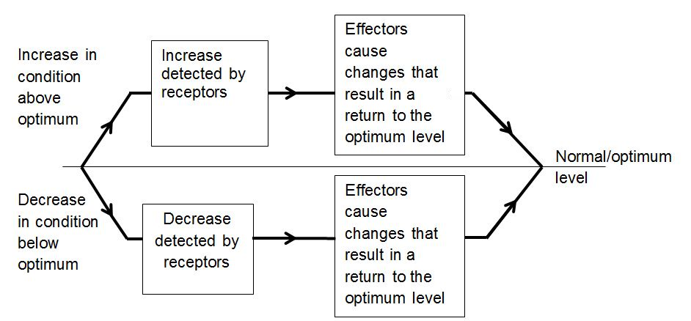

Body temperature in birds and mammals is kept constant by a negative feedback system.
Read the passage below and on the following page and use the information to complete the blank negative feedback diagram.
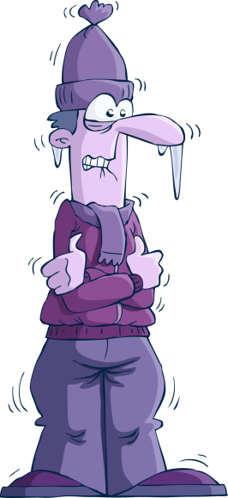
Core body temperature remains constant no matter what the temperature of the surroundings or the activity level of the individual. This is important so that enzymes have optimum conditions to work in and so the reactions that they control can be carried out efficiently.
Changes in the temperature of the blood are detected by receptors in a part of the brain called the hypothalamus and there are receptors in the skin which also send information to the hypothalamus about the temperature of the skin surface.

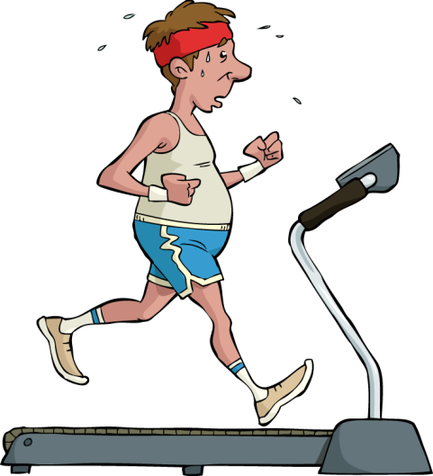
If receptors in the hypothalamus detect that the temperature has fallen then impulses are sent to different effectors.
- The muscles at the bottom of the skin hairs or feathers are raised by small muscles to trap a layer of air near the. Air is an insulator so this helps to keep heat in.
- Involuntarily muscle contraction starts, called shivering. This produces more heat due to an increase in the rate of respiration, which warms the surrounding tissues.
- The blood vessels leading to the skin constrict (get smaller) so that less blood then flows through these capillaries reducing heat loss from the skin. This is called vasoconstriction.
These changes cause the body temperature to rise and return to the optimum level.

Now complete the diagram below
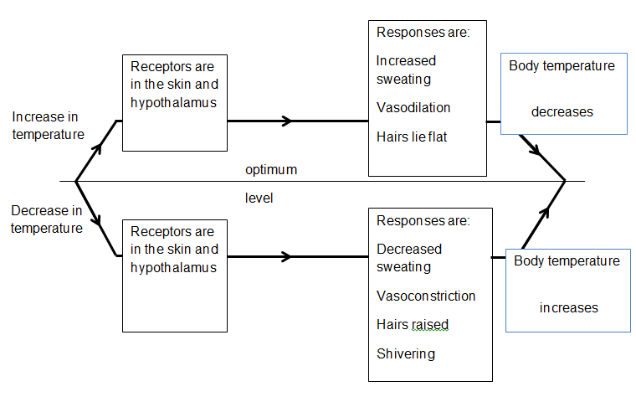

Learner Task Sheet 2

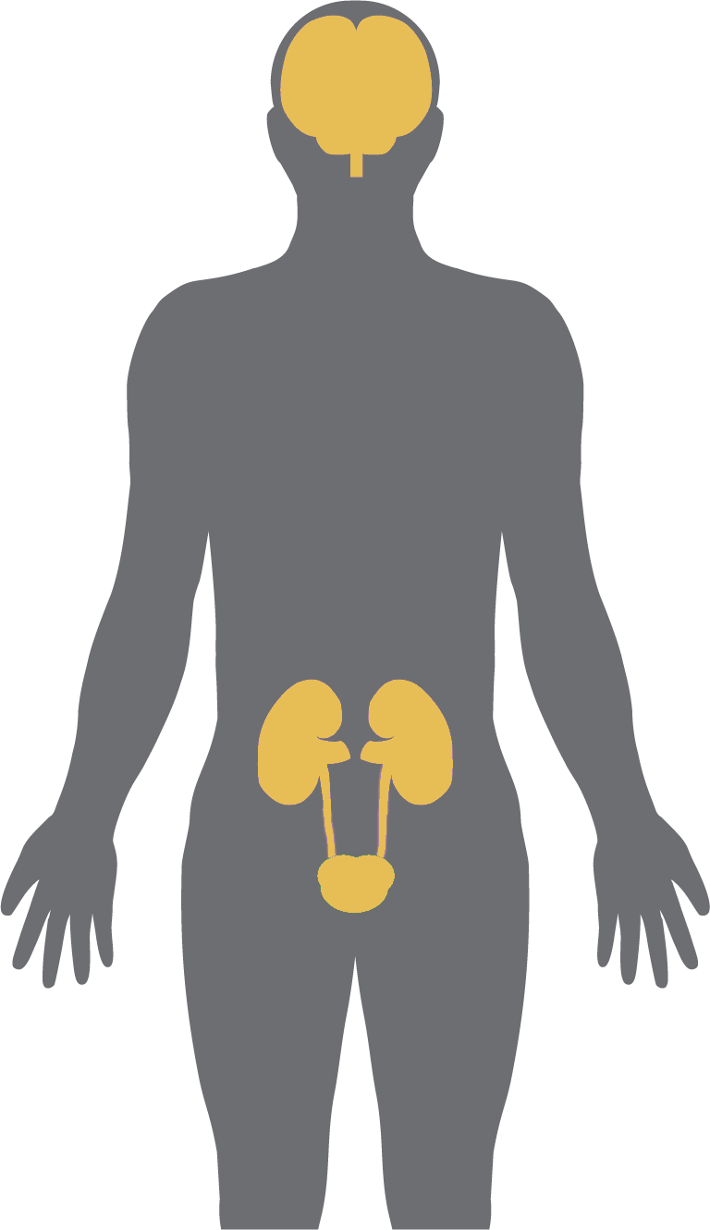
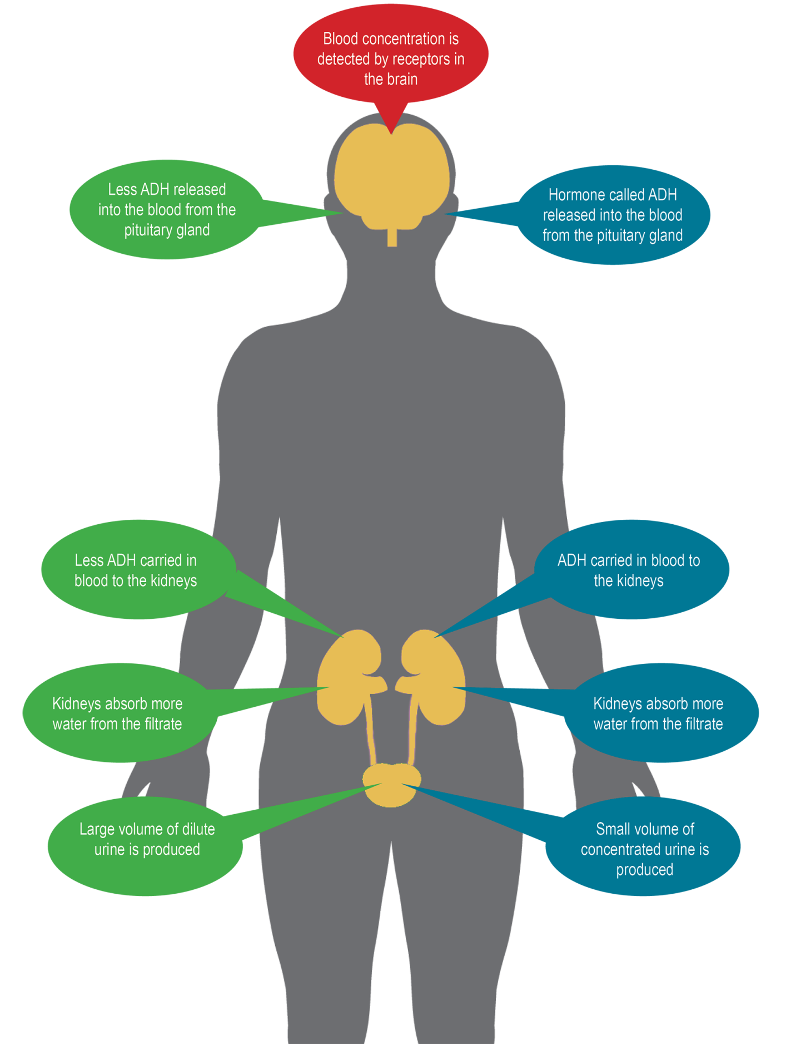
Suggested answers to the extension activity
Blood too
concentrated
Blood too dilute

Diabetes is becoming more common. It is caused when the pancreas makes too little insulin. Insulin increases the uptake of glucose from the blood into the cells of the muscles and liver where it is converted into glycogen for storage.
The graph shows the blood glucose concentration for two people both given a high glucose meal.
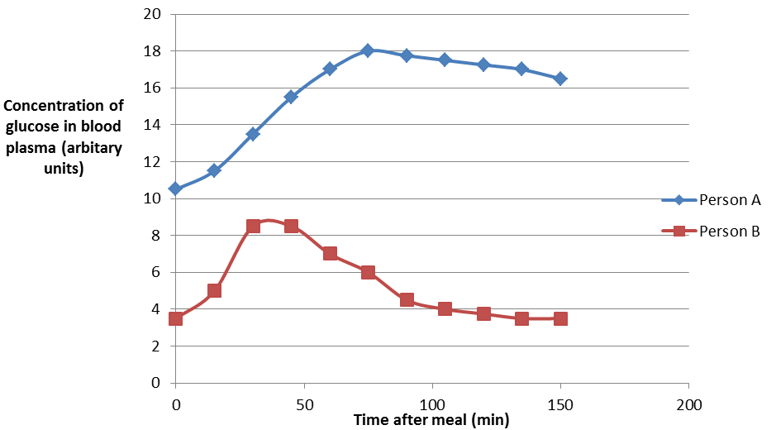
One person suffers from diabetes.
Which person is it?
Person A

Explain why you have selected that person.
They have higher level of glucose in their blood plasma after the meal
Their blood glucose level only slowly goes down and does not return to the original level

Use the graph to explain why blood glucose concentration is an example of negative feedback.
The level of blood sugar goes up and then returns to the same level as before the meal

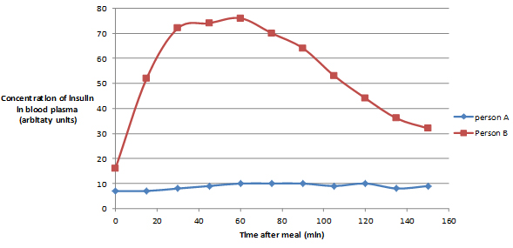
Draw a line on the graph showing the concentration of insulin for person A.
Credit as long as it is:
- Significantly below the level of person B
- It does not go up substantially

Explain why you have put it in that position.
Someone with diabetes does not increase the amount of insulin produced when blood sugar goes up and/or the blood sugar does not go down very much so there can’t be a lot of insulin produced

Using information from both graphs explain why the blood glucose level fell in person B.
- As the blood glucose level increased in Person B so did the amount of insulin produced
- Insulin promotes the uptake of glucose by liver and muscle cells
- Where it is converted into glycogen
- Hence the reduction in blood glucose level

Another hormone called glucagon has the opposite effect to insulin in that it changes glycogen into glucose. Produce a diagram to show how insulin and glucagon work to maintain a constant blood glucose level by negative feedback.
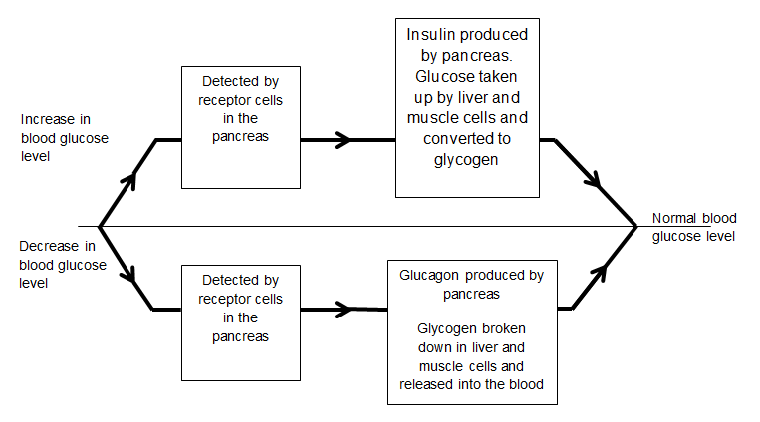

Further Extension Activities
TES site
For middle ability:
http://www.tes.co.uk/teaching-resource/BINGO-starter-plenary-3002695/
For lower ability:
http://www.tes.co.uk/teaching-resource/Homeostasis-worksheet-6013583/
Revision sheet:
http://www.tes.co.uk/teaching-resource/Summary-notes-for-homeostasis-6055725/
Abpi has some interesting resources both at 14-16 and some for 16-18 which might be useful as extension work.
Blood sugar
http://www.abpischools.org.uk/page/modules/hormones/horm6.cfm?coSiteNavigation_allTopic=1
Water balance
http://www.abpischools.org.uk/page/modules/homeostasis_kidneys/kidneys6.cfm?coSiteNavigation_allTopic=1
OCR Resources: the small print
OCR’s resources are provided to support the teaching of OCR specifications, but in no way constitute an endorsed teaching method that is required by the Board, and the decision to use them lies with the individual teacher. Whilst every effort is made to ensure the accuracy of the content, OCR cannot be held responsible for any errors or omissions within these resources.
© OCR 2014 - This resource may be freely copied and distributed, as long as the OCR logo and this message remain intact and OCR is acknowledged as the originator of this work.

OCR acknowledges the use of the following content: Maths and English icons: Air0ne/Shutterstock.com, Page 3 Shivering cartoon and Page 4 Exercising cartoon dedMazay/Shutterstock.com, Page 5 and Page 6 Human body image (modified) Turovsky/Shutterstock.com

We’d like to know your view on the resources we produce. By clicking on ‘Like’ or ‘Dislike’ you can help us to ensure that our resources work for you. When the email template pops up please add additional comments if you wish and then just click ‘Send’. Thank you.
Whether you already offer OCR qualifications, are new to OCR, or are considering switching from your current provider/awarding organisation, you can request more information by completing the Expression of Interest form which can be found here: www.ocr.org.uk/expression-of-interest
Looking for a resource? There is now a quick and easy search tool to help find free resources for your qualification:
www.ocr.org.uk/i-want-to/find-resources/

OCR Resources: the small print
OCR’s resources are provided to support the delivery of OCR qualifications, but in no way constitute an endorsed teaching method that is required by the Board, and the decision to use them lies with the individual teacher. Whilst every effort is made to ensure the accuracy of the content, OCR cannot be held responsible for any errors or omissions within these resources.
© OCR 2017 - This resource may be freely copied and distributed, as long as the OCR logo and this message remain intact and OCR is acknowledged as the originator of this work.
OCR acknowledges the use of the following content: Page 3 Shivering cartoon and Page 4 Exercising cartoon dedMazay/Shutterstock.com, Page 5 and Page 6 Human body image (modified) Turovsky/Shutterstock.com
Please get in touch if you want to discuss the accessibility of resources we offer to support delivery of our qualifications: resources.feedback@ocr.org.uk

Lesson Element

Negative Feedback

Learner Activity

Student Task Sheet 1
Negative feedback is the action taken by the body to return something to a normal / optimum level following a deviation from that level.. It is how the body keeps conditions within it constant at the optimum level (homeostasis).
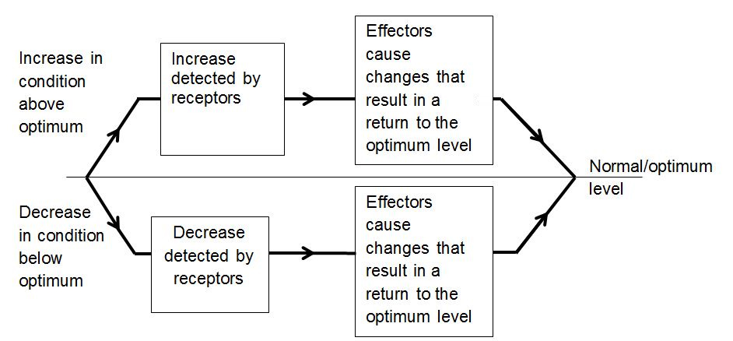
Body temperature in birds and mammals is kept constant by a negative feedback system.
Read the passage below and on the next page and use the information to complete the blank negative feedback diagram.
Core body temperature remains constant no matter what the temperature of the surroundings or the activity level of the individual. This is important so that enzymes have optimum conditions to work in and so the reactions that they control can be carried out efficiently.
Changes in the temperature of the blood are detected by receptors in a part of the brain called the hypothalamus and there are receptors in the skin which also send information to the hypothalamus about the temperature of the skin surface.
If receptors in the hypothalamus detect that the temperature has fallen then impulses are sent to different effectors.
- The muscles at the bottom of the skin hairs or feathers are raised by small muscles to trap a layer of air near the. Air is an insulator so this helps to keep heat in.
- Involuntarily muscle contraction starts called shivering. This produces more heat due to an increase in the rate of respiration, which warms the surrounding tissues.
- The blood vessels leading to the skin constrict (get smaller) so that less blood then flows through these capillaries reducing heat loss from the skin. This is called vasoconstriction.
These changes cause the body temperature to rise and return to the optimum level.

Now complete the diagram below
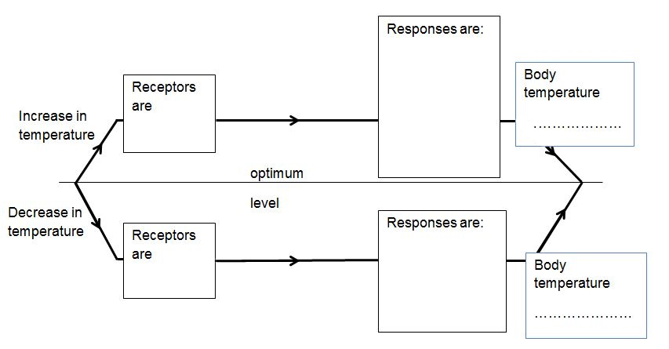

Student Task Sheet 2

Extension: Control of Blood Sugar

Diabetes is becoming more common. It is caused when the pancreas makes too little insulin. Insulin increases the uptake of glucose from the blood into the cells of the muscles and liver where it is converted into glycogen for storage.
The graph shows the blood glucose concentration for two people both given a high glucose meal.
One person suffers from diabetes.
Which person is it?

Explain why you have selected that person.

Use the graph to explain why blood glucose concentration is an example of negative feedback.
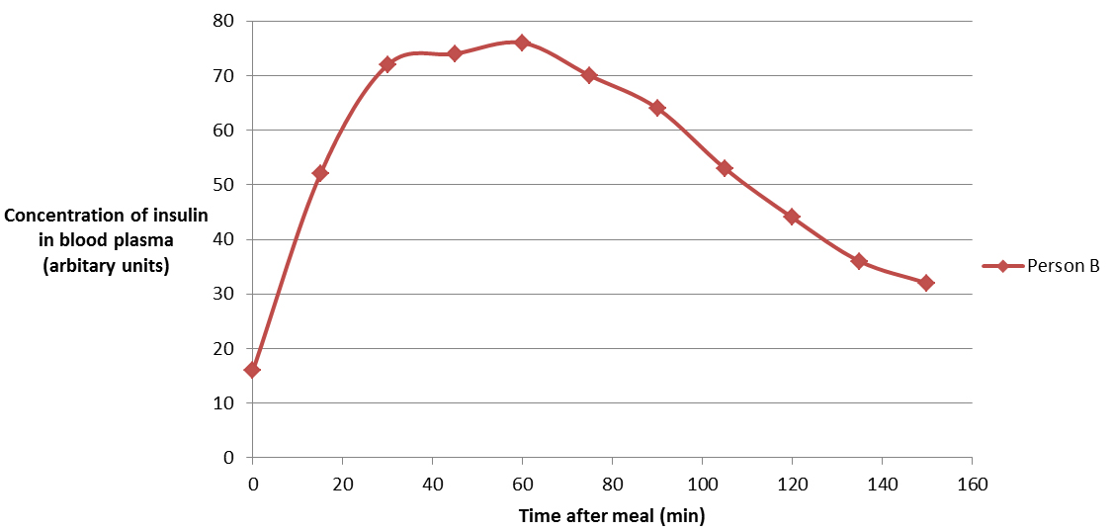
Draw a line on the graph showing the concentration of insulin for person A.
Explain why you have put it in that position.
Using information from both graphs explain why the blood glucose level fell in person B.

Another hormone called glucagon has the opposite effect to insulin in that it changes glycogen into glucose. Produce a diagram to show how insulin and glucagon work to maintain a constant blood glucose level by negative feedback.

