# OCR 08 Basic Geometry (Higher)

1. A quadrilateral has two pairs of parallel opposite sides. Its diagonals intersect at 90°.

Write the name of this shape.

1. Which of these shapes are regular polygons?

60°

**A**

**Not to scale**

**C**

**B**

60°

60°

1. Find the size of angle *a*.

*a*

**Not to scale**

1. Calculate the exterior angle of a regular octagon.
2. Quadrilateral KLMN is inscribed in a circle.

Calculate the size of angle *x*.

L

92°

64°

K

**Not to scale**

*x*

N

M

1. This 3D shape is an L-shaped prism.

Write down the number of edges, faces and vertices the shape has.

1. Which of these shapes have exactly two lines of symmetry **and** rotational symmetry of order 2?

**D**

**E**

**A**

**G**

**C**

**B**

**H**

**F**

**I**

1. This shape is made from 7 cubes.

Draw its plan view.

1. This is a regular 20-sided polygon.

Calculate the size of angle *a*.

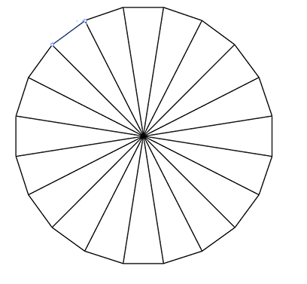

*a*

1. XY is a tangent to the circle at point P.

Calculate the angle QPY.

R

Q

Y

P

X

75°

50°

**Not to scale**

1. Draw a labelled diagram where

* point B is 4 cm from point A,
* C is equidistant from point A and point B,
* C is on a bearing of 215° from point B.

1. AB and BC are tangents to a circle with centre O. They meet the circle at P and Q respectively. POQ is a right angle. Prove that POQB is a square.

C

A

O

**Not to scale**

Q

P

B

1. P, Q, R and S are points on the circumference of a circle. PR meets QS at A.

Prove that angle QPR is equal to 47°.

P

77°

Q

R

**Not to scale**

56°

A

S

1. This shape is a regular tetrahedron. It is has four identical triangular faces.

Kit says “A regular tetrahedron is also a pyramid”.

Is Kit correct? Give a reason for your decision.

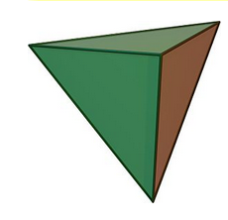

1. This is the plan of three different **cubes** on a flat surface.

Draw a side view looking along the arrow from X.

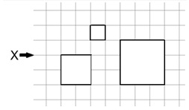

1. In triangle ABC, AB  AC.

Find an expression for *x* in terms of *b*.

A

*b*

**Not to scale**

D

*x*

C

B

1. The diagram shows a cross inscribed in a regular 10-sided polygon.

Find the size of angle *k*.

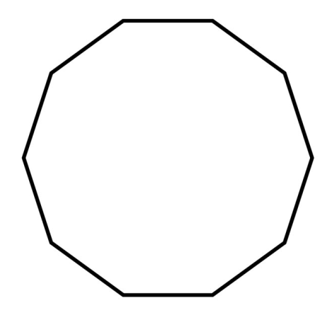

*k*

1. Three villages Princetown, Queensbury and Kingsham are joined by straight roads. Queensbury is 5 miles from Princetown on a bearing of 010°. Kingsham is 5 miles from Princetown on a bearing of 090°. Construct an accurate diagram to show the locus of points that are

* nearer to the road between Princetown and Queensbury than to the road between Princetown and Kingsham,
* less than four miles from Princetown.

Use a scale of 1 cm : 1 mile.

1. AB, CD and PQ are straight lines.

What value of *x* makes AB and CD parallel?

A

B

C

D

P

Q

(4*x* − 3)°

(3*x* + 8)°

(5*x* − 42)°

1. A square is drawn on a coordinate grid.

After the square is translated through , its vertices are the points

(5, 1), (1, 5), (-3, 1) and (1, -3).

Find the coordinates of the **centre** of the original square.

### Answers

1. Rhombus or square
2. B, C
3. 45°
4. 45°
5. 116°
6. 18 edges, 8 faces, 12 vertices
7. A, B, C, F
8. 20-sided polygon so angles at centre are 18°.

 (isosceles triangle)

1. PRQ  55° (angles in triangle sum to 180°)

QPY  55° (alternate segment theorem)

215°

4 cm

N

B

A

C

1.  (radius meeting tangent) so POQB has 4 right angles.

 so POQB is a square.

1.  (opposite angles)

so  (angles in a triangle sum to 180°)

 (angles in the same segment).

1. Yes, it is a triangle-based pyramid with triangular faces meeting at the apex.

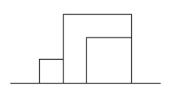

1.  (angles on a straight line sum to 180°)

 (angles in a triangle (BDC) sum to 180°)

 (alternate angles)

 (angles in a triangle (DAB) sum to 180°)

 (isosceles triangle)





*k*

*k°*

*k* is half the interior angle of the polygon (144°) so  (see diagram).

Alternatively, work out angles in pentagon that contains *k*: 



N

10°

P

K

Q

4 cm

1 cm

1.  (corresponding angles are equal when AB and CD are parallel)

so.

1. Centre of square is (1, 1) so original square had centre (3, -2).

**OCR Resources**: *the small print*OCR’s resources are provided to support the delivery of OCR qualifications, but in no way constitute an endorsed teaching method that is required by the Board, and the decision to use them lies with the individual teacher. Whilst every effort is made to ensure the accuracy of the content, OCR cannot be held responsible for any errors or omissions within these resources. This formative assessment resource has been produced as part of our free GCSE teaching and learning support package. All the GCSE teaching and learning resources, including delivery guides, topic exploration packs, lesson elements and more are available on the qualification webpages. If you are looking for examination practice materials, you can find Sample Assessment Materials (SAMs) and Practice Papers on the qualification webpage <http://www.ocr.org.uk/qualifications/gcse-mathematics-j560-from-2015/>

© OCR 2017 - This resource may be freely copied and distributed, as long as the OCR logo and this message remain intact and OCR is acknowledged as the originator of this work.

OCR acknowledges the use of the following content: n/a

Please get in touch if you want to discuss the accessibility of resources we offer to support delivery of our qualifications: [resources.feedback@ocr.org.uk](mailto:resources.feedback@ocr.org.uk)

We’d like to know your view on the resources we produce. By clicking on ‘[Like](mailto:resources.feedback@ocr.org.uk?subject=I%20liked%20the%20GCSE%20(9-1)%20Mathematics%20Check%20In%2008%20Higher)’ or ‘[Dislike](mailto:resources.feedback@ocr.org.uk?subject=I%20disliked%20the%20GCSE%20(9-1)%20Mathematics%20Check%20In%2008%20Higher)’ you can help us to ensure that our resources work for you. When the email template pops up please add additional comments if you wish and then just click ‘Send’. Thank you.

Whether you already offer OCR qualifications, are new to OCR, or are considering switching from your current provider/awarding organisation, you can request more information by completing the Expression of Interest form which can be found here: [www.ocr.org.uk/expression-of-interest](http://www.ocr.org.uk/expression-of-interest)

Looking for a resource? There is now a quick and easy search tool to help find free resources for your qualification:   
[www.ocr.org.uk/i-want-to/find-resources/](http://www.ocr.org.uk/i-want-to/find-resources/)

| **Assessment Objective** | **Qu.** | **Topic** | **R** | **A** | **G** |  | **Assessment Objective** | **Qu.** | **Topic** | **R** | **A** | **G** |
| --- | --- | --- | --- | --- | --- | --- | --- | --- | --- | --- | --- | --- |
| AO1 | 1 | Know basic properties of quadrilaterals |  |  |  |  | AO1 | 1 | Know basic properties of quadrilaterals |  |  |  |
| AO1 | 2 | Know properties of regular polygons |  |  |  |  | AO1 | 2 | Know properties of regular polygons |  |  |  |
| AO1 | 3 | Apply angles subtended at centre and circumference |  |  |  |  | AO1 | 3 | Apply angles subtended at centre and circumference |  |  |  |
| AO1 | 4 | Use the sum of exterior angles of a polygon |  |  |  |  | AO1 | 4 | Use the sum of exterior angles of a polygon |  |  |  |
| AO1 | 5 | Apply opposite angles of a cyclic quadrilateral are supplementary |  |  |  |  | AO1 | 5 | Apply opposite angles of a cyclic quadrilateral are supplementary |  |  |  |
| AO1 | 6 | Recognise terms relating to polyhedra |  |  |  |  | AO1 | 6 | Recognise terms relating to polyhedra |  |  |  |
| AO1 | 7 | Identify reflection and rotation symmetries |  |  |  |  | AO1 | 7 | Identify reflection and rotation symmetries |  |  |  |
| AO1 | 8 | Construct plans of 3D solids from elevations |  |  |  |  | AO1 | 8 | Construct plans of 3D solids from elevations |  |  |  |
| AO1 | 9 | Apply angle facts to find angles in rectilinear figures |  |  |  |  | AO1 | 9 | Apply angle facts to find angles in rectilinear figures |  |  |  |
| AO1 | 10 | Apply alternate segment theorem |  |  |  |  | AO1 | 10 | Apply alternate segment theorem |  |  |  |
| AO2 | 11 | Draw diagrams from written descriptions |  |  |  |  | AO2 | 11 | Draw diagrams from written descriptions |  |  |  |
| AO2 | 12 | Apply angle between radius and tangent |  |  |  |  | AO2 | 12 | Apply angle between radius and tangent |  |  |  |
| AO2 | 13 | Apply angles in the same segment |  |  |  |  | AO2 | 13 | Apply angles in the same segment |  |  |  |
| AO2 | 14 | Know properties of 3D solids |  |  |  |  | AO2 | 14 | Know properties of 3D solids |  |  |  |
| AO2 | 15 | Construct elevations of 3D solids from plans |  |  |  |  | AO2 | 15 | Construct elevations of 3D solids from plans |  |  |  |
| AO3 | 16 | Apply angle properties in formal proofs |  |  |  |  | AO3 | 16 | Apply angle properties in formal proofs |  |  |  |
| AO3 | 17 | Apply angle facts to find angles in rectilinear figures |  |  |  |  | AO3 | 17 | Apply angle facts to find angles in rectilinear figures |  |  |  |
| AO3 | 18 | Apply ruler and compass constructions to identify loci |  |  |  |  | AO3 | 18 | Apply ruler and compass constructions to identify loci |  |  |  |
| AO3 | 19 | Apply angle properties in more formal proofs |  |  |  |  | AO3 | 19 | Apply angle properties in more formal proofs |  |  |  |
| AO3 | 20 | Use *x*, *y* coordinates in plane geometry problems |  |  |  |  | AO3 | 20 | Use *x*, *y* coordinates in plane geometry problems |  |  |  |