# OCR 05 Ratio, Proportion and Rates of Change (Higher)

1. There are 12 inches in a foot. Write the ratio 3.5 feet : 14 inches in its simplest form.
2. Sam, Jenny and Lily share £54 in the ratio 1 : 2 : 3.

How much more money does Lily get than Sam?

1. Sam, Jenny and Lily again share £54, but this time in the ratio 2 : 3 : 4.

What fraction of the money does Jenny get?

1. Jack invests £500 for 5 years in an account paying 3.5% compound interest.

Calculate the amount in the account at the end of the 5 years.

1. Work out the single multiplier that is equivalent to an increase of 15% followed by a decrease of 20%.
2. Reece buys a new car costing £22 000. If it depreciates by 20% in the first year of ownership, 10% in the second year and then 15% in the third year, work out how much Reece’s car will be worth after three years.
3. Which two of the statements below represent a situation where *y* is inversely proportional to *x*?

A:  B:  C: 

D:  E:  F: 

1. This graph can be used to convert between New Zealand dollars and pounds.

Convert 30 New Zealand dollars to pounds.

Q8 graph

1. Silas drops a ball from a height of 3 m above the floor. The ball bounces on the floor and after each bounce rises to 50% of its previous height. What height will the ball rise to after the 4th bounce?
2.  and when , . Work out the value of *y* when , giving your answer as a fraction.
3. A recipe for 12 pancakes uses 110 g flour, 2 eggs, 200 ml milk and 50 g butter. Explain the problem you would face if you tried to convert this recipe to make just 8 pancakes.
4. Which of these graphs could represent ?

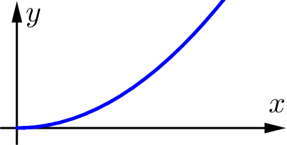 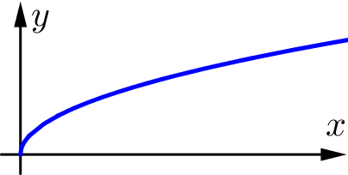 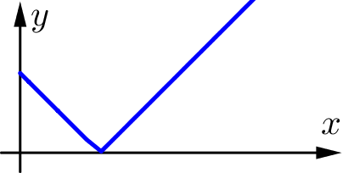 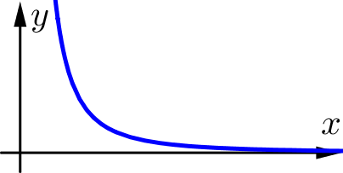

|  |  |  |  |
| --- | --- | --- | --- |
| A | B | C | D |

1. Explain why the graph below cannot represent a situation where .

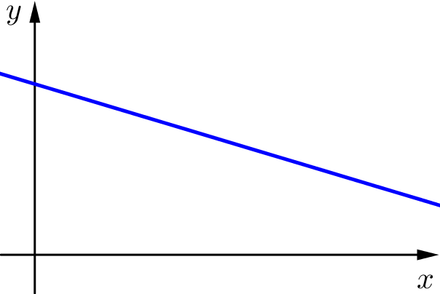

1. Determine if *y* is inversely proportional to *x* for the table of values below.

|  |  |  |  |
| --- | --- | --- | --- |
| *x* | 2 | 6 | 12 |
| *y* | 6 | 2 | 1 |

1. A planning officer is modelling the population of the town of Tessbourne. She uses the model  where *P* is the size of the population and *y* is the year. Describe the meaning of the numbers 7600 and 1.026 in the planning officer’s model.
2. A company experienced financial difficulties and cut its workers’ wages by 20%. When business improved, the company then reinstated the workers original wages. What is the percentage increase from the cut wage back to the original wage?
3. Karine wants to be able to give her son £10 000 on his 18th birthday. When her son is born she makes a one-off payment into an account that pays 3.2% compound interest each year. No withdrawals will be made from this account. What amount does the one-off payment need to be to result in a balance of £10 000 in 18 years’ time?
4. The time it takes for a pendulum to make one complete swing (returning to its starting point) is called its period. The period of a pendulum is directly proportional to the square root of its length. A 5 m long pendulum has a period of 4.5 seconds. Work out the period of a 15 m long pendulum.
5. Niki made a fruit salad out of strawberries, grapes and blueberries in the ratio 4 : 9 : 6. Chloe came along and ate 15 grapes from the fruit salad. After she did this, the ratio of fruit became

2 : 3 : 3. How many strawberries are in the fruit salad?

1. Given that , find the value of *k* and *n* and complete the missing entry in the table.

|  |  |  |  |
| --- | --- | --- | --- |
| *x* | 1 | 2 | 4 |
| *y* | 5 | 80 |  |

### Answers

1. 42 inches : 14 inches  42 : 14  3 : 1
2. There are 6 parts so each part is worth . Lily gets 2 parts more than Sam, so Lily gets £18 more.
3. Jenny gets 3 parts of the 9 total parts, so she gets .
4. £593.84
5.  or 92%
6. 
7. A and E
8. From the graph, $10 is approximately £5.60. Therefore $30 is approximately .

Similar arguments could be made by reading, for example, $5 or $15 from the graph.

1. 18.75 cm
2. . When ,  so  and .

When , .

1. To convert the recipe for 12 pancakes into one for 8 pancakes would mean using  of each ingredient. This would mean using  eggs. You cannot easily use  of an egg (so you would need to use either 1 or 2).
2. Graph B
3. Graphs of direct proportion cannot have a *y*-axis intercept that is not zero.

In most real-world situations, graphs of directly proportional relationships would have a positive gradient.

1. Yes, *y* is inversely proportional to *x* as for all values .
2. 7600 is the population in the year 2009.

1.026 represents a 2.6% population growth each year.

1. 25%
2. 
3. 





. When ,  seconds.

1. The final ratio is 2 : 3 : 3 which is equivalent to 4 : 6 : 6.

Comparing this to the initial ratio of 4 : 9 : 6 we can see that Chloe has eaten “3 parts” of the grapes. Since she ate 15 grapes, each “part” is 5 of each fruit. There were “4 parts” strawberry, so  strawberries.

1. The first pair of values gives . Since  for all values of *n* we have  and so . The second pair of values gives , so  and . Therefore the relationship is . The missing value is .

**OCR Resources**: *the small print*OCR’s resources are provided to support the delivery of OCR qualifications, but in no way constitute an endorsed teaching method that is required by the Board, and the decision to use them lies with the individual teacher. Whilst every effort is made to ensure the accuracy of the content, OCR cannot be held responsible for any errors or omissions within these resources. This formative assessment resource has been produced as part of our free GCSE teaching and learning support package. All the GCSE teaching and learning resources, including delivery guides, topic exploration packs, lesson elements and more are available on the qualification webpages. If you are looking for examination practice materials, you can find Sample Assessment Materials (SAMs) and Practice Papers on the qualification webpage <http://www.ocr.org.uk/qualifications/gcse-mathematics-j560-from-2015/>

© OCR 2017 - This resource may be freely copied and distributed, as long as the OCR logo and this message remain intact and OCR is acknowledged as the originator of this work.

OCR acknowledges the use of the following content: n/a

Please get in touch if you want to discuss the accessibility of resources we offer to support delivery of our qualifications: [resources.feedback@ocr.org.uk](mailto:resources.feedback@ocr.org.uk)

We’d like to know your view on the resources we produce. By clicking on [‘Like](mailto:resources.feedback@ocr.org.uk?subject=I%20liked%20the%20GCSE%20(9-1)%20Mathematics%20Check%20In%2005%20Higher)’ or ‘[Dislike](mailto:resources.feedback@ocr.org.uk?subject=I%20disliked%20the%20GCSE%20(9-1)%20Mathematics%20Check%20In%2005%20Higher)’ you can help us to ensure that our resources work for you. When the email template pops up please add additional comments if you wish and then just click ‘Send’. Thank you.

Whether you already offer OCR qualifications, are new to OCR, or are considering switching from your current provider/awarding organisation, you can request more information by completing the Expression of Interest form which can be found here: [www.ocr.org.uk/expression-of-interest](http://www.ocr.org.uk/expression-of-interest)

Looking for a resource? There is now a quick and easy search tool to help find free resources for your qualification:   
[www.ocr.org.uk/i-want-to/find-resources/](http://www.ocr.org.uk/i-want-to/find-resources/)

| **Assessment Objective** | **Qu.** | **Topic** | **R** | **A** | **G** |  | **Assessment Objective** | **Qu.** | **Topic** | **R** | **A** | **G** |
| --- | --- | --- | --- | --- | --- | --- | --- | --- | --- | --- | --- | --- |
| AO1 | 1 | Find the ratio of quantities in the form *a* : *b* and simplify |  |  |  |  | AO1 | 1 | Find the ratio of quantities in the form *a* : *b* and simplify |  |  |  |
| AO1 | 2 | Split a quantity into three parts |  |  |  |  | AO1 | 2 | Split a quantity into three parts |  |  |  |
| AO1 | 3 | Interpret a ratio as a fraction of a whole |  |  |  |  | AO1 | 3 | Interpret a ratio as a fraction of a whole |  |  |  |
| AO1 | 4 | Calculate with compound interest |  |  |  |  | AO1 | 4 | Calculate with compound interest |  |  |  |
| AO1 | 5 | Find the multiplier for a growth and decay situation |  |  |  |  | AO1 | 5 | Find the multiplier for a growth and decay situation |  |  |  |
| AO1 | 6 | Calculate with repeated percentage change |  |  |  |  | AO1 | 6 | Calculate with repeated percentage change |  |  |  |
| AO1 | 7 | Know that if , then *y* is proportional to *x* |  |  |  |  | AO1 | 7 | Know that if , then *y* is proportional to *x* |  |  |  |
| AO1 | 8 | Extrapolate with a currency conversion graph |  |  |  |  | AO1 | 8 | Extrapolate with a currency conversion graph |  |  |  |
| AO1 | 9 | Calculate with repeated percentage change |  |  |  |  | AO1 | 9 | Calculate with repeated percentage change |  |  |  |
| AO1 | 10 | Calculate with formal inverse proportionality notation |  |  |  |  | AO1 | 10 | Calculate with formal inverse proportionality notation |  |  |  |
| AO2 | 11 | Interpret proportion with real-life quantities |  |  |  |  | AO2 | 11 | Interpret proportion with real-life quantities |  |  |  |
| AO2 | 12 | Interpret graphs with proportion |  |  |  |  | AO2 | 12 | Interpret graphs with proportion |  |  |  |
| AO2 | 13 | Understand the properties of direct proportion |  |  |  |  | AO2 | 13 | Understand the properties of direct proportion |  |  |  |
| AO2 | 14 | Determine if *y* is inversely proportional to *x* for given values |  |  |  |  | AO2 | 14 | Determine if *y* is inversely proportional to *x* for given values |  |  |  |
| AO2 | 15 | Interpret an exponential growth formula |  |  |  |  | AO2 | 15 | Interpret an exponential growth formula |  |  |  |
| AO3 | 16 | Calculate with percentage change |  |  |  |  | AO3 | 16 | Calculate with percentage change |  |  |  |
| AO3 | 17 | Solve a compound interest problem |  |  |  |  | AO3 | 17 | Solve a compound interest problem |  |  |  |
| AO3 | 18 | Solve a problem involving a quantity in direct proportion to a root of another quantity |  |  |  |  | AO3 | 18 | Solve a problem involving a quantity in direct proportion to a root of another quantity |  |  |  |
| AO3 | 19 | Solve a ratio problem |  |  |  |  | AO3 | 19 | Solve a ratio problem |  |  |  |
| AO3 | 20 | Solve a problem involving a quantity in direct proportion to a power of another quantity |  |  |  |  | AO3 | 20 | Solve a problem involving a quantity in direct proportion to a power of another quantity |  |  |  |