# Section Check In – Pure Mathematics:

# Exponentials and Logarithms

## Questions

1. Solve the equation .

2. Evaluate .

3.* Sketch the graph of . Indicate clearly any points where the curve crosses the axes and any asymptotes.

4. Find the exact solution to the equation .

5. Find the equation of the tangent to the curve  at the point where. Give your answer in the form  where  and are exact values.

6. (i) Sketch the graph of  where . Indicate clearly any points

where the curve crosses the axes and any asymptotes.

(ii) Find  and state its domain and range.

(iii) Sketch  and  on the same axes showing the relationship between them.

(iv) Show that  is an increasing function.

(v) Show that  is an increasing function.

(vi) The curves  and  have two points of intersection. Amreet says that

the tangents to the curves at one of the points of intersection are perpendicular to each

other. Show that Amreet is wrong.

7. Solve the equation .

8. Find the coordinates of the stationary point on the curve .

9. The average number of visitors per month at a local museum between the year 2000 and 2005 is shown below.

|  |  |  |  |  |  |  |
| --- | --- | --- | --- | --- | --- | --- |
| Year | 2000 | 2001 | 2002 | 2003 | 2004 | 2005 |
| Average number of visitors per month | 350 | 455 | 585 | 761 | 989 | 1285 |

The average number of visitors per month can be modelled by an equation of the form, where is the number of years after 2000.

(i) Show that this equation can be written as .

The graph below shows the values of  plotted against .

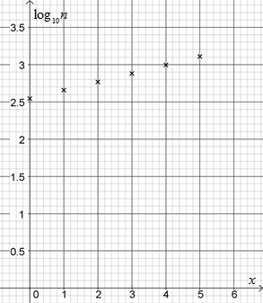

(ii) Find an estimate of the values of and .

(iii) Use your values of and  to predict the average number of visitors per month in the year 2010. Comment on the reliability of this estimate.

10. The radioactive decay of a substance is given by , , whereis the number of grams of radioactive substance after time, , years and  is a positive constant.

(i) How many grams of radioactive substance were there when the substance started to decay?

In 730 years, the number of grams of radioactive substance will be halved.

(ii) Find the value of  to three decimal places.

(iii) How many grams of radioactive substance will be left after 1000 years?

(iv) Find the rate at which the substance is decaying when .

(v) Sketch the graph of  against .

**Extension**

As a rule,  and.

Solve the equation , giving exact values for .

For each of these values of , determine any values of  for which .

## Worked solutions

1. 





 (3 s.f.)

2. 





3.

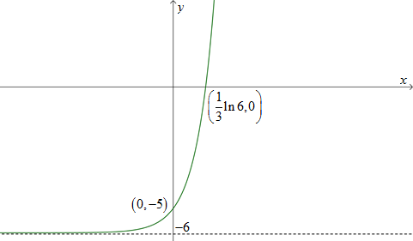

4. 









 Positive answer only.

5.   when 

 when 





6. (i)

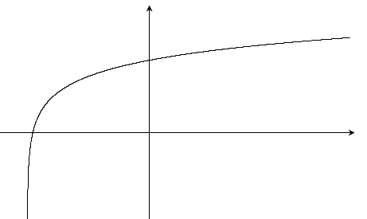

(0, 2 + ln 3)

*x*

f(*x*)

(e-2 ‒ 3, 0)

-3

(ii) 







So . Domain is all real numbers. Range is .

(iii)

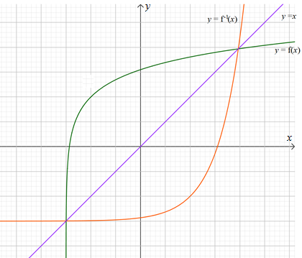

 is a reflection of  in the line .

(iv) 



 is only defined for  so ;  is an increasing function.

(v)  is a reflection of in the line . When  has positive gradient then so does..

 is an increasing function.

(vi) At the point of intersection, both curves have positive gradient so they cannot be perpendicular.

7.  Let



  or 

If  then  so  (3 d.p.)

If  then  so  (3 d.p.)

8.  where  and





 when so stationary point is

9. (i) 







(ii) Intercept is  so 

Gradient is  so 

(iii) In 2010,  and .

This is extrapolation. 2010 is 5 years after the data given. The museum may not have   
 the capacity for 4825 visitors per month or it may have closed or changed etc. The figure   
 is not reliable.

10. (i) 500

(ii) 







(iii) When  grams.

(iv) 

When Rate of decay is -0.466 grams of radioactive substance per year.

(v)

**Extension**





Let 











So 



If 





This is not possible for any value of .

If 

















If 















 This is a negative value so is not a solution of the original equation.

**OCR Resources**: *the small print*OCR’s resources are provided to support the delivery of OCR qualifications, but in no way constitute an endorsed teaching method that is required by the Board, and the decision to use them lies with the individual teacher. Whilst every effort is made to ensure the accuracy of the content, OCR cannot be held responsible for any errors or omissions within these resources.

© OCR 2017 - This resource may be freely copied and distributed, as long as the OCR logo and this message remain intact and OCR is acknowledged as the originator of this work.

OCR acknowledges the use of the following content: n/a

Please get in touch if you want to discuss the accessibility of resources we offer to support delivery of our qualifications: [resources.feedback@ocr.org.uk](mailto:resources.feedback@ocr.org.uk)

We’d like to know your view on the resources we produce. By clicking on ‘[Like’](mailto:resources.feedback@ocr.org.uk?subject=I%20liked%20the%20AS%20and%20A%20Level%20Maths%20B%20(MEI)%20Section%20Check%20In%20–%20%20Exponentials%20and%20Logarithms) or ‘[Dislike’](mailto:resources.feedback@ocr.org.uk?subject=I%20disliked%20the%20AS%20and%20A%20Level%20Maths%20B%20(MEI)%20Section%20Check%20In%20–%20%20Exponentials%20and%20Logarithms) you can help us to ensure that our resources work for you. When the email template pops up please add additional comments if you wish and then just click ‘Send’. Thank you.

Whether you already offer OCR qualifications, are new to OCR, or are considering switching from your current provider/awarding organisation, you can request more information by completing the Expression of Interest form which can be found here: [www.ocr.org.uk/expression-of-interest](http://www.ocr.org.uk/expression-of-interest)

Looking for a resource? There is now a quick and easy search tool to help find free resources for your qualification:   
[www.ocr.org.uk/i-want-to/find-resources/](http://www.ocr.org.uk/i-want-to/find-resources/)