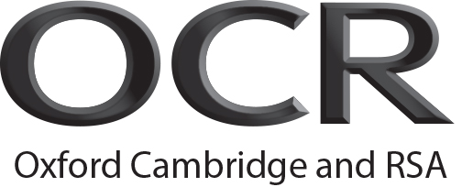 | Record of Achievement  OCR Level 6 Diploma in Career Guidance and Development
Candidate name:
Unit Title |  | Credit Value | Date | Assessor signature
Mandatory units
Unit 1 | Preparing to work in the Career Information, advice and guidance sector | 6
Unit 2 | Reflect on and improve professional practice | 6
Unit 3 | Career Guidance Theory | 9
Unit 4 | Agree the purpose of client-centred career guidance interviews and maintain communication with clients | 6
Unit 5 | Explore and agree the career guidance and development needs of clients | 6
Unit 6 | Use career and Labour Market Information with clients | 6
Unit 7 | Work with other agencies for the benefit of clients and the organisation | 6
Optional units
Unit 8 | Use diagnostic and assessment tools with clients | 6
Unit 9 | Advocate on behalf of clients | 4
Unit 10 | Understand how to support specific client groups to overcome barriers to learning, training and work | 3
Unit 11 | Engage with support networks to help clients to meet their career-related needs | 3
Unit 12 | Assist clients to apply for learning, training and work | 3
Unit 13 | Provide ongoing support to clients | 2
Unit 14 | Prepare to deliver services to clients in an outreach setting | 2
Unit 15 | Source, evaluate and use Labour Market Intelligence  with clients | 3
Unit 16 | Obtain and organise career-related information to support clients | 3
Unit 17 | Promote career-related learning to clients | 6
Unit 18 | Plan, deliver and evaluate career-related learning in groups | 6
Unit 19 | Evaluate service provision | 3
Unit 20 | Undertake research on behalf of the service | 6
Unit 21 | Lead and manage career development work in an organisation | 9
Unit 22 | Continuously improve career development work in an organisation | 6
Unit 23 | Plan and design Career Related Learning Programmes | 5

