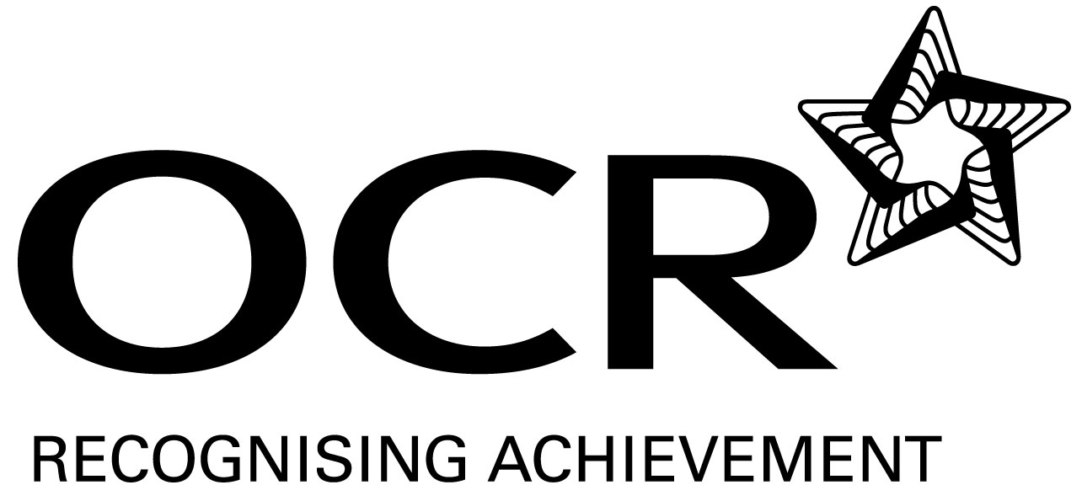
Support Material
GCE Modern Foreign Languages
OCR Advanced Subsidiary GCE in Turkish: H197
Unit: F889

This Support Material booklet is designed to accompany the OCR Advanced Subsidiary GCE specification in Turkish for teaching from September 2008.

Contents
Contents 2
Introduction 3
Turkish H197: Listening, Reading and Writing 1: F889 5
Sample Lesson Plan: Turkish H197 Listening, Reading and Writing 1: F889 8
Other forms of Support 10

Introduction

Background
A new structure of assessment for A Level has been introduced, for first teaching from September 2008. Some of the changes include:
- The introduction of stretch and challenge (including the new A* grade at A2) – to ensure that every young person has the opportunity to reach their full potential
- The reduction or removal of coursework components for many qualifications – to lessen the volume of marking for teachers
- A reduction in the number of units for many qualifications – to lessen the amount of assessment for learners
- Amendments to the content of specifications – to ensure that content is up-to-date and relevant.
OCR has produced an overview document, which summarises the changes to Turkish. This can be found at www.ocr.org.uk, along with the new specification.
In order to help you plan effectively for the implementation of the new specification we have produced this Scheme of Work and Sample Lesson Plans for Turkish. These Support Materials are designed for guidance only and play a secondary role to the Specification.

Our Ethos
All our Support Materials were produced ‘by teachers for teachers’ in order to capture real life current teaching practices and they are based around OCR’s revised specifications. The aim is for the support materials to inspire teachers and facilitate different ideas and teaching practices.

Each Scheme of Work and set of sample Lesson Plans is provided in:

- PDF format – for immediate use

- Word format – so that you can use it as a foundation to build upon and amend the content to suit your teaching style and students’ needs.

The Scheme of Work and sample Lesson plans provide examples of how to teach this unit and the teaching hours are suggestions only. Some or all of it may be applicable to your teaching.

The Specification is the document on which assessment is based and specifies what content and skills need to be covered in delivering the course. At all times, therefore, this Support Material booklet should be read in conjunction with the Specification. If clarification on a particular point is sought then that clarification should be found in the Specification itself.

A Guided Tour through the Scheme of Work

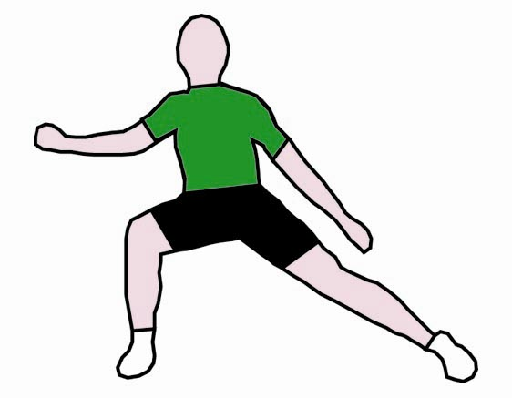
= Innovative Teaching Idea
All the teaching ideas contained in the SOW are innovative, but the icon is used to
Highlight exceptionally innovative ideas.

= Stretch & Challenge Activity
This icon is added at the end of text when there is an explicit opportunity to offer
Stretch and Challenge.

= ICT Opportunity
This icon is used to illustrate when an activity could be taught using ICT facilities.

Turkish H197: Listening, Reading and Writing 1: F889
Suggested teaching time | 8 hours | Topic | Leisure and entertainment: Tourism
Topic outline |  | Suggested teaching and homework activities | Suggested resources | Points to note
Listening |  | - A dialogue: Comparing and giving opinions about two popular holiday places in Turkey. Questions in Turkish. Gist and detailed comprehension with non-verbal responses. | - Radio / TV items.  - A dialogue written and recorded by the teacher. | - It can also be prepared in class by students and used as a pre assessment activity.
 |  | - A documentary about historical places in Turkey - gist and detailed comprehension with answers in Turkish. | - Radio / TV broadcasts.
 |  | - A Turkish speaker invited to class to share his/her holiday experiences in Turkey. Gist and detailed comprehension with non-verbal responses. | - A Turkish-speaking visitor. | - Students to prepare a questionnaire in advance.
 |  | - Commercials about holidays in Turkey. Gist and detailed comprehension with answers in English. | - Radio / TV broadcasts.
Speaking |  | - Role Play- A dialogue between a tourist and an information clerk about the historical and entertainment places of a holiday resort. | - Newspaper, magazine articles, internet items. | - Students to act out as a tourist and an information clerk.
 |  | - Role Play - Interview between a Turkish official and a member of Greenpeace. | - Newspaper, magazine articles, internet items.  - Cue cards.
= Innovative teaching idea  = Stretch and challenge opportunity idea  = ICT opportunity |  | - Presentation: Presenting favourite holiday places, giving reasons. Presenting ideas to improve tourism in a certain place. Presenting ideas to improve income through tourism. | - Newspaper, magazine articles, internet items. | - It is a good opportunity to use ICT facilities e.g. PowerPoint.
 |  | - Discussion: Different types of holidays. | - Cue cards. | - Students are given different scenarios.
Reading |  | - An article about two holiday resorts in Turkey. Comparing popular holiday places in Turkey. Questions in Turkish. Gist and detailed comprehension with non-verbal responses. | - Newspaper, magazine articles, internet items. | - Agreed set of key words for this topic to be added in students’ vocabulary books.
 |  | - An article about the most famous historical places in Turkey - gist and detailed comprehension with answers in Turkish. | - Newspaper, magazine articles, internet items.
 |  | - Holiday brochures, postcards, leaflets, newspaper and magazine advertisements about holidays in Turkey. Gist and detailed comprehension with non-verbal responses. | - Holiday brochures, postcards, leaflets, newspaper and magazine advertisements.
= Innovative teaching idea  = Stretch and challenge opportunity idea  = ICT opportunity |  | - An article about a popular holiday resort in Turkey - gist and detailed comprehension with answers in Turkish. | - Newspaper, magazine articles, internet items, holiday books.
Writing |  | - A dialogue between a tourist and an information clerk about the historical and entertainment places of a holiday resort. | - A dialogue written and recorded by the students after reading an article about a holiday place in Turkey in class. | - The text can be used for a Role Play.
 |  | - Brochures and leaflets on a particular aspect of tourism can be produced and used for display. | - Travel books, internet items, holiday brochures. | - A visit can be arranged to a Travel Agent’s.
 |  | - Describing, comparing and giving opinions about two possible tourist destinations in Turkey. | - Newspaper, magazine articles, internet items. | - Turkish-speaking people can be interviewed and a report or an article can be written by using the notes taken during the interview.
Consolidation |  | - Explore previous exam questions on this topic. | - Past papers.
 |  | - Presentation: Writing an essay on how to improve tourism in a certain place in Turkey and improve the conditions of the environment. Giving opinions and reasons. | - Independent research: opportunity to set as a library and / or internet session – gather items / articles on tourism in preparation for the task. | - It is a good opportunity to use ICT facilities e.g. PowerPoint.
= Innovative teaching idea
= Stretch and challenge opportunity idea
= ICT opportunity

Sample Lesson Plan: Turkish H197 Listening, Reading and Writing 1: F889

Describing Places
OCR recognises that the teaching of this qualification will vary greatly from school to school and from teacher to teacher. With that in mind, this lesson plan is offered as a possible approach but will be subject to modifications by the individual teacher.

Lesson length is assumed to be one hour.

Learning objectives for the lesson
Objective 1 | Students to improve the key vocabulary and structure to be able to describe a place.
Objective 2 | Students to improve their reading skills – reading for gist and detailed information.
Objective 3 | Students to improve their knowledge in discourse skills.

Recap of previous experience and prior knowledge
- Teacher puts up different types of brochures, posters, postcards, picture of holiday resorts, newspaper and magazine articles, and advertisements about holidays in Turkey. If possible teacher plays Turkish music softly in the background. Teacher asks students to describe a place they had been to on holiday or to choose one of the pictures on the walls to describe.
- Presumed knowledge: students have basic vocabulary and structure to describe a place from a previous topic.

Content
Time | Content
5 minutes | Warm up activity to assess prior knowledge. Teacher hands out A3 size papers and asks students to list the necessary vocabulary to describe a place. Teacher puts up the lists and students have a quick check on the lists.
10 minutes | In pairs, students are set a 10-minute challenge. (Have a stop watch to hand to ensure the time limit is adhered to.)  - Teacher to ask students what they would like to know about a place before they go on a holiday. Students write down in pairs: e.g. weather, geographical situation, hotels, food, entertainment, nature, sports facilities.  - Teacher to encourage students to guess the content of the article and to elicit questions.  - Teacher to hand out single paragraphs of an article, about a holiday destination in Turkey, to each group and students to read them silently.  - Groups to look up new words in the dictionary.

Time | Content
5-10 minutes | Students to give feedback on their paragraphs. One student from each group visits the other groups and tells them what they have found out about the place. The groups may take notes and ask questions.
15 minutes | - Teacher to re-group the students. One member from each group gets together and puts an article in order.  - They also exchange knowledge of vocabulary. Teacher monitors and gives assistance whenever needed.  - Students go back to their own groups and write down the new vocabulary in the list they had written at the beginning of the lesson using different coloured pens.  - Students prepare a short quiz on vocabulary to assess other groups’ knowledge.
15 minutes | - Teacher hands out the whole article and asks comprehension questions.  - Teacher hands out a shortened version of the text with gaps to be filled by students. (Vocabulary and structure assessment)  - The answers are compared in groups and read out loud by a member of a group. (Peer assessment.)

Consolidation
Time | Content
5 minutes | Teacher to write down the main idea of each paragraph on the board.  Students to stick the relating paragraphs under the idea.
 | Teacher to set homework. Students to do research and write an article about a tourist destination in Turkey.

Other forms of Support
In order to help you implement these new specification effectively, OCR offers a comprehensive package of support. This includes:

OCR Training

Get Ready…introducing the new specifications
A series of FREE half-day training events are being run during Autumn 2007, to give you an overview of the new specifications.

Get Started…towards successful delivery of the new specifications
These full-day events will run from Spring 2008 and will look at the new specifications in more depth, with emphasis on first delivery.
Visit www.ocr.org.uk for more details.

Mill Wharf Training
Additional events are also available through our partner, Mill Wharf Training. It offers a range of courses on innovative teaching practice and whole-school issues - www.mill-wharf-training.co.uk.

e-Communities
Over 70 e-Communities offer you a fast, dynamic communication channel to make contact with other subject specialists. Our online mailing list covers a wide range of subjects and enables you to share knowledge and views via email.
Visit https://community.ocr.org.uk, choose your community and join the discussion!

Interchange
OCR Interchange has been developed to help you to carry out day to day administration functions online, quickly and easily. The site allows you to register and enter candidates online. In addition, you can gain immediate a free access to candidate information at you convenience. Sign up at https://interchange.ocr.org.uk

Published Resources
Published Resources
OCR offers centres a wealth of quality published support with a fantastic choice of ‘Official Publisher Partner’ and ‘Approved Publication’ resources, all endorsed by OCR for use with OCR specifications.

Publisher partners
OCR works in close collaboration with three Publisher Partners; Hodder, Heinemann and Oxford University Press (OUP) to ensure centres have access to:

- Better published support, available when you need it, tailored to OCR specifications
- Quality resources produced in consultation with OCR subject teams, which are linked to OCR’s teacher support materials
- More resources for specifications with lower candidate entries
- Materials that are subject to a thorough quality assurance process to achieve endorsement

Oxford University Press (OUP) is the publisher partner for OCR GCE Modern Foreign Languages



Approved publications
OCR still endorses other publisher materials, which undergo a thorough quality assurance process to achieve endorsement. By offering a choice of endorsed materials, centres can be assured of quality support for all OCR qualifications.

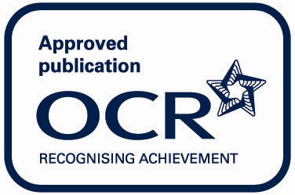

Endorsement
OCR endorses a range of publisher materials to provide quality support for centres delivering its qualifications. You can be confident that materials branded with OCR’s “Official Publishing Partner” or “Approved publication” logos have undergone a thorough quality assurance process to achieve endorsement. All responsibility for the content of the publisher’s materials rests with the publisher.

These endorsements do not mean that the materials are the only suitable resources available or necessary to achieve an OCR qualification. Any resource lists which are produced by OCR shall include a range of appropriate texts.

