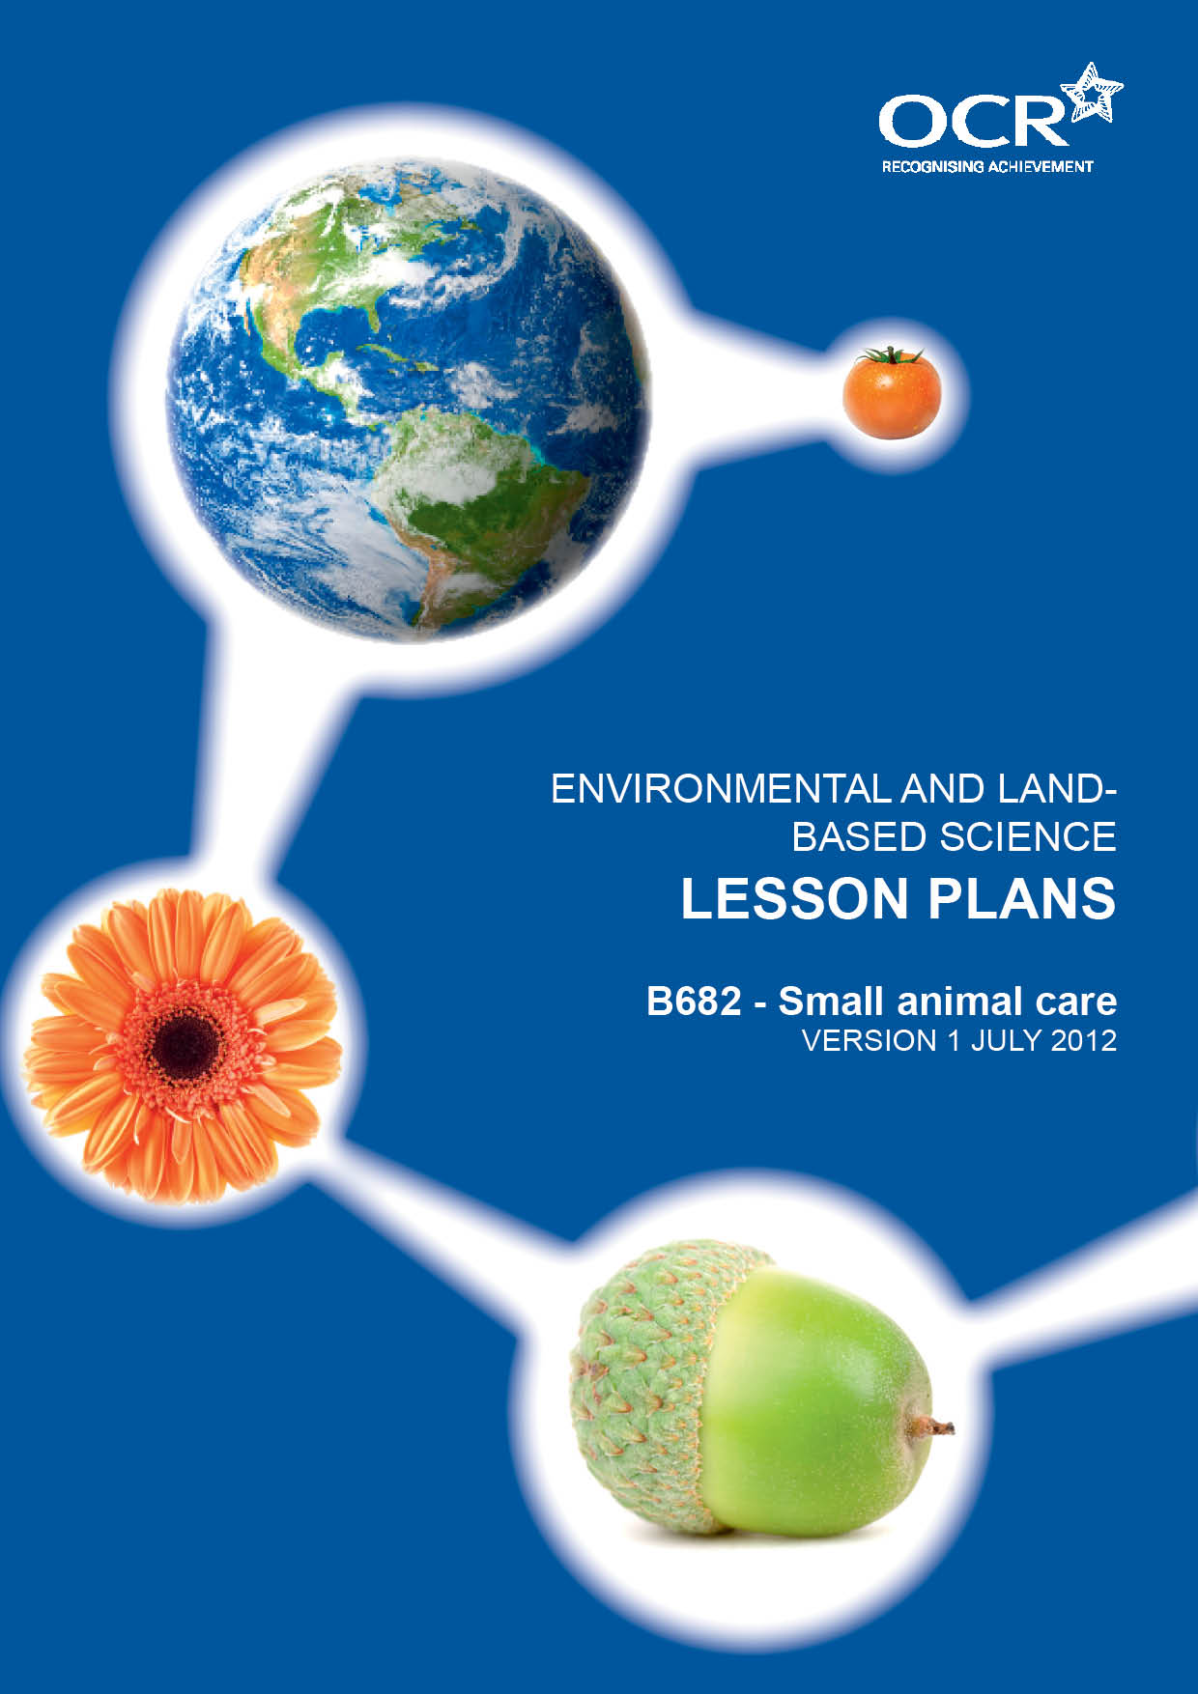
TWENTY FIRST CENTURY SCIENCE SUITE
SCHEMES OF WORK AND LESSON PLANS
C3: Chemicals in our lives
VERSION 1 JULY 2011
Introduction
OCR involves teachers in the development of new support materials to capture current teaching practices tailored to our new specifications. These support materials are designed to inspire teachers and facilitate different ideas and teaching practices. Each Lesson Plan is provided in Word format – so that you can use it as a foundation to build upon and amend the content to suit your teaching style and students’ needs.
The Lesson Plans provide examples of how to teach this unit and the teaching hours are suggestions only. Some or all of it may be applicable to your teaching.
The Specification is the document on which assessment is based and specifies what content and skills need to be covered in delivering the course. At all times, therefore, this Support Material booklet should be read in conjunction with the Specification. If clarification on a particular point is sought then that clarification should be found in the Specification itself. References to the content statements for each lesson are given in the ‘Points to note’ column.
PowerPoints, Worksheets and other resources can be found on the following website: www.elbs.info.

Lesson 1 – Keeping animals
Learning outcomes: by the end of the lesson Candidates should know:- | - animals can be kept for pets, food, research, competition, security, conservation or hunting and are treated differently for different purposes. Including requirements for space, exercise and security.  - factors needing to be considered when keeping animals including animal interaction with people and other animals and ethical and welfare issues.  - the biological, ethical and welfare issues involved with the castration and spaying of small animals.
Suggested lesson details and activities: | Starter: Use images of small animals that are kept for different purposes. Students decide why the animals are kept and any specific requirements they need.  Main Activity: Cut images out of magazines or print off the internet to produce a poster of all the different uses for small animals.  Class discussion on the issues surrounding spaying and castrating small animals.  Plenary: Post it Head – Students are paired up and one of the students has a post it on their forehead describing a small animal. They have to guess what it is using only YES or NO answers.  Homework: Write a letter to the newspaper arguing either for or against castration and spaying of small animals.
Suggested resources: | Keeping animals Powerpoint

Lesson 2 – Cross breeding vs line breeding
Learning outcomes: by the end of the lesson Candidates should know:- | - that different breeds have different characteristics, including size and temperament and are selected for different purposes.  - the difference between cross breeding and line breeding.  - the advantages and disadvantages.
Suggested lesson details and activities: | Starter: Images of different breeds of cattle to illustrate what is meant by a breed.  Main Activity: Working in groups with each group assigned a different small animal eg. dog, cat, rabbit, guinea pig, snake, lizard. Each group researches their animal producing information on the different breeds and relating this to their purpose.  Teacher led discussion of cross breeding and line breeding. Students write down a list of advantages and disadvantages of each.  Plenary: Design an animal to suit your families needs with a detailed description of how it meets the requirements and how it was bred.  Homework: Research examples of cross and line breeding.
Suggested resources: | Cross breeding vs line breeding Powerpoint

Lesson 3 – Breeding and hybrid vigour
Learning outcomes: by the end of the lesson Candidates should know:- | - how the process of selective breeding has led to the development of different breeds of animal; what to look for in a named show animal: correct conformation and markings.  - selective breeding can lead to inbreeding which can cause health problems to animals.  - the dangers associated with inbreeding: reduction in variation and accumulation of harmful recessive characteristics; the ethical and welfare issues involved in breeding pedigree animals.
Suggested lesson details and activities: | Starter: Brainstorming how show characteristics would be selected for using examples of pedigree dogs ie how the Pekinese may have ended up with such a foreshortened ‘smashed’ face, how show Basset hounds acquired such long ears etc.  Main Activity: Students work in groups to produce a presentation. Each group chooses a specific pedigree animal (dog, cat, rabbit, guinea pig) and explains which characteristics it has been selectively bred to display. Each group should also research any specific genetic problems associated with the breed.  Plenary: Group presentations and question and answer sessions.  Homework: Selective breeding in rabbits Afl sheet.
Suggested resources: | Breeding and Hybrid Vigour Powerpoint

Lesson 4 – Animal reproduction
Learning outcomes: by the end of the lesson Candidates should know:- | - the reproductive cycles in a named mammal and a named bird.  - the formation of gametes, fertilisation, gestation, development and birth in mammals and birds; the functions of the shell gland and vent in birds and the uterus and vagina in mammals.  - how hormones control the timing of oestrus and reproduction in mammals, and the effect of day length on egg production in birds.
Suggested lesson details and activities: | Starter: Students write a list of similarities and differences between reproduction in birds and mammals. Teacher led discussion of the ideas.  Main Activity: Use of model rabbit or cat and model bird to demonstrate the differences of the reproductive structures.  Students to label diagrams of the reproductive systems of a rabbit or bird.  Discussion of the role of sex hormones in mammals and the relevance of a reproductive cycle.  Plenary: Analysis of data on egg production and day length in birds.  Homework: Students produce report on reproductive cycle of a named small mammal and a named bird.
Suggested resources: | Animal reproduction Powerpoint

Lesson 5 – Incubation
Learning outcomes: by the end of the lesson Candidates should know:- | - how to set up and use an incubator, to include the conditions provided and ‘candling’.  - the advantages and disadvantages of natural and artificial incubation in birds.  - how an embryo obtains nutrients and removes waste during its development inside the egg, to include the porosity of the shell, yolk and allantoic sac.
Suggested lesson details and activities: | Starter: Break open an egg and use this as a way of explaining the similarities and differences between mammalian and bird eggs. Also explain the difference between fertile and infertile eggs.  Main Activity: Collect fertile eggs and set them up in an incubator. Teacher led discussion of how chick embryos obtain nutrients and remove waste.  Plenary: Pass around a diagram of an incubator and students take it in turns to label the important features.  Homework: Keep a log book of the incubation to include when eggs were turned, sprayed and candled.
Suggested practicals: | Set up an incubator and monitor the eggs.  Candle the eggs at 7 days.  Set up an artificial brooder for the young chicks.  Place an egg in acid to remove the shell and reveal the membranes.  Break open a newly laid egg and identify the important features.  Encourage a laying hen to become broody by using a dummy egg.
Suggested resources: | Incubation, chick development Powerpoint

Lesson 6 – Diet
Learning outcomes: by the end of the lesson Candidates should know:- | - the constituent’s of an animals diet: carbohydrates, proteins, fats, fibre and water; the importance of a balanced diet.  - the importance of carbohydrates, proteins, fats, fibre and water in an animal’s diet; the role of vitamins (A, C and D) and minerals (Ca and Fe); the effects of a poor diet, to include deficiencies in fibre, vitamins (A, C and D) and minerals (Ca and Fe) and excesses of fats and carbohydrates.  - how different small animals meet their dietary requirements, to include carnivores, herbivores and omnivores.
Suggested lesson details and activities: | Starter: Brainstorm the components of a balanced diet.  Main Activity: Use of printed food labels to determine the proportions of each nutrient.  Teacher led discussion of why proportions may differ depending on the species and the stage in their life cycle (young, old, pregnant).  Plenary: Pictures of animals with specific deficiency diseases.  Homework: Make a list of common pets. State whether they are carnivores, omnivores or herbivores and describe what they eat and why.
Suggested practicals: | Tests a sample of ground up animal feed for starch, glucose, protein and fat, using iodine, Benedicts, biuret and the emulsion test.
Suggested resources: | Diet Powerpoint

Lesson 7 – Feedstuffs
Learning outcomes: by the end of the lesson Candidates should know:- | - the range of different types of food used for small animals, including poultry and rabbits.  - the difference between roughage, succulent and concentrate foods and an example of each.  - the difference between feeding a ration and feeding ad lib and the advantages/disadvantages of each.
Suggested lesson details and activities: | Starter: Students have to come up with a definition of the terms ration and ad lib. Teacher led discussion of the advantages and disadvantages of each.  Main Activity: Students are given a number of photos of feed stuffs and using the criteria from the powerpoint they classify each feed.  Students work in groups to design a feed label for a chosen small animal. Marking criteria are set before hand such as name, quality of scientific information, layout etc.  Plenary: Feed labels are passed around the groups and each group marks them using the original criteria.  Homework: Students to produce simple factsheet on how to feed one small animal species of their choice.
Suggested practicals: | Match up the feed stuff to the animal.  Routine care of small mammals to include supplying their dietary requirements.
Suggested resources: | Feedstuffs Powerpoint

Lesson 8 – Digestive systems
Learning outcomes: by the end of the lesson Candidates should know:- | - the differences in the structure of the digestive systems of a rabbit and a bird; the significance of the caecum in rabbits and of grit in the diet of seed-eating birds.  - the functions, in outline, of the mouth, stomach, small intestine, large intestine, caecum/caeca, rectum, anus, crop and gizzard in digestion in small animals.  - the principle of enzyme action in digestion ( no specific enzyme details needed); the role of microorganisms in cellulose.
Suggested lesson details and activities: | Starter: Snowball activity in which students write down one way in which the digestive systems of a rabbit and a bird might be similar or different. The paper is then screwed up and thrown randomly. Each student picks up a piece of paper and writes down a further similarity or difference and this is repeated.  Teacher led discussion of ideas generated.  Main Activity: Use of model rabbit and bird to show digestive systems.  Model to show enzyme action, breaking up large insoluble molecules into smaller soluble molecules so they can be absorbed.  Teacher led discussion about why rabbits eat their faeces and why birds eat grit.  Plenary: Students take it in turns around the classroom to describe the next stage in the digestion process of either a rabbit or a bird.  Homework: Students to sketch a diagram of a plant cell and use it to explain why rabbits need such a complex digestive system.
Suggested resources: | Digestive Systems Powerpoint

Lesson 9 – Animal housing
Learning outcomes: by the end of the lesson Candidates should know:- | - the characteristics of different forms of housing used for small mammals, birds and fish or reptiles; how they meet the needs of animals.  - the risks associated with inadequate housing for small mammals.
Suggested lesson details and activities: | Starter: Match up different forms of housing to the most suitable animal. Teacher led discussion on the different needs of small animals and how the housing meets those needs.  Main Activity: Review the housing of all the animals in the establishment and make recommendations for any improvements. Carry out improvements where possible.  Plenary: Group discussion of the possible risks associated with poor housing.  Homework: Design a suitable home for a named animal and include a description of all the main features.
Suggested practicals: | Set up suitable housing for a range of small animals to include provision of feed, water, toys and bedding.  Routine care of small animals to include cleaning out housing.

Lesson 10 – Animal health
Learning outcomes: by the end of the lesson Candidates should know:- | - the routine health checks that are used when keeping a named small animal.  - the reasons for the routine health checks of a named small animal; including how ill health (diseases caused by bacteria, viruses, fungi and parasites) can be recognised (loss of condition and other evidence of parasites and diseases).  - the treatment of diseases caused by bacteria, viruses, fungi and parasites; the use of routine vaccinations to prevent diseases of small animals, including the advantages and disadvantages of these techniques.
Suggested lesson details and activities: | Starter: Using a healthy animal, brainstorm students about the signs that show it is healthy. Lead onto a discussion on signs of ill health.  Main Activity: Teacher led discussion on the causes of ill health with a specific focus on zoonoses.  Disease word sort to match up common diseases with the cause, symptoms and treatment.  Internet research to produce a vaccination schedule for a named animal.  Group debate on the advantages and disadvantages of vaccinations.  Plenary: Students write a short article for an animal magazine about their views on vaccination.  Homework: Produce a word search containing all the new words in this section.
Suggested practicals: | Working in pairs students carry out a routine health check on a given animal.

Lesson 11 – Handling small animals
Learning outcomes: by the end of the lesson Candidates should know:- | - how to handle, transport and weigh small animals correctly.  - the importance of handling small animals in the correct manner and the hazards of poor handling, including disease (tetanus and salmonella), parasite, being bitten; the ways these hazards may be reduced.  - the health and safety and legal requirements for keeping, transporting and breeding small animals, and the reasons for these.
Suggested lesson details and activities: | Starter: Using a carrying case, students brainstorm the requirements of a box for carrying small animals.  Main Activity: Students write out a list of rules for handling the animals in their care.  Students plan an investigation to compare the weights of different small animals including the safest and least stressful method of weighing them, how to record the results and an evaluation of each technique.  Plenary: Students produce a poster of the hazards of incorrect handling of a specific animal.  Homework: Internet research on pet passports and the legal requirements for transporting small animals in and out of the UK.
Suggested practicals: | Handling a range of small animals.  Weighing a range of small animals.

Lesson 12 – Husbandry tasks
Learning outcomes: by the end of the lesson Candidates should know:- | - the regular routine husbandry for small mammals, birds and reptiles or fish, including feeding and cleaning.  - the care needed for pregnant mammals and very young mammals and birds, including housing, diet and health care.
Suggested lesson details and activities: | Starter: Students brainstorm the routine husbandry requirements for small animals.  Main Activity: Teacher led discussion on the general requirements for the care of pregnant small mammals and very young birds.  Students produce an illustrated report on how they would care for a pregnant small mammal in their care and how they would care for very young birds.  Plenary: Make a list of all the key terms from the whole topic and a description of what each means.  Homework: Learn the spellings and meanings of all the key terms in the topic.
Suggested practicals: | Regular routine husbandry tasks of animals such as grooming, trimming nails, exercising.

