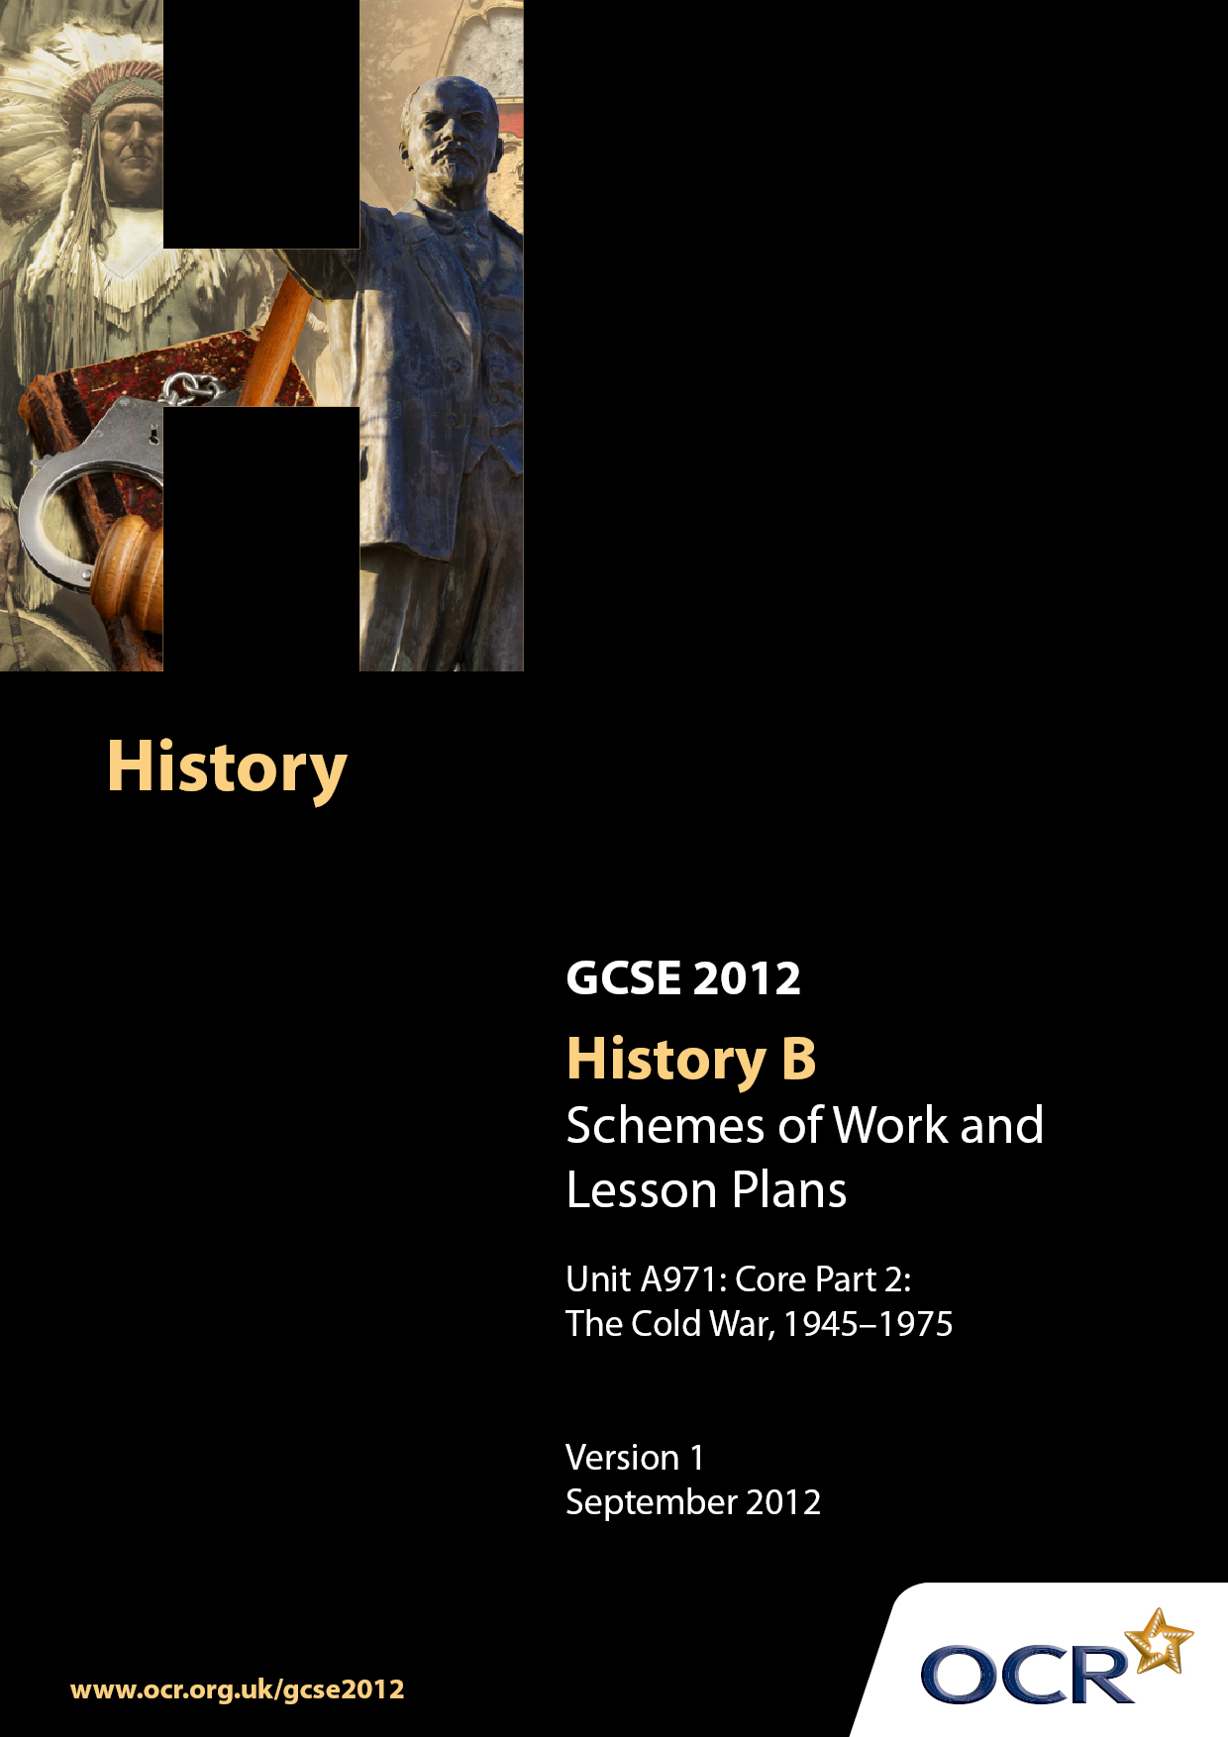

Contents
Contents 2
Introduction 3
Sample Scheme of Work: Unit A971/Part 2 The Cold War 1945–1975 6
Sample Lesson Plan: Unit A971/Part 2 The Cold War 1945–1975 11

Introduction

Background
Following a review of 14–19 education and the Secondary Curriculum Review, the Qualifications and Curriculum Authority (QCA) has revised the subject criteria for GCSEs for first teaching in September 2009. This applies to all awarding bodies.
The new GCSEs have more up-to-date content and encourage the development of personal learning and thinking skills in your students.
We have taken this opportunity to redevelop all our GCSEs to ensure they meet your requirements. These changes will give you greater control of assessment activities and make the assessment process more manageable for you and your students. Controlled assessment will be introduced for most subjects.
From September 2012 assessment tasks may be undertaken at any point between release of the task and the examination series for which the task must be submitted. Centres must ensure that candidates undertake a task that is valid for submission in the year in which the candidate intends to submit it.
OCR has produced a summary brochure, which summarises the changes to History B. This can be found at www.ocr.org.uk along with the new specification.
In order to help you plan effectively for the implementation of the new specification, we have produced these Schemes of Work and sample Lesson Plans for History B. These Support Materials are designed for guidance only and play a secondary role to the Specification.

Our Ethos
OCR involves teachers in the development of new support materials to capture current teaching practices tailored to our new specifications. These support materials are designed to inspire teachers and facilitate different ideas and teaching practices.
Each Scheme of Work and set of sample Lesson Plans is provided in Word format – so that you can use it as a foundation to build upon and amend the content to suit your teaching style and students’ needs.
The Scheme of Work and sample Lesson Plans provide examples of how to teach this unit and the teaching hours are suggestions only. Some or all of them may be applicable to your teaching.
The specification is the document on which assessment is based and specifies what content and skills need to be covered in delivering the course. At all times, therefore, this Support Material booklet should be read in conjunction with the specification. If clarification on a particular point is sought, then that clarification should be found in the specification itself.

A Guided Tour through the Scheme of Work

= Innovative Teaching Idea
This icon is used to highlight exceptionally innovative ideas.


= ICT Opportunity
This icon is used to illustrate when an activity could be taught using ICT facilities.

Unit A971: Core Part 2: The Cold War, 1945–1975
Suggested teaching time | 1 hour | Topic | Key Question 4: Who was to blame for the Cold War?
Topic outline |  | Suggested teaching and homework activities |  | Suggested resources | Points to note
How likely was it that the USSR, USA and GB would become allies during WW2? |  | Students require a brief introduction to the relationship between GB, the USA and the USSR from the October Revolution to the end of World War 2. This should include details of:  - Ideology, liberal capitalism vs. communism  - GB and USA’s response to the October Revolution in the context of WW1 and subsequent invasion  - The concepts of Permanent Revolution, United Front and Popular Front  - The Spanish Civil War  - Appeasement and the Nazi-Soviet Pact  - German invasion of USSR  - War time co-operation and suspicions  Produce a graph illustrating the negative or positive relationship between the USSR and USA from 1917 to 1945. |  | - Walsh B, (1996), GCSE Modern World History  - Kelly, N and Lacey, G, 2001, Modern World History (Useful for teachers)  - Communist manifesto  www.anu.edu.au/polsci/marx/classics/manifesto.html  - Historical inevitability of USA / Russian conflict  Democracy in America, Alexis de Tocqueville,  p470-471, http://books.google.co.uk/ (Useful for teachers)  - Library of Congress  www.ibiblio.org/expo/soviet.exhibit/entrance.html  - Lesson Plans and revision guides  www.historygcse.org  - War relations with the USSR Churchill, W, 1950, The Second World War,  http://books.google.co.uk (Useful for teachers)  - Spanish Civil War Romero Salvado, Francisco J, 1999, Twentieth Century Spain,, 1898-1998 (Useful for teachers)  - Waugh, S and Wright, J, 2006, The Russian  - Revolution and the Soviet Union 1910-1991: GCSE Modern World | - Capitalism  - Communism  - Ideology – Marxism vs Capitalism  - democracy, free market, equality, social good, command economy  - US, French and GB invade USSR  - Permanent Revolution  - United Front  - Popular Front  - Spanish Civil War  - Nazi-Soviet Pact  - German invasion of USSR  - Second front
Explore reasons why the relationship between the allies deteriorated during 1945 |  | Students should consider the tensions that arose between the allies in formulating a post -war settlement.  - How had the war changed the balance of power? Did the allies share the same interests?  - February 1945, Yalta  - July-Aug 1945, Potsdam  - The personalities of the leaders  - The testing of an atomic bomb  - Soviet occupation of Eastern Europe  Ask students as individuals or in groups to research the personalities of the leaders and national interests of their country and represent them at a mock conference. Would be interesting to have FDR / Truman and Churchill / Atlee arguing with each other. |  | - Walsh B, (1996), GCSE Modern World History, (pp318-323)  - Kelly, N and Lacey, G, 2001, Modern World History, pp216-221 (Useful for teachers)  - Kennedy , P(1989), The Rise and Fall of the Great Powers, Fantastic source of statistics (Useful for teachers)  www.bbc.co.uk/schools/gcsebitesize  - www.schoolhistory.co.uk  - The Truman Library, photos and documents  www.trumanlibrary.org/photographs/search.php?  access=selectbyname&nameid=2136  - FDR Library, photos and documents  www.fdrlibrary.marist.edu/  - Photos of Churchill, FDR and Stalin at Potsdam  www.trumanlibrary.org/photographs/search.php?  access=selectbyname&nameid=2136  - Churchill’s account of the start of the Cold War  - Churchill, W, 1950, The Second World War, Volume 6 Book 2 http://books.google.co.uk (Useful for teachers) | - Superpowers  - The atomic bomb  - Spheres of Influence  - Truman replaces FDR and Churchill replaced by Atlee (following the Potsdam Conference)  - Soviet occupation of Eastern Europe  - Intervention in Greece  - National interest

Unit: A971: Core Part 2: The Cold War 1945-1975
Suggested teaching time | 2 hours | Topic | Key Question 4 Who Was To Blame For The Cold War?
Topic outline |  | Suggested teaching and homework activities |  | Suggested resources | Points to note
How and why had the USSR gained control of Eastern Europe by 1948? |  | Students should explore why Stalin and USSR occupied Eastern Europe, how the USSR asserted control over those countries. Soviet strength or fear?  - Consider USSR’s security needs,  - Failure of collective security in 30s,  WW2, loss of life and casualties, routes of German invasion,  - Possible future threats; resurgent Germany and Japan, threat of a western coalition,  - Increased tensions over Germany, Iran, Greece, the Truman Doctrine increased military power,  - Personality of Stalin and desire for world revolution  - Rise of the left throughout  - Europe,  free elections, Communists join coalition governments, imposition of one-party states  Provide a briefing for Stalin, identifying the most likely threats to the USSR and recommending key actions to make the USSR secure following the end of WW2. |  | - Walsh B, (1996), GCSE Modern World History, (p324) (Useful for teachers)  - Good map and state by state summary  - Kelly, N and Lacey, G, 2001, Modern World History, pp221-223 (Useful for teachers)  - Kennedy , P, (1989), The Rise and Fall of the Great Powers, source of statistics (Useful for teachers)  - Excerpts from Churchill’s Iron Curtain speech  - www.fordham.edu/halsall/mod/churchill-iron.html  - Stalin’s response to Churchill’s speech  - www.fordham.edu/halsall/mod/1946stalin.html  - Waugh, S and Wright, J, 2006, The Russian Revolution and the Soviet Union 1910-1991: GCSE Modern World (Useful for teachers)  - Leffler, MP and Painter, DS, Origins of the Cold War, 1995, Chapter 2 (Useful for teaches)  - Dunbabin, JPD, 1994, The Cold War, The Great Powers and their Allies, Chapter 3 Waugh, S and Wright, J, 2006, The Russian (Useful for teachers)  - Revolution and the Soviet Union 1910–1991: GCSE Modern World | - Cominform  - One-party states  - Occupation zones  - Yugoslavia  - Reparations  - The Iron Curtain  - Red Army  - Purges
How did the USA react to Soviet expansionism? |  | Students should consider how the USA responded to the increased tensions with the USSR and whether their actions increased tensions.  - Greek Civil War  - Merging of occupation zones  - Keenan’s ‘Long Telegram’  - The Truman Doctrine  - Czechoslovakia  - The Marshall Plan  - The Berlin Blockade  - NATO  What is a Cold War and why was this pattern established?  Produce a poster as a piece of pro-US or pro-USSR propaganda. |  | - Walsh B, (1996), GCSE Modern World History, (pp328-333)  - Kelly, N and Lacey, G, 2001, Modern World History, pp224-227 (Useful for teachers)  - Kennedy, P, (1989), The Rise and Fall of the Great Powers, source of statistics (Useful for teachers)  - Keenan’s influential ‘Long Telegram’ from Moscow www.johndclare.net/cold_war7_Kennan.html  - Ambrose, SE and Brinkley, GB, The Rise to Globalism, Chapters 4 and 5 (Useful for teachers) | - Containment  - Anti-communist  - Diplomacy  - Propaganda

Unit A971/Part 2 The Cold War, 1945-1975
Suggested teaching time | 1 hour | Topic | Key Question 4 Who Was To Blame For The Cold War?
Topic outline |  | Suggested teaching and homework activities |  | Suggested resources | Points to note
Who was more to blame for the start of the Cold War, the USA or the USSR? |  | Students should consider the combination of long- term and short- term origins of the Cold War. This should include details of the relative significance of:  - Ideological antagonism  - Historical inevitability  - Stalin’s paranoia, leader’s personalities  - Soviet expansionism  - American economic imperialism  - WW2 and change in balance of power, decline of Britain and France  - Misunderstandings and fear  Students should consider all above factors to evaluate whether the Cold War was caused by Soviet or American aggression. |  | - Walsh B, (1996), GCSE Modern World History  - Kelly, N and Lacey, G, 2001, Modern World History, pp228-229 (Useful for teachers)  - Kennedy , P, (1989), The Rise and Fall of the Great Powers, source of statistics (Useful for teachers).Uses Soviet archives and excellent chapter on origins and Stalin’s role  - Gaddis, JL, 1998, We Now Know – Rethinking Cold War History, Chapter one (Useful for teachers) | - Cold War

Unit A971 Core Part 2: The Cold War 1945-1975

How and why did the Soviet Union occupy Eastern Europe?
OCR recognises that the teaching of this qualification will vary greatly from school to school and from teacher to teacher. With that in mind, this lesson plan is offered as a possible approach but will be subject to modification by the individual teacher.
Lesson length is assumed to be one hour.

Learning Objectives for the Lesson
Objective 1 | To understand the reasons for the Soviet occupation of Eastern Europe
Objective 2 | To understand the effect this had on the local populations of each occupied country
Objective 3 | To understand how the USSR strengthened control over Eastern Europe

Recap of Previous Experience and Prior Knowledge
- This should follow the lessons dealing with the unlikely alliance between the USSR and USA and the breakdown in that relationship. Pupils should understand the atmosphere of mistrust and the catastrophic effect of the war.

Content
Time | Content
5 minutes | “From Stettin in the Baltic to Trieste in the Adriatic an iron curtain has descended across the Continent.” Winston Churchill - March 5, 1946. Ask students to brainstorm what Churchill meant by these words. Do they think that it is true in 1946?
10 minutes | Ask pupils to write down a time line of events that lead to the USSR controlling Eastern Europe. Do the USSR initiate events or respond to US action?
5-10 minutes | Class discussion - ask students to think of reasons why the Soviet Union felt it necessary to occupy Eastern Europe.
15 minutes | Divide the students into groups and give them a country from Eastern Europe. Ask them to consider how they would have felt to be liberated / invaded / occupied / controlled by the USSR.
10 minutes | Class discussion – Was the USSR right or wrong to occupy Eastern Europe?

Consolidation
Time | Content
10 minutes | Ask groups to produce a defence of the Soviet occupation that would be presented to the United Nations.  They must emphasise the historical antagonism, WW2, the actions of the USA and the future defence needs of the USSR.

