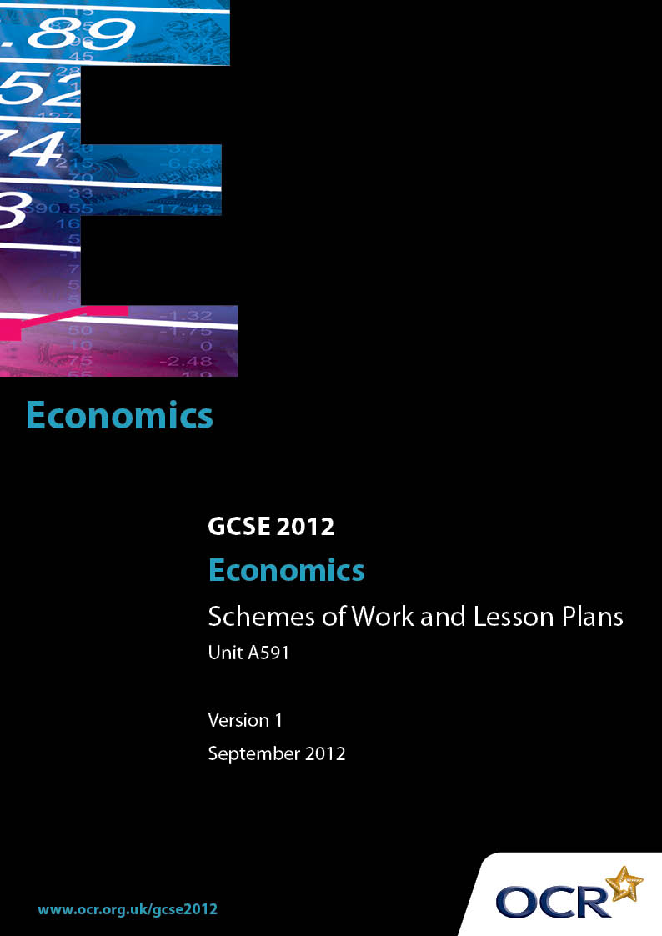

Contents
Introduction 3
Sample Scheme of Work: OCR GCSE Economics J320 Unit A591: How the market works? 5
Sample Lesson Plan: OCR GCSE Economics J320 Unit A591: How the market works? 13

Introduction

Background
Following a review of 14 – 19 education and the Secondary Curriculum Review, the Qualifications and Curriculum Authority (QCA) has revised the subject criteria for GCSEs, for first teaching in September 2009. This applies to all awarding bodies.
The new GCSEs have more up-to-date content and encourage the development of personal, learning and thinking skills in your students.
We’ve taken this opportunity to redevelop all our GCSEs, to ensure they meet your requirements. These changes will give you greater control of assessment activities and make the assessment process more manageable for you and your students. Controlled assessment will be introduced for most subjects.
From September 2012 assessment tasks may be undertaken at any point between release of the task and the examination series for which the task must be submitted. Centres must ensure that candidates undertake a task that is valid for submission in the year in which the candidate intends to submit it.
OCR has produced a summary brochure, which summarises the changes to Economics. This can be found at www.ocr.org.uk, along with the new specification.
In order to help you plan effectively for the implementation of the new specification we have produced these Schemes of Work and Sample Lesson Plans for Economics. These Support Materials are designed for guidance only and play a secondary role to the Specification.

Our Ethos
OCR involves teachers in the development of new support materials to capture current teaching practices tailored to our new specifications. These support materials are designed to inspire teachers and facilitate different ideas and teaching practices.
Each Scheme of Work and set of sample Lesson Plans is provided in Word format – so that you can use it as a foundation to build upon and amend the content to suit your teaching style and students’ needs.
The Scheme of Work and sample Lesson plans provide examples of how to teach this unit and the teaching hours are suggestions only. Some or all of it may be applicable to your teaching.
The Specification is the document on which assessment is based and specifies what content and skills need to be covered in delivering the course. At all times, therefore, this Support Material booklet should be read in conjunction with the Specification. If clarification on a particular point is sought then that clarification should be found in the Specification itself.

A Guided Tour through the Scheme of Work

= Innovative Teaching Idea
This icon is used to highlight exceptionally innovative ideas.


= ICT Opportunity
This icon is used to illustrate when an activity could be taught using ICT facilities.

OCR GCSE Economics J320 Unit A591: How the market works?
Suggested teaching time | 8 hours | Topic | What is the economic problem?
Topic outline |  | Suggested teaching and homework activities |  | Suggested resources | Points to note
  Factors of production |  | - Choose a business such as Sony, Microsoft or Toyota. Under headings; Land, Labour, Capital and Enterprise, write down what the business uses as its factors of production.  - Collect pictures to illustrate each of the four factors of production. |  | - OCR GCSE Economics Heinemann text.  - EBEA website. | - A good way for pupils to remember the 4 factors of production is CELL.
Scarcity, choice and opportunity cost |  | - Ask pupils to answer the following questions;  - Identify 10 scarce resources.  - Identify 10 wants you have.  - Why can you not get/achieve all your wants?  - Bring together with a group discussion. |  | - OCR GCSE Economics Heinemann text.  - EBEA website. | - Use of examples when explaining opportunity cost is important.
Approaches to the economic problem |  | - Working in small groups list the goods and services you buy that are provided by the public sector only, the private sector only and a combination of both.  - List 5 businesses that are in the primary sector.  - List 5 businesses that are in the secondary sector.  - List 5 business that are in the tertiary sector.  - Group task – divide class into two production teams each producing birthday cards. All cards must be exactly the same with a flower on the front and Happy Birthday (give measurements). Give the groups 30 minutes to produce as many cards as possible with a limited number of resources (10 sheets of paper, 2 pencils, 1 rubber and 1 ruler). Ask one group to divide the tasks up between them and the other group to each make whole cards.  - Pupils should write a report at the end of the task saying what worked well and what didn’t in their group. |  | - OCR GCSE Economics Heinemann text.  - EBEA website. | - Learning by doing will allow pupils to gain a better understanding of specialisation.  - Extension opportunity – pupils to find using the internet objectives of 3 private firms and 3 public firms. Compare.

OCR GCSE Economics J320 Unit A591: How the market works?
Suggested teaching time | 12 hours | Topic | What are competitive markets?
Topic outline |  | Suggested teaching and homework activities |  | Suggested resources | Points to note
  Markets |  | - Take a trip to the local town centre. Give pupils a map of a small area of the town with a number of coffee shops marked on (both chains and independents). Pupils must visit a number of these coffee shops. They will need a worksheet to jot down prices, appearance, facilities, customer service etc. Discussions when back in class of how these firms compete.  - Ask pupils to list factors of competition other than price. Which is the most important? |  | - OCR GCSE Economics Heinemann text  - Sources of recent news  - EBEA learning resources | - Extension opportunity – investigate a large supermarket chain such as Sainsbury’s, how successful are they, is it due to price alone or is it other factors?  
Demand |  | - Ask pupils to think about a can of fizzy drink like Coke. Ask them to construct a table with two columns and eleven rows. The first column should be labelled price and the second column quantity. Pupils must decide how many cans they would buy in a week if the price was 10p, 20p and so on up to £1. They must then each draw their individual demand curve.  - You could then add up all the demand in the class at each price and call that the market demand and plot on another graph.  - A good way to get pupils to remember the factors which cause the demand curve to shift is:  - PASIFIC – Population, Advertising, Substitutes (price of), Income, Fashion and trends, Interest Rates, Complements (price of).  - Ask pupils to stand in a single file line with room to move right and left. Read out a situation such as; this is the market for Nike trainers, Nike spend an extra £3m on advertising. Pupils must decide whether they should move right or left (as the demand curve).  - Create a poster with pictures of goods with relatively elastic/inelastic demand. |  | - OCR GCSE Economics Heinemann text  - EBEA learning resources | - This area of the specification is very important and may be used in unit 3.  - Extension – Economics today article September 2005 “Should a football club raise or lower prices to increase total revenue?”  - Students will find PED difficult, they will not be expected to calculate PED in this exam however they must understand what elastic and inelastic means and be able to draw a diagram.
Supply |  | - Construct individual and market supply curves from given data.  - Discussion: Why is the supply curve upward sloping and the demand curve downward sloping?  - A good way for pupils to remember the factors which cause the supply curve to shift is;  - PINTSWC – Productivity, Indirect Taxes, Number of firms, Technology, Subsidies, Weather, Cost of production.  - Compile a glossary of key terms and diagrams for demand and supply. |  | - OCR GCSE Economics Heinemann text  - EBEA learning resources | - This area of the specification is very important and may be used in unit 3.  - Keep PES simple in order to avoid confusion with PED.
Markets |  | - Collect newspaper articles about prices and apply theory to real life.  - Research price of petrol at local garages, Group discussion about differences in price.  - Research project on minimum wage. |  | - OCR GCSE Economics Heinemann text  - Sources of recent news  - EBEA learning resources | - Time will need to be spent re-enforcing demand and supply and factors that cause a shift.

OCR GCSE Economics J320 Unit A591: How the market works?
Suggested teaching time | 10 hours | Topic | How do firms operate in competitive markets?
Topic outline |  | Suggested teaching and homework activities |  | Suggested resources | Points to note
Costs, revenues and profit |  | - News cuttings of two firms showing profit/loss  - Look for reasons for profit/loss – what other objective might they have – growth, survival, max revenue.  - Compile keys term glossary. |  | - OCR GCSE Economics Heinemann text  - EBEA learning resources.  - Newspaper articles | - Extension task – use the FT company reports to identify objectives and possible conflicts.  - Pupils may be asked to calculate total and average, fixed and variable costs and total and average revenues and profit in the exam. They will not be asked about break even.
Productivity |  | - Revisit previous specialisation task  - Discussion of what may have made people produce more in the same period of time.  - Visit a local manufacturing firm such as Pork Farms or Mini. Discuss with pupils use of capital versus’ labour.  - Obtain job advertisement for large firm and small firm – identify degree of specialisation – Look at implications for firm and worker |  | - OCR GCSE Economics Heinemann text  - EBEA learning resources. | - Extension task – list areas of international specialisation.  - A visit to a local factory gives pupils greater insight into the theories. Many companies still do this but you need to book well in advance.
Growth of firms |  | - Class discussion why do firms grow larger?  - A good way to remember the types of economies of scale is;  - Really Fun Mums Try Making Pies! – Risk bearing, Financial, Managerial, Technical, Marketing, Purchasing.  - Role play – some students as consumers, some as the firm and some as competitors, what do they gain from competitive markets? |  | - OCR GCSE Economics Heinemann text  - EBEA learning resources.  - Newspaper articles
Rewards for labour |  | - Using a payslip explain how pay works.  - Complete a wage slip showing gross pay, statutory deductions and net pay.  - Introduce the idea of purchasing power, through data on wage increases and inflation.  - Ask pupils to find 3 newspaper articles about groups of workers who are trying to secure real pay increases.  - Obtain two adverts for jobs, one high paid and one low paid, give 4 reasons why they might be different.  - Compare the differences in pay of nurses and footballers.  - Outline the reasons for having a minimum wage – list jobs that may be affected  - Revisit supply and demand and apply to minimum wage |  | - OCR GCSE Economics Heinemann text  - EBEA learning resources.  - Newspaper articles. | - Extension task - introduce the idea of progressive taxation, and incentive to work.  - Inflation will be covered in more depth in unit 2.

OCR GCSE Economics J320 Unit A591: How the market works?

Demand
OCR recognises that the teaching of this qualification above will vary greatly from school to school and from teacher to teacher. With that in mind this lesson plan is offered as a possible approach but will be subject to modifications by the individual teacher.
Lesson length is assumed to be one hour.

Learning Objectives for the Lesson
Objective 1 | Students to explain what is meant by demand
Objective 2 | Students to be able to construct an individual demand curve and a market demand curve from consumer data.

Recap of Previous Experience and Prior Knowledge
- There are many opportunities for extension material. For example, asking pupils to find newspaper articles about price and demand and getting pupils to think about the slope of the demand curve.

Content
Time | Content
5 minutes | Lesson objectives are communicated to the students. Q & A session to find the meaning of demand. What do they demand? What affects their demand?
15 minutes | Using the idea of a can of fizzy drink ask the pupils how many they would buy a week if the price was 10p, 20p and so on. Ask pupils to fill in the table. Then get the pupils to draw a graph with this information (reminding them that price goes on the y axis and quantity demanded goes on the x axis). Ask pupils to join the dots to make up the demand curve.  You can use visual aids by bringing in cans, bottles, packaging etc to help focus.  DIFFERENTIATION – For some pupils sheets with axis and scale already on could be distributed.
10 minutes | In groups answer the following questions:  What is the shape of the line and which way does it slope?  What is the simple explanation for this?  After brief discussion ask students to feed back. Why do they think that the demand curve is downward sloping?
10 minutes | Students to construct a market demand curve using the data from the whole group.
5 minutes | Reinforce the slope of the demand curve by asking pupils to draw a straight line downward sloping demand curve.
10 minutes | What is effective demand? Explain concept to class with an example. Ask each pupil to think of a recent example where their demand was not effective. Ask for responses from pupils.

Consolidation
Time | Content
5 minutes | Teacher to summarise key points and refer back to the lesson objectives.  Introduce a written homework task ‘Discuss the factors which will affect your demand for a good”

