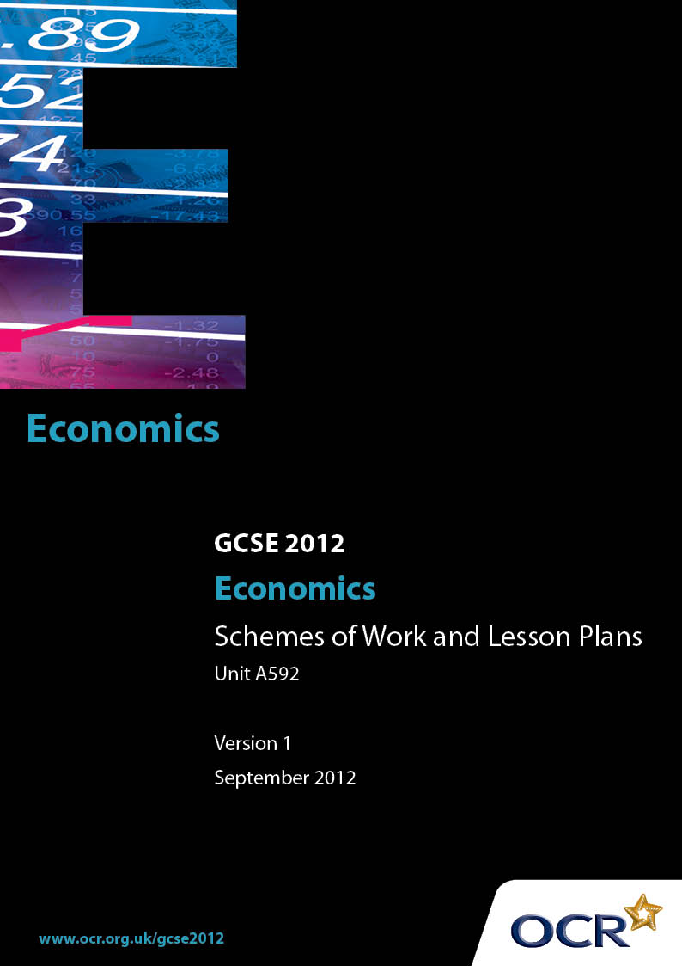

Contents
Introduction 3
Sample Scheme of Work: OCR GCSE Economics J320 Unit A592: How the
economy works 5
Sample Lesson Plan: OCR GCSE Economics J320 Unit A592: How the
economy works 17

Introduction

Background
Following a review of 14 – 19 education and the Secondary Curriculum Review, the Qualifications and Curriculum Authority (QCA) has revised the subject criteria for GCSEs, for first teaching in September 2009. This applies to all awarding bodies.
The new GCSEs have more up-to-date content and encourage the development of personal, learning and thinking skills in your students.
We’ve taken this opportunity to redevelop all our GCSEs, to ensure they meet your requirements. These changes will give you greater control of assessment activities and make the assessment process more manageable for you and your students. Controlled assessment will be introduced for most subjects.
From September 2012 assessment tasks may be undertaken at any point between release of the task and the examination series for which the task must be submitted. Centres must ensure that candidates undertake a task that is valid for submission in the year in which the candidate intends to submit it.
OCR has produced a summary brochure, which summarises the changes to Economics. This can be found at www.ocr.org.uk, along with the new specification.
In order to help you plan effectively for the implementation of the new specification we have produced these Schemes of Work and Sample Lesson Plans for Economics. These Support Materials are designed for guidance only and play a secondary role to the Specification.

Our Ethos
OCR involves teachers in the development of new support materials to capture current teaching practices tailored to our new specifications. These support materials are designed to inspire teachers and facilitate different ideas and teaching practices.
Each Scheme of Work and set of sample Lesson Plans is provided in Word format – so that you can use it as a foundation to build upon and amend the content to suit your teaching style and students’ needs.
The Scheme of Work and sample Lesson plans provide examples of how to teach this unit and the teaching hours are suggestions only. Some or all of it may be applicable to your teaching.
The Specification is the document on which assessment is based and specifies what content and skills need to be covered in delivering the course. At all times, therefore, this Support Material booklet should be read in conjunction with the Specification. If clarification on a particular point is sought then that clarification should be found in the Specification itself.

A Guided Tour through the Scheme of Work

= Innovative Teaching Idea
This icon is used to highlight exceptionally innovative ideas.

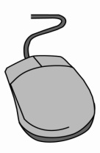
= ICT Opportunity
This icon is used to illustrate when an activity could be taught using ICT facilities.

OCR GCSE Economics J320 Unit A592: How the economy works
Suggested teaching time | 3 hours | Topic | The objectives of government policy
Topic outline |  | Suggested teaching and homework activities |  | Suggested resources | Points to note
An introduction to how the economy works |  | - Collect one week’s worth of daily quality newspapers. Working in pairs/small groups, students find economic news /stories / articles. These are collated in class to find the topics covered, which may include inflation, jobs, interest rates, taxes, etc. Discussion of the relevance of these issues to the individual students and their families. Use the idea of interdependence within the economy and possibly a simple circular flow of income. |  | - OCR GCSE Economics Heinemann text  - National newspapers | - No detail required at this stage but rather an overview of Unit 2
An introduction to government policies |  | - Introduce the four main objectives of government macro economic policies, i.e. maintaining full employment, ensuring price stability, achieving economic growth and balancing exports and imports.  - Discuss possible ways of achieving each objective.  - Summarise the three policies used to achieve these objectives, i.e. fiscal, interest rate and supply side policies, and emphasise that a combination of policies could be used.  - Use spider diagrams to summarise. |  | - OCR GCSE Economics Heinemann text  - Newspapers | - Conflicts between objectives will be dealt with later.  - Consider which objectives and policies to achieve them are currently relevant in the UK.

OCR GCSE Economics J320 Unit A592: How the economy works
Suggested teaching time | 4 hours | Topic | Economic Growth
Topic outline |  | Suggested teaching and homework activities |  | Suggested resources | Points to note
  Defining and measuring economic growth |  | - Definitions required for economic growth, GDP and GDP per capita.  - Calculations of growth rates and GDP per capita can be practised.  - GDP and GDP per capita figures can be compared between countries, e.g. the ‘Top 20’ can be identified. |  | - OCR GCSE Economics Heinemann text  - Worksheet for calculations  - ICT opportunity Internet for country comparisons, e.g. World Bank website | - Extension opportunity:  - Production Possibility Curves are not required but teachers may wish to introduce the concept and relate economic growth to an outward shift in the PPC.  - Extension opportunity: different measures could be considered and compared.
Causes of economic growth |  | - Students to suggest factors which could enable a country to increase its output. Relate to factors of production from unit A591. Suggested use of PowerPoint presentation to introduce the causes.  - Students to practise a mini essay on the causes of growth. |  | - OCR GCSE Economics Heinemann text  - PowerPoint presentation | - Extension opportunity: case studies could be used, e.g. UK growth in the industrial revolution, rise of Middle East oil producers, more recent Chinese growth.
  Costs and benefits of economic growth |  | - Scope for discussion or debate – is more growth always beneficial for an economy?  - From this, various benefits and costs of growth should become apparent.  - There are many environmental issues which could be explored, and costs and benefits evaluated, such as global warming, destruction of rainforests, building on flood plains. |  | - OCR GCSE Economics Heinemann text  - including activity on sources of energy  - ICT opportunity Newsletters / campaign leaflets / magazines / websites of environmental organisations such as Greenpeace, friends of the Earth. | - Extension opportunity – a specific issue which has a connection with economic growth could be researched, e.g. whether to build a major airport in the Thames estuary.

OCR GCSE Economics J320 Unit A592: How the economy works
Suggested teaching time | 4 hours | Topic | Employment and Unemployment
Topic outline |  | Suggested teaching and homework activities |  | Suggested resources | Points to note
Unemployment and its causes |  | - Definitions / explanations required for employment, unemployment, Claimant Count and Labour Force Survey.  - ICT opportunity: students given figures for both measures of unemployment over a time period and plot graphs using Excel. |  | - OCR GCSE Economics Heinemann text  - ICT opportunity ONS website for unemployment figures | - Extension opportunity – research into regional unemployment rates to find out if there are significant differences.
Types and causes of unemployment |  | - Distinguish between the various types of unemployment and their causes. A PowerPoint presentation could be used.  - Students can be given various scenarios and have to identify the type of unemployment. |  | - OCR GCSE Economics Heinemann text  - PowerPoint presentation | - Voluntary, seasonal, frictional, structural, technological and cyclical are the types of unemployment to cover here.
Effects of unemployment |  | - Discussion about the possible effects of unemployment. From this, the consequences of unemployment for both the unemployed and their families and the economy as a whole should be identified and explained. |  | - OCR GCSE Economics Heinemann text  - ICT opportunity Websites such as the BBC and The Times for news stories about unemployment. | - Extension opportunity – for teachers who have introduced PPCs, unemployment can be applied to a PPC diagram.

OCR GCSE Economics J320 Unit A592: How the economy works
Suggested teaching time | 3 hours | Topic | Price Stability and Inflation
Topic outline |  | Suggested teaching and homework activities |  | Suggested resources | Points to note
Inflation and its measurement |  | - Definitions / explanations required for price stability, inflation and rate of inflation.  - ICT opportunity: students given figures for inflation rates over a time period and plot graphs using Excel.  - Introduce the Consumer Prices Index and explain how it measures inflation / changes in the cost of living. Student practise index and inflation rate calculations.  - Homework task to check interpretation of inflation graphs – a fall in the inflation rate is not a fall in the price level! |  | - OCR GCSE Economics Heinemann text  - ONS website for inflation figures  - Worksheets for simple calculations of consumer price index and rates of inflation | - Students should understand that weighting in the CPI reflects the pattern of consumers’ expenditure, but weighting calculations are not required.
The causes of inflation |  | - Introduce the ideas of demand-pull, monetary and cost-push inflation, and the wage-price spiral.  - Case studies could be used, for example UK’s inflation rate to Sept 08 was 5.2% (well above target) – what were the causes?  - What caused hyperinflation in Zimbabwe? |  | - OCR GCSE Economics Heinemann text  - PowerPoint presentation  - ICT opportunity Websites such as the BBC and The Times for news reports e.g. with regard to oil, food price changes. | - The monetary cause of inflation could be treated as a third cause of inflation or it could be treated as an aspect of demand pull inflation.
The consequences of inflation |  | - Discussion of the effects of inflation, and who are affected. Are there winners and losers?  - From discussion, the main effects are identified and explained. |  | - OCR GCSE Economics Heinemann text  - PowerPoint presentation  - Paper money, e.g. Zimbabwean $1000000 note. | - There must be a distinction between the benefits of a low, stable rate of inflation and the costs of high inflation rates.

OCR GCSE Economics J320 Unit A592: How the economy works
Suggested teaching time | 3 hours | Topic | Government Income and Expenditure
Topic outline |  | Suggested teaching and homework activities |  | Suggested resources | Points to note
Government revenue and expenditure |  | - Discussion based on prior knowledge – 1. What does the UK government provide for its citizens? The main areas of government spending to be identified. 2. Where does the money come from? Some taxes to be identified.  - Individual, pairs or group work: ‘Chancellor for the day’: which areas of spending and tax would you change? Give reasons for your choices. This can lead to plenty of discussion and debate. |  | - OCR GCSE Economics Heinemann text  - ICT opportunity The Treasury website | - ‘Chancellor for the day’ can be used early in the topic so students can apply their preconceived ideas to the task. They can be introduced to concepts such as progressive taxation later as the topic progresses.
Direct and indirect taxation |  | - Definitions and distinction between direct and indirect taxation required.  - Match it’ task: students can match definitions of taxes to their names and classify each as direct or indirect.  - Explain the economic effects of changes in both direct and indirect taxes, and so introduce arguments for and against each type of tax.  - Homework mini essay e.g. whether to fund extra health spending from income tax or VAT. |  | - OCR GCSE Economics Heinemann text including taxation activity  - ICT opportunity Treasury website for details of taxes | - When evaluating the effects of changes in direct or indirect taxes, issues such as equity (fairness), incentives, choice, and demerit goods should be considered.

OCR GCSE Economics J320 Unit A592: How the economy works
Suggested teaching time | 3 hours | Topic | Redistribution of Income
Topic outline |  | Suggested teaching and homework activities |  | Suggested resources | Points to note
Distribution and redistribution of income |  | - Initial discussion – why are incomes unevenly distributed?  - Links can be made with A591 wage determination.  - Scope for a quiz – who are the richest businesspersons / musicians / pop stars / sportspersons? Why are they so well rewarded?  - Discussion or debate – should redistribution take place? |  | - OCR GCSE Economics Heinemann text  - Newspapers for job vacancies and rates of pay.  - ‘The Rich List’ published annually by the Sunday Times. | - Uneven income distribution should not be confined to wage differentials. Income from ownership of assets should be considered as should reliance on state benefits.
Methods of redistribution and their consequences |  | - Students are introduced to progressive, proportional and regressive taxes, and transfer payments.  - Numerical examples can be used to distinguish between the taxes.  - Discussion or debate – should sixth formers receive EMA?  - Homework based on the quintiles chart to explain how the redistribution has been achieved. |  | - OCR GCSE Economics Heinemann text including chart showing original and final income by quintiles.  - Worksheets for numerical examples of progressive, proportional and regressive taxes. | - Extension opportunity – find out which state benefits are available and whether they are means-tested or not.

OCR GCSE Economics J320 Unit A592: How the economy works
Suggested teaching time | 3 hours | Topic | Correcting Market Failure
Topic outline |  | Suggested teaching and homework activities |  | Suggested resources | Points to note
Positive and negative externalities |  | - Students introduced to concepts of positive and negative externalities.  - Case studies could be used to identify externalities, e.g. building of the Three Gorges Dam. |  | - OCR GCSE Economics Heinemann text  - ICT opportunity Publications and websites of environmental organisations such as Greenpeace, Friends of the Earth, RSPB, WWF.
Policies to correct market failure regarding externalities |  | - Policies to reduce negative externalities including taxation and charges, laws and regulation, and subsidies (e.g. to public transport) are identified and explained, with examples.  - Students should understand that government provision of merit goods provides positive externalities. |  | - OCR GCSE Economics Heinemann text | - Extension opportunity - discussion of consequences of policies to reduce smoking in the UK.  - This could include actual policies such as smoking ban, raising the purchasing age; and possible policies such as making tobacco illegal.
Policies to correct market failure regarding externalities: a case study |  | - Case study – policies to reduce negative externalities associated with road traffic. |  | - Enclosed lesson plan | - Extension opportunity – research into the impact of a specific measure, e.g. the London congestion charge

OCR GCSE Economics J320 Unit A592: How the economy works
Suggested teaching time | 2 hours | Topic | Fiscal Policy
Topic outline |  | Suggested teaching and homework activities |  | Suggested resources | Points to note
Fiscal policy and its effects |  | - Introduce the concepts of the balanced budget, budget surplus and budget deficit, and explain how a surplus or a deficit affects the whole economy.  - It is important to relate fiscal policy to the objectives of government policy previously considered in this unit. |  | - OCR GCSE Economics Heinemann text  - ICT opportunity The Treasury website, in particular the pages devoted to the Budget. | - Fiscal policy will have a multiplier effect on the economy. The basic working of the multiplier should be understood.

OCR GCSE Economics J320 Unit A592: How the economy works
Suggested teaching time | 2 hours | Topic | Monetary and Interest Rate Policy
Topic outline |  | Suggested teaching and homework activities |  | Suggested resources | Points to note
Money and interest rates |  | - Introduce money – what forms it takes and its functions.  - Use bank/building society leaflets and /or websites to identify many different rates of interest at any one time. Discussion leads to reasons for these different rates. |  | - OCR GCSE Economics Heinemann text  - ICT opportunity Leaflets from and websites of banks and building societies
Interest rate policy |  | - Introduce the framework of UK monetary / interest rate policy with the role of the MPC of the Bank of England  - Students need to understand why a rise in interest rates leads to a fall in (aggregate) demand in the economy.  - It is important to relate interest rate policy to the objectives of government policy previously considered in this unit. |  | - OCR GCSE Economics Heinemann text  - ICT opportunity Bank of England website | - The effects of interest changes on consumption via effects on mortgage interest payments, buying on credit and rewards for saving should be understood.  - Teachers may also refer to effects on investment and the exchange rate.

OCR GCSE Economics J320 Unit A592: How the economy works
Suggested teaching time | 1 hour | Topic | Supply Side Policies
Topic outline |  | Suggested teaching and homework activities |  | Suggested resources | Points to note
Supply side policies |  | - Students could work in pairs or groups to suggest how the economy could produce more output.  - Their ideas can be collated in class.  - Consideration should then be given to whether there is a role for the government with regard to each of these suggestions.  - Supply side policies which could be identified and explained include education and training, reducing direct taxes, reducing state benefits, encouraging enterprise, research and development and innovation, and reducing monopoly power.  - It is important to relate supply side policies to the objectives of government policy previously considered in this unit. |  | - OCR GCSE Economics Heinemann text  - ICT opportunity Websites for news articles regarding the economy and government policies, e.g. BBC, The Times. | - Other supply side issues could be considered. E.g. the UK economy has used labour from eastern EU countries.

OCR GCSE Economics J320 Unit A592: How the economy works
Suggested teaching time | 2 hours | Topic | Government Policies and Conflicts
Topic outline |  | Suggested teaching and homework activities |  | Suggested resources | Points to note
Comparison of policies  Conflicts of government objectives |  | - Fiscal, monetary and interest rate policies should be compared.  - Students can be given scenarios, e.g. reducing unemployment is the top priority; and asked to provide details of policies which they recommend. They should then identify possible problems and conflicts with other objectives. |  | - OCR GCSE Economics Heinemann text  - ICT opportunity Websites for news articles regarding the economy and government policies, e.g. BBC, The Times.  - Treasury website  - Bank of England website | - Extension opportunity: Find out the current direction of fiscal and monetary policies. For example, if there is a budget deficit is it rising or falling? Are interest rates going up or down? Are the policies complementing or conflicting with each other? Which seem to be currently the priority objectives of policy?  - At the end of this unit is important that students ‘see the overall picture’ of the economy, i.e. how the economic variables and policies relate to one another, and the roles of individuals and groups within the economy.

OCR GCSE Economics J320 Unit A592: How the economy works

Policies to correct negative externalities
OCR recognises that the teaching of this qualification above will vary greatly from school to school and from teacher to teacher. With that in mind this lesson plan is offered as a possible approach but will be subject to modifications by the individual teacher.
Lesson length is assumed to be one hour.

Learning Objectives for the Lesson
Objective 1 | Students to explain what is meant by negative externalities or external costs.
Objective 2 | Students to be able to apply their understanding of the concept to road transport.
Objective 3 | Students to analyse and evaluate policies to reduce negative externalities caused by road transport.

Recap of Previous Experience and Prior Knowledge
- There are many opportunities for extension material. For example, research could be undertaken into the impact of the Congestion Charge following its introduction in London.

Content
Time | Content
5 minutes | Lesson objectives are communicated to the students. Q & A session to find the meaning of negative externalities. Students suggest their own examples. Students can give a written explanation.
5 minutes | Students to work in small groups to identify the negative externalities associated with road transport (private cars, vans, trucks, etc). They should be able to identify air pollution/carbon emissions, noise pollution, congestion and danger to other road users/road casualties.  Teacher could present a PowerPoint with some of these external costs quantified.
30 minutes | Each student group is allocated a possible method of reducing the external costs of road traffic. Suggested methods include:  Higher taxes on petrol and diesel.  Increased vehicle excise duty (road tax), with more tax on the greater polluters.  Subsidies for public transport.  Road tolls and/or congestion charge.  Direct restrictions such as bus only lanes in towns, motorway lanes prohibited for cars with no passengers.  Build more roads.  Students can use the internet to find arguments for or against their method, e.g. websites of motoring organisations, environmental pressure groups.
15 minutes | Each group reports back their findings to the whole class. Teacher-led discussion of the issues raised by the findings. Concepts such as price elasticity of demand (tax on fuel), costs to taxpayers (subsidies, road building) may be referred to. Students could vote on their preferred option if desired.

Consolidation
Time | Content
5 minutes | Teacher to summarise key points and refer back to the lesson objectives. Introduce a written homework task ‘Evaluate two policies which the UK government could use to reduce pollution and congestion caused by road traffic.’

