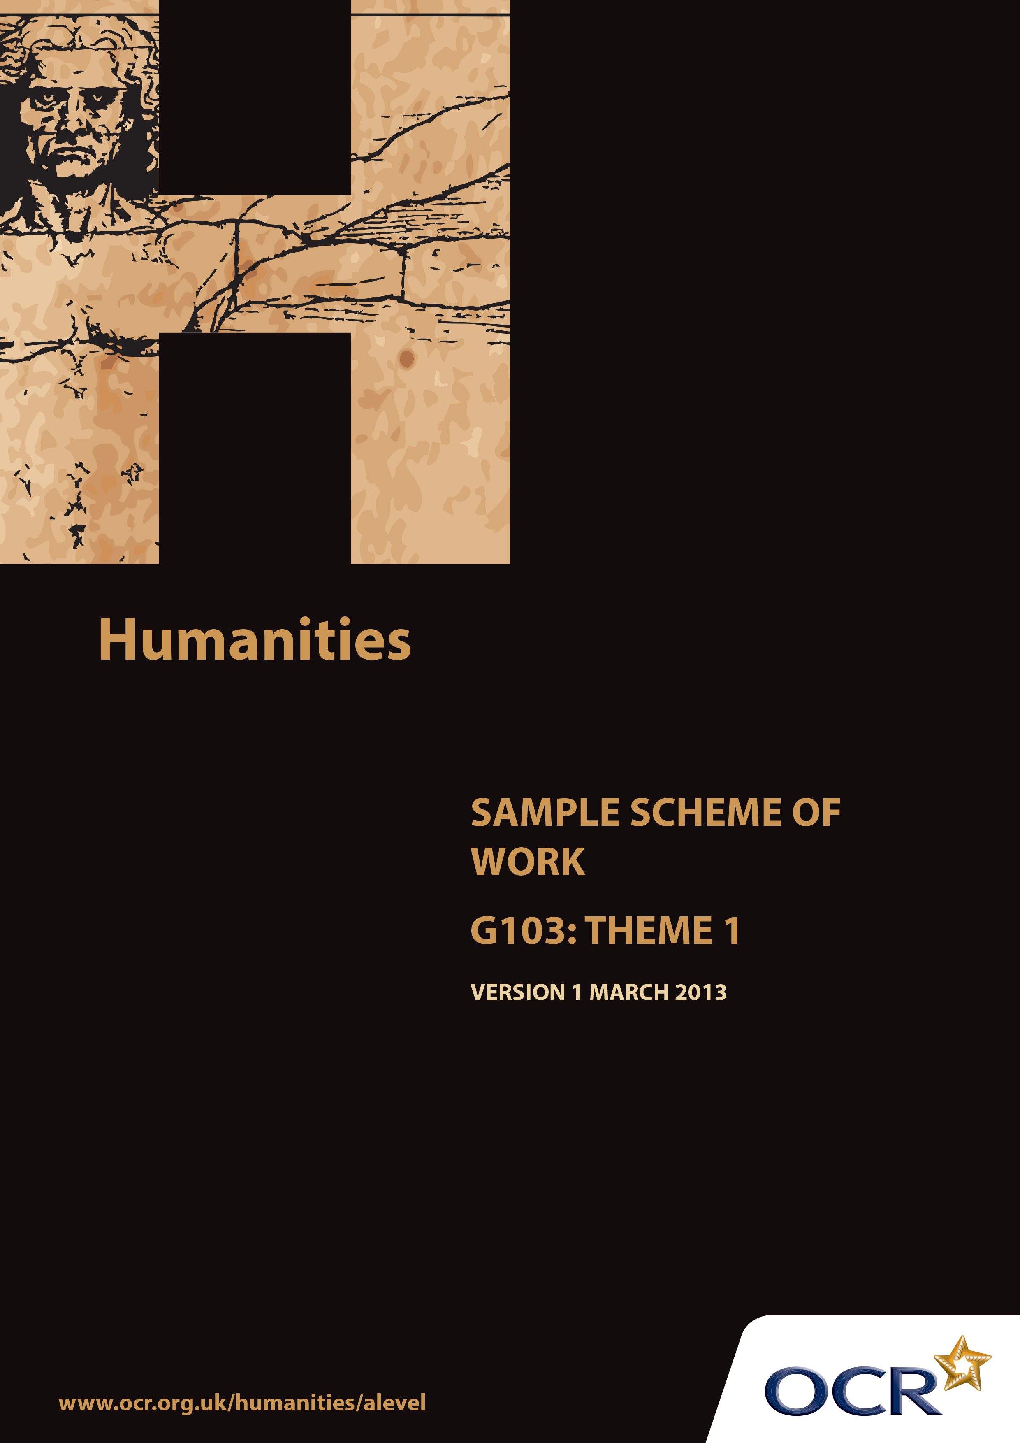
TWENTY FIRST CENTURY SCIENCE SUITE
SCHEMES OF WORK AND LESSON PLANS
B1: You and your genes
VERSION 1.1 JULY 2011
Introduction
OCR involves teachers in the development of new support materials to capture current teaching practices tailored to our new specifications. These support materials are designed to inspire teachers and facilitate different ideas and teaching practices. Each Scheme of Work is provided in Word format – so that you can use it as a foundation to build upon and amend the content to suit your teaching style and students’ needs.
The Scheme of Work provides examples of how to teach this unit and the teaching hours are suggestions only. Some or all of it may be applicable to your teaching.
The Specification is the document on which assessment is based and specifies what content and skills need to be covered in delivering the course. At all times, therefore, this Support Material booklet should be read in conjunction with the Specification. If clarification on a particular point is sought then that clarification should be found in the Specification itself.

Sample Scheme of Work
GCE Humanities
G103: International and Global Controversies Theme 1: Inequalities in living standards

Suggested Teaching Time: 15 Hours

Aims of the whole unit

This unit is about analysing the nature of recent global controversies, reviewing evidence from across a range of disciplines which challenges or supports particular views. The focus is international, with a time frame of the last 25 years.

The unit will develop:
- Candidates’ intellectual curiosity about current global issues
- The skills and attributes of working independently
- The ability to consider different sides of controversies objectively and to select and analyse relevant evidence from across a range of academic disciplines
- The ability to construct a reasoned argument and reach independent substantiated conclusions
- Essay writing skills to present arguments and findings in a clear, coherent way.

Content of this theme

This theme responds to two key aspects of the economic, political and ethical debate over global inequality in the last 25 years – debates which continue to be urgently relevant. The UN’s Millennium Development Goals identify inequalities in health and the consequences of those inequalities as a major factor in global injustice, and seek to make progress in tackling them by 2015. From the Live 8 response to G8 international debt agreement to continuing debates over aid and trade, broader inequalities of wealth and their consequences continue to be a major issue. This sequence of lessons provides some starting points for students to explore these problems and both gather and evaluate relevant evidence in order to increase their levels of knowledge. It then goes on to provide some structured sequences for debating and judging this evidence, and producing sustained academic arguments in written form.

Teaching this unit

All the topics can be studied with reference to the following key questions:
- What is the current situation?
- Why is this happening?
- What, if any, action needs to be taken?

Sample Scheme of Work
GCE Humanities
G103: International and Global Controversies Theme 1: Inequalities in living standards

The function of expanded content

The specification responds to the key questions, and the expanded content provides resources and prompts for the students to develop the skills of academic curiosity, independent working, objective analysis from across the range of academic disciplines, reasoned argument and essay writing using those key questions. The structure is iterative, repeating these skills for each part of the theme and across themes to give students the opportunity to absorb and retain the required knowledge, and to practice the skills through deliberately organised rehearsal using targeted feedback.

Topic outline | Suggested teaching and  homework activities | Suggested resources | Points to note
Introduction to the theme and the unit | Introduce the overall content (theme areas) and assessment focus of this unit.  Help students to use a checklist to conduct an audit of skills they have learnt at AS, especially those of critical analysis of sources, research, and writing and other presentational skills for different academic purposes. Share the results of this audit with one another and the class. | Short summary of course content and assessment.  Simple checklist which will allow students to indicate where they think they have fully achieved, partially achieved or not achieved a list of key course skills. Leave blank rows for them to add items of their own. | Given the nature of the course, it is important at the outset for students to realise they are building on core skills they developed at AS, so the first task aims to encourage them to make those connections.
Inequalities in health – what is happening? | Introduce context of the UN’s Millennium Development Goals by exploring the official website and watching the ‘Make it Happen’ (2008) video using a gapped worksheet to prompt for notes on the specific inequalities of health which are highlighted. There may be some discussion of the credibility and reliability of this source (e.g. reputation, selectivity, currency).  Split class between child health (goal 4), maternal health (goal 5) and reducing HIV/AIDS (goal 6). Each group in turn should divide up to read the appropriate data and context for these goals on the UN website and report back to the rest of the class on what they have found.  As a more accessible alternative for this activity, students could use the UN Cyber School Bus on the MDGs, which is organised by goal in a similar way.  Homework: ask students to visit the UN WHO factfile on health inequities and their causes. Make notes on the definition of health inequity and the factors associated with the causes of health inequity. | UN Millennium Development Goals website:  http://www.un.org/millenniumgoals/  ‘Make it Happen’ video: http://webcast.un.org/ramgen/ondemand/documentary/2008/mdg_makeithappen_081017.rm?start=00:00:11&end=00:04:38  UN Cyberschool Bus on the MDGs:  https://cyberschoolbus.un.org/mdgs/flash/index.asp  UN WHO Factfile on ‘Health Inequities and their causes’:  http://www.who.int/features/factfiles/health_inequities/en/index.html
Why is this happening? Investigating the evidence base. | Divide class into 4 groups to research the evidence on sanitation, clean water, adequate nutrition and access to medicines. Groups use suggested resources as starting points for their research, some of which could be used initially with the whole class to exemplify the analysis and evaluation of evidence in terms of credibility, reliability, relevance and significance.  Each group could produce a poster presentation which identifies relevant evidence, evaluates it and links it to the possible causes of health inequality identified in the WHO factfile homework. | Sanitation: http://www.un.org/waterforlifedecade/sanitation.shtml (UN page on water for life decade on sanitation)  Clean water:  http://www.un.org/waterforlifedecade/quality.shtml (UN page on water for life decade on water quality)  Nutrition:  http://www.worldhunger.org/articles/Learn/world%20hunger%20facts%202002.htm (World Hunger Education Service charity factsheet on world hunger in 2012)  Access to medicines:  http://www.parliament.uk/business/publications/research/briefing-papers/POST-PN-160 (Parliamentary Office of Science and Technology: briefing note on access to medicines in the developing world) | This sequence of 2-3 lessons contains some guided teaching content on methods of evaluating evidence, but also gives students the opportunity in groups, with some seed resources, to engage in their own research and to evaluate and present their findings. The aspects of health inequality identified in the specification allow for contrasting foci, but also contrasting evidence types from across the humanities.
What, if any, action needs to be taken? Analysing and evaluating contrasting arguments. | Either ask students to read the two opposing arguments in advance, or break the documents down (by colour-coding or into physical sections) for reading in class. Practice analysing the argument structure to establish the two positions and discuss how strong they are based on the evidence that has been explored so far. Students then come up with and explain their own judgements on the issue.  Homework:  Students produce a scaffolded piece of work with the title: ‘What, if any, action needs to be taken about global health inqualities?’  - Explain what the situation is with examples of different inequalities  - Analyse the evidence for why it is happening  - Suggest the best solution and justify this. | A sceptical argument on aid and health: Laura Freschi, ‘Does health aid to governments make governments spend more on health?’, http://aidwatchers.com/2010/04/does-health-aid-to-governments-make-governments-spend-more-on-health/  A positive, contrasting one: Bill Gates, ‘Why Is Foreign Aid Important?’ http://www.thegatesnotes.com/Topics/Development/Why-Development-Aid-Matters | Having established the overall context for global health inequalities and some of the key factors (level of development, access to healthcare, poverty, specific disease types, etc), the focus now shifts to the skills of analysing and evaluating contrasting arguments on the solutions to these inequalities and the evidence which could be used to support students’ own judgements.
Inequality of wealth. What is happening, and why is it happening? | Use the ‘Is Inequality Wrong?’ section of the Why Poverty? site to explore issues of inequality of wealth. One possible sequence is to watch and discuss the first video in the list, then select one or two of the other videos, then ask groups to read and feed back on the articles listed at the end of the page. | ‘Is Inequality Wrong?’ on the ‘Why Poverty?’ website: http://www.whypoverty.net/en/article/631/ | This session, coming after the first iteration, both turns to inequalities of wealth and uses the excellent Why Poverty resource to use video and written resources to encourage students to identify the issues, explore explanations and collate their findings. As this site tends to focus on inequality within countries, it will then be appropriate to turn more explicitly to global inequalities in subsequent lessons.
The distribution of wealth between countries. What is happening? | The resource from Global Finance magazine contains some useful maps which could be printed or displayed on an interactive whiteboard. They could be used by groups or a whole class to generate ideas about global patterns, which could then be summarised using the key terms which the site clarifies (i.e. ‘wealth distribution’ and ‘income inequality’). | ‘Global Finance Magazine’, ‘Wealth Distribution and Income Inequality by Country’: http://www.gfmag.com/tools/global-database/economic-data/11944-wealth-distribution-income-inequality.html
Why is it happening? Exploring explanations for inequality of wealth through research. | Having established some context, some key data and some of the central terms, in the spirit of greater independence students can now be asked to undertake a research task and gather together some sources which will provide them with a range of possible explanations (and perhaps approaches to the problem). As a starting point (perhaps using your institution’s VLE) you could point students towards the Poverty and Inequality page on ‘Share the World’s Resources’. Some of the sources share the perspective of this charity, but it also includes a link to an Economist article for a contrasting view.  There is also a wealth of other sources available via Internet searches. However, some kind of prompt to evaluate for credibility and bias will be crucial as students explore these. | ‘Poverty and Inequality’ on Share the World’s Resources: http://www.stwr.org/poverty-inequality/  Other potential resources:  BBC News: http://www.bbc.co.uk/news/business-16545898  The Guardian:  http://www.guardian.co.uk/money/2006/dec/06/business.internationalnews  Inequality.org:  http://inequality.org/global-inequality/  OECD: http://www.oecd.org/site/worldforumindia/Davies.pdf
Why is it happening? Recording answers | Given the need to retain a sense of the overall picture and recall specific information for the exam, it would be good to record what has been found so far as a class. This could be done with a large map of the world on the board. Groups and individuals could then annotate different parts of it with data they have collected about inequalities of wealth and possible explanations (with sources). The whole class could then review what has been collected.
What, if any, action needs to be taken?  Proposing some answers. | Organise a class debate (with proposer, seconder, responders on the other side and a moderator, etc) around one possible solution to global inequality of wealth: reforming trade between countries. The Economist debate on fair trade can be used to structure the debate and as a source of arguments which can be analysed, evaluated and responded to on each side. Students can draw on the evidence they have already researched and a vote can be held at the end. | Economist Debates – Fair Trade: http://www.economist.com/debate/overview/172  How to set up a debate: instructions from the Guardian and English Speaking Union: http://www.guardian.co.uk/higher-education-network/teacher-blog/2012/jun/18/pupil-class-debate
Combining the questions: writing task | At this stage, students can be reminded of the scaffolded structure for the health essay, and use it in class to generate materials in an appropriate sequence in answer to the following question:  ‘To what extent are rich nations responsible for solving the problems experienced by poorer ones?’  A reflective activity at this point to encourage students to remind themselves of feedback from their last essay and aim to implement targets may well be helpful at this point.  The essay itself can be completed as homework. Alternatively, after the preparatory notes it could be completed in class under timed conditions.

