Preparing for a job interview

Unit 3 – Prepare for and learn from a job interview

Task 1 – Where are you?

One of the things you will need to do is to identify information for a job interview. This could be useful if someone urgently needed to get hold of you when you are at an interview. Find out information about the job interview and fill out the table below.

Here is the information should you need to contact me
during my job interview
Name
Job title
Date of interview
Time of interview
Name of the organisation
Phone number of the organisation
Address of the organisation
Interview address
Email address of the organisation
Contact name/Interviewer
Where did you find the information?
Where else could you have looked for information about a job interview?
Task 2 – What to wear

It can be difficult to decide what to wear at a job interview – but it helps if you know what people often wear in their jobs.

Look at the dress code images on the next page and try to match them with the jobs listed.

Write the letter of the job alongside the image it matches

Letter | Job
A | Electrician
B | Police
C | Animal Care
D | Security Guard
E | Administration
F | Teacher
G | Catering
H | Care
I | Construction
J | Retail
K | Mechanic

Dress Code Images
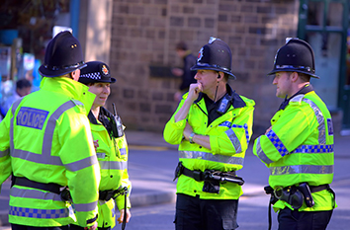


Image letter
Image letter
Image Letter
Image Letter




Image Letter
Image Letter




Image Letter
Image Letter

Image Letter
Image Letter

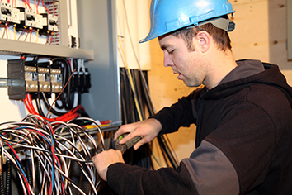

Image Letter
Image Letter




Image Letter
Image Letter

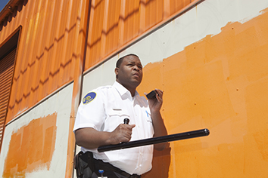

Image Letter

Are these the clothes you would wear to a job interview?

Task 3 – What organisations do

It is important to know what organisations do before you go to an interview.

Cut up the following two sheets into 16 triangles.

Now try to match the name of the organisation with what the organisation does by putting the
correct triangles alongside each other. Start with ASDA at the top.

Keep going until you have used all 16 triangles to make a pyramid.

