Topic Exploration Pack

Theme: Rhythms of the World

Introduction 5
Lesson Activities 7
Suggested repertoire and resources 12
Appendix 15
Language for learning 15
Learner Worksheet 1 17
Learner Worksheet 1 – Answers 18
Learner Worksheet 2 – Greek-style folk dance composition ideas 19

Instructions and answers for teachers

These instructions cover the student activity section which can be found on page 17. This Topic Exploration Pack supports OCR GCSE (9-1) Music.
When distributing the activity section to the students either as a printed copy or as a Word file you will need to remove the teacher instructions section.

Introduction
This Area of Study explores the traditional rhythmic roots from four geographical regions of the world:
- India and Punjab
- Eastern Mediterranean and Middle East
- Africa
- Central and South America.
The rhythmic element is a starting point for a wider study, essentially involving other musical elements. Knowledge and understanding of characteristic rhythms and metres is the initial focus of study. From this starting point candidates will learn about instrumentation, and ways in which performers work together. A range of musical elements will be integral to the learning, including tempo, structure, melody, timbre, harmony and phrasing.
Some of the music of the regions listed will be familiar to teachers, while others may not be. Listening to a variety of recordings and watching video clips will help gain familiarity with the characteristic musical features of each chosen region of the world.
This Exploration Pack gives suggested repertoire and resources (see below) for all the listed geographical regions. Hopefully these will give insight and helpful teaching ideas. The Exploration Pack will also give specific resources which focus on teaching ideas and approaches for traditional Eastern Mediterranean and Middle Eastern folk music.

Learning aims and objectives
- To consider the characteristic rhythms and features of the music from the geographical regions listed above, involving:
  - Listening and class discussion
  - Starter activities.
- To develop creativity through composition and performance exercises:
  - Short taster exercises.
  - Group activities.
  - Extended composition activities.
- To learn how to develop and extend composition ideas:
  - Learning from good examples of rhythmic and melodic development.
- To develop an awareness of musical structure, including:
  - Introduction.
  - Rhythmic ideas and motifs.
  - Melodic ideas and themes.
  - Phrases and Sections.
  - Modulation.
  - Development.
  - Ending.

Focus for learning and understanding
For each geographical region listed above, learners should study and develop an understanding of:
- Characteristic rhythms and metres.
- The origins and cultural context of the traditional music.
- The musical characteristics of the folk music.
- The impact of modern technology on traditional music.
- The names of performers and groups.
For traditional Eastern Mediterranean and Middle Eastern folk music, learners should study and develop an understanding of:
- The irregular rhythms and metres often found in Greek and Palestinian folk dances.
- Melodic shapes, including modal ideas.
- Parallel melodic lines.
- Harmonic support.
- Phrasing and cadences.
- Structure and texture and how the parts are combined.

Lesson Activities

Starters and plenaries
Beginning each lesson with a short Starter Activity will help to capture the imagination of the students and draw on their prior knowledge and learning. A succession of starter and plenary activities throughout a Unit of Work will help to maintain interest and reinforce vocabulary. Ideas include:
- Matching cards – pictures of drums from around the world, with separate name cards that learners match together. Cards labelled with the geographical regions can also be included. Learners can work in pairs or small groups to encourage discussion. Correct answers could be displayed on a PowerPoint presentation and short audio extracts will help to reinforce learning. Discussion about the way the instruments are played can follow.
- Listening exercises (see the Learner Worksheet 1 in the Appendix for sample questions and answers) – depending on the time available in each lesson, short or longer extracts can be played to illustrate timbre, structure and a range of musical elements.
- Group activities (see the suggestions and short musical excerpts given below) – with a selection of short rhythmic and melodic ideas, a layered piece of music can be created, giving learners an awareness of how parts work together. Creating short compositions in a relaxed environment is an ideal way of leading into more lengthy, structured, individual composition work. Experimenting with a range of starting points, including a variety of melodic shapes, rhythmic ideas or chords, will give the learners confidence and experience in composing, maintaining the ‘fun’ aspect of this activity.

Main activities
Learning gained from the Areas of Study will be required in the Listening Examination. To prepare for this, longer, more structured listening and appraising activities will be needed. Learners will develop skills in identifying musical elements and being able to appraise and make critical judgements, using appropriate musical vocabulary from the Language for Learning.
Learners will also need to link their Composition 2 in Component 2 with a specific Area of Study. A selection of stimuli will be provided by the exam board. One of these must be selected as the basis and starting point for the composition. Learners may wish to combine their chosen stimulus with the specific musical features of one of the geographical regions listed in Area of Study 3.
During the course, learners will discover how to organise their material and ideas into structured compositions and further their skills in composing. They will also learn about how creative ideas can be enhanced by the use of instrumentation, dynamics and texture. Some may wish to experiment with loops using a sequencer and add melodic and rhythmic ideas above. Some may be creating layered tracks using a program such as Sibelius and may wish to experiment with a variety of instrumental timbres in order to compare the effect. Others may be competent performers and may wish to record short ideas to be developed subsequently.

‘Taster’ activities
- Starter activity (eg. matching cards), with a discussion to reinforce vocabulary and resolve any misconceptions about the chosen instruments and the way they are played.
- Listening to extract of a Greek folk dance:

The above sound clip requires the latest version of Flash Player. You can download it here: https://get.adobe.com/flashplayer/.
You need to double click the play button.
A second piece is Koritsaki Mou by Elenis (https://www.youtube.com/watch?v=yaLx8TF3wlg or download from here: http://www.amazon.co.uk/Koritsaki-Mou/dp/B001HCSVYC/ref=sr_1_1?ie=UTF8&qid=1426673296&sr=8-1&keywords=Koritsaki+Mou) and Athanasiou from Greek Folk Dances (Monitor label).
The worksheet questions provided in the Appendix can be used in a number of ways. The main purpose is to generate class discussion in a relaxed environment rather than cause stress by using the sheets for a ‘test’ (although a ‘test’ situation is necessary later in the course). A sample score is also included in the Appendix.
- Discussion, involving answers to the given questions about rhythm, metre, instrumentation, layers and contrasting roles etc.
- Discussion about the musical elements of Koritsaki Mou and how similar ideas can be used to create a composition, focussing on the:
- rhythmic ideas (especially the idea of irregular patterns)
- bassline (clear tonic/dominant repeating pattern)
- melodic shape (including repeated notes, modal ideas and parallel melodies)
- ornamentation (to decorate repeated notes)
- use of percussion (enhancing the rhythmic interest)
- accompanying chords (enhancing the texture)
- structure, including phrasing and cadences (clear, regular phrasing and contrasting sections).
- Group practical activities
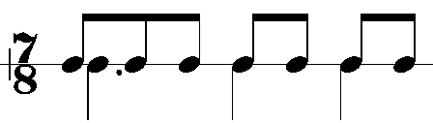
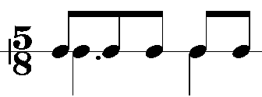
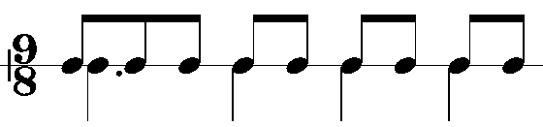
- Rhythm work: Group/class clapping in irregular metres, putting stresses on different beats, with someone in the class to play just the accented notes, eg:
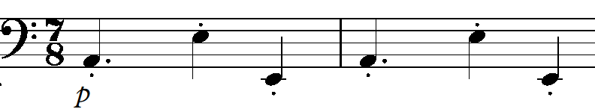
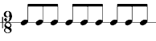
NB: a possible misconception here is that 9/8 (compound) time has to be in 3 groups of 3 quavers, eg:

but in Middle Eastern music, stresses are often placed on different beats in the bar.
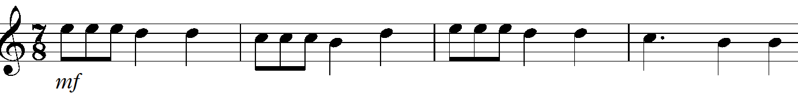
- Bassline: After choosing which metre to work with, a simple repeated bassline can be added below, eg:
- Melodic ideas: A simple melody line can be added above, eg:
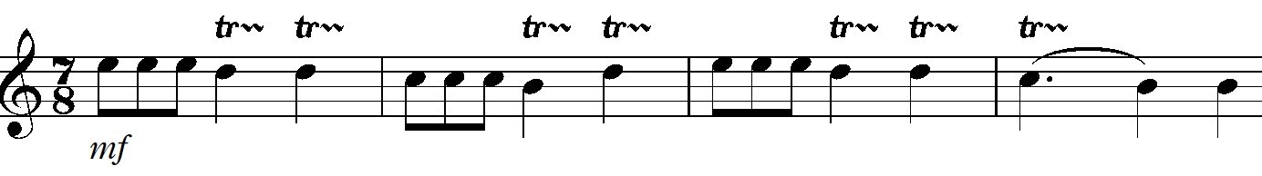

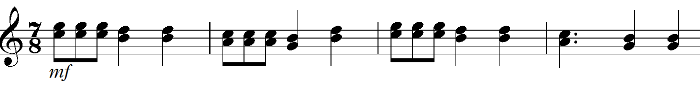
which could be decorated with trills (as played by the Bouzouki in the listening extract), eg:

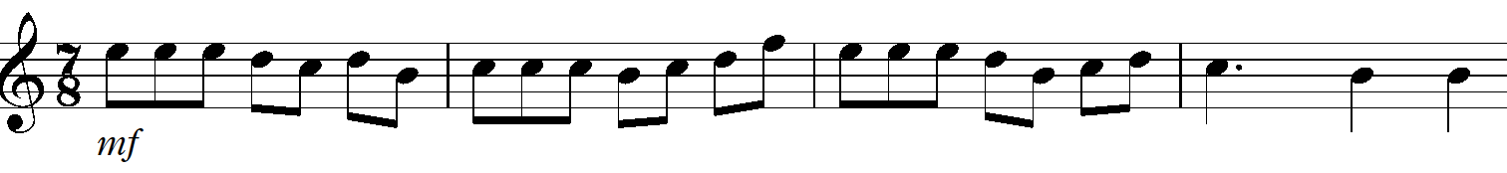
or there could be another parallel part added a 3rd lower (again, as played by the Bouzouki), eg:

There could be more continuous quavers in the melody line, eg:
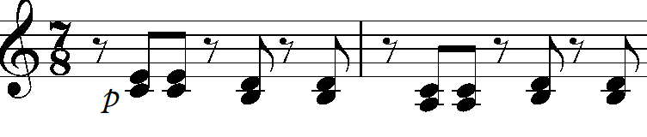
- Chords: Some off-beat chords would add to the rhythmic interest and help to fill out the texture, eg:

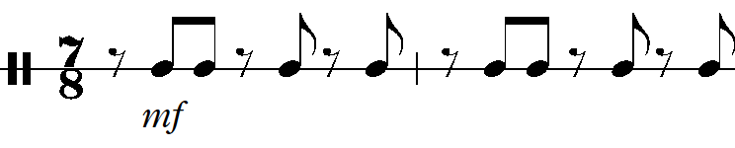
- Percussion: Some off-beat Tambourine (like the Greek ‘Defi’) would also add to the rhythmic interest and help to fill out the texture, eg:
A full score and audio track of the combined ideas given above is available. It consists of a few introductory bars which help to illustrate the kind of effect that can be created using music software.

Structured Composition work for Component 2
All the ideas given above could be extended and developed. After engaging in whole class/group activities, learners may wish to continue composing in this style for their own composition. After choosing an appropriate stimulus for Component 2:
- Layered ideas can be created on software such as Sibelius
- Phrases can be repeated
- Melodic lines can be decorated with additional quavers or semiquavers
- Other parts can be added to give further melodic interest and parallel melodies
- A contrasting section can be added in another mode/key.
Opportunities for reflection and self-assessment should be encouraged regularly, to enable clear thinking and efficient use of allotted time. Success criteria should be shared with each Learner to help them to make effective progress. Many learners know that they need to improve but do not know how to. Interesting examples of good practice from a variety of sources (including exemplar material from former candidates) is invaluable. It is also possible for the teacher to demonstrate how a composition can be developed effectively, by devising a simple motif and then:
- Extending it
- Breaking it up into fragments
- Inverting it
- Adding passing notes
- Decorating it
- Altering the rhythms
- Combining it with other ideas
- Adding harmony.
The class can discuss the effectiveness of the emerging sounds and contribute suggestions. Creating an environment of fun and encouragement gives learners the freedom and incentive to ‘have a go!’

Suggested repertoire and resources
The World Music Network is a useful resource for CDs and information about World Music:
http://www.worldmusic.net/
There are numerous audio CDs produced by the Naxos World label:
http://www.naxos.com/nwgenrelist.asp?genre=World&workcat=World&p_id=I
A number of audio CDs from different labels with the title Drums Of The World contain useful tracks.
There are various resources available for teaching world rhythms in the classroom. Some are designed for KS2 and KS3, but could be a useful starting point e.g.:
World Beats: Exploring Rhythms From Different Cultures (Music Express Extra) which includes resources for Ghana, Brazil and India.
http://www.amazon.co.uk/World-Beats-Exploring-Different-Cultures/dp/0713688904
BBC GCSE Bitesize: Rhythm and Metre
http://www.bbc.co.uk/education/clips/zphq6sg
BBC GCSE Bitesize: Composing Using Rhythm
http://www.bbc.co.uk/education/clips/z33hyrd
BBC GCSE Bitesize: Using Rhythmic Motifs To Develop A Composition
http://www.bbc.co.uk/education/clips/z74yr82
TES teaching resources (a wealth of resources covering all parts of this Area of Study):
https://www.tes.co.uk/teaching-resource/World-music-activities-6071609

Traditional Indian and Punjabi Drumming and Indian Classical Music:
Tabla performances:
BBC GCSE Bitesize: Kathak Indian Dance Music
http://www.bbc.co.uk/education/clips/zkcfgk7
TES teaching resources
https://www.tes.co.uk/TaxonomySearchResults.aspx?keywords=indian+drumming&parametrics=secondary,46153%7c48750%7c51433,46651,i-48750
Punjabi Bhangra
Traditional Dhol playing
Audio CD: Bhangra: Original Punjabi Pop, Arc Music label
Audio CD: Bhangra Beatz, Naxos World label

Traditional Eastern Mediterranean and Middle Eastern Folk Rhythms
Palestinian folk music
Audio CD: Israeli Folk Dances Vol 1, Hataklit label
Eg: Ve’Shuv Itchem
Greek folk music
Audio CD: The Rough Guide to Greek Café, World Music Network label
Eg. Lesvos Aiolis: Kontrabatzidhes
Audio CD: Traditional Greek Music, Arc Music label
Audio CD: Greek Folk Dances, Monitor label
Eg. Koritsaki Mou

Traditional African drumming
BBC GCSE Bitesize: Music of Africa
http://www.bbc.co.uk/schools/gcsebitesize/music/world_music/music_africa2.shtml
The Drummers of Burundi featured in several WOMAD festivals.

Traditional rhythms of the Americas
Samba band
Samba percussion kits can be purchased for use in the classroom from £300.
The Beatlife Book: Playing & Teaching Samba by Preston and Hardcastle.
BBC GCSE Bitesize: Samba Music:
http://www.bbc.co.uk/education/clips/z99vcdm
Musical Futures:
https://www.musicalfutures.org/resource/271
TES teaching resources:
https://www.tes.co.uk/teaching-resource/An-introduction-to-Samba-6018319
DVD and book: In The Heart Of Rio's Baterias with Jean-Christophe Jaquin (2001)
http://www.tdsounds.co.uk/index.php?option=com_ixxocart&p=product&id=297&parent=162&is_print_version=true&lang=en
Calypso/Steel band
BBC GCSE Bitesize: Playing Percussion With A Steel Band
http://www.bbc.co.uk/education/clips/zsn2hyc

Appendix

Language for learning

Traditional Indian and Punjabi drumming and Indian classical music:
ostinato
polyrhythms
cross-rhythms
tabla
tala
raga
sitar
tanpura

Punjabi Bhangra:
ostinato
chaal
dhol

Traditional African drumming:
ostinato
polyrhythms
cross-rhythms
syncopation
dotted rhythyms
djembe
talking drum
conga

Traditional Eastern Mediterranean and Middle Eastern folk rhythms:
irregular metre (5/8, 7/8, etc)
mode
microtonal
parallel melodies
ornament
improvise
cadence
tambourine (can be labelled ‘Defi’ or ‘Daf’ or ‘Riq’ in Greek and Arabic countries)
bouzouki

Traditional rhythms of the Americas:
Samba band:
son clave
call and response
surdo
timbales
repenique
cuica
shakers
guiro
agogo bells
whistle

Calypso/Steel band:
syncopation
dotted rhythyms
steel pan
tenor pan
double seconds
guitar pan
cello pan
bass pan
maracas
cabasa
We’d like to know your view on the resources we produce. By clicking on ‘Like’ or ‘Dislike’ you can help us to ensure that our resources work for you. When the email template pops up please add additional comments if you wish and then just click ‘Send’. Thank you.
Whether you already offer OCR qualifications, are new to OCR, or are considering switching from your current provider/awarding organisation, you can request more information by completing the Expression of Interest form which can be found here: www.ocr.org.uk/expression-of-interest
Looking for a resource? There is now a quick and easy search tool to help find free resources for your qualification:
www.ocr.org.uk/i-want-to/find-resources/

OCR Resources: the small print
OCR’s resources are provided to support the teaching of OCR specifications, but in no way constitute an endorsed teaching method that is required by the Board, and the decision to use them lies with the individual teacher. Whilst every effort is made to ensure the accuracy of the content, OCR cannot be held responsible for any errors or omissions within these resources.
© OCR 2016 - This resource may be freely copied and distributed, as long as the OCR logo and this message remain intact and OCR is acknowledged as the originator of this work.
OCR acknowledges the use of the following content: n/a
Please get in touch if you want to discuss the accessibility of resources we offer to support delivery of our qualifications: resources.feedback@ocr.org.uk

Topic Exploration Pack

Title/theme

Student Activity

Learner Worksheet 1
- At the beginning there is a (underline the correct answer):

cymbal crash drum roll maracas shake tambourine rattle

- Describe the rhythms you hear after the introduction and try to identify how many beats there are in a bar.

- Name two melody instruments you can hear:

- Name the instrument playing the bass line and describe the music it plays.

Instrument:

Description:

- Decide whether each of the following statements is true or false.
(Circle your choice).
- The piece is in a major key True / False
- The first melody is repeated True / False
- There is a verse/chorus structure True / False
- The percussion is only heard in the introduction True / False
- There are lots of trills that decorate the melody line True / False

Learner Worksheet 1 – Answers
- At the beginning there is a… (underline the correct answer):

cymbal crash drum roll maracas shake tambourine rattle

- Describe the rhythms you hear after the introduction and try to identify how many beats there are in a bar.
Description: irregular; 7 quavers per bar or alternating 3/8, 4/8;

- Name two melody instruments you can hear:
Bazouki
Flute

- Name the instrument playing the bass line and describe the music it plays.
(electric) Bass Guitar
Instrument:
plucked; often Tonic/Dominant; loud; irregular rhythms; some arpeggios; some stepwise movement; a mixture of crotchets and quavers
Description:

- Decide whether each of the following statements is true or false.
(Circle your choice).
- The piece is in a major key True / False
- The first melody is repeated True / False
- There is a verse/chorus structure True / False
- The percussion is only heard in the introduction True / False
- There are lots of trills that decorate the melody line True / False

Learner Worksheet 2 – Greek-style folk dance composition ideas
