Lesson Element

Component 2: Memory research comparison

Instructions and answers for teachers
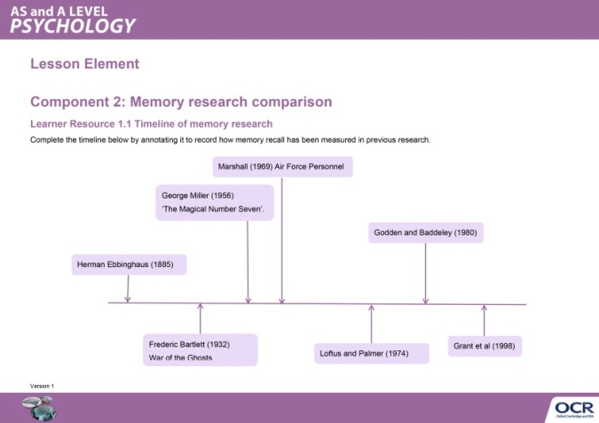
These instructions cover the student activity section which can be found on page 5. This lesson element supports the teaching and learning of Component 2 for OCR AS and A Level Psychology.
When distributing the activity section to the students either as a printed copy or as a Word file you will need to remove the teacher instructions section.

Introduction

The aim of this lesson element is to provide a structured activity that will enable students to summarise the comparison points between Loftus and Palmer’s research and Grant’s research.

Students should be able to:
• Identify how the two studies are similar.
• Identify how the two studies are different.

Both pieces of research within the topic of memory go beyond the analogy that the ‘mind is like a computer’ as they believe that there are further variables that influence how memory recall occurs. Loftus and Palmer believe that memory is influenced by post-event information which has an effect on the memory recalled whereas Grant et al believe that memory recall is affected by the context in which information is encoded. Both pieces of research demonstrate that the accuracy of memory recall can potentially be improved with further understanding of what contributes to the process of memory recall.

The following tasks are designed to support students’ exploration of the similarities and differences between these two pieces of research. The following resources can be implemented within a flipped lesson or used within a classroom lesson.

Teacher Preparation
The worksheets provided are designed to be used after the students have learnt about both of the core studies and are aimed as preparation for a comparison of the research to support the preparation for component 2 of the AS and the A Level examinations

Comparing Key Studies of Cognitive Psychology
Starter: Students are asked to recall a piece of information from the last psychology lesson they had. This can be done on a discussion forum, or if in class, using mini whiteboards. Students are then encouraged to discuss how effective the method of memory recall was.

Learner resource 1.1: Timeline of memory research
Students are given a timeline of research into memory and asked to annotate it using knowledge gained from further reading. There are also discussion points to enable students to understand the context of memory research they have looked into.

Learner resource 1.2: Variables in memory research
Students fill in the grid in learner resource 1.2 to identify the independent and dependent variables in both pieces of research. This allows students to develop an understanding of the difference in the way memory recall was tested between the two studies. There are also discussion points to encourage students to consider the similarities and differences between the two pieces of research. This can be done individually or in small groups, followed by directed questioning to check students’ understanding. Suggested answers are given below.

Teacher answers for Learner resource 1.2
Research | Independent variable | Dependent variable | Notes on discussion questions
Loftus and Palmer (1974) | Experiment 1  The level of severity in the questioning. As measured by the verb used: smashed, collided, bumped, hit and contacted. | Experiment 1  The estimated speed recalled as measured in mph on the questionnaire. There were 7 films the participants responded to this question about. | Quantitative Data
 | Experiment 2  The level of severity in the leading question as measured by the verbs smashed and hit along with a control group. | Experiment 2  The recall of false memories as measured by the recall of broken glass or not (Yes/ No) in one film of a multiple car crash.
Grant et al (1998) | The context as measured by the silent or noisy conditions. The silent condition had headphones with no noise transmitted and the noisy condition heard a moderately loud background noise through headphones. | The reading comprehension as measured by the reading time in minutes in a reading test and the mean number correct on the two tests. There was a maximum score of 10 on the short-answer test and 16 in the multiple choice test. | Quantitative Data

Discussion points
- What type of data did each experiment collect?
Quantitative for both.

- How valid is the data collected in each piece of research?
Students should comment on the nature of the tasks. L&P is unlike eyewitness testimony as they watch videos and then complete a questionnaire. Grant et al is unrealistic as it plays background noise through headphones however the nature of the task is more reflective of memory recall when learning.

- Is the data a good reflection of memory recall in real life?
Students should comment on the lack of qualitative data to record participants true recall in L&P. Grant et al does record short answer questions but these are still coded as correct or incorrect.
Students may draw on the controls within each piece of research to increase validity.

Learner resource 1.3 Research design decisions
Students complete the table with suggestions of alternative ways to measure the variables and evaluate their ideas. Students then have to answer the reflection question to draw on the importance of control when measuring hypothetical constructs.

OCR Resources: the small print
OCR’s resources are provided to support the teaching of OCR specifications, but in no way constitute an endorsed teaching method that is required by the Board, and the decision to use them lies with the individual teacher. Whilst every effort is made to ensure the accuracy of the content, OCR cannot be held responsible for any errors or omissions within these resources. We update our resources on a regular basis, so please check the OCR website to ensure you have the most up to date version.
© OCR 2015 - This resource may be freely copied and distributed, as long as the OCR logo and this message remain intact and OCR is acknowledged as the originator of this work.
Please get in touch if you want to discuss the accessibility of resources we offer to support delivery of our qualifications: resources.feedback@ocr.org.uk

We’d like to know your view on the resources we produce. By clicking on ‘Like’ or ‘Dislike’ you can help us to ensure that our resources work for you. When the email template pops up please add additional comments if you wish and then just click ‘Send’. Thank you.
If you do not currently offer this OCR qualification but would like to do so, please complete the Expression of Interest Form which can be found here: www.ocr.org.uk/expression-of-interest

Lesson Element

Component 2: Memory research comparison

Student Activity

Learner Resource 1.1 Timeline of memory research
Complete the timeline below by annotating it to record how memory recall has been measured in previous research.
Herman Ebbinghaus (1885)
Frederic Bartlett (1932)
War of the Ghosts
George Miller (1956)
‘The Magical Number Seven’.
Marshall (1969) Air Force Personnel
Loftus and Palmer (1974)
Godden and Baddeley (1980)
Grant et al (1998)

Discussion points
Try to include key psychological terms in your answer.

- What type of research method tends to be employed when researching memory?

- What type of data do cognitive psychologists tend to collect on memory?

- Why do you think this type of data is used in cognitive research?

- What are the limitations of the type of research carried out to investigate memory?

- A student is revising for their A Level exams. They have tried flash cards, getting family members to quiz them and completing past paper questions in their room. Use the above research to suggest how they could do this most effectively.

Learner Resource 1.2 Variables in memory research
Complete the table below to identify the independent and dependent variables in both pieces of research. You need to identify the variables as well as state how they have been operationalised.

Research | Independent variable | Dependent variable | Notes on discussion questions
Loftus and Palmer (1974) | Experiment 1 | Experiment 1
 | Experiment 2 | Experiment 2
Grant et al (1998)

Discussion points
- What type of data did each experiment collect?

- How valid is the data collected in each piece of research?

- Is the data a good reflection of memory recall in real life?

Once you have made notes on the discussion points record below what was similar and what was different.
Similarities | Differences

Learner Resource 1.3 Research design decisions
Both Loftus & Palmer and Grant et al’s research used laboratory experiments to investigate how their chosen independent variables affected memory recall. Many have criticised the use of this type of experiment because it lowers the ecological validity.

Why does this lower the ecological validity for each piece of research?

The use of laboratory experiments in Loftus and Palmer’s research lowers ecological validity because...

The use of laboratory experiments in Grant et al’s research lowers ecological validity because…

A key part of psychological research is evaluating current research and striving to improve it to understand human behaviour fully and ultimately improve the applications to real life that research has. Draw the following table and complete it to suggest improvements to the methodology and measurement of variables, then critique your changes.

Research to be improved | Change suggested including how to implement this | Benefits of change | Weaknesses to consider
Loftus and Palmer | Change to a field experiment so more realistic setting such as a real crash in front of participants… | Higher ecological validity because… | Lowers the control because…
Loftus and Palmer
Grant et al
Grant et al
Once you have completed the table, look at the weaknesses you have identified and write a paragraph to justify why these pieces of research have used a laboratory setting to investigate memory. The following key terms may be of use:
Hypothetical construct
Control
Laboratory
Memory recall
Cognitive psychology

