WORKSHEET 1: What’s the space?
Match the name to the space and write a detailed description of it in the space provided
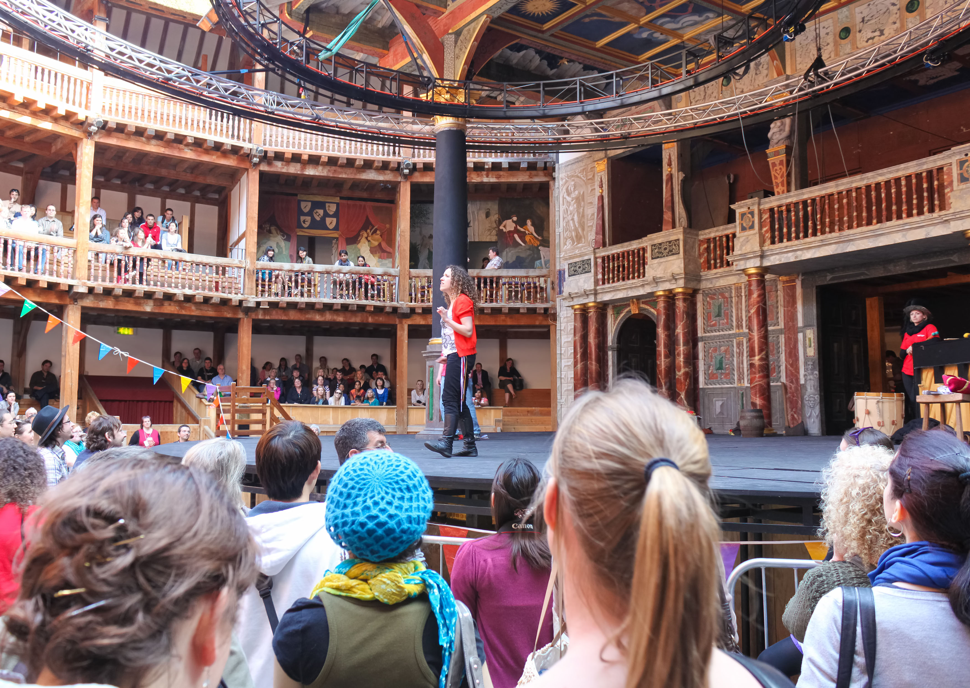 | A
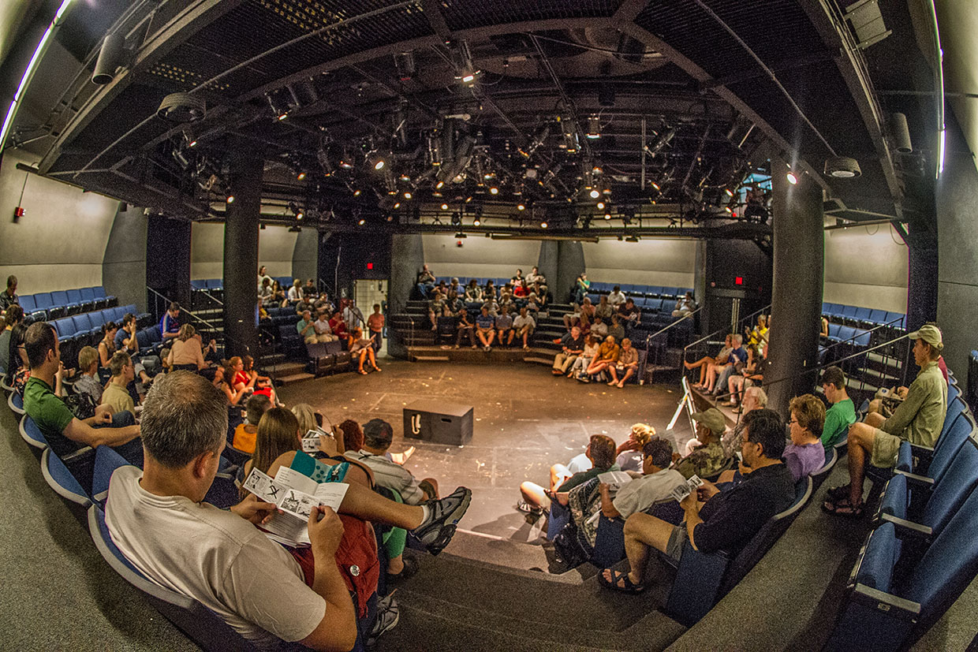 | B
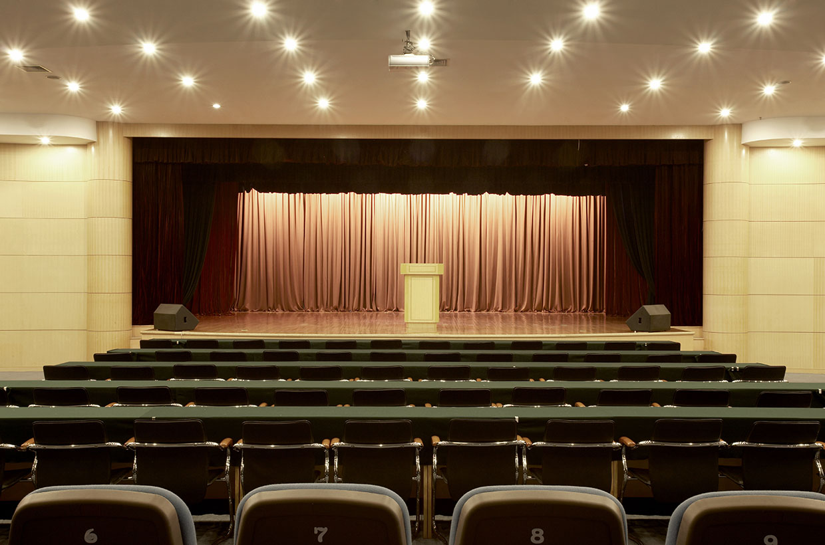 | C

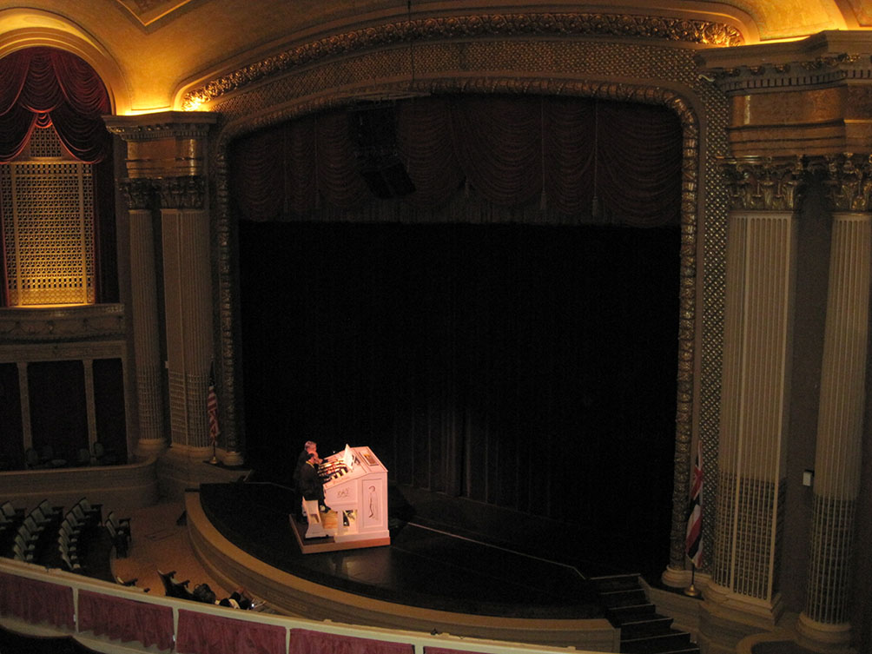 | D
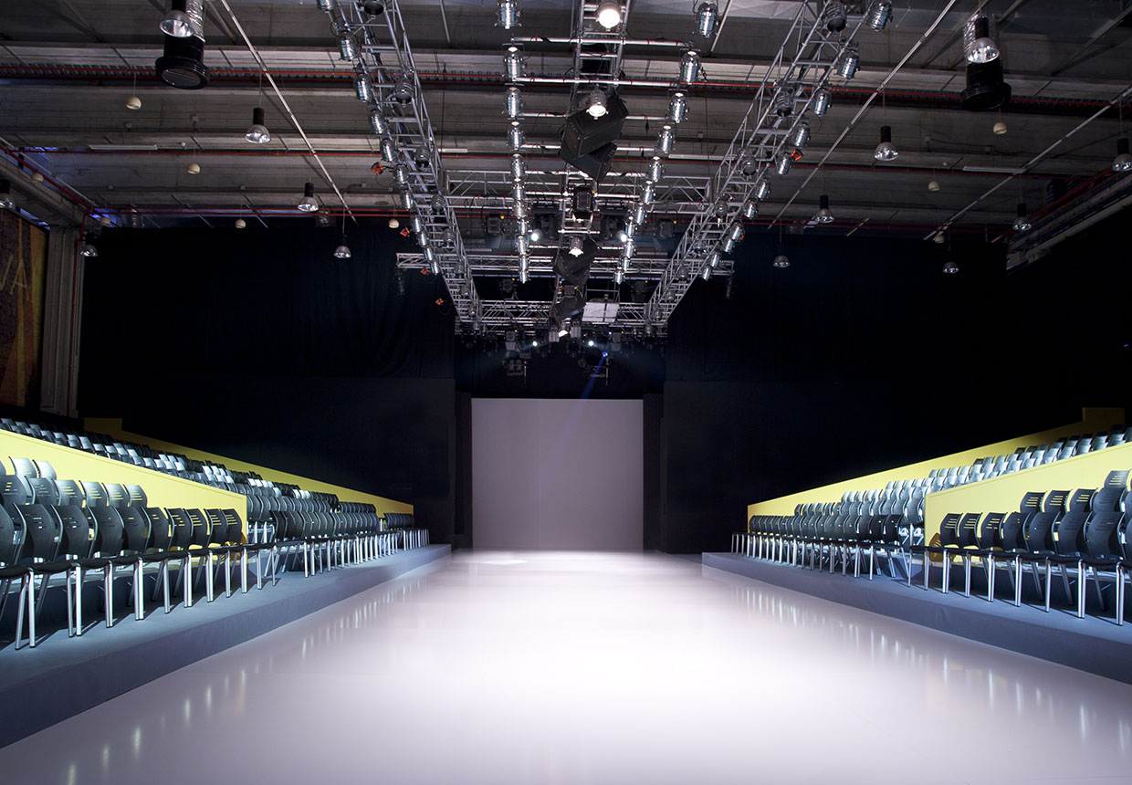 | E
 | F

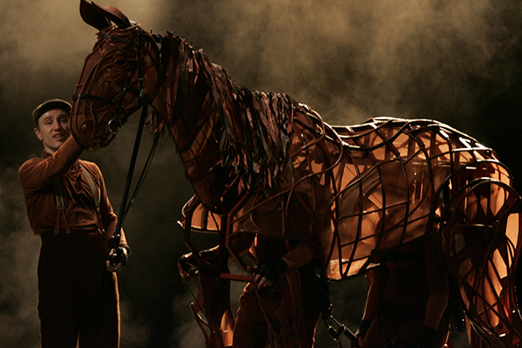

War Horse at Sydney Lyric Theatre

Aladdin’s lamp for a Pantomime
Click here to see an example of and read about the making of the Seagull prop itself by The Guildhall School of Music & Drama:
https://propmakingdotcom.wordpress.com/2014/03/20/the-seagull/

A prop for The Seagull by Chekov - Naturalism

Props or set?

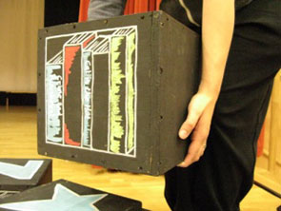

This is classed as a prop as it’s being lifted and used by an actor.

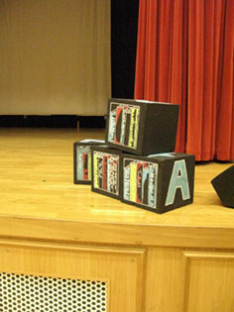

This is classed as set because it is static. Could also be classed as set dressing.

Props or costume?

Because the hat is being used for the act it is classed as a prop.

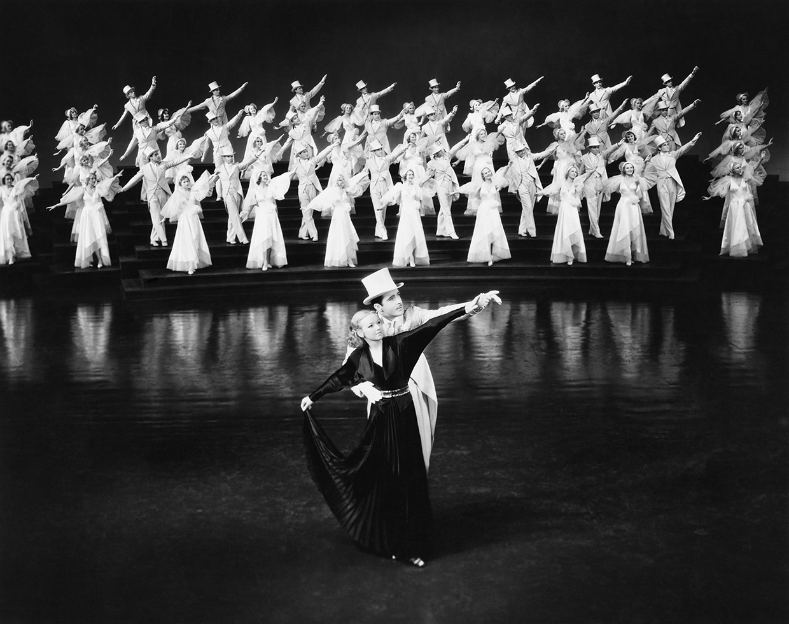

The cast wear their hatsand don’t use it to enhance the drama.

WORKSHEET 3: Extract from The Wardrobe by Sam Holcroft
Synopsis
Across five centuries of British history, small groups of children seek sanctuary in the
same solid, old wardrobe. It's the safest place they know – but is it safe enough?

SCENE NINE
A boys’ Catholic boarding school attached to an abbey and run by Benedictine monks, England,
11th November 1888. We hear singing choristers or similar sounds of the time and place.
The papers are awash with stories of a series of gruesome murders that have terrorized
Whitechapel in London since the summer. TOM, fifteen-years-old, ARCHIE, sixteen-years-old,
HUGO, fifteen-years-old, and JAMES, sixteen-years-old, are students of the school. They huddle
together in the wardrobe. TOM reads from a copy of The London Times dated 10th November
1888; he reads with flourish. He reads by the light of a church candle or candle-lamp. HUGO
scratches his initials into the wall with a knife.

TOM. (Reading) "During the early hours of yesterday morning another murder of a most revolting and
fiendish character took place in Spitalfields. This is the seventh which has occurred in this
immediate neighbourhood, and the character of the mutilations leaves very little doubt that the
murderer in this instance is the same person who has committed the previous ones.”
HUGO. I thought there were only four.
JAMES. Shhh!
TOM. “The scene of this last crime is at Number 26 Dorset Street, which is about 200 yards distant
from 35 Hanbury Street, where the unfortunate woman, Mary Ann Nicholls, was so foully
murdered.
ARCHIE. Hugo, what are you doing?
HUGO. Writing my initials. Next to these ones. A. R. Who do we know with the initials A.R.?
JAMES. (To TOM) Get on with it, Tom.
TOM. (Reading) About one o'clock yesterday morning a person living in the court opposite to the room
occupied by the woman heard her singing the song "Sweet Violets."
ARCHIE sings the song "Sweet Violets," chorus by Joseph Emmet taken from his 1882 play "Fritz
Among the Gypsies."
ARCHIE. (Singing the song) Sweet Violets, sweeter than all the roses...
JAMES. (Speaking over ARCHIE'S singing) Shhh! Tom, finish reading it.
ARCHIE. (Continuing) Covered all over from head to toe.
JAMES. Tom?
TOM and ARCHIE. Covered all over with sweet violets.
ARCHIE. (Singing) There once was a farmer who took a young miss
In the back of the barn where he gave her a...
TOM. Lecture on horses and chickens and eggs
And told her that she had such beautiful...
HUGO. Manners that suited a girl of her charms
A girl that he wanted to take in his...
TOM. Washing and ironing and then if she did
They would get married and raise lots of...
ARCHIE/TOM/HUGO: (Deliberately taunting JAMES) Sweet Violets, sweeter than all the roses,
Covered all over from head to toe,
Covered all over with sweet violets…!

Source: Holcroft, S. (2014) The Wardrobe, London: Nick Hern Books

WORKSHEET 4: Advantages and disadvantages of The Wardrobe set design
The two images below are a basic design for The Wardrobe by Sam Holcroft where thirteen short scenes are performed in a traditional Tudor wardrobe and move through the eras from 1644 – present day. If the wooden blocks reflect the wardrobe as a solid entity, what are the practical difficulties for this design?
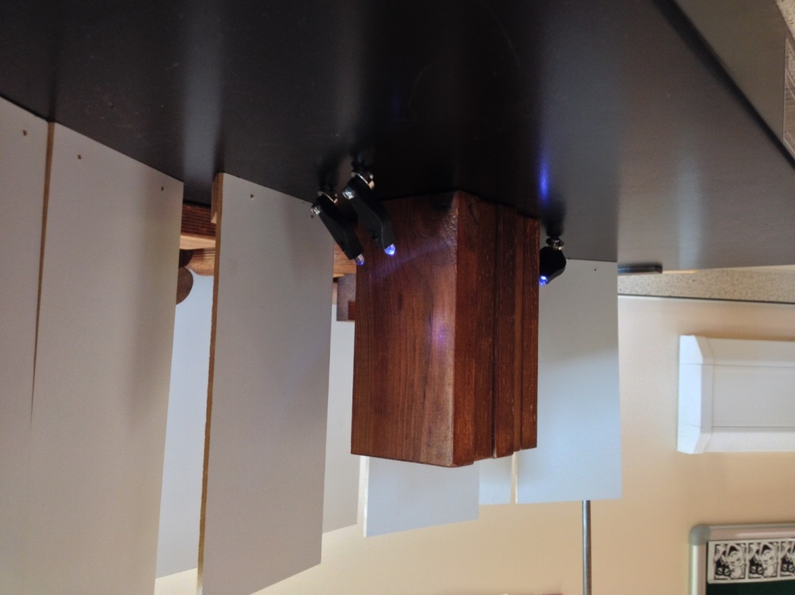

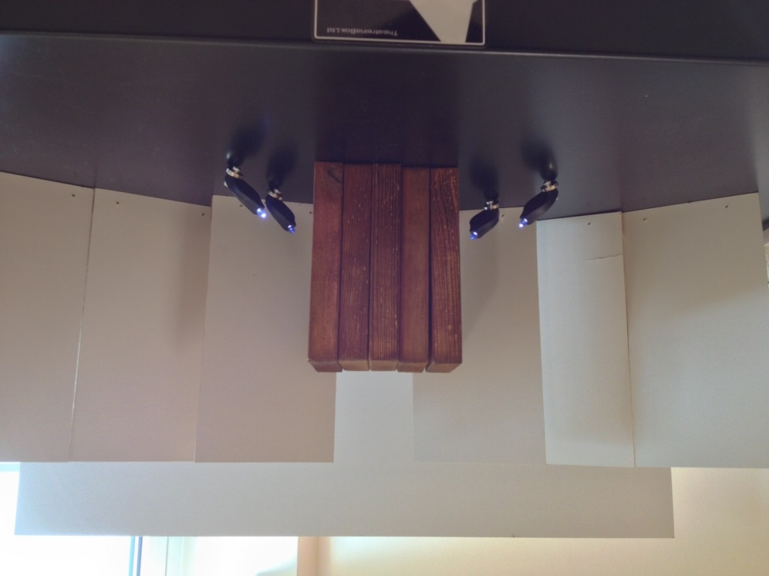

What could you change to make this wardrobe more effective?

WORKSHEET 5: Two set designs
Set design 1
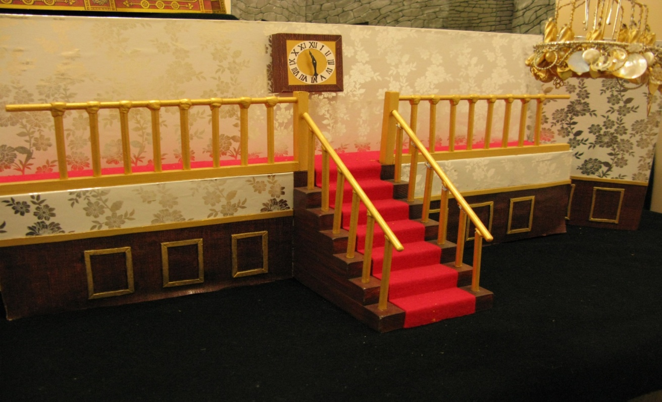

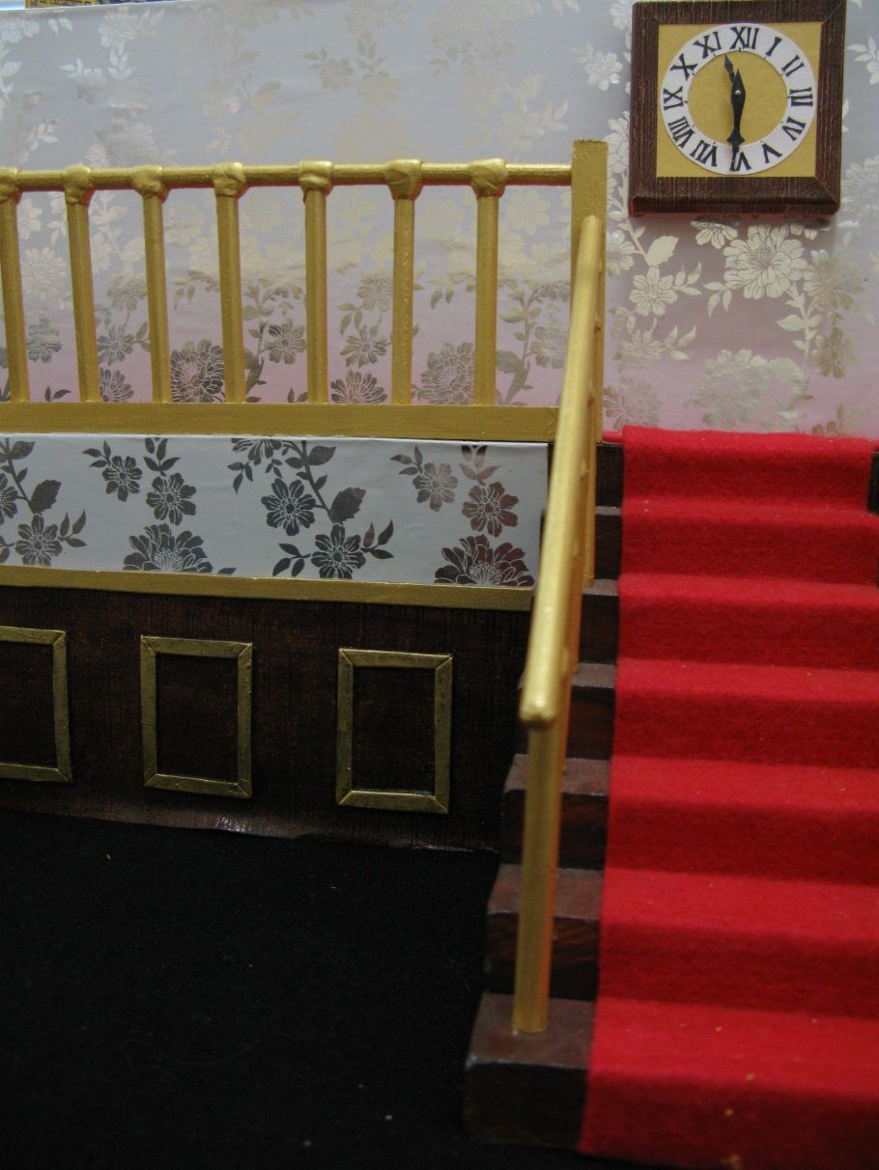
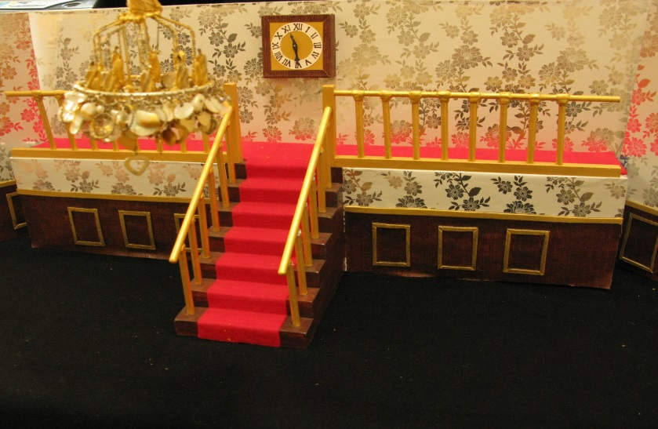

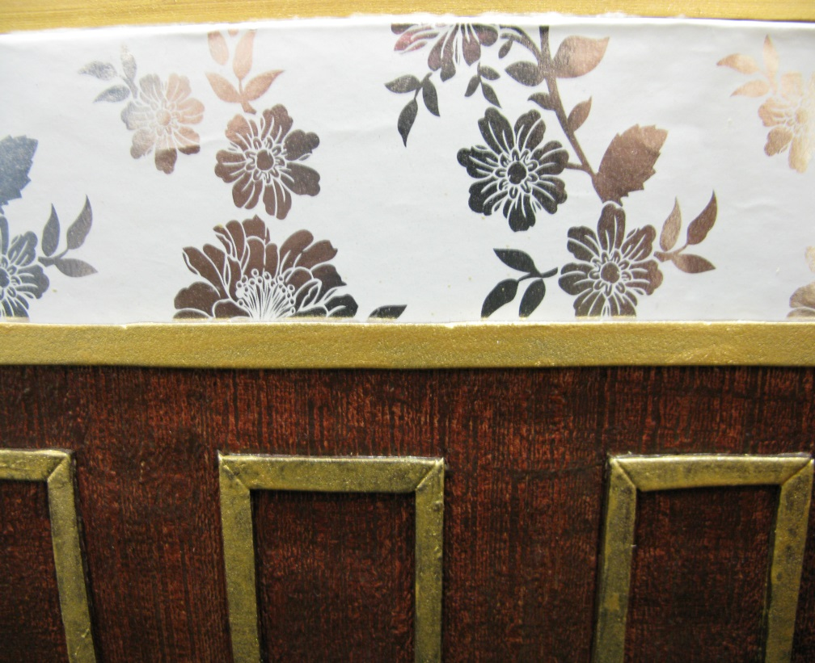

WORKSHEET 5: Two set designs
Set design 2
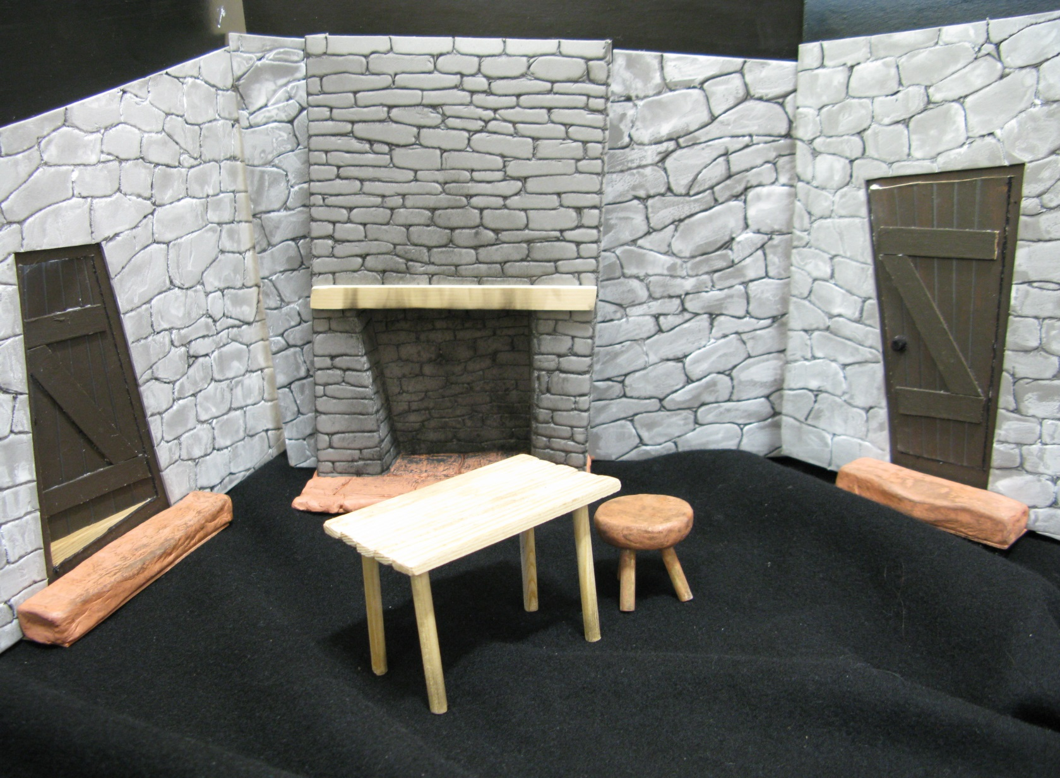

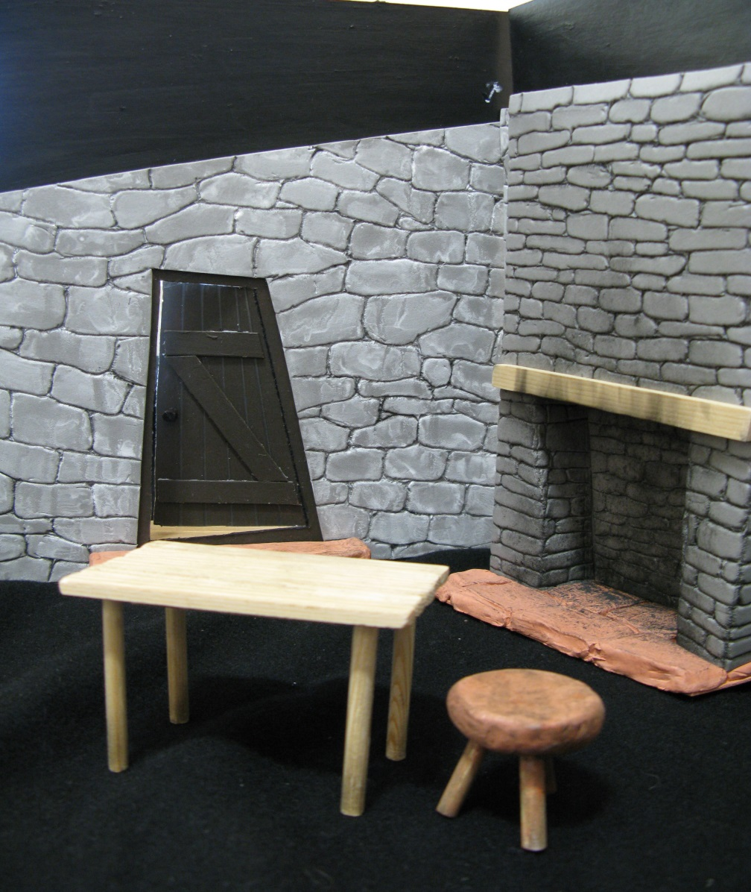

WORKSHEET 6: Five W’s for design
Who | Who is your target audience?
What | What are the intentions of the play? What performance space is most suitable for this play? What restrictions does it have? What health and safety elements do you need to consider for this play? What materials are you going to use? What colour scheme are you going to use? What is life like at the time of the play/ scene?
Why | Ask the question why to all the ‘What’ questions.
Where | Location – where is the scene set?
When | When is the play set? Time / era/ context/ season/ day.
How | How are you going to put all the answers to these questions in to your design?

WORKSHEET 7: Proscenium arch design

WORKSHEET 7: Ground plan of design

WORKSHEET 7: Advantages and disadvantages of performance space
 | Stage space one: | Stage space two:
What are the pros and cons of this staging type?
What problems may be encountered?

What kinds of performances would work well on this stage?

What effect might this stage have on the audience?

WORKSHEET 8: The briefcase
What type of character would suit these briefcases? What type of play would you expect to see these in?

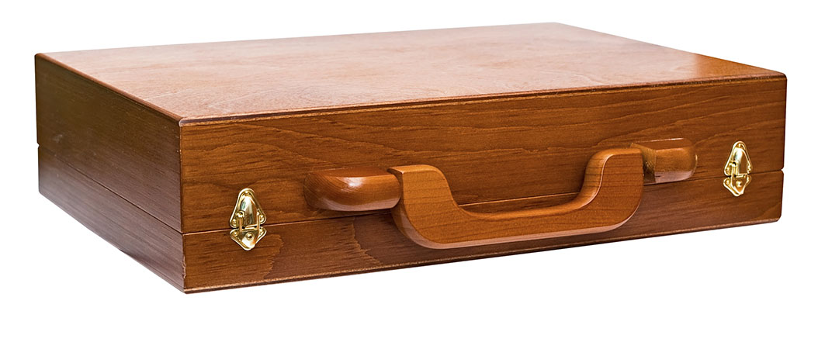

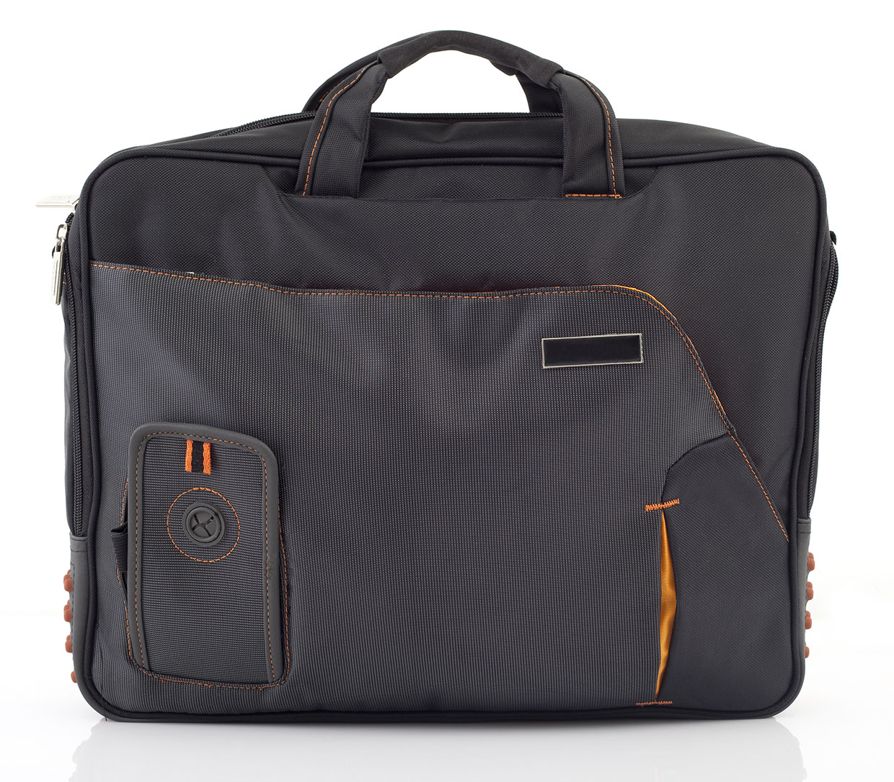

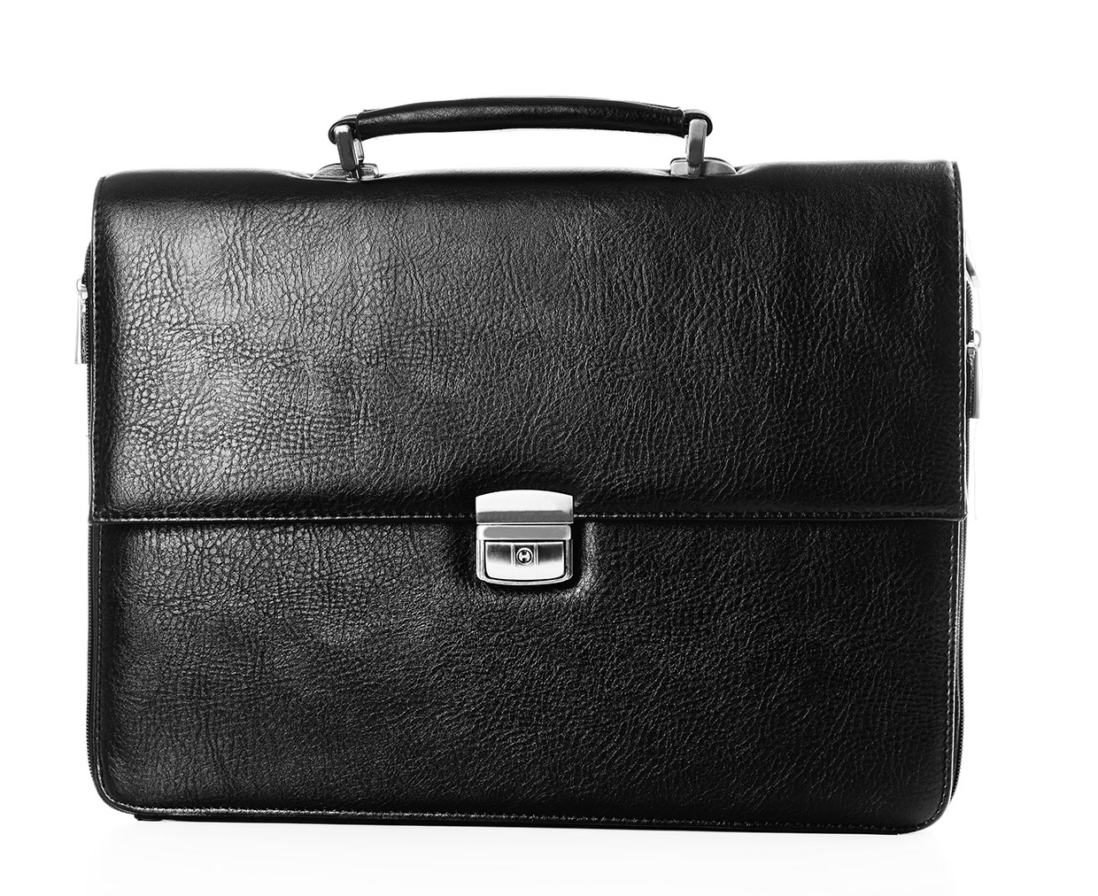

WORKSHEET 9: Semiotic exercise
End-on
In-the-Round
Thrust

Traverse
Promenade
Proscenium Arc

WORKSHEET 10: Designing a prop for characters
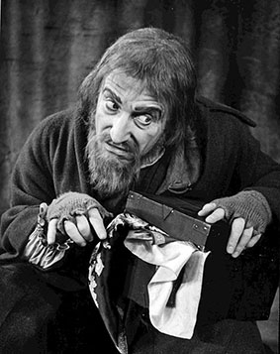

Fagin Mikey
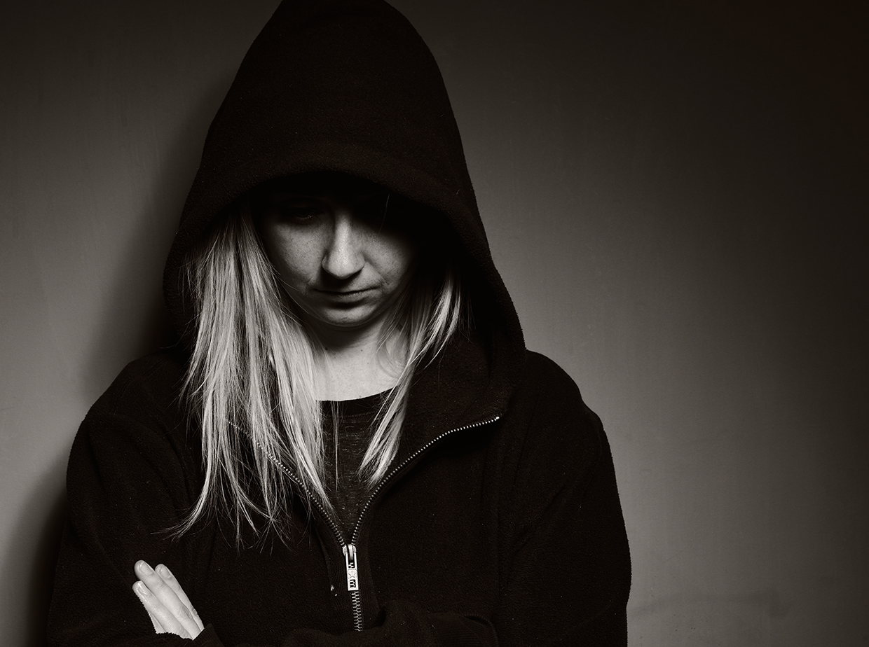

Leah
There are many websites that are very useful both for teachers and students alike that give examples of designs of props and set for shows that are currently running. Many productions now have resource packs that often have a design element to them and images of the set design, with props, that would provide examples to refer to when discussing the topics.
http://www.nottinghamplayhouse.co.uk/participation/teachers-packs/ The Macbeth pack contains information on set.
http://www.bbc.co.uk/dna/ptop/plain/A1097255
http://www.dramainfoweb.co.uk/
http://www.theatredesign.org.uk/
http://www.bbc.co.uk/schools/gcsebitesize/drama/performing/supportrev6.shtml
http://www.thewomaninblack.com/connectwp/wp-content/uploads/downloads/2012/11/wib_pack.pdf
The Wardrobe by Sam Holcroft was commissioned for the National Theatre Connections project 2014.
http://www.nickhernbooks.co.uk/Book/1642/The-Wardrobe.html

