# Foundation Check In - 5.01 Calculations with ratio

1. A school canteen has 45 chairs and 18 tables. Write the ratio of tables to chairs in its simplest form.
2. Share 1.5 litres of juice in the ratio 3 : 5 : 2.

Give the quantities in millilitres.

1. Some flour is shared in the ratio 4 : 3. The smaller share weighs 120 g.

Find the weight of the flour that was shared out.

1. *Seaweed green* is made by mixing yellow paint, blue paint and orange paint in the ratio 3 : 7 : 1. What fraction of the mixture is blue paint?
2. Write 5 g : 200 mg in the ratio *n* : 1.
3. A piece of wood is cut into three pieces, *A*, *B* and *C*. *A* is  of the total length. The lengths of *B* and *C* are in the ratio 1 : 2. Explain why *B* is the same length as *A*.
4. Lily and Rema win a sum of money which they agree to share in the ratio 1 : 4. Lily says, “I will have a quarter of the winnings”. Explain why Lily is wrong and correct her answer.
5. A large pack of gravy granules weighs 700 g and costs £2.80. A small pack of gravy granules weighs 250 g and costs £1.05. Show that the larger pack gives better value for money.
6. Jan has this recipe for macaroni cheese that serves 4 people.

|  |  |
| --- | --- |
| 400 g | macaroni pasta |
| 300 ml | evaporated milk |
| 150 g | mature cheddar cheese |
| 2 | shallots |

If Jan has 2.5 kg of macaroni pasta, 2 L of evaporated milk, 1 kg of mature cheddar cheese and 15 shallots and she makes as much macaroni cheese as possible, how many people will it serve?

1. During a one hour training session, Darren walks, jogs and runs in the ratio 1 : 5 : 2. The length of his stride is 0.8 m when walking, 1.1 m when jogging and 1.4 m when running. His pedometer records 5600 strides in a session. Work out his average speed in km/h.

**Extension**

The graph below shows the relationship between *f*, the amount of flour in grams,

and *b*, the amount of butter in grams, used to make pastry.

Graph showing relationship between f, the amount of flour in grams, and b, the amount of butter in grams, used to make pastry.

Height (= 400 g)

Base (= 200 g)

*f*

*b*

The **gradient** of this line is 2 because, for any right-angled triangle joining two

points on the line as shown, the height is twice the base.

The **equation** of the line is .

1. Write the ratio *f* : *b* in its simplest form.

Find how much butter is used when 1.2 kg of flour is used.

1. Draw a graph for when the ratio is *f* : *b*  3 : 1.

Write down the equation of the graph.

1. Draw a graph for when .

Write the ratio *f* : *b* in its simplest form.

Find how much flour is used when 550 g of butter is used.

## Answers

1. 2 : 5
2. 450 ml, 750 ml, 300 ml
3. 280 g
4. 
5. 25 : 1
6. *A* is of the whole so *B* + *C* is  of the whole. These are shared in the ratio 1 : 2 or  so *B* is the same fraction of the whole as *A*.
7. 1 : 4 means there are 5 parts, so Lily will get  of the total.
8. Cost per 100 g of the larger pack , whilst cost per 100 g of the smaller pack . The larger pack is better value than the smaller pack oe.
9. 25 people
10. 6.37 km/h

**Extension**

* + 1. *f* : *b*  2 : 1

0.6 kg or 600 g of butter used

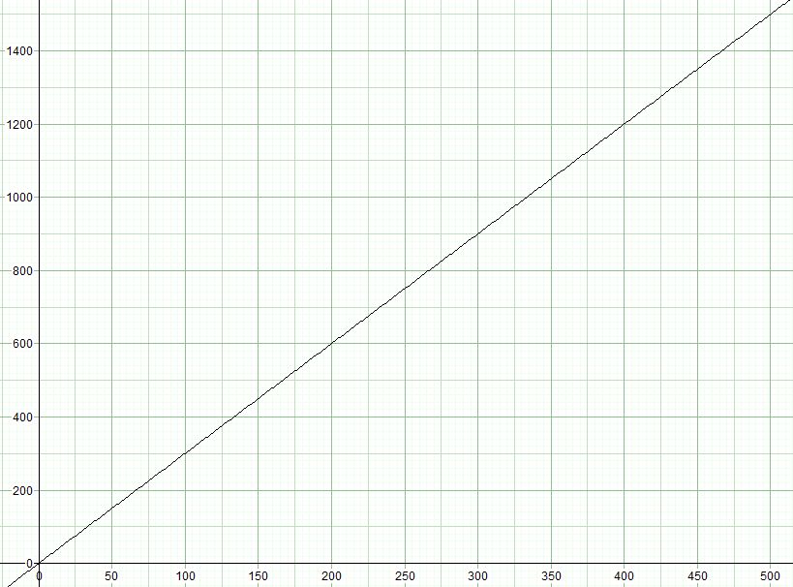



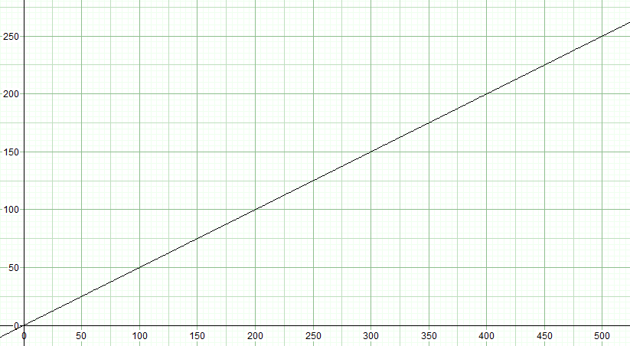

*f* : *b*  1 : 2

275 g of flour used

We’d like to know your view on the resources we produce. By clicking on ‘[Like](mailto:resources.feedback@ocr.org.uk?subject=I%20liked%20the%20GCSE%20(9-1)%20Mathematics%20Foundation%20Check%20In%255.01%20Calculations%20with%20ratio)’ or ‘[Dislike](mailto:resources.feedback@ocr.org.uk?subject=I%20disliked%20the%20GCSE%20(9-1)%20Mathematics%20Foundation%20Check%20In%20-%2012.03c%20&%205.01%20Calculations%20with%20ratio)’ you can help us to ensure that our resources work for you. When the email template pops up please add additional comments if you wish and then just click ‘Send’. Thank you.

If you do not currently offer this OCR qualification but would like to do so, please complete the Expression of Interest Form which can be found here: [www.ocr.org.uk/expression-of-interest](http://www.ocr.org.uk/expression-of-interest)

**OCR Resources**: *the small print*OCR’s **resources** are provided to support the teaching of OCR specifications, but in no way constitute an endorsed teaching method that is required by the Board, and the decision to use them lies with the individual teacher. Whilst every effort is made to ensure the accuracy of the content, OCR cannot be held responsible for any errors or omissions within these resources.   
© OCR 2016 - This resource may be freely copied and distributed, as long as the OCR logo and this message remain intact and OCR is acknowledged as the originator of this work.

OCR acknowledges the use of the following content: n/a

Please get in touch if you want to discuss the accessibility of resources we offer to support delivery of our qualifications: [resources.feedback@ocr.org.uk](mailto:resources.feedback@ocr.org.uk)

To give us feedback on, or ideas about the OCR resources you have used, email [resourcesfeedback@ocr.org.uk](mailto:resourcesfeedback@ocr.org.uk)

To give us feedback on, or ideas about the OCR resources you have used, email [resourcesfeedback@ocr.org.uk](mailto:resourcesfeedback@ocr.org.uk)

To give us feedback on, or ideas about the OCR resources you have used, email [resourcesfeedback@ocr.org.uk](mailto:resourcesfeedback@ocr.org.uk)

To give us feedback on, or ideas about the OCR resources you have used, email [resourcesfeedback@ocr.org.uk](mailto:resourcesfeedback@ocr.org.uk)

To give us feedback on, or ideas about the OCR resources you have used, email [resourcesfeedback@ocr.org.uk](mailto:resourcesfeedback@ocr.org.uk)

To give us feedback on, or ideas about the OCR resources you have used, email [resourcesfeedback@ocr.org.uk](mailto:resourcesfeedback@ocr.org.uk)

**OCR Resources**: *the small print*OCR’s resources are provided to support the teaching of OCR specifications, but in no way constitute an endorsed teaching method that is required by the Board, and the decision to use them lies with the individual teacher. Whilst every effort is made to ensure the accuracy of the content, OCR cannot be held responsible for any errors or omissions within these resources.   
© OCR 2014 - This resource may be freely copied and distributed, as long as the OCR logo and this message remain intact and OCR is acknowledged as the originator of this work.

**OCR Resources**: *the small print*OCR’s resources are provided to support the teaching of OCR specifications, but in no way constitute an endorsed teaching method that is required by the Board, and the decision to use them lies with the individual teacher. Whilst every effort is made to ensure the accuracy of the content, OCR cannot be held responsible for any errors or omissions within these resources.   
© OCR 2014 - This resource may be freely copied and distributed, as long as the OCR logo and this message remain intact and OCR is acknowledged as the originator of this work.

OCR acknowledges the use of the following content::  
⚫ Garden: Elen Eliseeva/Shutterstock.com ⚫ Flag: Pixel Europe/Shutterstock.com

To give us feedback on, or ideas about the OCR resources you have used, email resourcesfeedback@ocr.org.uk

| **Assessment Objective** | **Qu.** | **Topic** | **R** | **A** | **G** |  | **Assessment Objective** | **Qu.** | **Topic** | **R** | **A** | **G** |
| --- | --- | --- | --- | --- | --- | --- | --- | --- | --- | --- | --- | --- |
| AO1 | 1 | State a ratio of quantities in its simplest form |  |  |  |  | AO1 | 1 | State a ratio of quantities in its simplest form |  |  |  |
| AO1 | 2 | Split a quantity into three parts given the ratio |  |  |  |  | AO1 | 2 | Split a quantity into three parts given the ratio |  |  |  |
| AO1 | 3 | Calculate one quantity from another, given the ratio of the two quantities |  |  |  |  | AO1 | 3 | Calculate one quantity from another, given the ratio of the two quantities |  |  |  |
| AO1 | 4 | Interpret a ratio as a fraction of a whole |  |  |  |  | AO1 | 4 | Interpret a ratio as a fraction of a whole |  |  |  |
| AO1 | 5 | Find a ratio of mixed unit quantities in the form *n* : 1 |  |  |  |  | AO1 | 5 | Find a ratio of mixed unit quantities in the form *n* : 1 |  |  |  |
| AO2 | 6 | Interpret a ratio as a fraction |  |  |  |  | AO2 | 6 | Interpret a ratio as a fraction |  |  |  |
| AO2 | 7 | Interpret a ratio as a fraction of a whole |  |  |  |  | AO2 | 7 | Interpret a ratio as a fraction of a whole |  |  |  |
| AO2 | 8 | Use ratios to determine value for money |  |  |  |  | AO2 | 8 | Use ratios to determine value for money |  |  |  |
| AO3 | 9 | Solve a proportion problem |  |  |  |  | AO3 | 9 | Solve a proportion problem |  |  |  |
| AO3 | 10 | Solve a problem involving a quantity split into three parts |  |  |  |  | AO3 | 10 | Solve a problem involving a quantity split into three parts |  |  |  |
|  |  |  |  |  |  |  |  |  |  |  |  |  |
| **Assessment Objective** | **Qu.** | **Topic** | **R** | **A** | **G** |  | **Assessment Objective** | **Qu.** | **Topic** | **R** | **A** | **G** |
| AO1 | 1 | State a ratio of quantities in its simplest form |  |  |  |  | AO1 | 1 | State a ratio of quantities in its simplest form |  |  |  |
| AO1 | 2 | Split a quantity into three parts given the ratio |  |  |  |  | AO1 | 2 | Split a quantity into three parts given the ratio |  |  |  |
| AO1 | 3 | Calculate one quantity from another, given the ratio of the two quantities |  |  |  |  | AO1 | 3 | Calculate one quantity from another, given the ratio of the two quantities |  |  |  |
| AO1 | 4 | Interpret a ratio as a fraction of a whole |  |  |  |  | AO1 | 4 | Interpret a ratio as a fraction of a whole |  |  |  |
| AO1 | 5 | Find a ratio of mixed unit quantities in the form *n* : 1 |  |  |  |  | AO1 | 5 | Find a ratio of mixed unit quantities in the form *n* : 1 |  |  |  |
| AO2 | 6 | Interpret a ratio as a fraction |  |  |  |  | AO2 | 6 | Interpret a ratio as a fraction |  |  |  |
| AO2 | 7 | Interpret a ratio as a fraction of a whole |  |  |  |  | AO2 | 7 | Interpret a ratio as a fraction of a whole |  |  |  |
| AO2 | 8 | Use ratios to determine value for money |  |  |  |  | AO2 | 8 | Use ratios to determine value for money |  |  |  |
| AO3 | 9 | Solve a proportion problem |  |  |  |  | AO3 | 9 | Solve a proportion problem |  |  |  |
| AO3 | 10 | Solve a problem involving a quantity split into three parts |  |  |  |  | AO3 | 10 | Solve a problem involving a quantity split into three parts |  |  |  |