Topic Exploration Pack

Film Music

Instructions and answers for teachers 1
Specification coverage 2
Introduction 3
Suggested activities 4
Lesson suggestions 5
Additional teacher preparation 9
Learner activities 10
Learner activity 1: Which scene is which? 10
Learner activity 2: Which excerpt? 12
Learner activity 3: Legend of Zelda questions 13
Learner information sheet: Film Music 14

Instructions and answers for teachers
These instructions cover the learner activity section which can be found on page 10. This Topic Exploration Pack supports OCR GCSE (9–1) Music.
When distributing the activity section to the Learners either as a printed copy or as a Word file you will need to remove the teacher instructions section.

Specification coverage
There are three aspects to this area of study:

- Film Music
- Video Game Music
- Western Classical music that has been used in films.
Learners need to study a variety of each aspect in order to develop an understanding of the way that composers write or use music to help convey a scene or moving image with a storyline and characters. They should develop an understanding of the musical elements that composers use to do this and be able to identify and write about such features.
Within the lesson ideas below a variety of music will be used to enable candidates to develop an awareness of the way that music portrays specific ideas or characters or scenes.

Introduction
Film Music has now become a genre in its own right within Western Classical Music. The concept of music to support a film has been around since the 1930s; one of the earliest being the film score to the 1933 film King Kong. Over the next 90 years there have been some amazing soundtracks with some wonderfully descriptive music by some incredible composers – Bernard Hermann, John Williams, John Barry and Danny Elfman to name but a few and of course every year there are a whole host of new film scores that are written.
Learners should study the way that composers use the various elements of music along with varied instrumentation to convey their story. A general information sheet to cover this area of study has been provided in the pack to give a broad overview of what the learner should be aware of when listening to this type of music.
Learners may well have watched a variety of films and many may have played video games and they will therefore have experienced a range of musical styles within this area. They will no doubt have developed their own preferences. This does not matter at all.
There is no need for learners to have knowledge of the film industry but they may well be able to hear how music has developed over time and be able to see that there has been an impact from technology in some film or video game music.
Learners need to be able to identify the elements of music and be able to recognise instruments and some of the techniques used, and the skills taught should focus on the learners’ listening and aural perception. Learners need to be able to write about the music that they hear and so this should be introduced very early on in the course.
Much of the work undertaken for Area of Study 4 will focus on the listening and appraising paper, so it is these skills that need to be taught. However there are plenty of opportunities to use this area of study as a starting point for composition. There will always be a brief linked to Area of Study 4 and learners may choose this and then go on to choose a stimulus from which to start their piece. The specimen brief for this area of study is as follows:
Create a descriptive composition suggested by the theme of the story line or image that would be suitable for accompanying a short film at a film festival.
In this brief the learner is instructed to use the story or the image stimulus as a direct place to start their composition but there may be briefs in future years where the story line is left to the learner. This would mean that the learner could create a piece using their own story line and then they could use one of the other stimuli as their starting point.
Listening, performing and composing can be integrated very well through this Area of Study – use well known or catchy film themes as the basis for a performance activity, which can then lead into arranging, composing and discussing the music the learners are creating.

Suggested activities

Starters and plenaries
There are many different ideas that can be used at the start or end of a lesson to teach and develop principles within this area of study.
- Whilst learners do not have to decide what a piece of music might be about – they will usually be given this information – it is often fun to play pieces of music and see whether the different learners within the class have the same or different views as to what might be on a screen to go with the extract they are listening to.
- Another idea is to play several pieces of music and discuss within the group how they are different and then go on to look at what the composer has used within his music to create the varied scenes.
- Learners could be given cards with key words on (staccato, legato, crescendo etc.) and then pieces of music for film scores could be played and the learners could hold up their words when they hear those features in the music.
- Learners could be asked to bring in a clip from a favourite movie (that has an orchestral soundtrack) and present it to the class with an explanation of how the music helps to portray the clip they have chosen.
- There are some good educational resources about film music – there is an excellent one on James Bond’s Casino Royale produced by Film Education – www.filmeducation.org

Main lesson activities
There are hundreds of film scores from which many suitable extracts can be chosen. There are some suggestions for listening regarding this area of study in the specification but teachers should feel free to choose any appropriate film or video game score to use within their classroom.
The study of this type of music will largely focus on the elements of music and instruments, including textures and timbres, as well as various compositional devices. There may also be some focus on the development of a leitmotif or theme that has been used for a specific character or place within the music for a film or video game.
Although extracts of music on the listening paper will usually be around one minute long it can be good to watch longer sections of films to discover how music can develop and how composers write for different types of scene within one film.

Lesson suggestions
These ideas might be used as starters or plenaries but they can also be developed into complete lessons or even longer projects.

Learner activity 1: Which scene is which?
- Watch an extract from a film without the sound – discuss what the learners think the music might be like to accompany this scene. You may want to play the extract twice or even several times depending on how much detail you would like your students to go into – learners might work alone or maybe in pairs. You might do this from YouTube or from a DVD. The extract could be from any film of your choosing but there are some suggestions below. The ideas can then be discussed and then the film can be watched with the sound track and a discussion could follow on how similar or different their ideas were.
- Teachers might also like to use this idea the other way around, i.e. listening to the music first and thinking about what the film or scene would be about. The learners can discuss their ideas and then the extract can then be watched in its entirety with a discussion on whether their ideas were correct.
- Here are some film suggestions but obviously you can use any clip from any film. Sometimes clips with a lot of dialogue or sound effects give the story away, particularly if you listen to the music first, so it is useful to either find a clip that has predominantly music for the soundtrack or use a source like Spotify where you will get just the music:

- https://www.youtube.com/watch?v=h32m969zQCE – James Bond – Dr No – a scene with a deadly spider
- https://www.youtube.com/watch?v=luJASVU7ZBs – Pirates of the Caribbean – On Stranger Tides – Jack Sparrow defeats the Mermaids
- https://www.youtube.com/watch?v=e-QFj59PON4 – 2001 Space Odyssey – opening scene with Strauss’s music – Also Sprach Zarathustra
- https://www.youtube.com/watch?v=vOoWpTxKJGA – Schindler’s list – ending scene – this works particularly well if the main theme to the film is played and discussed first.

Lesson activity 2: Which excerpt is it?
- Play extracts from the following film scores – eight films are listed below. It is probably best to play an excerpt of about one minute. The URL has been given from YouTube but you can use any source that you prefer. For example you could create a playlist in a music provider such as Spotify which can be prepared in advance.
- Use the student worksheet below and ask the learners to decide which excerpt belongs to which description. They may not be correct but this gives a good opportunity for discussion. They should be encouraged to think through what it was about the music that made them make the choices that they did. It is however, important to note that in the listening paper it is generally expected that learners will be told the programme or story to go with the music, they will not be expected to guess what the story might be, however it is often fun to do this early in the course.

- Mind Heist – The Birth of an Idea
https://www.youtube.com/watch?v=lCGlIjLT8OQ
- Out of Africa – Opening Titles
https://www.youtube.com/watch?v=eWZ2adCaKo4
- Superman – Main Theme
https://www.youtube.com/watch?v=e9vrfEoc8_g
- Jurassic Park – The Hatching of a Baby Raptor https://www.youtube.com/watch?v=UiriMLyXeDQ
- Ladies In Lavender – Main Theme
https://www.youtube.com/watch?v=HZacIOIZQAQ
- Interstellar – No Time For Caution (Docking) https://www.youtube.com/watch?v=m3zvVGJrTP8
- Kingdom of Heaven – Battle of Kerak
https://www.youtube.com/watch?v=GOdZStATz98
- Avatar: The Last Airbender – Love theme
https://www.youtube.com/watch?v=lHryqbuTlCs

- To develop the listening skills further you could take one of the pieces of music and use the second student worksheet to underline the features etc that they hear in each extract. Depending on how far you are into the course it may be necessary to go over the words on the sheet to make sure that the learners understand the musical terminology. You may substitute or change the words if you feel that there are others that are going to be more appropriate for a particular piece of music. You can also choose to use all musical vocabulary if you prefer. They can also underline a mood and list some instruments that they hear for the melodic ideas and for the accompaniment (where appropriate). All the things that they are being required to do with this worksheet lead into possible questions on the listening paper.
- This worksheet can obviously be used again for the other extracts and for any other music that you might like to use. You might like to use this worksheet every few weeks with another extract.

Lesson activity 3: Legend of Zelda questions
- This is a video game that was first released in 1986 and there have been many subsequent games in the series naturally all becoming more technologically advanced than the previous ones. The first game was called ‘The Legend of Zelda’ but subsequent games have had other titles as well. One of the most recent is called Skyward Sword and the last one which was released in October 2015 was called Tri Force Heroes.
- The game revolves around a boy called Link who has to save the princess and the world but of course there are many different adventures and settings for each of the many games. The main character, Link, battles an evil character called Ganondorf in most of the games. In each game Link lives in a different environment and although there are many variations, the story of each game is actually quite similar to the last and in fact maybe quite predictable. This does not stop the fact that the games are incredibly popular.
- There are many styles of music for this game; tracks that have just a few instruments to tracks that are fully orchestrated. The early soundtracks were all computer generated but not highly complex because these early games did not have enough memory to embed a complex soundtrack within the game. These soundtracks were quite basic by today’s standards because technology was far less advanced in the 1980s. Now the soundtracks are nearly always fully orchestrated and whilst technology is used in their creation they often use less technology in the performance. The composer uses the computer to create the score, it is then played by an orchestra and then digitally converted and integrated into the game.
- There are a wealth of examples of the music from the Zelda games that can be found from all sorts of sources – YouTube and Spotify to name two – there is also a 25th anniversary CD that has a number of the main themes played by an orchestra.
- Below there are numerous links to some of the main themes. It is interesting to note that the main character Link does not have his own theme. However, Princess Zelda does and there is also a general main theme tune for the game. There are various other themes that represent the different places that Link travels through in order to progress and ultimately win the game. Some of these themes occur in only one game but there are a number of themes that occur in different games and it is interesting to see how they develop over time. Whilst it is clear that the melodies are the same there are differences in orchestration etc which will allow learners to listen to the musical comparisons. You can listen to these themes from Spotify or YouTube as well as downloading a selection of your own from zeldauniverse.net
The main theme:
https://www.youtube.com/watch?v=uyMKWJ5e1kg – created by an old synthesiser via a sequencer
https://www.youtube.com/watch?v=ncg72VswyTs – this is slightly later version of the same theme
https://www.youtube.com/watch?v=xnkYFaMxhiM – listen from 2:33 of this scene which is from the end credits of Skyward Sword – an orchestral version
https://www.youtube.com/watch?v=gxEyzxJ4NGI
– the theme here is from the 25th anniversary CD
Zelda’s lullaby is her theme tune – this describes a beautiful princess:
https://www.youtube.com/watch?v=NFi5Y2_OMPc – link to the past – original – 1992 – early synthesised soundtrack
https://www.youtube.com/watch?v=EPhfbtjqWM8 – from Ocarina of Time – and is the original – quite basic – 1998
https://www.youtube.com/watch?v=ROjzjsMljeA – from Twilight Princess – 2006 – an orchestra version
https://www.youtube.com/watch?v=cAVn71rNImI – from Skyward Sword – much later so more sophisticated – 2011
Kakariko village – this is calm place:
https://www.youtube.com/watch?v=agR5aaQL2PY
Fairy Fountain – so every time Link goes to a fairy fountain in different games this is the theme that is used:
https://www.youtube.com/watch?v=U7JQgyNw068 – from the 25th Anniversary CD
Gandondorf Battles – this is a clip from the actual game:
https://www.youtube.com/watch?v=BDA7RNjeZ10
You may use these extracts in many ways but below there are some basic sets of questions that you might like to use with your learners.

Additional teacher preparation
There is a specimen paper for this specification and there are two questions for this area of study on that paper. There are also a number of questions from the legacy specification from the Descriptive Music Area of Study:
- June 2010 – Q3 – Prose question – Chase scene
- January 2011 – Q1b – Short question – Lord of the Rings
- January 2011 – Q7 – Pirates of the Caribbean
- June 2011 – Q2 – Gladiator
- June 2011 – Q4 – Score question – Ladies in Lavender
- January 2012 – Q3 – Prose question – Alien
- June 2012 – 1a – Short question – Rocket Launch
- June 2012 – Q5 – Comparison question – Superheroes
- January 2013 – Q3 – Prose question – Avatar
- January 2013 – Q7 – Classical music used in a film
- June 2013 – Q1a – Short question – Vampire Hunters
- June 2013 – Q2 – The Lion, The witch and The Wardrobe
- June 2014 – Q7 – Jaws
- June 2015 – Q1c – Short question – The Musketeer
- June 2015 – Q3 – Prose question – The Hobbit
OCR Resources: the small print
OCR’s resources are provided to support the teaching of OCR specifications, but in no way constitute an endorsed teaching method that is required by the Board, and the decision to use them lies with the individual teacher. Whilst every effort is made to ensure the accuracy of the content, OCR cannot be held responsible for any errors or omissions within these resources.
© OCR 2016 - This resource may be freely copied and distributed, as long as the OCR logo and this message remain intact and OCR is acknowledged as the originator of this work.
OCR acknowledges the use of the following content: RAIDERS OF THE LOST ARK (1981) - FORD, HARRISON: LUCASFILM LTD/PARAMOUNT / Album / Universal Images Group, Dracula (1931): UNIVERSAL PICTURES/ Album / Universal Images Group, Game console: ByEmo/Shutterstock.com, Headphones: Jane Kelly/Shutterstock.com
Please get in touch if you want to discuss the accessibility of resources we offer to support delivery of our qualifications: resources.feedback@ocr.org.uk
We’d like to know your view on the resources we produce. By clicking on ‘Like’ or ‘Dislike’ you can help us to ensure that our resources work for you. When the email template pops up please add additional comments if you wish and then just click ‘Send’. Thank you.
If you do not currently offer this OCR qualification but would like to do so, please complete the Expression of Interest Form which can be found here: www.ocr.org.uk/expression-of-interest

Learner activities

Learner activity 1: Which scene is which?
Listen to the main theme from eight films and decide which scene or character fits best with each piece of music:
- An action hero
- The birth of an idea
- A peaceful village
- Outer space
- A battle
- The hatching of a dinosaur
- Wide open countryside
- A romantic scene.

Write the scene or character in each box to go with the extract you hear:
1 | 2 | 3 | 4
5 | 6 | 7 | 8

Give two musical reasons for your choice of scene or character:
1  Reason 1  Reason 2 | 2  Reason 1  Reason 2 | 3  Reason 1  Reason 2 | 4  Reason 1  Reason 2
5  Reason 1  Reason 2 | 6  Reason 1  Reason 2 | 7  Reason 1  Reason 2 | 8  Reason 1  Reason 2

Learner activity 2: Which excerpt is it?
- Underline any musical element or feature that you hear in this extract:
(All these words are part of the Language for Learning)
Staccato Legato Accents Pizzicato Arco Tremolo
Fast Slow Moderate Steady Rubato
High Low Wide Range Scales Arpeggios
Sequence Imitation Ostinato Repetition
(Very) Loud (Very) Soft Crescendo Diminuendo
Fast notes Long notes Dotted notes Syncopation
Chords Unison Homophonic Polyphonic Counter melody
Major Minor Dissonant Chromatic
4/4 ¾ 6/8 Free rhythm

- Underline a mood that you feel is most appropriate:
Happy Sad Exciting Dramatic Scary
- List any instruments that are used for the melody.

- List any instruments you hear in the accompaniment.

Learner activity 3: Legend of Zelda questions
Please be aware that the quality of your written communication may be taken into account.
A – This is a comparison question where you will hear two extracts one after the other three times.
Using your knowledge of Area of Study 4 compare the music of the two extracts from either the Main Theme or Zelda’s Lullaby. Give similarities and/or differences.

[6]
B – This is a prose question on one extract which you will hear four times.
This is an extract that describes ………………………………………… (Your teacher will insert the title of the extract). Write a paragraph, using sentences, explaining how the music conveys the scene. You may wish to refer to instruments, rhythm, melody, texture, tempo and any other features that might be relevant.

[9]

Learner information sheet: Film Music
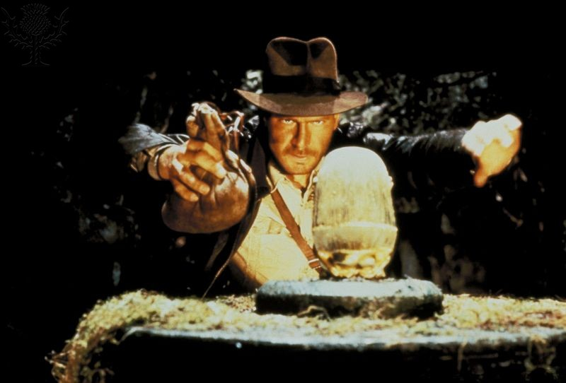
Listen to some of the amazing sound tracks that have been written for films:
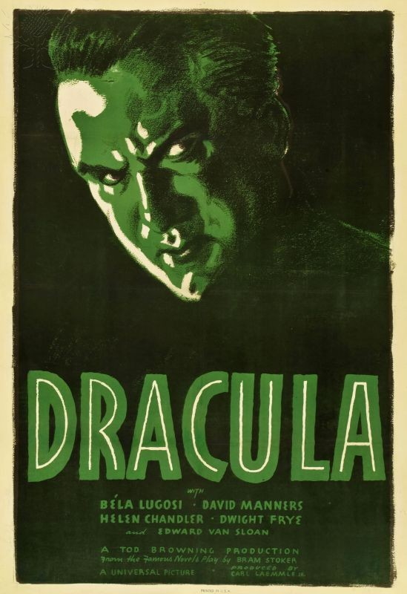
Jaws Raiders of the Lost Ark
Star Wars Psycho
Classical Music used in films
Many composers of the past have written wonderful music that has been used by others as part of a film sound track
Famous composers
of film music:
John Williams
James Horner
Jerry Goldsmith
- Rachmaninov’s ‘2nd Piano concerto’ was used in Brief Encounter.
- Wagner’s ‘Ride of the Valkyrie’ was used in Apocalypse Now.
- Tchaikovsky’s ‘Swan Lake’ theme was used in 1931 was a Dracula film.
Famous composers of video game music:
Koji Kondo
Michael Glacchino
Mieko Ishikawa
 |  | Video game music  There are some really exciting orchestral sound tracks that have been written for video games:  - Zelda  - Halo  - Assassin’s Creed  - Advent Rising.
How do you describe the music that you hear?
It is not always easy and it takes practice!
Use the elements of music to help:  - Tempo (fast and slow)  - Dynamics (loud and soft  - Pitch (high and low)  - Articulation (staccato/legato)  - Texture (thick and thin)  - Timbre (tone quality |  | Other things to listen for:  - Instruments    - Melody  - Rhythm  - Harmony  - Tonality  - Structure

