Physics PAG P3: Motion

Combined Science PAG P3: Motion

Suggested Activity 1: Investigating acceleration of a trolley down a ramp

Instructions and answers for teachers & technicians
These instructions cover the learner activity section which can be found on page 8. This Practical activity supports OCR GCSE Physics.
When distributing the activity section to the learners either as a printed copy or as a Word file you will need to remove the teacher instructions section.
This is a suggested practical activity that can be used as part of teaching the GCSE (9-1) Gateway Science (A) and Twenty First Century Science (B) specifications.
These are not controlled assessment tasks, and there is no requirement to use these particular activities.
You may modify these activities to suit your learners and centre. Alternative activities are available from, for example, Royal Society of Biology, Royal Society of Chemistry, Institute of Physics, CLEAPSS and publishing companies, or of your own devising.
Further details are available in the specifications (Practical Skills Topics), and in these videos.
OCR recommendations:
Before carrying out any experiment or demonstration based on this guidance, it is the responsibility of teachers to ensure that they have undertaken a risk assessment in accordance with their employer’s requirements, making use of up-to-date information and taking account of their own particular circumstances. Any local rules or restrictions issued by the employer must always be followed.
CLEAPSS resources are useful for carrying out risk-assessments: (http://science.cleapss.org.uk).
Centres should trial experiments in advance of giving them to learners. Centres may choose to make adaptations to this practical activity, but should be aware that this may affect the Apparatus and Techniques covered by the learner.

Introduction
In this experiment pupils will be investigating how to measure the acceleration of a trolley down a ramp and the effect of changing force on the acceleration.

DfE Apparatus and Techniques covered
The codes used below match the OCR Practical Activity Learner Record Sheet (Physics / Combined Science) and Trackers (Physics / Combined Science) available online. There is no requirement to use these resources.
1a [1]: Use of appropriate apparatus to make and record a range of measurements accurately, including: i [i]) length; iv [iv]) time
3 [15]) Use of appropriate apparatus and techniques for measuring motion, including determination of: i) speed; ii) rate of change of speed (acceleration/deceleration)

Aims
To use appropriate apparatus to measure speed, acceleration, force and mass.
To calculate acceleration using a = (v-u)/t
To plot a graph of force against acceleration to determine the relationship between these terms.

Intended class time
50-60 minutes

Links to Specifications:

Gateway Science (Suite A) including Working Scientifically (WS)
PM2.1ii recall and apply:
acceleration (m/s²) = change in velocity (m/s) / time (s)
P2.1h apply formulae relating distance, time and speed, for uniform motion, and for motion with uniform acceleration
PM2.2i recall and apply:
force (N) = mass (kg) x acceleration (m/s²)

WS1.2e Evaluate methods and suggest possible improvements and further investigations
WS1.3a Presenting observations and other data using appropriate methods
WS1.3b Translating data from one form to another
WS1.3e Interpreting observations and other data
WS1.4a Use scientific vocabulary, terminology and definitions
WS1.4b Recognise the importance of scientific quantities and understand how they are determined
WS1.4c Use SI units and IUPAC chemical nomenclature unless inappropriate
WS2a Carry out experiments
WS2c Presenting observations using appropriate methods

Twenty First Century Science (Suite B) including Ideas about Science (IaS)
P4.2.6a recall and apply the relationship:
acceleration (m/s²) = change in speed (m/s) ÷ time taken (s)
P4.2.6b explain how to use appropriate apparatus and techniques to investigate acceleration
P4.3.12 Recall and apply Newton’s second law relating force, mass and acceleration:

Force (N) = mass (kg) x acceleration (m/s²)

IaS1.2 Suggest appropriate apparatus, materials and techniques, justifying choice with reference to the precision, accuracy and validity of the data that will be collected
IaS1.4 Identify factors that need to be controlled, and the ways in which they could be controlled
IaS2.1 Present observations and other data using appropriate formats
IaS2.2 When processing data use SI units where appropriate (e.g. kg, g, mg, km, m, mm, kJ, J)
IaS2.4 Be able to translate data from one form to another
IaS2.7 When displaying data graphically select an appropriate graphical form, use appropriate axes and scales, plot data points correctly, draw an appropriate line of best fit, and indicate uncertainty (e.g. range bars)
IaS2.11 In a given context interpret observations and other data (presented in diagrammatic, graphical, symbolic or numerical form) to make inferences and to draw conclusions, using appropriate scientific vocabulary and terminology to communicate the scientific rationale for findings and conclusions

Mathematical Skills covered
M3b Change the subject of an equation
M3c Substitute numerical values into algebraic equations using appropriate units for physical quantities
M3d Solve simple algebraic equations
M4a Translate information between graphical and numerical form
M4b Understand that y=mx+c represents a linear relationship
M4c Plot two variables from experimental or other data

Health and Safety
This is a very safe experiment when performed sensibly; masses may be heavy so care must be taken to not drop them. Placing a buffer at the end of the ramp or something soft for the trolley to land in is suggested so not to damage equipment. Eye protection should be worn.

Method 1: Using ruler and stopwatch to calculate average speed and then acceleration
Learners calculate the speed the trolley is travelling at the bottom of the ramp by timing how long it takes for the trolley to travel the last 30 cm and using speed = distance ÷ time. Learners then time how long it takes the trolley to travel the whole length of the ramp.
Using acceleration = change in speed ÷ time and an initial speed of 0 m/s². Learners can calculate the acceleration of the trolley.

Method 2: Using light gates and data loggers
Learners set up two light gates one near the top and one near the bottom of the ramp. Depending on the data logger that you have you can either get them to measure the speeds of the trolley at both points and get the learners to calculate the acceleration or you can get the data loggers to work out the acceleration between the two light gates.

Method 3: The effect of force on acceleration
Learners use a pulley and slotted masses to change the amount of force that causes a trolley to accelerate along a flat surface. They use light gates to work out the acceleration of the trolley with varying forces and plot a graph of their results. Using their graphs learners find the relationship between force and acceleration.

Notes
Learners should be able to compare the acceleration calculated via both methods. Encourage learners to consider where the inaccuracies in their measurements may be. This is an opportunity to look at the accuracy of the measuring equipment they are using. It is also good for pupils to consider how they could improve on their experimental technique.

Technician Notes

For this practical the teacher will require for a class of 30:
- 15x trolleys
- 15x ramps
- 15x wooden blocks to prop up the ramps
- 15x metre rulers
- 15x stop watches
- 15x data loggers
- 15x card for top of trolley
- 15x pulleys
- 15x mass hangers and slotted masses
- string
- 30x light gates
- 30x goggles
- 30x graph paper
- 30x 30cm ruler

Answers for quiz questions
1ai [3 marks]
No
F = ma
Mass is inversely proportional to acceleration
1aii [4 marks]
Trolley down a ramp with two light gates
Change mass by adding masses
Use light gate to measure acceleration / speed and calculate acceleration
Plot graph to see relationship
1b [2 marks]
Correct gradient calculation using change in y ÷ change in x
Answer between 2 and 2.25 m/s²
1c [3 marks]
acceleration = change in velocity ÷ time
= 27 m/s ÷ 9.6 s
= 2.8 m/s² (to 2sf)

Document updates
v1 Published on the qualification pages
v1.1 January 2017 Consolidated labelling and formatting of activities
v1.2 February 2017 Correction to Combined Science labelling
v1.3 June 2021 Updated to digital accessibility standards

We’d like to know your view on the resources we produce. Click ‘Like’ or ‘Dislike’ to send us an auto generated email about this resource. Add comments if you want to. Let us know how we can improve this resource or what else you need. Your email will not be used or shared for any marketing purposes.
Looking for another resource? There is now a quick and easy search tool to help find free resources for your qualification.
OCR is part of Cambridge Assessment, a department of the University of Cambridge.
For staff training purposes and as part of our quality assurance programme your call may be recorded or monitored.
Oxford Cambridge and RSA Examinations is a Company Limited by Guarantee. Registered in England. Registered office
The Triangle Building, Shaftesbury Road, Cambridge, CB2 8EA. Registered company number 3484466. OCR is an exempt charity.
OCR operates academic and vocational qualifications regulated by Ofqual, Qualifications Wales and CCEA as listed
in their qualifications registers including A Levels, GCSEs, Cambridge Technicals and Cambridge Nationals.
OCR provides resources to help you deliver our qualifications. These resources do not represent any particular teaching method we expect you to use. We update our resources regularly and aim to make sure content is accurate but please check the OCR website so that you have the most up to date version. OCR cannot be held responsible for any errors or omissions in these resources.
Though we make every effort to check our resources, there may be contradictions between published support and the specification, so it is important that you always use information in the latest specification. We indicate any specification changes within the document itself, change the version number and provide a summary of the changes. If you do notice a discrepancy between the specification and a resource, please contact us.
© OCR 2021 - You can copy and distribute this resource freely if you keep the OCR logo and this small print intact and you acknowledge OCR as the originator of the resource.
OCR acknowledges the use of the following content: N/A
Whether you already offer OCR qualifications, are new to OCR or are thinking about switching, you can request more information using our Expression of Interest form.
Please get in touch if you want to discuss the accessibility of resources we offer to support you in delivering our qualifications.

Physics PAG P3: Motion

Combined Science PAG P3: Motion

Suggested Activity 1: Investigating acceleration of a trolley down a ramp

Learner Activity

Introduction
In this experiment you will be investigating how to measure the acceleration of a trolley down a ramp and the effect of changing force on the acceleration.

Aims
To use appropriate apparatus to measure speed, acceleration, force and mass.
To calculate acceleration using a = (v-u)/t
To plot a graph of force against acceleration to determine the relationship between these terms.

Intended class time
50-60 minutes

Equipment (per group)
- trolley
- ramp
- wooden block to prop up the ramp
- metre ruler
- stop watch
- data logger
- card for top of trolley
- pulley
- mass hanger and slotted masses
- string
- 2x light gates
- goggles
- graph paper
- 30cm ruler

Health and Safety
This is a very safe experiment when performed sensibly; masses may be heavy so care must be taken to not drop them. Placing a buffer at the end of the ramp or something soft for the trolley to land in is suggested so not to damage equipment. Eye protection should be worn.

Method 1
- Set up apparatus as shown below. Do not set the ramp at too steep an angle as it will make measuring time too difficult.
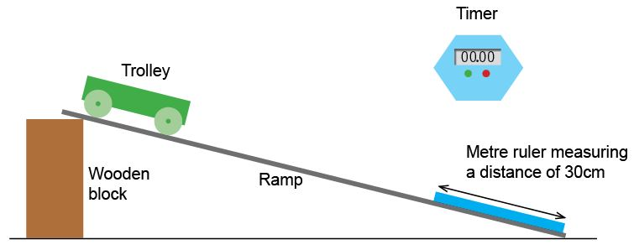
- Release (do not push) the trolley from the top of the ramp, start the timer and record the time taken for the trolley to move the whole distance of the ramp.
- Repeat this 2 more times and calculate the mean. Record results in the table below.
- Release (do not push) the trolley from the top of the ramp again but this time start the timer when the trolley reaches the marked last 30 cm of the ramp, record the time it takes for the trolley to travel the last 30 cm of the ramp.
- Repeat this 2 more times and take an average. Record results in the table below.
- Use your results to calculate the speed of the trolley when it was descending the last 30 cm of the ramp. Speed (m/s) = distance (m) ÷ time (s)
- Use your result from above as the final speed and take the initial speed of the trolley as 0m/s. Calculate the acceleration of the trolley when descending the entire length of the ramp using acceleration (m/s²) = change in speed (m/s) ÷ time taken (s)

Results
Times for trolley to descend ramp
Time 1 (s) | Time 2 (s) | Time 3 (s) | Mean time (s)

Time for trolley to descend last 30 cm of ramp
Time 1 (s) | Time 2 (s) | Time 3 (s) | Mean time (s)

Speed of trolley while descend the last 30 cm of ramp

m/s
Acceleration of trolley

m/s²

Method 2
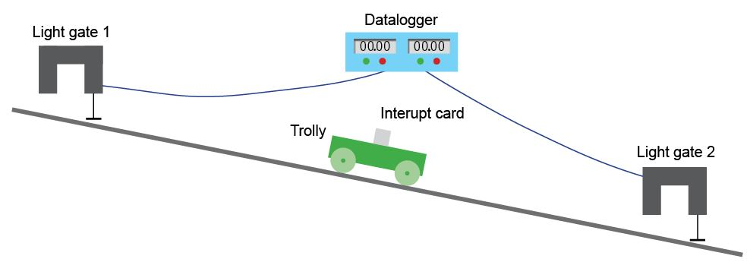
- Set up apparatus as shown below. Keep the angle of the slop the same as it was for the first experiment.

- Set up the data logger so that the acceleration of the trolley between the two light gates is recorded. If this is not possible than set them up to record the speed at each point and calculate the acceleration using acceleration (m/s²) = change in speed (m/s) ÷ time (s)
- Release (do not push) the trolley from the top of the ramp, record in the table below the acceleration of the trolley.
- Repeat 2 more times and calculate the mean acceleration of the trolley.

Results
Acceleration 1 (m/s²) | Acceleration 2 (m/s²) | Acceleration 3 (m/s²) | Mean acceleration (m/s²)

Evaluation
Compare and contrast the two different methods of measuring the acceleration. Where were the potential errors and inaccuracies?
Which method was more accurate and why?

Method 3 How does force effect acceleration?
- Set up apparatus as shown below, choose a length of string so that the mass does not touch the ground.

- Set up the data logger so that the acceleration of the trolley between the two light gates is recorded. If this is not possible than set them up to record the speed at each point and calculate the acceleration using acceleration (m/s²) = change in speed (m/s) ÷ time (s)
- Start with a force of 1 N (100 g) and record the acceleration in the table below.
- Increase the force by 1 N each time and record the accelerations in the table below.
- Repeat this 2 more times and calculate means.
- Plot a graph of force against acceleration

Results
Force (N) | Acceleration 1 (m/s²) | Acceleration 2 (m/s²) | Acceleration 3 (m/s²) | Mean acceleration (m/s²)

Evaluation
What does the graph show?

What type of mathematical relationship does this graph suggest exists between force and acceleration?

What law is this evidence for?

Quiz - test your knowledge and understanding
1. (a) (i) | Two students are measuring the acceleration of a trolley down a ramp. They predict that if they increase the mass of the trolley the acceleration will also increase. Are they correct? Write down why. [3 marks]

(a) (ii) | What experiment could the students do to test this? Include any measurements they need to make and the equipment used. [4 marks]

(b) | In a different experiment students recorded the velocity and time as the trolley descended the ramp. They got the following results and plotted a graph.
 |  | Time(s) | Velocity (m/s)
 |  | 1 | 2.2
 |  | 2 | 4.3
 |  | 3 | 6.6
 |  | 4 | 9
 |  | 5 | 10.9

Use the graph to work out the acceleration of the trolley. [2 marks]
m/s²

(c) | A car accelerates from rest to a final speed of 27 m/s in a time of 9.6 s. Work out the acceleration of the car. Give your answer to 2 s.f. [3 marks]
 |  |  | m/s²

DfE Apparatus and Techniques covered
If you are using the OCR Practical Activity Learner Record Sheet (Physics / Combined Science) you may be able to tick off the following skills:

Physics |  |  |  |  | Combined Science
1a-i | 1a-iv | 3-i | 3-ii |  | 1-i | 1-iv | 15-i | 15-ii

