Physics PAG 5: Energy

Combined Science PAG P5: Energy

Suggested Activity 1: Determining the specific heat capacity of a metal

Instructions and answers for teachers & technicians
These instructions cover the learner activity section which can be found on page 9. This Practical activity supports OCR GCSE Physics.
When distributing the activity section to the learners either as a printed copy or as a Word file you will need to remove the teacher instructions section.
This is a suggested practical activity that can be used as part of teaching the GCSE (9-1) Gateway Science (A) and Twenty First Century Science (B) specifications.
These are not controlled assessment tasks, and there is no requirement to use these particular activities.
You may modify these activities to suit your learners and centre. Alternative activities are available from, for example, Royal Society of Biology, Royal Society of Chemistry, Institute of Physics, CLEAPSS and publishing companies, or of your own devising.
Further details are available in the specifications (Practical Skills Topics), and in these videos.

OCR recommendations:
Before carrying out any experiment or demonstration based on this guidance, it is the responsibility of teachers to ensure that they have undertaken a risk assessment in accordance with their employer’s requirements, making use of up-to-date information and taking account of their own particular circumstances. Any local rules or restrictions issued by the employer must always be followed.
CLEAPSS resources are useful for carrying out risk-assessments: (http://science.cleapss.org.uk).
Centres should trial experiments in advance of giving them to learners. Centres may choose to make adaptations to this practical activity, but should be aware that this may affect the Apparatus and Techniques covered by the learner.

Introduction
In this activity learners will be determining the specific heat capacity of a block of metal.

DfE Apparatus and Techniques covered
The codes used below match the OCR Practical Activity Learner Record Sheet (Physics / Combined Science) and Trackers (Physics / Combined Science) available online. There is no requirement to use these resources.
1a [1]: Use of appropriate apparatus to make and record a range of measurements accurately, including: iii [iii]) mass; iv [iv]) time; vi [v]) temperature
5 [17]) Safe use of appropriate apparatus in a range of contexts to measure: i) energy changes/transfers; ii) associated values such as work done

Aims
To use appropriate apparatus to take measurements to determine energy transferred
To use appropriate apparatus to determine temperature rise
To calculate specific heat capacity using the measurements taken

Intended class time
50-60 minutes

Links to Specifications:

Gateway Science (Suite A) including Working Scientifically (WS)
P1.2c describe how heating a system will change the energy stored within the system and raise its temperature or produce changes of state
P1.2d define the term specific heat capacity and distinguish between it and the term specific latent heat
P1.2e apply the relationship between change in internal energy of a material and its mass, specific heat capacity and temperature change to calculate the energy change involved
P3.2l explain how the power transfer in any circuit device is related to the potential difference across it and the current, and to the energy changes over a given time
P3.2m apply the equations relating potential difference, current, [quantity of charge], resistance, power, energy, and time and solve problems for circuits which include resistors in series, using the concept of equivalent resistance
WS1.2e evaluate methods and suggest possible improvements and further investigations
WS1.3a presenting observations and other data using appropriate methodsWS1.3f presenting reasoned explanations
WS1.3h identifying potential sources of random and systematic error
WS1.4a use scientific vocabulary, terminology and definitions
WS1.4b recognise the importance of scientific quantities and understand how they are determined
WS1.4c use SI units and IUPAC chemical nomenclature unless inappropriate
WS1.4e interconvert units
WS1.4f use an appropriate number of significant figures in calculations
WS2a carry out experiments
WS2b make and record observations and measurements using a range of apparatus and methods

Twenty First Century Science (Suite B) including Ideas about Science (IaS)
P3.4.1 describe the energy transfers that take place when a system is changed by work done when a current flows through a component

P3.4.2 explain, with reference to examples, how the power transfer in any circuit device is related to the energy transferred from the power supply to the device and its surroundings over a given time:
power (W) = energy (J) ÷ time (s)

P3.4.3 recall and use the relationship between the potential difference across the component and the total charge to calculate the energy transferred in an electric circuit when a current flows through a component:
energy transferred (work done) (J) = charge (C) x potential difference (V)

P3.4.3 recall and apply the relationships between power transferred in any circuit device, the potential difference across it, the current through it, and its resistance:
power (W) = potential difference (V) x current (A)
power (W) = (current (A))² x resistance (Ω)

P6.1.3 describe the energy transfers involved when a system is changed by heating (in terms of temperature change and specific heat capacity)

P6.1.4 define the term specific heat capacity and distinguish between it and the term specific latent heat

P6.1.5 a) select and apply the relationship between change in internal energy of a material and its mass, specific heat capacity and temperature:
change in internal energy (J) = mass (kg) x specific heat capacity (J / kg / °C) x change in temperature (°C)

P6.1.5 b) explain how to safely use apparatus to determine the specific heat capacity of materials

P6.1.8 make calculations of the energy transfers associated with changes in a system when the temperature changes, recalling or selecting the relevant equations for mechanical, electrical, and thermal processes (M1a, M1c, M2a, M3b, M3c, M3d)

IaS1.3 Recognise the importance of scientific quantities and understand how they are determined
IaS1.4 Identify factors that need to be controlled, and the ways in which they could be controlled
IaS1.8 Use appropriate scientific vocabulary, terminology and definitions to communicate the rationale for an investigation and the methods used using diagrammatic, graphical, numerical and symbolic forms
IaS2.1 Present observations and other data using appropriate formats
IaS2.2 When processing data use SI units where appropriate (e.g. kg, g, mg, km, m, mm, kJ, J)
IaS2.5 When processing data interconvert units
IaS2.6 When processing data use an appropriate number of significant figures
IaS2.10 Evaluate an experimental strategy, suggest improvements and explain why they would increase the quality (accuracy, precision, repeatability and reproducibility) of the data collected, and suggest further investigations

Mathematical Skills covered
M1a Recognise and use expressions in decimal form
M3b Change the subject of an equation
M3c Substitute numerical values into algebraic equations using appropriate units for physical quantities
M3d Solve simple algebraic equations

Health and Safety
The heater and metal block will get hot, learners should be warned not to touch hot objects and a heatproof mat should be used to protect working surfaces.
Electric circuits should be checked to ensure that they are connected correctly.

Method
Learners will construct a circuit to power the electric heater with meters to determine the energy transferred to the metal block over a fixed period of time.
In its most simple form this will be using the voltmeter and ammeter to determine power using P=IV, then converting this into energy by multiplying by time (in seconds).
The learners can then use the idea of ratio to determine energy per kilogram per degree centigrade.
Should the centre have joule meters then these can be used to provide the measurement for the amount of energy.
Should the centre have data logging equipment this can be used to record voltage and current to determine power and temperature as the block increases in temperature.

Extension
In carrying out the activity learners can be challenged to identify factors contributing to inaccuracy or uncertainty.
The key aspect will be transfer of energy from the block to the surroundings. Providing insulation materials allows a comparative set of data to be obtained which should give a more accurate result.

Notes
Learners should be encouraged to give a step by step explanation as to how their data was translated into a value for specific heat capacity in the appropriate S.I. units.
Teachers should trial this activity to be able to modify the learner sheet in the light of the equipment (e.g. metal used, voltage supply, etc) and lesson time available at the centre.
These should cover the appropriate voltage setting for the heater supply and a definition of either the time for which the block should be heated or the temperature rise that learners should work to.
Aspects of the activity which introduce uncertainty or cause inaccuracy are:
- Thermal capacity of the beaker
- Thermal capacity of the heater
- Conduction from the base to the surface
- Transfer from the sides of the beaker to the surroundings
- Convection and evaporation from the surface

Technician Notes

For this practical the teacher will require:
- Metal blocks (with provision to accommodate electric heater and thermometer)
- Low voltage electric heaters
- Low voltage power supplies
- Voltmeters
- Ammeters
- Stopclocks
- Thermometers
- Connecting leads
- Heatproof mats
- Insulating materials (for extension)

Alternative equipment
- Joulemeters (in place of voltmeters and ammeters)
- Data loggers with voltage, current and temperature sensors (in place of voltmeter, ammeter, stopclock and thermometer)

Answers for quiz questions
1 [4 marks]
Any two reasons and any two improvements from
Reasons
Heat escapes to the surroundings
Part of the immersion heater is outside the block
Poor thermal conduct between the immersion heater and block
It takes time for the thermometer to reach its maximum temperature (once the heater is turned off)

Improvements
Lag/insulate the metal block
Make sure all the heater is in the block
Use petroleum jelly to transfer heat between the immersion heater and the block
Wait until the max temperature is reached

2a [1 mark]
Lead
2b [4 marks]
change in internal energy (J) = mass (kg) x specific heat capacity (J / kg°C) x change in temperature (°C)
Temperature change = 40°C - 23°C = 17°C
Energy = 10(kg) x 385(J/kg°C) x 17(°C)
= 65460 J
2c [4 marks]
converts 7000 g to 7 kg
change in temperature = energy ÷ (mass x shc)
Change in temperature = 58548 ÷ (7 x 4182)
= 2 °C

Document updates
v1 Published on the qualification pages
v1.1 January 2017 Consolidated labelling of activities
v1.2 February 2017 Correction to Combined Science labelling
v1.3 June 2021 Updated to meet accessibility standards

We’d like to know your view on the resources we produce. Click ‘Like’ or ‘Dislike’ to send us an auto generated email about this resource. Add comments if you want to. Let us know how we can improve this resource or what else you need. Your email will not be used or shared for any marketing purposes.
Looking for another resource? There is now a quick and easy search tool to help find free resources for your qualification.
OCR is part of Cambridge Assessment, a department of the University of Cambridge.
For staff training purposes and as part of our quality assurance programme your call may be recorded or monitored.
Oxford Cambridge and RSA Examinations is a Company Limited by Guarantee. Registered in England. Registered office
The Triangle Building, Shaftesbury Road, Cambridge, CB2 8EA. Registered company number 3484466. OCR is an exempt charity.
OCR operates academic and vocational qualifications regulated by Ofqual, Qualifications Wales and CCEA as listed
in their qualifications registers including A Levels, GCSEs, Cambridge Technicals and Cambridge Nationals.
OCR provides resources to help you deliver our qualifications. These resources do not represent any particular teaching method we expect you to use. We update our resources regularly and aim to make sure content is accurate but please check the OCR website so that you have the most up to date version. OCR cannot be held responsible for any errors or omissions in these resources.
Though we make every effort to check our resources, there may be contradictions between published support and the specification, so it is important that you always use information in the latest specification. We indicate any specification changes within the document itself, change the version number and provide a summary of the changes. If you do notice a discrepancy between the specification and a resource, please contact us.
© OCR 2021 - You can copy and distribute this resource freely if you keep the OCR logo and this small print intact and you acknowledge OCR as the originator of the resource.
OCR acknowledges the use of the following content: N/A
Whether you already offer OCR qualifications, are new to OCR or are thinking about switching, you can request more information using our Expression of Interest form.
Please get in touch if you want to discuss the accessibility of resources we offer to support you in delivering our qualifications.

Physics PAG 5: Energy

Combined Science PAG P5: Energy

Suggested Activity 1: Determining the specific heat capacity of a metal

Learner Activity

Introduction
In this activity you will be determining the specific heat capacity of a block of metal.

Aims
To use appropriate apparatus to take measurements to determine energy transferred
To use appropriate apparatus to determine temperature rise
To calculate specific heat capacity using the measurements taken

Intended class time
50-60 minutes

Equipment (per group)
- Metal block (with provision to accommodate electric heater and thermometer)
- Low voltage electric heater
- Low voltage power supply
- Voltmeter
- Ammeter
- Stopclock
- Thermometer
- Connecting leads
- Heatproof mat
- Insulating materials (for extension)

Alternative equipment
CENTRE SHOULD AMEND WORKSHEET BASED ON EQUIPMENT PROVIDED
- Joulemeter ( in place of voltmeter and ammeter)
- Data logger with voltage, current and temperature sensors (in place of voltmeter, ammeter, stopclock and thermometer)

Health and Safety
The heater and metal block will get hot, do not to touch hot objects and use a heatproof mat to protect working surfaces.
Electric circuits should be checked by the teacher before turning on to ensure that they are connected correctly.

Method
- Connect the circuit as shown in the diagram below and ask your teacher to check it. Make sure that the metal block and heater are placed on the heatproof mat.
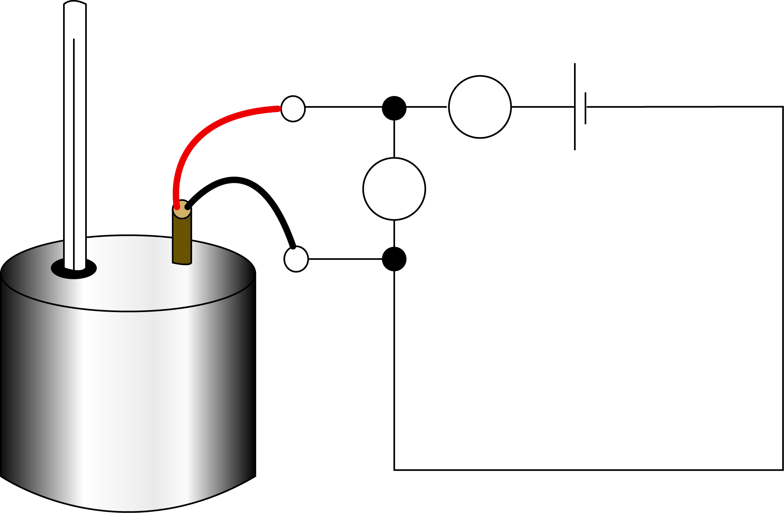
Thermometer
Heater
Metal block
A
V

- Record the mass of the metal block.
- Record the temperature of the metal block before turning on the power supply.
- Turn on the power supply with the voltage set at the value instructed by your teacher.
- Leave the block to heat for 20 minutes or other time given by your teacher. Check that the voltage remains constant during this time.
- Record the current at the start of the heating
- Calculate the power of the heater from the voltage and current.
- Calculate the energy transferred from the power and time.
- Record the temperature at the end of the heating time.
- Calculate the energy transferred for each degree centigrade
- Calculate the energy which would be required to raise the temperature of 1kg of the metal by one degree centigrade.

Results
Measurement | Value | Unit
Mass of block (m)
Initial temperature of block (T₁)
Final temperature of block (T₂)
Voltage (V)
Current (I)
Time taken (t)

Evaluation
1. | Work out the power of the heater
 |  | P = I x V
 |  | Power = | W

2. | Work out the energy transferred by the heater
 |  | E = P x t
 |  | Energy = | J

3. | Record the temperature at the end of the heating time and use this to work out temperature change.
 |  | T = T₂ – T₁
 |  | Temperature change = | ºC

4. | Work out the energy transferred for each degree centigrade that the temperature increased.
 |  | E_{o} = E_{h} ÷ T
 |  | Energy transferred for  each degree centigrade = | J

5. | Work out the energy which would be required to raise the temperature of 1kg of the metal by one degree centigrade.
 |  | Mass of block = | kg

To increase the temperature of 1 kg will require more / less energy than for my block.
Should I multiply / divide my answer in 4) by the mass of the block in kg to get the value for 1kg? (try it out)

 | The specific heat capacity is the amount of energy required to raise the temperature of 1 kg of a material by one degree centigrade.
 |  | Specific heat capacity = | J/kg/ ºC

Extension
Think through the process of carrying out this activity and list things about this activity which would cause your result to be inaccurate.
For each of these, write down what you could do to make your result more accurate.
If there is time and there is material available for you to carry out any of these improvements and repeat the activity.

Quiz - test your knowledge and understanding
- A student completes an experiment to find the specific heat capacity of a metal.
Thermometer
Heater
Metal block
A
V

The value obtained from the experiment is much higher than expected.
Give two reasons how this could have occurred and write down two improvements to the experimental procedure. [4 marks]

2. Use the table below to answer the following questions
Substance | Specific heat capacity (J/kg°C)
Copper | 385
Aluminium | 897
Lead | 129
Water | 4182

(a) | Which substance requires the least amount of energy to raise its temperature?  [1 mark]
(b) | A 10 kg block of copper is at 23°C. Work out the energy required to raise its temperature to 40°C. [4 marks]

(c) | What is the rise in temperature of 7000 g of water if it is given 58548 J of heat energy? [4 marks]

DfE Apparatus and Techniques covered
If you are using the OCR Practical Activity Learner Record Sheet (Physics / Combined Science) you may be able to tick off the following skills:

Physics |  |  |  |  | Combined Science
1a-iii | 1a-iv | 1a-vi | 5-i |  | 1-iii | 1-iv | 1-v | 17-i
5-ii |  |  |  |  | 17-ii

