Physics PAG 2: Forces

Combined Science PAG P2: Forces

Suggested Activity 1: Investigating the effects of forces on the extension of a spring

Instructions and answers for teachers & technicians
These instructions cover the learner activity section which can be found on page 7. This Practical activity supports OCR GCSE Physics.
When distributing the activity section to the learners either as a printed copy or as a Word file you will need to remove the teacher instructions section.
This is a suggested practical activity that can be used as part of teaching the GCSE (9-1) Gateway Science (A) and Twenty First Century Science (B) specifications.
These are not controlled assessment tasks, and there is no requirement to use these particular activities.
You may modify these activities to suit your learners and centre. Alternative activities are available from, for example, Royal Society of Biology, Royal Society of Chemistry, Institute of Physics, CLEAPSS and publishing companies, or of your own devising.
Further details are available in the specifications (Practical Skills Topics), and in these videos.
OCR recommendations:
Before carrying out any experiment or demonstration based on this guidance, it is the responsibility of teachers to ensure that they have undertaken a risk assessment in accordance with their employer’s requirements, making use of up-to-date information and taking account of their own particular circumstances. Any local rules or restrictions issued by the employer must always be followed.
CLEAPSS resources are useful for carrying out risk-assessments: (http://science.cleapss.org.uk).
Centres should trial experiments in advance of giving them to learners. Centres may choose to make adaptations to this practical activity, but should be aware that this may affect the Apparatus and Techniques covered by the learner.

Introduction
In this experiment pupils will be investigating the extension of a spring when masses are hung on it.

DfE Apparatus and Techniques covered
The codes used below match the OCR Practical Activity Learner Record Sheet (Physics / Combined Science) and Trackers (Physics / Combined Science) available online. There is no requirement to use these resources.
1a [1]: Use of appropriate apparatus to make and record a range of measurements accurately, including: i [i]) length; ii [ii]) area, iii [iii]) mass
2 [14]): Use of appropriate apparatus to measure and observe the effects of forces including the extension of springs
5 [17]): Safe use of appropriate apparatus in a range of contexts to measure: i [i] energy changes/transfers, ii [ii] associated values such as work done.

Aims
To use appropriate apparatus to measure force and length.
To plot a graph of force against extension
To calculate the spring constant of a spring
To calculate the work done in stretching a spring

Intended class time
50-60 minutes

Links to Specifications:

Gateway Science (Suite A) including Working Scientifically (WS)
P2.3c describe the relationship between force and extension for a spring and other simple systems
P2.3d describe the difference between linear and non-linear relationships between force and extension
P2.3e calculate a spring constant in linear cases
P2.3f calculate the work done in stretching
PM2.3i recall and apply: force exerted by a spring (N) = extension (m) x spring constant (N/m)
PM2.3ii apply: energy transferred in stretching (J) = 0.5 x spring constant (N/m) x (extension (m))²
WS1.2e Evaluate methods and suggest possible improvements and further investigations
WS1.3a Presenting observations and other data using appropriate methods
WS1.3b Translating data from one form to another
WS1.3e Interpreting observations and other data
WS1.4a Use scientific vocabulary, terminology and definitions
WS1.4b Recognise the importance of scientific quantities and understand how they are determined
WS1.4c Use SI units and IUPAC chemical nomenclature unless inappropriate
WS2a Carry out experiments
WS2c Presenting observations using appropriate methods

Twenty First Century Science (Suite B) including Ideas about Science (IaS)
P6.3.3a describe the relationship between force and extension for a spring and other simple systems
P6.3.3b describe how to measure and observe the effect of forces on the extension of a spring
P6.3.4 describe the difference between the force-extension relationship for linear systems and for non-linear systems
P6.3.5 recall and apply the relationship between force, extension and spring constant for systems where the force-extension relationship is linear:
force exerted by a spring (N) = extension (m) x spring constant (N/m)
P6.3.6a) calculate the work done in stretching a spring or other simple system, by calculating the appropriate area on the force-extension graph
P6.3.7 select and apply the relationship between energy stored, spring constant and extension for a linear system:
energy stored in a stretched spring (J) = ½ x spring constant (N/m) x (extension (m))²
IaS1.2 Suggest appropriate apparatus, materials and techniques, justifying choice with reference to the precision, accuracy and validity of the data that will be collected
IaS1.4 Identify factors that need to be controlled, and the ways in which they could be controlled
IaS2.1 Present observations and other data using appropriate formats
IaS2.2 When processing data use SI units where appropriate (e.g. kg, g, mg, km, m, mm, kJ, J)
IaS2.4 Be able to translate data from one form to another
IaS2.7 When displaying data graphically select an appropriate graphical form, use appropriate axes and scales, plot data points correctly, draw an appropriate line of best fit, and indicate uncertainty (e.g. range bars)
IaS2.11 In a given context interpret observations and other data (presented in diagrammatic, graphical, symbolic or numerical form) to make inferences and to draw conclusions, using appropriate scientific vocabulary and terminology to communicate the scientific rationale for findings and conclusions

Mathematical Skills covered
M3b Change the subject of an equation
M3c Substitute numerical values into algebraic equations using appropriate units for physical quantities
M3d Solve simple algebraic equations
M4a Translate information between graphical and numerical form
M4b Understand that y=mx+c represents a linear relationship
M4c Plot two variables from experimental or other data
M4d Determine the slope and intercept of a linear graph
M4f Understand the physical significance of area between a curve and the x-axis and measure it by counting squares as appropriate

Health and Safety
This is a very safe experiment when performed sensibly; masses may be heavy so care must be taken to not drop them. Learners should take care that they do not add too many masses to the spring as to break the spring. Learners should also take care when adding masses that the equipment doesn’t topple over. Eye protection should be worn.

Method
Learners to hang masses from a spring suspended from a clamp and stand. Learners measure the extension of the spring for each mass added and record their results in a table. Learners then plot a graph of their results and describe the pattern in the results. Learners calculate the spring constant for the spring both through numerical calculation and through calculation of the gradient of the graph.

Notes
Learners should be able compare the spring constants calculated via both methods. Encourage learners to consider where the inaccuracies in their measurements may be. This is an opportunity to look at the accuracy of the measuring equipment they are using. It is also good for learners to consider how they could improve on their experimental technique.

Technician Notes

For this practical the teacher will require for a class of 30:
- 15x clamp, stand and boss
- 15x metre ruler
- 15x extendable steel spring
- 15x mass hanger and slotted masses
- 30x goggles
- 30x graph paper
- 30x 30cm ruler

Answers for quiz questions
1a [1 mark]
Not to hang too much weight so not to break spring / careful with dropping masses
1bi [5 marks]
force exerted by a spring = extension x spring constant
spring constant = force ÷ extension
12 cm = 0.12 m
0.14 kg = 1.4 N
1.4 N ÷ 0.12 m = 11.6 N/m
1bii [3 marks]
extension = force ÷ spring constant
= 4 N ÷ 11.6 N/m
= 0.34 m
2a [2 marks]
A
It has the steepest gradient
2b [2 marks]
It has reached its limit of proportionality
So no longer obeys Hooke’s law

Document updates
v1 Published on the qualification pages
v1.1 January 2017 Consolidated labelling and formatting of activities
v1.2 February 2017 Added in energy and work calculations
v1.3 June 2021 Updated to meet digital accessibility standards

We’d like to know your view on the resources we produce. Click ‘Like’ or ‘Dislike’ to send us an auto generated email about this resource. Add comments if you want to. Let us know how we can improve this resource or what else you need. Your email will not be used or shared for any marketing purposes.
Looking for another resource? There is now a quick and easy search tool to help find free resources for your qualification.
OCR is part of Cambridge Assessment, a department of the University of Cambridge.
For staff training purposes and as part of our quality assurance programme your call may be recorded or monitored.
Oxford Cambridge and RSA Examinations is a Company Limited by Guarantee. Registered in England. Registered office
The Triangle Building, Shaftesbury Road, Cambridge, CB2 8EA. Registered company number 3484466. OCR is an exempt charity.
OCR operates academic and vocational qualifications regulated by Ofqual, Qualifications Wales and CCEA as listed
in their qualifications registers including A Levels, GCSEs, Cambridge Technicals and Cambridge Nationals.
OCR provides resources to help you deliver our qualifications. These resources do not represent any particular teaching method we expect you to use. We update our resources regularly and aim to make sure content is accurate but please check the OCR website so that you have the most up to date version. OCR cannot be held responsible for any errors or omissions in these resources.
Though we make every effort to check our resources, there may be contradictions between published support and the specification, so it is important that you always use information in the latest specification. We indicate any specification changes within the document itself, change the version number and provide a summary of the changes. If you do notice a discrepancy between the specification and a resource, please contact us.
© OCR 2021 - You can copy and distribute this resource freely if you keep the OCR logo and this small print intact and you acknowledge OCR as the originator of the resource.
OCR acknowledges the use of the following content: N/A
Whether you already offer OCR qualifications, are new to OCR or are thinking about switching, you can request more information using our Expression of Interest form.
Please get in touch if you want to discuss the accessibility of resources we offer to support you in delivering our qualifications.

Physics PAG 2: Forces

Combined Science PAG P2: Forces

Suggested Activity 1: Investigating the effects of forces on the extension of a spring

Learner Activity

Introduction
In this experiment you will be investigating the extension of a spring when masses are hung on it.

Aims
To use appropriate apparatus to measure force and length.
To plot a graph of force against extension
To calculate the spring constant of a spring
To calculate the work done in stretching a spring

Intended class time
50-60 minutes

Equipment (per group)
- clamp, stand and boss
- metre ruler
- extendable steel spring
- mass hanger and slotted masses
- goggles
- graph paper
- 30 cm ruler

Health and Safety
This is a very safe experiment when performed sensibly; masses may be heavy so care must be taken to not drop them. You should take care that you do not add too many masses to the spring as this will break the spring. You should also take care when adding masses that the equipment doesn’t topple over. Eye protection must be worn.

Method
- Set up apparatus as shown below but do not hang the mass hanger or masses on the spring yet.
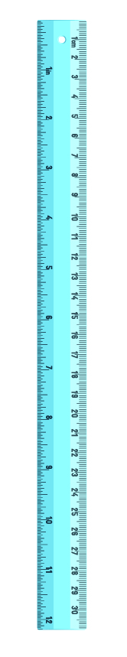
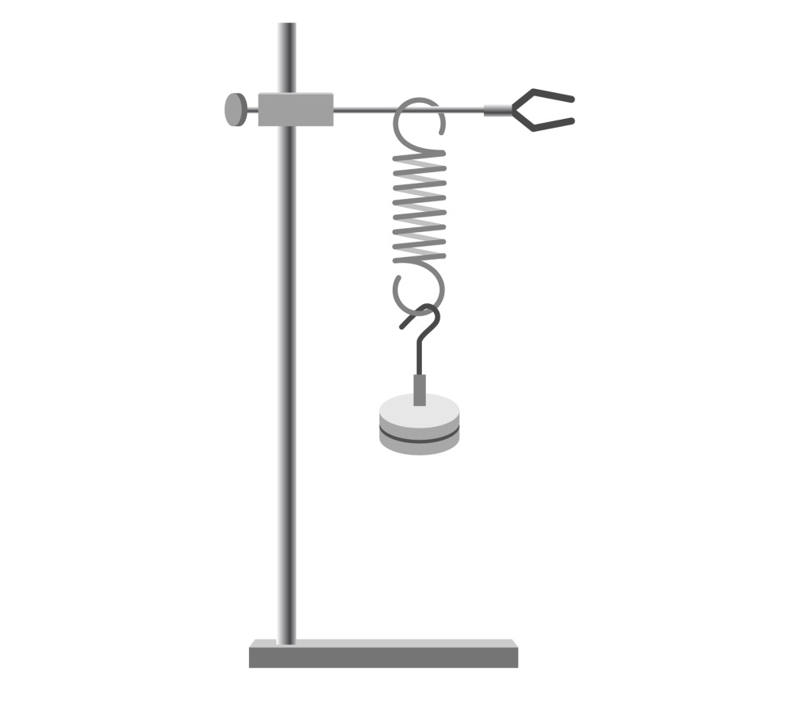
Ruler
Clamp
Mass hanger
Boss head
Retort stand
Spring

- Measure the original length of the spring and record it in your results below.
- Now start adding the mass hanger and masses. After each mass is added and the spring is stationary read off the new length of the spring.

- Calculate the extension of the spring after each mass is added by using :
Extension = new length (cm) – original spring length (cm)
- Record results in the table below
- Convert the mass (kg) into weight (Force, N) by using the equation:
Weight (N) = mass (kg) x gravitational field strength (N/kg) where g = 10 N/kg
- Keep adding masses until you have 10 results or the limit of proportionality is reached (this is the point at which the spring will no longer return to its original length when the masses are removed)
- Repeat the above 3 times and calculate an mean value
- Plot a graph of force (N) against extension (m)
- Calculate the spring constant of the spring by rearranging the equation:
force exerted by a spring (N) = extension (m) x spring constant (N/m)
- Calculate the spring constant of the spring by calculating the gradient of your graph
- Calculate the work done in stretching the spring by working out the area under the graph
- Calculate the energy transferred in stretching by using the equation:
energy transferred in stretching (J) = 0.5 x spring constant (N/m) x (extension (m))²

Results

Original spring length = (cm)

 |  | Start length of spring (cm) |  |  | End length of spring (cm) |  |  | Extension of spring (cm) |  |  | Mean Extension of spring (m)
Mass added (kg) | Force (N) | 1 | 2 | 3 | 1 | 2 | 3 | 1 | 2 | 3

Calculated spring constant =

(N/m)
Spring constant from graph =

(N/m)

Work done from graph

(J)
Energy transferred in stretching

(J)

Evaluation
What does the graph show?
What type of mathematical relationship does this graph suggest exists between force and extension?

Quiz - test your knowledge and understanding
1. (a) |  | A student is investigating springs and forces. They measure how much a spring extends when different weights are hung on it. Write down one safety precaution the students should take when completing this experiment. [1 mark]

(b) (i) | Work out the spring constant of a spring if it extends by 12 cm when a mass of 0.14 kg is attached to it. [5 marks]

(N/m)

(b) (ii) | Work out what the extension of the same spring would be if a force of 4 N was applied.  [3 marks]

(m)

2. | The extension of four different springs is shown in the graph below.
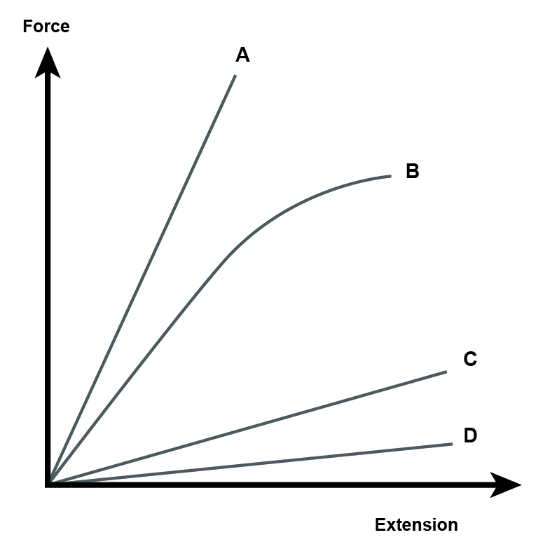
(a) | Which spring A, B, C or D has the highest spring constant? Write down why. [2 marks]

(b) | Why does the line for B have a different shape to the others? [2 marks]

DfE Apparatus and Techniques covered
If you are using the OCR Practical Activity Learner Record Sheet (Physics / Combined Science) you may be able to tick off the following skills:

Physics |  |  |  |  | Combined Science
1a–i | 1a-ii | 1a–iii | 2 |  | 1–i | 1–ii | 1–iii | 14
5–i | 5–ii |  |  |  | 17–i | 17–ii

