Physics PAG 6: Circuit components

Combined Science PAG P6: Circuits

Suggested Activity 1: Investigate the I–V characteristics of circuit elements

Instructions and answers for teachers & technicians
These instructions cover the learner activity section which can be found on page 9. This Practical activity supports OCR GCSE Physics.
When distributing the activity section to the learners either as a printed copy or as a Word file you will need to remove the teacher instructions section.
This is a suggested practical activity that can be used as part of teaching the GCSE (9-1) Gateway Science (A) and Twenty First Century Science (B) specifications.
These are not controlled assessment tasks, and there is no requirement to use these particular activities.
You may modify these activities to suit your learners and centre. Alternative activities are available from, for example, Royal Society of Biology, Royal Society of Chemistry, Institute of Physics, CLEAPSS and publishing companies, or of your own devising.
Further details are available in the specifications (Practical Skills Topics), and in these videos.
OCR recommendations:
Before carrying out any experiment or demonstration based on this guidance, it is the responsibility of teachers to ensure that they have undertaken a risk assessment in accordance with their employer’s requirements, making use of up-to-date information and taking account of their own particular circumstances. Any local rules or restrictions issued by the employer must always be followed.
CLEAPSS resources are useful for carrying out risk-assessments: (http://science.cleapss.org.uk).
Centres should trial experiments in advance of giving them to learners. Centres may choose to make adaptations to this practical activity, but should be aware that this may affect the Apparatus and Techniques covered by the learner.

Introduction
In this activity, learners will investigate the I-V characteristics of a resistor, filament bulb and diode.

DfE Apparatus and Techniques covered
The codes used below match the OCR Practical Activity Learner Record Sheet (Physics / Combined Science) and Trackers (Physics / Combined Science) available online. There is no requirement to use these resources.
6a [18a]) Use of appropriate apparatus to measure: i) current; ii) potential difference; iii) resistance
6b [18b]) Use of appropriate apparatus to explore a variety of circuit elements
7 [19]) Use of circuit diagrams to construct and check: i [i]) series circuits including a variety of common circuit elements; ii [ii]) parallel circuits including a variety of common circuit elements

Aims
Use of appropriate apparatus to measure current, potential difference (voltage) and resistance of a resistor, filament bulb and diode.
Plot an I-V graph for a resistor, filament bulb and diode.
Use graphs and relate the curves produced to their function and properties.

Intended class time
50-60 minutes

Links to Specifications:

Gateway Science (Suite A) including Working Scientifically (WS)
P3.2c recall that current (I) depends on both resistance (R) and potential difference (V) and the units in which these are measured
P3.2d recall and apply the relationship between I, R and V
P3.2e explain that for some resistors the value of R remains constant but that in others it can change as the current changes
P3.2g use graphs to explore whether circuit elements are linear or nonlinear
P3.2h use graphs and relate the curves produced to the function and properties of circuit elements

WS1.1b, Use models to solve problems, make predictions and to develop scientific explanations and understanding of familiar and unfamiliar facts representational, spatial, descriptive, computational and mathematical models
WS1.2a, use scientific theories and explanations to develop hypotheses
WS1.2b, plan experiments or devise procedures to make observations, produce or characterise a substance, test hypotheses, check data or explore phenomena
WS1.2c, apply a knowledge of a range of techniques, instruments, apparatus, and materials to select those appropriate to the experiment
WS1.3b, translating data from one form to another
WS1.3e, interpreting observations and other data
WS1.3f, presenting reasoned explanations
WS1.3h, identifying potential sources of random and systematic error
WS1.4a, use scientific vocabulary, terminology and definitions
WS2a, carry out experiments
WS2c, presenting observations using appropriate methods
WS2d, communicating the scientific rationale for investigations, methods used, findings and reasoned conclusions

Twenty First Century Science (Suite B) including Ideas about Science (IaS
P3.2.3 recall that current (I) depends on both resistance (R) and potential difference (V) and the units in which these quantities are measured
P3.2.4(a) recall and apply the relationship between I, R, and V, to calculate the currents, potential differences and resistances in d.c. series circuits
P3.2.5 recall that for some components the value of R remains constant (fixed resistors) but that in others it can change as the current changes (e.g. heating elements, lamp filaments)
P3.2.6(a) use graphs to explore whether circuit elements are linear or non-linear and relate the curves produced to their function and properties
P3.2.6(b) describe experiments to investigate the I-V characteristics of circuit elements. To include: lamps, diodes, LDRs and thermistors. Be able to draw circuit diagrams for the circuits used
IaS1.1 present observations and other data using appropriate formats
IaS1.2 when processing data use SI units where appropriate (e.g. kg, g, mg; km, m, mm; kJ, J) and IUPAC chemical nomenclature unless inappropriate
IaS1.3 when processing data use prefixes (e.g. tera, giga, mega, kilo, centi, milli, micro and nano) and powers of ten for orders of magnitude
IaS1.4 be able to translate data from one form to another
IaS1.5 when processing data interconvert units
IaS1.6 . when processing data use an appropriate number of significant figures
IaS1.7 when displaying data graphically select an appropriate graphical form, use appropriate axes and scales, plot data points correctly, draw an appropriate line of best fit, and indicate uncertainty (e.g. range bars)
IaS1.8 when analysing data identify patterns/trends, use statistics (range and mean) and obtain values from a line on a graph (including gradient, interpolation and extrapolation),
IaS 2.9 in a given context evaluate data in terms of accuracy, precision, repeatability and reproducibility, identify potential sources of random and systematic error, and discuss the decision to discard or retain an outlier
IaS 2.11 in a given context interpret observations and other data (presented in diagrammatic, graphical, symbolic or numerical form) to make inferences and to draw reasoned conclusions, using appropriate scientific vocabulary and terminology to communicate the scientific rationale for findings and conclusions
IaS 2.12 explain the extent to which data increase or decrease confidence in a prediction or hypothesis
IaS 3.1 use ideas about correlation and cause to: - identify a correlation in data presented as text, in a table, or as a graph M2g - distinguish between a correlation and a cause effect link - suggest factors that might increase the chance of a particular outcome in a given situation, but do not invariably lead to it - explain why individual cases do not provide convincing evidence for or against a correlation - identify the presence (or absence) of a plausible mechanism as reasonable grounds for accepting (or rejecting) a claim that a factor is a cause of an outcome

Mathematical Skills covered
M1a Recognise and use expressions in decimal form
M2a Use an appropriate number of significant figures
M2g g Use a scatter diagram to identify a correlation between two variables
M3a Understand and use the symbols: =, <>, >, ∝, ~
M3b Change the subject of an equation
M3c Substitute numerical values into algebraic equations using appropriate units for physical quantities
M3d Solve simple algebraic equations
M4a Translate information between graphical and numeric form
M4b Understand that y=mx+c represents a linear relationship
M4c Plot two variables from experimental or other data
M4d Determine the slope and intercept of a linear graph

Health and Safety
Check with your teacher the circuit is set up correctly
Turn off switch between readings to ensure components don’t get too hot
Be aware that components can get very hot so do not touch the components until they are cooled down
Always have components on a heat proof mat
Before carrying out any experiment or demonstration based on this guidance, it is the responsibility of teachers to ensure that they have undertaken a risk assessment in accordance with their employer’s requirements, making use of up-to-date information and taking account of their own particular circumstances. Any local rules or restrictions issued by the employer must always be followed.
CLEAPSS document R151 “Ammeters,Voltmeters etc,for Class Use” and the Laboratory Handbook sections 12.3.1 “DMMs compared to analogue meters”, 12.3.2 “Provision of digital multimeters” and 12.3.3 “Which DMMs to buy”, contain useful information on selection and use of digital multimeters
Based on the components available the teacher should assess the maximum permissible current and define this to the learners.

Technician Notes

For this practical the teacher will require:
- 12V variable supply or 4 x 1.5V cells
- Potentiomater/Rheostat
- 4mm connecting leads
- Ammeter (Multimeter)
- Voltmeter (Multimeter)
- 12V Bulb
- Fixed Resistor at least 10 ohm
- Semiconductor diode
- Switch
- Heat proof mat

Answers for quiz questions
1. (a) (i) | A student measures the current through a thermistor at varying potential differences. They plot a graph for their results. Sketch below the graph they would expect to see. [2 marks]
Current (I)
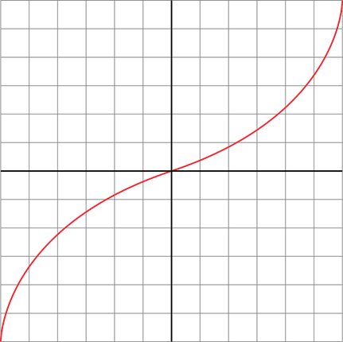

Potential Difference (V)

(ii) | Use the graph to write down how the resistance of the thermistor changes with temperature.[3 marks]
As the current increases the temperature of the thermistor increases
At low temperatures the thermistor has high resistance
At high temperatures the thermistor has low resistance

(b) | 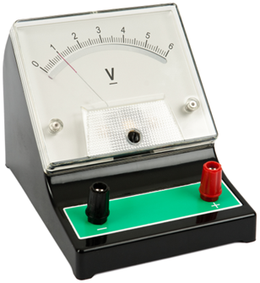  A voltmeter is used to measure the output voltage produced from the circuit. The voltmeter is not connected to the circuit and not recording a voltage.
 | Name the error on the voltmeter and suggest how it should be dealt with. [2 marks]
 | Zero error Reset the meter/subtract 1.0V from all readings

(c) | Draw below the circuit symbol for an LDR. [1 mark]
 | 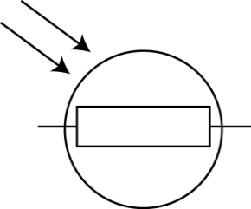

(d) | A student has a resistor of unknown resistance. They find that the current through the resistor is 120 mA when the potential difference is 12 V. Work out the resistance of the resistor. [4 marks]
Resistance = potential difference ÷ current
120 mA = 0.12 A
Resistance = 12 V ÷ 0.12 A
= 100 ohm

Document updates
v1 Published on the qualification pages
v1.1 January 2017 Consolidated labelling and formatting of activities
v1.2 June 2021 Updated to meet digital accessibility standards

We’d like to know your view on the resources we produce. Click ‘Like’ or ‘Dislike’ to send us an auto generated email about this resource. Add comments if you want to. Let us know how we can improve this resource or what else you need. Your email will not be used or shared for any marketing purposes.
Looking for another resource? There is now a quick and easy search tool to help find free resources for your qualification.
OCR is part of Cambridge Assessment, a department of the University of Cambridge.
For staff training purposes and as part of our quality assurance programme your call may be recorded or monitored.
Oxford Cambridge and RSA Examinations is a Company Limited by Guarantee. Registered in England. Registered office
The Triangle Building, Shaftesbury Road, Cambridge, CB2 8EA. Registered company number 3484466. OCR is an exempt charity.
OCR operates academic and vocational qualifications regulated by Ofqual, Qualifications Wales and CCEA as listed
in their qualifications registers including A Levels, GCSEs, Cambridge Technicals and Cambridge Nationals.
OCR provides resources to help you deliver our qualifications. These resources do not represent any particular teaching method we expect you to use. We update our resources regularly and aim to make sure content is accurate but please check the OCR website so that you have the most up to date version. OCR cannot be held responsible for any errors or omissions in these resources.
Though we make every effort to check our resources, there may be contradictions between published support and the specification, so it is important that you always use information in the latest specification. We indicate any specification changes within the document itself, change the version number and provide a summary of the changes. If you do notice a discrepancy between the specification and a resource, please contact us.
© OCR 2021 - You can copy and distribute this resource freely if you keep the OCR logo and this small print intact and you acknowledge OCR as the originator of the resource.
OCR acknowledges the use of the following content: N/A
Whether you already offer OCR qualifications, are new to OCR or are thinking about switching, you can request more information using our Expression of Interest form.
Please get in touch if you want to discuss the accessibility of resources we offer to support you in delivering our qualifications.

Physics PAG 6: Circuit components

Combined Science PAG P6: Circuits

Suggested Activity 1: Investigate the I–V characteristics of circuit elements

Learner Activity

Introduction

In this activity, you will investigate the I-V characteristics of a resistor, filament bulb and diode.

Aims
Use of appropriate apparatus to measure current, potential difference (voltage) and resistance of a resistor, filament bulb and diode.
Plot an I-V graph for a resistor, filament bulb and diode.
Use graphs and relate the curves produced to their function and properties.

Intended class time
50-60 minutes

Equipment (per group)
- 12V Variable supply or 4 x 1.5V cells
- Potentiomater/Rheostat
- 4mm connecting leads
- Ammeter (Multimeter)
- Voltmeter (Multimeter)
- 12V Bulb
- Fixed Resistor at least 10 ohm
- Semiconductor diode
- Switch
- Heat proof mat

Health and Safety
Check with your teacher the circuit is set up correctly
Turn off switch between readings to ensure components don’t get too hot
Be aware that components can get very hot so do not touch the components until they are cooled down
Always have components on a heat proof mat

Method
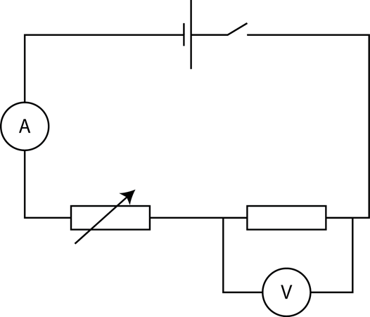
- Connect the circuit as shown with the switch open, check with your teacher it is set up safely and correctly.

- Close the switch and move the slider on the rheostat until there is a zero current reading on the ammeter
- Move the slider slowly until you get a reading for voltage and current and record these values in your table
- Move the slider up in approximately equal steps another 5 times so you have a total of six readings for voltage and current and record all of these value in your table
- Swap the leads round on the powerpack and repeat for negative values
- Replace the fixed resistor with a filament bulb and repeat steps 2-5
- Replace the fixed resistor with a diode and repeat steps 2-5

Results
- Record all your results in the table provided

- Plot a scatter graph of current on the y-axis and voltage on the x-axis and draw a line of best fit for the bulb, the diode and the resistor
Diode
Voltage(V) | Current(A)

Filament bulb
Voltage(V) | Current(A)

Resistor
Voltage (V) | Current(A)

Evaluation
- Look at the three graphs you have drawn. Write down the similarities and the differences between them. What do you think the relationship between voltage and current is?

- Pick three points on your line (not from your results table) for each graph and divide voltage by current to work out the resistance as R=V/I. Use an appropriate number of significant figures.
Resistor
Voltage(V) | Current(A) | Resistance V/I(Ω)

Diode
Voltage(V) | Current(A) | Resistance V/I(Ω)

Filament bulb
Voltage(V) | Current(A) | Resistance V/I(Ω)

- What is the relationship between current and resistance in a resistor?

- What is the relationship between current and resistance in a filament bulb?

- What is the relationship between current and resistance in a diode?

Extension
- Using your knowledge of the properties of a metal write down why you think the resistance behaves the way it does in a filament bulb.

Quiz - test your knowledge and understanding
1. (a) (i) | A student measures the current through a thermistor at varying potential differences. They plot a graph for their results. Sketch below the graph they would expect to see. [2 marks]
P.d (V)
Current (A)

(ii) | Use the graph to write down how the resistance of the thermistor changes with temperature. [3 marks]

(b) | A voltmeter is used to measure the output voltage produced from the circuit. The voltmeter is not connected to the circuit and not recording a voltage.
 | Name the error on the voltmeter and suggest how it should be dealt with. [2 marks]

(c) | Draw below the circuit symbol for an LDR. [1 mark]

(d) | A student has a resistor of unknown resistance. They find that the current through the resistor is 120 mA when the potential difference is 12 V. Work out the resistance of the resistor. [4 marks]

DfE Apparatus and Techniques covered
If you are using the OCR Practical Activity Learner Record Sheet (Physics / Combined Science) you may be able to tick off the following skills:

Physics |  |  |  |  | Combined Science
6a-i | 6a-ii | 6a-iii | 6b |  | 18a-i | 18a-ii | 18a-iii | 18b
7-i | 7-ii |  |  |  | 19-i | 19-ii

