Physics PAG 4: Measuring waves

Combined Science PAG P4: Waves

Suggested Activity 1: Investigating water waves

Instructions and answers for teachers & technicians

These instructions cover the learner activity section which can be found on page 7. This Practical activity supports OCR GCSE Physics.
When distributing the activity section to the learners either as a printed copy or as a Word file you will need to remove the teacher instructions section.
This is a suggested practical activity that can be used as part of teaching the GCSE (9-1) Gateway Science (A) and Twenty First Century Science (B) specifications.
These are not controlled assessment tasks, and there is no requirement to use these particular activities.
You may modify these activities to suit your learners and centre. Alternative activities are available from, for example, Royal Society of Biology, Royal Society of Chemistry, Institute of Physics, CLEAPSS and publishing companies, or of your own devising.
Further details are available in the specifications (Practical Skills Topics), and in these videos.

OCR recommendations:
Before carrying out any experiment or demonstration based on this guidance, it is the responsibility of teachers to ensure that they have undertaken a risk assessment in accordance with their employer’s requirements, making use of up-to-date information and taking account of their own particular circumstances. Any local rules or restrictions issued by the employer must always be followed.
CLEAPSS resources are useful for carrying out risk-assessments: (http://science.cleapss.org.uk).
Centres should trial experiments in advance of giving them to learners. Centres may choose to make adaptations to this practical activity, but should be aware that this may affect the Apparatus and Techniques covered by the learner.

Introduction
In this experiment pupils will be investigating how to measure how to measure the speed, frequency and wavelength of a water wave.

DfE Apparatus and Techniques covered
The codes used below match the OCR Practical Activity Learner Record Sheet (Physics / Combined Science) and Trackers (Physics / Combined Science) available online. There is no requirement to use these resources.
1a [1]: Use of appropriate apparatus to make and record a range of measurements accurately, including: i [i]) length; iv [iv]) time
4a [16a]) Making observations of waves in fluids and solids to identify the suitability of apparatus to measure: i) speed; ii) frequency; iii) wavelength
8) Making observations of waves to identify the suitability of apparatus to measure the effects of interactions of waves with matter in: i) fluids

Aims
To use appropriate apparatus to measure speed, frequency and wavelength.
To make observations of waves in fluids.
To calculate the speed of a wave using the equation:
Wave speed (m/s) = frequency (Hz) x wavelength (m)
To evaluate methods and suggest improvements

Intended class time
50-60 minutes

Links to Specifications:

Gateway Science (Suite A) including Working Scientifically (WS)
P5.1a describe wave motion in terms of amplitude, wavelength, frequency and period
P5.1b define wavelength and frequency
P5.1c describe and apply the relationship between these and the wave velocity
P5.1d apply formulae relating velocity, frequency and wavelength

PM5.1i recall and apply: Wave speed (m/s) = frequency (Hz) x wavelength (m)
WS1.2e Evaluate methods and suggest possible improvements and further investigations
WS1.3e Interpreting observations and other data
WS1.4a Use scientific vocabulary, terminology and definitions
WS1.4b Recognise the importance of scientific quantities and understand how they are determined
WS1.4c Use SI units and IUPAC chemical nomenclature unless inappropriate
WS2a Carry out experiments
WS2c Presenting observations using appropriate methods

Twenty First Century Science (Suite B) including Ideas about Science (IaS)
P1.3.1 describe wave motion in terms of amplitude, wavelength, frequency and period
P1.3.2 describe evidence that for both ripples on water surface and sound waves in air, it is the wave and not the water it air itself that travels
P1.3.5 define wavelength and frequency
P1.3.6 recall and apply the relationship between speed, frequency and wavelength to waves, including waves on water, sound waves and across the electromagnetic spectrum:
Wave speed (m/s) = frequency (Hz) x wavelength (m)
1.3.7a describe how the speed of ripples on water surfaces and the speed of sound waves in air can be measured
1.3.7b describe how to use a ripple tank to measure speed/frequency and wavelength of a wave
IaS1.2 Suggest appropriate apparatus, materials and techniques, justifying choice with reference to the precision, accuracy and validity of the data that will be collected
IaS1.4 Identify factors that need to be controlled, and the ways in which they could be controlled
IaS2.1 Present observations and other data using appropriate formats
IaS2.2 When processing data use SI units where appropriate (e.g. kg, g, mg, km, m, mm, kJ, J)

Mathematical Skills covered
M3b Change the subject of an equation
M3c Substitute numerical values into algebraic equations using appropriate units for physical quantities
M3d Solve simple algebraic equations

Health and Safety
This is a very safe experiment when performed sensibly; spilled water can be a slip hazard so back sure and spills are dealt with quickly. Make sure any electrical supplies are not close to the water. If class members have photo-induced epilepsy than a stroboscope shouldn’t be used.

Method 1: wavelength
Learners use a ripple tank or tray to work out the wavelength of a water wave. Depending on centres equipment they can either use a ripple tank, motor driven paddle and stroboscope or they can use a tray, ruler and digital camera or camera phone. Learners create ripples on the water and measure the distance between waves 1 times and then work out the mean wavelength.

Method 2: frequency and wavelength
Learners keep the frequency of the waves created the same as for experiment 1. A stopwatch is used and the number of ripples that pass appoint in a set time is recorded. Learners repeat this and calculate an average. The frequency is then calculated by dividing the average by the time. Using the wave speed equation learners can then use their results from part 1 and 2 to calculate an estimated wave speed.

Notes
Teachers should trial this activity to be able to modify the learner sheet in the light of the equipment and lesson time available at the centre.
Encourage learners to consider where the inaccuracies in their measurements may be. This is a good opportunity to look at the accuracy of the measuring equipment they are using.

Technician Notes

For this practical the teacher will require:
- Ripple tank and accessories (or tray of water if ripple tank not available)
- Motor driven beam with supports to create ripples (or ruler if this is unavailable)
- Hand stroboscope (or digital camera / mobile phone if this isn’t available)
- Metre ruler
- White paper
- Stopwatch

Answers for quiz questions
1a [1 mark]
40 cm = 0.40m
1b [1 mark]
120 cm = 1.20 m
1c [4 marks]
wave speed = frequency x wavelength
Rearrange to give frequency = wave speed ÷ wavelength
Frequency = 25m/s ÷ 1.2m
= 20.83 Hz
2a [1 mark]
Water/light/any EM wave
1b [1 mark]
Sound/P wave
3 [4 marks]
Equipment needed = stopwatch, meter ruler, wall, person or something to make noise
Place source of noise or person in front of wall, Measure distance to wall from source
Make sound and time how long it takes for echo of sound from wall to be heard
Calculate speed using speed = (2 x distance) x time

Document updates
v1 Published on the qualification pages
v1.1 January 2017 Consolidated labelling and formatting of activities
v1.2 February 2017 Correction of Combined Science labelling
v1.3 June 2021 Updated to digital accessibility standards

We’d like to know your view on the resources we produce. Click ‘Like’ or ‘Dislike’ to send us an auto generated email about this resource. Add comments if you want to. Let us know how we can improve this resource or what else you need. Your email will not be used or shared for any marketing purposes.
Looking for another resource? There is now a quick and easy search tool to help find free resources for your qualification.
OCR is part of Cambridge Assessment, a department of the University of Cambridge.
For staff training purposes and as part of our quality assurance programme your call may be recorded or monitored.
Oxford Cambridge and RSA Examinations is a Company Limited by Guarantee. Registered in England. Registered office
The Triangle Building, Shaftesbury Road, Cambridge, CB2 8EA. Registered company number 3484466. OCR is an exempt charity.
OCR operates academic and vocational qualifications regulated by Ofqual, Qualifications Wales and CCEA as listed
in their qualifications registers including A Levels, GCSEs, Cambridge Technicals and Cambridge Nationals.
OCR provides resources to help you deliver our qualifications. These resources do not represent any particular teaching method we expect you to use. We update our resources regularly and aim to make sure content is accurate but please check the OCR website so that you have the most up to date version. OCR cannot be held responsible for any errors or omissions in these resources.
Though we make every effort to check our resources, there may be contradictions between published support and the specification, so it is important that you always use information in the latest specification. We indicate any specification changes within the document itself, change the version number and provide a summary of the changes. If you do notice a discrepancy between the specification and a resource, please contact us.
© OCR 2021 - You can copy and distribute this resource freely if you keep the OCR logo and this small print intact and you acknowledge OCR as the originator of the resource.
OCR acknowledges the use of the following content: N/A
Whether you already offer OCR qualifications, are new to OCR or are thinking about switching, you can request more information using our Expression of Interest form.
Please get in touch if you want to discuss the accessibility of resources we offer to support you in delivering our qualifications.

Physics PAG 4: Measuring waves

Combined Science PAG P4: Waves

Suggested Activity 1: Investigating water waves

Learner Activity

Introduction
In this experiment you will be investigating how to measure the speed, frequency and wavelength of a water wave.

Aims
To use appropriate apparatus to measure speed, frequency and wavelength.
To make observations of waves in fluids.
To calculate the speed of a wave using the equation:
Wave speed (m/s) = frequency (Hz) x wavelength (m)
To evaluate methods and suggest improvements

Intended class time
50-60 minutes

Equipment (per group)
- Ripple tank and accessories (or tray of water if ripple tank not available)
- Motor driven beam with supports to create ripples (or ruler if this is unavailable)
- Hand stroboscope (or digital camera / mobile phone if this isn’t available)
- Metre ruler
- White paper
- Stopwatch

Health and Safety
This is a very safe experiment when performed sensibly; spilled water can be a slip hazard so make sure that spills are dealt with quickly. Make sure any electrical supplies are not close to the water. If class members have photo-induced epilepsy then a stroboscope shouldn’t be used.

Method 1
- Set up apparatus as shown below.
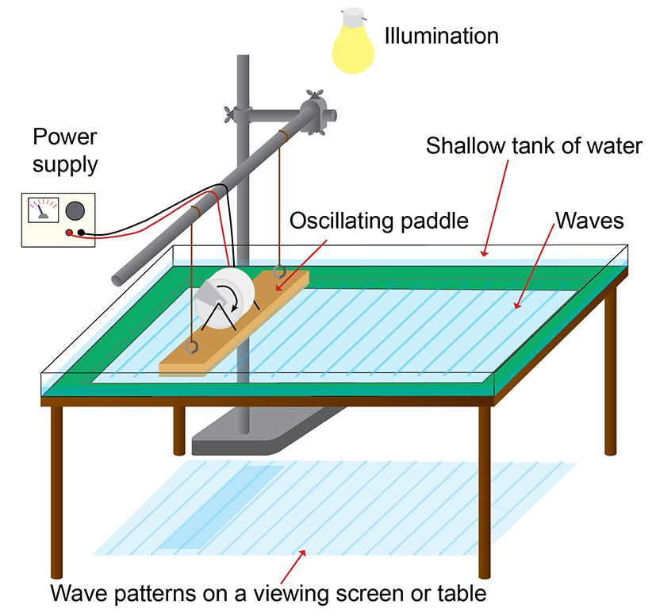
NB alternatively use a tray and create the ripples by hand using a ruler, waves can then be photographed to analyse while stationary
- Use the motor driven beam or a ruler to create a continuous straight wave, this should be of low frequency for easier measuring
- Use the stroboscope to freeze the wave pattern, if a stroboscope is not available then a digital image of the wave should be taken with the meter ruler lying alongside the wave fronts
- Find the wavelength by measuring 10 waves on the paper under the ripple tank and finding the average wavelength. If using the camera technique then do the same thing but from the images produced rather than from the paper

Results
Wavelengths (m)
1 | 2 | 3 | 4 | 5 | 6 | 7 | 8 | 9 | 10 | Mean

Evaluation
Why does this method only produce an ‘estimated’ wavelength?
Why is it more accurate to produce the ripples using a motor than by hand?

Method 2 – frequency and wave speed

Keep the frequency the same as you did for method 1.

Use the stop watch and count the number of ripples that pass in a given time, say 10 seconds

Repeat at least 3 times and calculate a mean

Calculate the number of waves that pass per second (frequency)

Calculate the wave speed using the equation:

Wave speed (m/s) = frequency (Hz) x wavelength (m)

Results
 | Number of waves
Time (s) | 1 | 2 | 3 | Mean

Work out the frequency = mean number of waves ÷ time (s)
=…………………..Hz
Work out the wave speed = frequency (Hz) x wavelength (m)
=…………………..m/s

Evaluation
If you doubled the frequency what would happen to the wavelength assuming the wave speed was kept constant?
Write down the good and bad points of your method. How could the accuracy of the measurements have been improved? Can you think of any other improvements you could make to your method?

Quiz - test your knowledge and understanding
1. A student is investigating with waves on a skipping rope, below is an image of the wave produce?
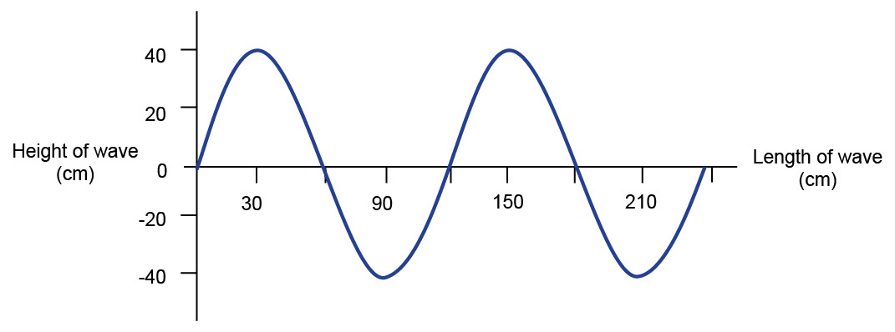
(a) What is the amplitude of the wave in meters? [1 mark]

(b) What is the wavelength of the wave in meters? [1 mark]

(c) The wave travels at a speed of 25m/s. Work out the frequency of the wave.
[4 marks]

2. (a) Waves on a rope are an example of a transverse wave. Give another example of a transverse wave. [1 mark]

(b) Give an example of a longitudinal wave. [1 mark]

3. A student wants to measure the speed of a sound wave using an echo. What apparatus would they need and what measurements should they take? [4 marks]

DfE Apparatus and Techniques covered
If you are using the OCR Practical Activity Learner Record Sheet (Physics / Combined Science) you may be able to tick off the following skills:

Physics |  |  |  |  | Combined Science
1a-i | 1a-iv | 4a-i | 4a-ii |  | 1-i | 1-iv | 16a-i | 16a-ii
4a-iii | 8-i |  |  |  | 16a-iii

