Biology PAG 4: Rates of enzyme-controlled reactions

Combined Science PAG B3: Rates of enzyme controlled reactions

Suggested Activity 1: The effect of substrate concentration on catalase

Instructions and answers for teachers & technicians
These instructions cover the student activity section which can be found on page 11. This Practical activity supports OCR GCSE Biology.
When distributing the activity section to the students either as a printed copy or as a Word file you will need to remove the teacher instructions section.
This is a suggested practical activity that can be used as part of teaching the GCSE (9-1) Gateway Science (A) and Twenty First Century Science (B) specifications.
These are not controlled assessment tasks, and there is no requirement to use these particular activities.
You may modify these activities to suit your learners and centre. Alternative activities are available from, for example, Royal Society of Biology, Royal Society of Chemistry, Institute of Physics, CLEAPSS and publishing companies, or of your own devising.
Further details are available in the specifications (Practical Skills Topics), and in these videos.
OCR recommendations:
Before carrying out any experiment or demonstration based on this guidance, it is the responsibility of teachers to ensure that they have undertaken a risk assessment in accordance with their employer’s requirements, making use of up-to-date information and taking account of their own particular circumstances. Any local rules or restrictions issued by the employer must always be followed.
CLEAPSS resources are useful for carrying out risk-assessments: (http://science.cleapss.org.uk).
Centres should trial experiments in advance of giving them to learners. Centres may choose to make adaptations to this practical activity, but should be aware that this may affect the Apparatus and Techniques covered by the learner.

Introduction
This practical activity describes just one of many methods that can be used to investigate and demonstrate the way in which the rate of enzyme controlled reactions can be changed by various factors. You have the freedom to choose any other method, or indeed to adapt this method, if you want to explore the topic in a slightly different way or if you have a tried and tested way of doing a similar experiment.
Learners will vary the concentration of hydrogen peroxide and use potato as the source of the enzyme, catalase.
Preliminary work to investigate the properties of enzymes in general and catalase in particular could be carried out by, for example, using liver or yeast as an alternative source of the enzyme. Discussion could be had about the differing amounts of oxygen released over a short amount of time from each source and the reasons. It would also be possible to consider the effect of temperature and pH by placing pieces of liver of the same mass in boiling water and vinegar for a fixed period e.g. 5 minutes. Using a fresh piece as a control, a discussion could take place as to why boiled and pickled liver does not cause the breakdown of the hydrogen peroxide.
This method is going to use the standard method of displacement of water from a measuring cylinder to measure the volume of oxygen released as a way of assessing the rate of reaction. However, if equipment is a limiting factor, the method can be adapted to use a source of catalase that will react a little more vigorously than potato e.g. blended celery. The height of foam given off in a boiling tube when the substrate concentration is varied can then be measured.

DfE Apparatus and Techniques covered
The codes used below match the OCR Practical Activity Learner Record Sheet (Biology / Combined Science) and Trackers (Biology / Combined Science) available online. There is no requirement to use these resources.

1 [1]: Use of appropriate apparatus to make and record a range of measurements accurately, including: i [i]) length; iv [iv]) time; vi [vi]) volume of liquids; vii [vii]) volume of gases
3 [3]: Use of appropriate apparatus and techniques for the: i) observation of biological changes and/or processes; ii) measurement of biological changes and/or processes
5 [5]: Measurement of rates of reaction by a variety of methods including: i) production of gas

Aims
To use appropriate apparatus and techniques to observe and measure an enzyme-controlled reaction.
To measure the rate of an enzyme-controlled reaction by measuring the production of gas.
To use apparatus to measure length, mass, time and the volume of a liquid.

Intended class time
60 minutes

Links to Specifications:

Twenty First Century
B3.1.3a explain the mechanism of enzyme action including the active site, enzyme specificity and factors affecting the rate of enzyme-catalysed reactions, including substrate concentration, temperature and pH
B3.1.3b describe practical investigations into the effect of substrate concentration, temperature and pH on the rate of enzyme-controlled reactions

Gateway
B1.2f describe experiments that can used to investigate enzymatic reactions
B1.2g explain the mechanism of enzyme action. To include the role of enzymes in metabolism, the role of the active site, enzyme specificity (lock and key hypothesis) and factors affecting the rate of enzyme controlled reactions (pH, temperature, substrate and enzyme concentration)

Mathematical Skills covered
M1a Recognise and use expressions in decimal form
M1c Use fractions, ratios and percentages
M2b Find arithmetic means
M2f Understand the terms mean, mode and median
M3d Solve simple algebraic equations
M4a Translate information between graphical and numeric form
M4b Understand that y=mx+c represents a linear relationship
M4c Plot two variables from experimental or other data

Twenty First Century IaS references covered
IaS2.1 present observations and other data using appropriate formats
IaS2.2 when processing data use SI units where appropriate
IaS2.4 be able to translate data from one form to another
IaS2.6 when processing data use an appropriate number of significant figures
IaS2.7 when displaying data graphically select an appropriate graphical form, use appropriate axes and scales, plot data points correctly, draw an appropriate line of best fit, and indicate uncertainty (e.g. range bars)
IaS2.8 when analysing data identify patterns / trends, use statistics (range and mean) and obtain values from a line on a graph (including gradient, interpolation and extrapolation)

Gateway Working scientifically references covered
WS1.3a presenting observations and other data using appropriate methods
WS1.3b translating data from one form to another
WS1.3c carrying out and representing mathematical and statistical analysis
WS1.3e interpreting observation and other data
WS1.4a use scientific vocabulary, terminology and definitions
WS1.4c use SI units
WS1.4f use an appropriate number of significant figures in calculation
WS2a carry out experiments
WS2b make and record observations and measurements using a range of apparatus and methods
WS2c presenting observations using appropriate methods

Equipment
- 20 volume hydrogen peroxide
- Distilled water
- 5 ml syringe (×2)
- 5 boiling tubes
- Marker pen / labels
- Boiling tube rack
- 25 ml measuring cylinder or graduated boiling tube
- 50 ml conical flask
- ‘S’ shaped delivery tube with a bung to fit the conical flask
- Large trough / washing up bowl for water
- Potato
- Cork borer
- Ruler
- Knife
- White tile
- Stopwatch
Large receptacle for waste hydrogen peroxide and potato cylinders which can be used by the whole class.

Health and Safety
Eye protection must be worn as hydrogen peroxide is harmful.
Care should be taken when using the knife to cut / trim the pieces of potato and when handling glassware.

Method
It is a good idea for learners to practise the manipulation of the apparatus i.e. getting the piece of potato into the conical flask and the bung on without dislodging the delivery tube in the measuring cylinder. It is possibly a good idea to demonstrate this to learners first, too. Care needs to be taken with knives and glassware. If time is limiting or if differentiation is required, it might be necessary to make up the different hydrogen peroxide solutions in advance so that learners can use them immediately. If this is the case, careful labelling is required.

Hydrogen peroxide concentration (%) | Volume of water (ml) | Volume of 20 vol. hydrogen peroxide (ml)
100 | 0.0 | 10.0
80 | 2.0 | 8.0
60 | 4.0 | 6.0
40 | 6.0 | 4.0
20 | 8.0 | 2.0
0 | 10.0 | 0.0

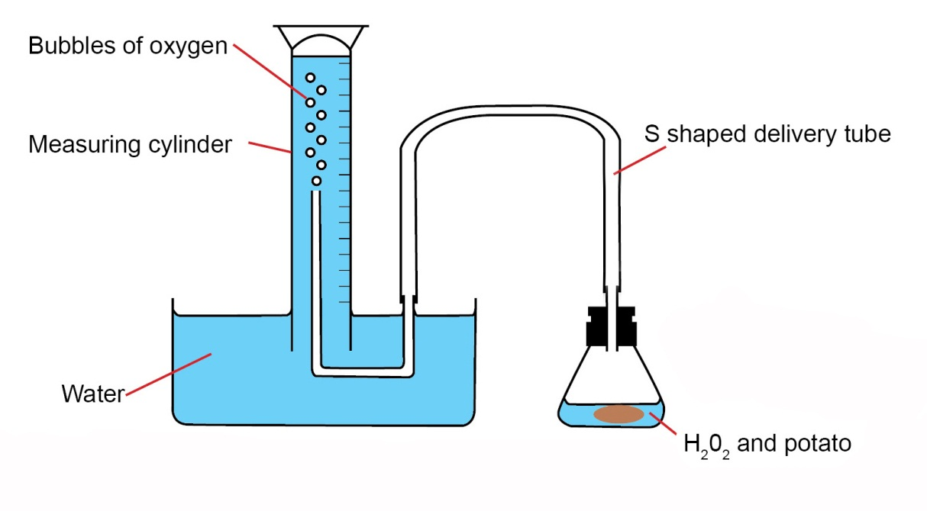

Notes
This practical activity will need to be preceded by some teaching and learning about the mechanism of enzyme action, including the introduction of some of the terminology e.g. substrate. The mathematical skills associated with this practical activity include the calculation of means and good practice would recommend the repeating of results in order to do this. The most efficient way to do this would be for the class to pool their data in some way. However, if any result does not appear to fit the expected trend, it is a good opportunity to discuss outliers and how to manage them. Learners may then choose to repeat one or two dilutions as required. The drawing of a graph that naturally follows the collection of rates of reaction data is an important part of the process, though not directly related to the practical skills. Learners may well be presented with a set of data generated in a similar way in an examination and so they need to be prepared and to have had plenty of opportunities to develop a range of graph drawing skills. The learner activity sheet requires students to calculate the rate of reaction for each dilution and to plot a graph of rate of reaction against hydrogen peroxide dilution. These instructions can be modified or added to depending on the ability of the group or the time allowed for the activity.
An alternative method to that described above involves using filter paper discs which can be cut out using a hole punch. The catalase is, in this case, sourced from celery extract. This can be obtained by blending celery stalks with a small amount of water to make a thick paste. After preparing the range of hydrogen peroxide dilutions, the learner places 1 ml of celery extract in a watch glass and then soaks 3 filter paper discs in it for 5 minutes. Using forceps, one is removed (any excess celery extract is shaken off to avoid drips) and placed into the first hydrogen peroxide dilution. A glass rod can be used to push the disc to the bottom of the tube if needed and the stopwatch must be started immediately the disc lands at the bottom of the tube. Timing continues until the disc rises to the top of the hydrogen peroxide. This process is then repeated in this dilution for the other 2 filter paper discs. The celery extract is then thrown away and another 1 ml placed in the watch glass. Three more filter paper discs are soaked in it for 5 minutes ready for the next dilution of hydrogen peroxide. The process is repeated for all of the dilutions. Results are recorded in a table and the mean time for the disc to rise can be calculated for each dilution.

Technician Notes
For this practical the teacher will require for a class of 30, working in pairs:
- 20 volume hydrogen peroxide, at least 750 ml
- Distilled water, at least 750 ml
- 30 × 5 ml syringes
- 75 × boiling tubes
- 15 × marker pens / 75 × labels
- 15 × boiling tube racks
- 15 × 25 ml measuring cylinder or graduated boiling tube
- 15 × 50 ml conical flask
- 15 × ‘S’ shaped delivery tube with a bung to fit the conical flask
- 15 × large troughs / washing up bowls for water
- 15 × potatoes
- 15 × cork borer
- 15 × rulers
- 15 × knives
- 15 × white tiles
- 15 × stopwatches
Large container for learners to place used hydrogen peroxide and potato cylinders.

Answers for quiz questions
1 Which graph shows the effect of substrate concentration on the rate of an enzyme controlled reaction? [1 mark]
B

Your answer

2a Name two factors in this experiment that had to be kept constant. [2 marks]
Any two from: substrate concentration , enzyme concentration , temperature .

2b Plot the results from the table on the grid below. [4 marks]
2c Draw a line / curve of best fit on the graph. [1 mark]
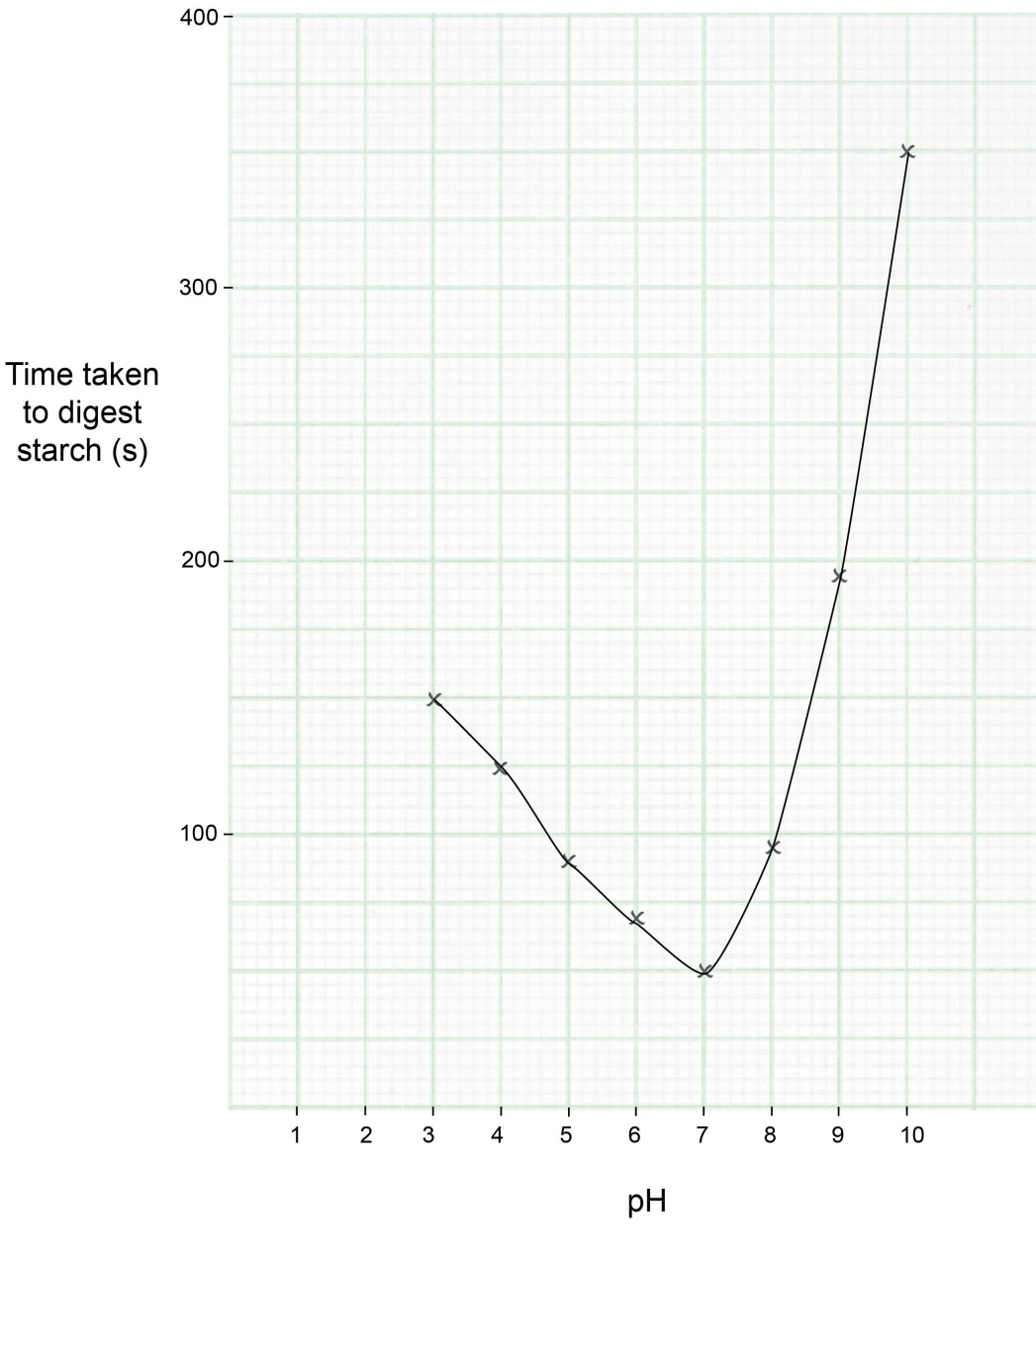

2di From the results, suggest what the optimum pH of amylase is. [1 mark]
pH 7

2dii Explain your answer to 2di. [2 marks]
This is the pH that has the fastest time to digest the starch.
The enzyme is able to work / the active site has the correct shape to work, at its maximum rate.

Document updates
v1 Published on the qualification pages
v1.1 January 2017 Consolidated labelling and formatting of activities
v1.2 June 2021 Update to meet digital accessibility standards

We’d like to know your view on the resources we produce. Click ‘Like’ or ‘Dislike’ to send us an auto generated email about this resource. Add comments if you want to. Let us know how we can improve this resource or what else you need. Your email will not be used or shared for any marketing purposes.
Looking for another resource? There is now a quick and easy search tool to help find free resources for your qualification.
OCR is part of Cambridge Assessment, a department of the University of Cambridge.
For staff training purposes and as part of our quality assurance programme your call may be recorded or monitored.
Oxford Cambridge and RSA Examinations is a Company Limited by Guarantee. Registered in England. Registered office
The Triangle Building, Shaftesbury Road, Cambridge, CB2 8EA. Registered company number 3484466. OCR is an exempt charity.
OCR operates academic and vocational qualifications regulated by Ofqual, Qualifications Wales and CCEA as listed
in their qualifications registers including A Levels, GCSEs, Cambridge Technicals and Cambridge Nationals.
OCR provides resources to help you deliver our qualifications. These resources do not represent any particular teaching method we expect you to use. We update our resources regularly and aim to make sure content is accurate but please check the OCR website so that you have the most up to date version. OCR cannot be held responsible for any errors or omissions in these resources.
Though we make every effort to check our resources, there may be contradictions between published support and the specification, so it is important that you always use information in the latest specification. We indicate any specification changes within the document itself, change the version number and provide a summary of the changes. If you do notice a discrepancy between the specification and a resource, please contact us.
© OCR 2021 - You can copy and distribute this resource freely if you keep the OCR logo and this small print intact and you acknowledge OCR as the originator of the resource.
OCR acknowledges the use of the following content: N/A
Whether you already offer OCR qualifications, are new to OCR or are thinking about switching, you can request more information using our Expression of Interest form.
Please get in touch if you want to discuss the accessibility of resources we offer to support you in delivering our qualifications.

Biology PAG 4: Rates of enzyme-controlled reactions

Combined Science PAG B3: Rates of enzyme controlled reactions

Suggested Activity 1: The effect of substrate concentration on catalase

Learner Activity

Introduction
In this practical activity you will have the chance to consider the effect that changing the substrate concentration has on the rate of an enzyme-controlled reaction. You will follow this up with some processing of the data you collect.

Aims
To use appropriate apparatus and techniques to observe and measure biological processes.
To measure the rate of reaction by measuring the volume of gas produced over time.
To use appropriate apparatus to make and record length, time and the volume of liquids accurately.

Intended class time
60 minutes

Equipment (per group)
- 20 volume hydrogen peroxide
- Distilled water
- 5 ml syringe (×2)
- 5 boiling tubes
- Marker pen / labels
- Boiling tube rack
- 25 ml measuring cylinder or graduated boiling tube
- 50 ml conical flask
- ‘S’ shaped delivery tube with a bung to fit the conical flask
- Large trough / washing up bowl for water
- Potato
- Cork borer
- Ruler
- Knife
- White tile
- Stopwatch

Health and Safety
Eye protection must be worn as hydrogen peroxide is harmful.
Care should be taken when using the knife to cut the pieces of potato and when handling glassware.

Method
- Place the 5 boiling tubes in the rack and label them “100%”, “80%”, “60%”, “40%” and “20%”.
- Dilute the 20 vol. hydrogen peroxide according to the table below, placing the correct dilution in the matching boiling tube. Use one 5 ml syringe for the hydrogen peroxide and one for the water.
Hydrogen peroxide concentration (%) | Volume of water (ml) | Volume of 20 vol. hydrogen peroxide (ml)
100 | 0.0 | 10.0
80 | 2.0 | 8.0
60 | 4.0 | 6.0
40 | 6.0 | 4.0
20 | 8.0 | 2.0
0 | 10.0 | 0.0

- Set up the apparatus as shown below. Take care when filling up the measuring cylinder with water in the trough and turning it upside down (with it still underwater) that all of the water remains in it.
- Use the cork borer to cut out five cylinders of potato and then use the knife and white tile to carefully trim off the skin and cut them all to exactly 50 mm in length.
- Get ready with the stopwatch and as you drop the first piece of potato into the conical flask with the 100% hydrogen peroxide, start the stopwatch. Make sure the bung is fixed firmly back in place and that all of the apparatus is stable. It might be worth practising this part without any chemicals or potato before you start the actual experiment.
- Time for 5 minutes and then read off the volume of oxygen that has been released in that time period.
- Record the volume of oxygen in a suitable designed table of results.
- Discard the 100% hydrogen peroxide and potato into a container as directed by your teacher.
- Rinse out the conical flask and place the 80% dilution of hydrogen peroxide into the conical flask. Repeat the procedure with the potato and the timing for 5 minutes.
- Repeat the entire procedure for all of the hydrogen peroxide dilutions and record the values for oxygen released in 5 minutes in the table

Results
Once you have recorded values for all of the dilutions, pool your data with two other groups, add this to your table and calculate mean values of oxygen released for each dilution.
Calculate the rate of reaction for each dilution using the following formula:
rate of reaction = volume of oxygen released
5

Draw a graph of rate of reaction against dilution of hydrogen peroxide.

Conclusion
Write a paragraph to explain what your data shows about the effect of substrate concentration on the rate of this enzyme-controlled reaction. Use enzyme theory to help you to explain your data.

Quiz - test your knowledge and understanding
1. Which graph shows the effect of substrate concentration on the rate of an enzyme controlled reaction? [1 mark]
A

B

C

D

Your answer

2. A student investigated the action of the enzyme amylase in solutions of different pH.
Tubes were set up at pH 3, 4, 5, 6, 7, 8, 9 and 10. 5 ml amylase and 30 ml starch were added to each tube, one at a time, and the iodine test was used to determine the time taken for the starch to be digested.
The results are recorded in the table below.

pH | Time taken for starch to be digested (s)
3 | 150
4 | 125
5 | 90
6 | 70
7 | 50
8 | 95
9 | 195
10 | 350

a. Name two factors in this experiment that had to be kept constant. [2 marks]

b. Plot the results from the table on the grid below. [4 marks]
c. Draw a line / curve of best fit on the graph. [1 mark]
d. i. From the results, suggest what the optimum pH of amylase is. [1 mark]

d. ii. Explain your answer to d. i. [2 marks]

DfE Apparatus and Techniques covered
If you are using the OCR Practical Activity Learner Record Sheet (Biology / Combined Science) you may be able to tick off the following skills:

Biology |  |  |  | Combined Science
1i | 1iv | 1vi |  | 1–i | 1–iv | 1–vi
1vii | 3i | 3ii |  | 1-vii | 3–i | 3–ii
5i |  |  |  | 5–i

