Physics PAG 8: Interaction of waves

Suggested Activity 1

Combined Science PAG P4: Waves

Suggested Activity 2

Investigating the reflection of light off a plane mirror and the refraction of light through a rectangular prism

Instructions and answers for teachers & technicians
These instructions cover the learner activity section which can be found on page 9. This Practical activity supports OCR GCSE Physics.
When distributing the activity section to the learners either as a printed copy or as a Word file you will need to remove the teacher instructions section.
This is a suggested practical activity that can be used as part of teaching the GCSE (9-1) Gateway Science (A) and Twenty First Century Science (B) specifications.
These are not controlled assessment tasks, and there is no requirement to use these particular activities.
You may modify these activities to suit your learners and centre. Alternative activities are available from, for example, Royal Society of Biology, Royal Society of Chemistry, Institute of Physics, CLEAPSS and publishing companies, or of your own devising.
Further details are available in the specifications (Practical Skills Topics), and in these videos.
OCR recommendations:
Before carrying out any experiment or demonstration based on this guidance, it is the responsibility of teachers to ensure that they have undertaken a risk assessment in accordance with their employer’s requirements, making use of up-to-date information and taking account of their own particular circumstances. Any local rules or restrictions issued by the employer must always be followed.
CLEAPSS resources are useful for carrying out risk-assessments: (http://science.cleapss.org.uk).
Centres should trial experiments in advance of giving them to learners. Centres may choose to make adaptations to this practical activity, but should be aware that this may affect the Apparatus and Techniques covered by the learner.

Introduction
In this activity, learners will investigate the behaviour of light off a plane mirror and through a rectangular prism.

DfE Apparatus and Techniques covered
The codes used below match the OCR Practical Activity Learner Record Sheet (Physics / Combined Science) and Trackers (Physics / Combined Science) available online. There is no requirement to use these resources.
4b [16b]) Making observations of the effects of the interaction of electromagnetic waves with matter
8) Making observations of waves to identify the suitability of apparatus to measure the effects of interactions of waves with matter in: ii) solids

Aims
To use suitable apparatus to measure the angle of incidence and the angle of reflection when light is reflected off a plane mirror.
Determine the relationship between the angle of incidence and the angle of reflection when light is reflected off a plane mirror.
To use suitable apparatus to measure the angle of incidence and the angle of refraction when light is passed through a rectangular prism
To relate this to the speed that light travels through different materials.

Intended class time
50-60 minutes

Links to Specifications:

Gateway Science (Suite A) including Working Scientifically (WS)
P5.1g describe the effects of reflection, transmission, and absorption of waves at material interface
P5.3a recall that different substances may absorb, transmit, refract, or reflect electromagnetic waves in ways that vary with wavelength
P5.3b explain how some effects are related to differences in the velocity of electromagnetic waves in different substances
P5.3d construct two-dimensional ray diagrams to illustrate reflection and refraction (qualitative only)
WS1.2a, use scientific theories and explanations to develop hypotheses
WS1.2c, apply a knowledge of a range of techniques, instruments, apparatus, and materials to select those appropriate to the experiment
WS1.3f, presenting reasoned explanations
WS1.3h, identifying potential sources of random and systematic error
WS1.4a use scientific vocabulary, terminology and definitions
WS2a, carry out experiments
WS2d communicating the scientific rationale for investigations, methods used, findings and reasoned conclusions

Twenty First Century Science (Suite B) including Ideas about Science (IaS)
P1.3.8a describe the effects of reflection and refraction of waves at material interfaces
P1.3.8b describe how to measure the refraction of light through a prism
P1.3.8c describe how to investigate the reflection of light off a plane mirror
P1.3.9 recall that waves travel in different substances at different speeds and that these speeds may vary with wavelength
P1.3.10 explain how refraction is related to differences in the speed of the waves in different substances
P1.4.1 construct and interpret two-dimensional ray diagrams to illustrate specular reflection by mirrors (qualitative only)
P1.4.2 construct and interpret two-dimensional ray diagrams to illustrate refraction at a plan surface and dispersion by a prism (qualitative only)
IaS1.1 suggest appropriate apparatus, materials and techniques, justifying the choice with reference to the precision, accuracy and validity of the data that will be collected
IaS2.1 present observations and other data using appropriate formats
IaS2.9 in given context evaluate data in terms of accuracy, precision, repeatability and reproducibility, identify potential sources of random and systematic error, and discuss the decision to discard or retain an outlier

Health and Safety
Use a low voltage power supply for the ray box so not to blow the bulb
Turn off switch between readings to ensure ray boxes don’t get too hot
Be aware that ray boxes can get very hot so do not touch the ray box until they are cooled down
Before carrying out any experiment or demonstration based on this guidance, it is the responsibility of teachers to ensure that they have undertaken a risk assessment in accordance with their employer’s requirements, making use of up-to-date information and taking account of their own particular circumstances. Any local rules or restrictions issued by the employer must always be followed.

Method 1
Learners use a ray box and single slit to reflect a ray of light off of a plane mirror. They measure the angle of incidence and the angle of reflection to determine the relationship between the two angles.

Method 2
Learners use a ray box and single slit to refract light through a Perspex/glass block. They measure the angle of incidence and the angle of refraction and relate these to the speed at which the light travels through different mediums.

Notes
Teachers should trial this activity to be able to modify the learner sheet in the light of the equipment and lesson time available at the centre. These should include the appropriate voltage setting for use with the ray boxes available. Learners do not need to calculate refractive indices.

Technicians notes

For this practical the teacher will require:
- Ray boxes
- Low voltage power supplies
- Single slits
- Plane mirrors
- Holders for mirrors
- Protractors
- White paper
- Pencils
- Glass/Perspex blocks

Answers for quiz questions
1. | A student shines a light from a ray box onto a mirror. The image below show the path of the ray as it leaves the ray box and hits the mirror. Draw on the reflected ray. [2 marks]
mirror
normal

Line reflected off the mirror with arrow head in correct direction
Angle of reflection same as angle of incidence (judged by eye)

2. | A periscope is used in a submarine to allow people to see above the water’s surface. A simple diagram of a periscope is shown below. Complete the diagram to show the path of the light and write down how the periscope allows the user to see above the water. [4 marks]
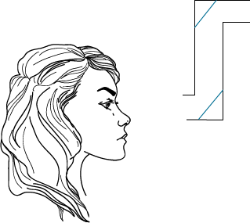
mirror

Straight line drawn from entrance to top mirror, reflected down to second mirror and into eye
mirror
Arrow head on rays in correct direction
Mirrors are at 45° angles so light is reflected off the first mirror onto the second and then into the observers eye

3 (a) | A student is investigating refraction of light. They shine a light through a rectangular glass block at an angle. The diagram below shows the ray as it hits the glass block. Complete the diagram to show the path of the ray and label the angle of incidence and angle of refraction. [2 marks]
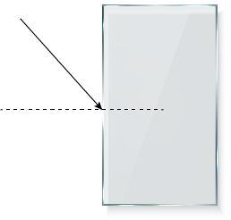

Normal

Air

Line drawn so ray bends towards normal
Glass
Both angles correctly labelled

(b) | Fill in the gaps using words below: [2 marks]  smaller larger closer to further from
The light is now passed through a more dense material. This means the angle of refraction is now and therefore the normal.

smaller closer to

4 | A sound wave travels from water into air. Its wavelength in air is longer than in water.  Fill in the gaps to show how the frequency and speed of the wave in air compares with its value in water. [2 marks]
The frequency in air is as the frequency in water.

The speed in air is than the speed in water.

same faster

Document updates
v1 Published on the qualification pages
v1.1 January 2017 Consolidated labelling and formatting of activities
v1.2 February 2017 Added mapping to Combined Science
v1.3 June 2021 Updated to meet accessibility standards

We’d like to know your view on the resources we produce. Click ‘Like’ or ‘Dislike’ to send us an auto generated email about this resource. Add comments if you want to. Let us know how we can improve this resource or what else you need. Your email will not be used or shared for any marketing purposes.
Looking for another resource? There is now a quick and easy search tool to help find free resources for your qualification.
OCR is part of Cambridge Assessment, a department of the University of Cambridge.
For staff training purposes and as part of our quality assurance programme your call may be recorded or monitored.
Oxford Cambridge and RSA Examinations is a Company Limited by Guarantee. Registered in England. Registered office
The Triangle Building, Shaftesbury Road, Cambridge, CB2 8EA. Registered company number 3484466. OCR is an exempt charity.
OCR operates academic and vocational qualifications regulated by Ofqual, Qualifications Wales and CCEA as listed
in their qualifications registers including A Levels, GCSEs, Cambridge Technicals and Cambridge Nationals.
OCR provides resources to help you deliver our qualifications. These resources do not represent any particular teaching method we expect you to use. We update our resources regularly and aim to make sure content is accurate but please check the OCR website so that you have the most up to date version. OCR cannot be held responsible for any errors or omissions in these resources.
Though we make every effort to check our resources, there may be contradictions between published support and the specification, so it is important that you always use information in the latest specification. We indicate any specification changes within the document itself, change the version number and provide a summary of the changes. If you do notice a discrepancy between the specification and a resource, please contact us.
© OCR 2021 - You can copy and distribute this resource freely if you keep the OCR logo and this small print intact and you acknowledge OCR as the originator of the resource.
OCR acknowledges the use of the following content: N/A
Whether you already offer OCR qualifications, are new to OCR or are thinking about switching, you can request more information using our Expression of Interest form.
Please get in touch if you want to discuss the accessibility of resources we offer to support you in delivering our qualifications.

Physics PAG 8: Interaction of waves

Suggested Activity 1

Combined Science PAG P4: Waves

Suggested Activity 2

Investigating the reflection of light off a plane mirror and the refraction of light through a rectangular prism

Learner Activity

Introduction
In this activity, learners will investigate the behaviour of light off a plane mirror and through a rectangular prism.

Aims
To use suitable apparatus to measure the angle of incidence and the angle of reflection when light is reflected off a plane mirror.
Determine the relationship between the angle of incidence and the angle of reflection when light is reflected off a plane mirror.
To use suitable apparatus to measure the angle of incidence and the angle of refraction when light is passed through a rectangular prism
To relate this to the speed the light travels through different materials.

Intended class time
50-60 minutes

Equipment (per group)
- Ray box
- Low voltage power supply
- Single slit
- Plane mirror
- Holder for mirror
- Protractor
- White paper
- Pencil
- Glass/Perspex block

Health and Safety
Use a low voltage power supply for the ray box so not to blow the bulb
Turn off switch between readings to ensure ray boxes don’t get too hot
Be aware that ray boxes can get very hot so do not touch the ray box until they are cooled down

Method 1 – Reflection
- Set up apparatus as shown below; do not turn on the power pack.
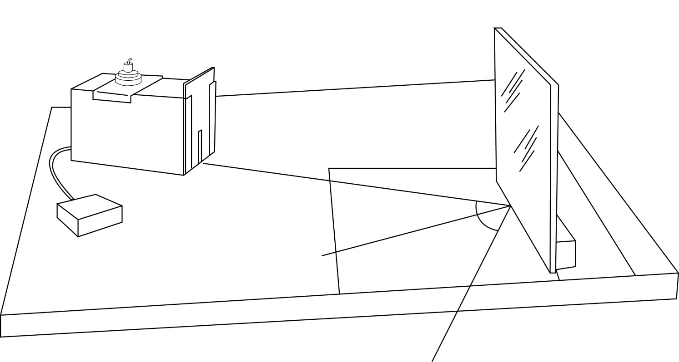
Power pack
Angle of incidence
Normal
Angle of reflection

2. Turn on the power pack at the voltage suggested by your teacher. Line up the ray of light so that it is at a 90° angle to the mirrors surface. At this angle the ray should reflect back on itself.
3. Use a pencil to draw a dashed line along the ray and a straight line to show the position of the mirror. Label the dashed line as the normal.
4. Move the ray box so that the ray of light now hits the mirror at the point where the normal meets the mirror but at an angle so the light is reflected off. Draw over the path of the light with a pencil.
5. Measure the angle of incidence (the angle at which the light hits the mirror from the normal) and the angle of reflection (the angle at which the light is reflected off the mirror from the normal). Record measurements in the table below.
6. Repeat steps 4 and 5 till you have measurements for a least 5 angles. Record all results in the table below.

Results
Angle of incidence (°) | Angle of reflection (°)

Evaluation
- Using your results, write down the relationship between the angle of incidence and the angle of reflection.

Method 2 – Refraction
- Set up apparatus as shown below; do not turn on the power pack.
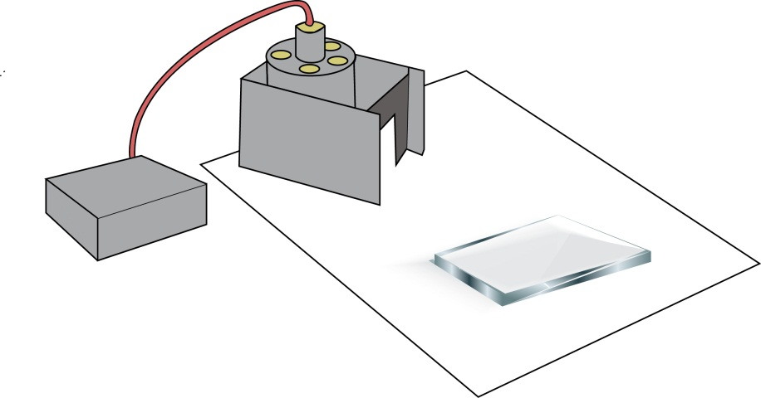

2. Turn on the power pack at the voltage suggested by your teacher. Draw around the block in pencil. Line up the ray of light so that it is at a 90° angle to the rectangular blocks surface. At this angle the ray should pass through the rectangular block without refracting.
3. Use a pencil to draw a dashed line along the ray. Label the dashed line as the normal.
4. Move the ray box so that the ray of light now hits the block at the point where the normal meets the block but at an angle so the light is refracted through. Draw over the path of the light with a pencil.
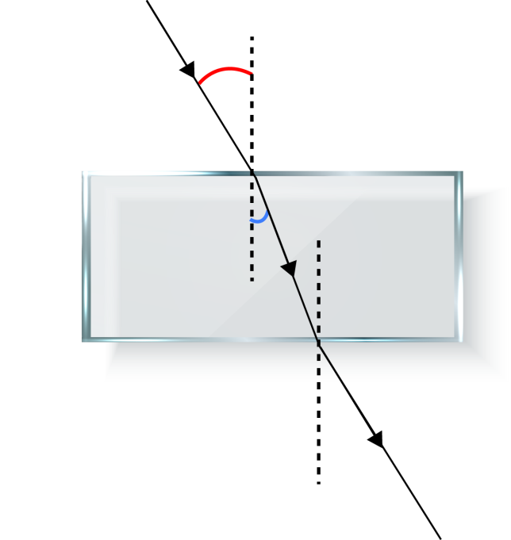
5. Measure the angle of incidence (the angle at which the light hits the rectangular block from the normal) and the angle of refraction (the angle at which the light is refracted through the black from the normal). Record measurements in the table below.
Angle of incidence
Transparent block
normal
Angle of refraction

6. Repeat steps 4 and 5 till you have measurements for a least 5 angles. Record all results in the table below.

Results
Angle of incidence (°) | Angle of refraction (°)

Evaluation
- In relation to the normal, in which way did the light bend when it entered the rectangular block?

- Write down, using ideas about particle model, how the density of the glass block in compares to the density of air.

- How does the speed of the light change when it enters the glass block?

- Why does the speed of light change when travelling through the glass block?

Quiz - test your knowledge and understanding
1. | A student shines a light from a ray box onto a mirror. The image below show the path of the ray as it leaves the ray box and hits the mirror. Draw on the reflected ray. [2 marks]
mirror
normal

2. | A periscope is used in a submarine to allow people to see above the water’s surface. A simple diagram of a periscope is shown below. Complete the diagram to show the path of the light and write down how the periscope allows the user to see above the water. [4 marks]
mirror

mirror

3 (a) | A student is investigating refraction of light. They shine a light through a rectangular glass block at an angle. The diagram below shows the ray as it hits the glass block. Complete the diagram to show the path of the ray and label the angle of incidence and angle of refraction. [2 marks]

Air
Normal
Glass

(b) | Fill in the gaps using words below: [2 marks]  smaller larger closer to further from
 | The light is now passed through a more dense material. This means the angle of refraction is now and therefore the normal.

4 | A sound wave travels from water into air. Its wavelength in air is longer than in water.  Fill in the gaps to show how the frequency and speed of the wave in air compares with its value in water. [2 marks]
The frequency in air is as the frequency in water.

The speed in air is than the speed in water.

DfE Apparatus and Techniques covered
If you are using the OCR Practical Activity Learner Record Sheet (Physics / Combined Science) you may be able to tick off the following skills:

Physics |  |  | Combined Science
4b | 8−ii |  | 16b

