Prescribed Sources for Cleopatra: Rome and Egypt, 69–30 BC

Literary sources

Suetonius, The Divine Julius 52

He even made love to queens, among whom was Eunoe, wife of Bogudes the Moor, and Caesar presented very many, expensive gifts to her and her husband, so Naso has written. But he especially loved Cleopatra. He often kept feasts with her going until dawn and he sailed with her in the state yacht through Egypt almost as far as Ethiopia – or at least would have, if his army had not refused to follow him there. He finally summoned her to the city of Rome and sent her back only when she had received the greatest honours and rewards. He allowed her to call her son by him by his own name. Certain Greek writers have reported that he was similar to Caesar in appearance and in his way of walking. Indeed Mark Antony confirmed to the Senate that he had been acknowledged by him and that Caius Matius and Caius Oppius knew this along with the rest of Caesar’s friends. Of them Oppius, on the grounds that this matter needed some explanation and defence, published a book saying that he was not Caesar’s son as Cleopatra claimed. Helvius Cinna a tribune of the people admitted to several others that he had written and prepared a proposal, which Caesar had ordered to be made law while he was away. This law was to state that he was allowed to marry as many wives as he wished for the sake of producing children. In case any one should doubt the bad reputation Caesar had for disgraceful behaviour and adultery, Curio, the elder, in a certain speech called Caesar a man for all women and a woman for all men.

Plutarch, The Life of Caesar 48–49

48
Caesar gave the Thessalians back their freedom to celebrate his victory and then followed after Pompey; when he reached Asia he also made the Cnidians free to please Theopompus (the one who collected stories together) and he let off all the people who lived in Asia for a third of their taxes. Arriving at Alexandria just after Pompey’s death, Caesar turned away in horror when Theodotus showed him Pompey’s head, but he accepted Pompey’s seal-ring and he cried when he saw it. Also, he was kind to all the friends and associates of Pompey who had been captured by the King of Egypt as they wandered about the country and he got them onto his side. He wrote to his friends in Rome that the greatest and sweetest pleasure he got from his victory was that each day he was saving the lives of his fellow citizens who had fought against him. As for the war in Egypt, some people say that it was not necessary but that Caesar did it because of his love for Cleopatra, and that it was not glorious for him but very dangerous. Other people blame the King of Egypt’s assistants for it, and especially the eunuch Potheinus, who had the most influence at court, and had recently killed Pompey; he had also driven Cleopatra out of the country and was now secretly plotting against Caesar. People say that because of this, from then on, Caesar spent whole nights at drinking parties to protect himself. But Potheinus was openly unbearable, since he said and did many things that were spiteful and insulting to Caesar. For example, when the soldiers had the oldest and worst wheat given out to them, he told them to put up with it and be satisfied, because they were eating what belonged to others. At the state suppers, he used wooden and pottery dishes, saying that Caesar had taken all the gold and silver to pay off a debt because the king’s father owed Caesar 17.5 million drachmas. He said that Caesar had already cancelled part of the debt for the king’s children, but now he demanded a payment of 10 million to support his army. When Potheinus told Caesar to go away and look after his important business, telling him that he would get his money back later with thanks, Caesar replied that he did not need Egyptians as advisers, and secretly sent for Cleopatra, who was in the country.
49
So Cleopatra, taking only Apollodorus the Sicilian from among her friends, got on a little boat and landed at the palace when it was already getting dark. As it was impossible to escape being noticed, she stretched herself at full length inside a sleeping bag and Apollodorus tied the bag up with a string and carried it indoors to Caesar. It is said that because of this plan of Cleopatra’s, Caesar was first charmed by her and afterwards he liked her more because of her sweet conversation and pleasant entertainment, so he reunited her with her brother and arranged that she would be co-ruler with him. Then, while everybody was feasting to celebrate the agreement, one of Caesar’s slaves, his barber, who noticed everything because he was so timid (he kept his ears open and was here, there, and everywhere) realised that Achillas the general and Potheinus the eunuch were hatching a plot against Caesar. After Caesar had found out, he had the banqueting-hall guarded and put Potheinus to death but Achillas escaped to his camp. Achillas started a war with Caesar which was dangerous and difficult as Caesar was defending himself with only a few troops against a large city and army. In this war, to begin with, Caesar had the problem of being shut off from water, since the canals were dammed up by the enemy. Secondly, when the enemy tried to cut off his fleet, he was forced to resist the danger by using fire, and this spread from the dockyards and destroyed the great library. Thirdly, when a battle arose at Pharos, he jumped from the pier into a small boat and tried to go to the aid of his men in their struggle but the Egyptians sailed up against him from every side so that he threw himself into the sea and with great difficulty escaped by swimming. It is said that at this time too, he was holding many papers in his hand and would not let them go, although missiles were flying at him and he was in the sea, but he held them above water with one hand and swam with the other: his little boat had been sunk at the beginning. But finally, after the king had gone over to the enemy, Caesar marched against him and conquered him in a battle where many died and the king himself disappeared. Then, leaving Cleopatra on the throne of Egypt (a little later she had a son by him whom the Alexandrians called Caesarion), he set out for Syria.

Cassius Dio, Roman History XLII 44–45

44
... Caesar overcame Egypt. But he did not make it subject to the Romans; he gave it to Cleopatra because he had fought the war for her. But he was afraid that the Egyptians might rebel again because they had a woman ruling them, and that the Romans might be angry. So, because of this and because he was living with the woman, he ordered her to “marry” her other brother, and gave the kingdom to both of them, at least supposedly. In reality, Cleopatra was to hold all the power alone, since her husband was still a boy, and because of Caesar’s favour she could do anything. So she accepted that she would live with her brother and pretend to share the rule with him but in truth she ruled alone and spent her time with Caesar.
45
She would have kept him even longer in Egypt or else would have set out with him at once for Rome, if Pharnaces had not only drawn Caesar away from Egypt, very much against his will, but also stopped him from hurrying to Italy. This king was the son of Mithridates and ruled the Cimmerian Bosporus, as has been said. He wanted to win back again the whole kingdom of his ancestors, and so he rebelled just at the time of the clash between Caesar and Pompey. At that time the Romans were occupied with one another and after were busy in Egypt, so he got possession of Colchis without any difficulty, and because Deiotarus was away, he conquered all Armenia, and part of Cappadocia, and some cities of Pontus that had been allocated to the district of Bithynia.

Cassius Dio, Roman History XLIII 27

27
He [Julius Caesar] did all these things and the other things which he was planning for the good of everyone, not on his own authority, nor of his own accord, but communicated everything all the time to the leaders of the Senate, and sometimes even to the whole Senate. And even after he passed some rather harsh measures he still succeeded in pleasing them because he had consulted them before. He received praise for these acts. But many murmurings of all sorts arose against him when he encouraged some of the tribunes to allow many of those who had been exiled after a proper trial to live in Italy again, and also allowed those who had been convicted of bribery in canvassing for office to live in Italy. In addition, he enrolled once more in the Senate some who were not worthy of it. But he earned the greatest disapproval from everyone because of his passion for Cleopatra – not now the passion he had displayed in Egypt (for that was a matter of hearsay), but that which was displayed in Rome itself. For she had come to the city with her husband and settled in Caesar’s own house, so that he too got a bad reputation because of both of them. But he was not at all concerned about this and actually signed them up among the friends and allies of the Roman people.

Cicero, Letter to Atticus XV.15

To Atticus (at Rome)

Astura, 13 June 44 BC

... I hate the Queen. Ammonius (the one who is meant to keep her promises) knows that I have a good reason for it. What she promised, indeed, were all things of a logical type and suitable to my position so that I would dare to speak about them even in a public meeting. But Sara: besides the fact that he is a criminal, I also found him defiant towards me.
I only saw him once at my house. When I was asking him what he wanted, he said that he was looking for Atticus. But I cannot remember without great pain the arrogance of the Queen herself, when she was at the pleasure gardens across the River Tiber. So I won’t have anything to do with that lot. They think not so much that I have no spirit, as that I have no ill-temper. ...

Plutarch, Life of Mark Antony 24–33

24
He [Antony] was, so to speak, straightforward by nature, and he was slow to realise things were happening. However when he did realise he had made a mistake, his regret was considerable. He would admit his mistakes to those who had been badly treated and he was generous in repairing the wrongs as well as harsh in punishing the criminals. Even so people considered that he was far more likely to give favours than punishments. As far as the outrageous fun and joking he enjoyed, it had its own remedy. In fact anyone might joke with him, and he liked being made fun of just as much as he enjoyed making fun of someone else. It was this aspect of character which harmed many of his affairs because he couldn’t believe that people who made jokes really intended to flatter him. He had never realised that some men speak bluntly, openly using it like some spicy seasoning to hide the sickly taste of the flattery. Such men use this direct way of talking when drinking or drunk. That way, when dealing with business-affairs, they appear not to be the sort whose only method is to flatter, but the sort who are convinced by better knowledge.
25
So this was Antony’s character when this final disaster – his love for Cleopatra – overtook him. This love stirred up to near-madness those many passions which were up till now hidden, or kept under control. It now removed and destroyed any useful or saving qualities which could have held out against it. In this way he was captured by her. While preparing for the Parthian War, he ordered Cleopatra to meet him in Cilicia in order to answer to the charges made against her of supplying a large amount of money to help Cassius in the war against himself and Octavian. Dellius was sent by Antony, but when he saw Cleopatra, he understood her cunning and cleverness in conversation. Straightaway he realized that Antony was unlikely to do such a woman any harm, in fact it was more likely that she would have the greatest influence with him. He therefore changed his approach to flatter her and persuade the Egyptian Queen to go to Cilicia ‘dressed to the best of her ability’ (as Homer says); not to be afraid of Antony, who was the most pleasant and well-disposed of commanders. She was convinced by Dellius. She understood Romans from the evidence of her previous affairs with Julius Caesar and Gnaeus, the son of Pompey, and so she hoped that she would more easily bring Antony under her power. For they had known her when she was still young and less experienced in these matters. However, she was not intending to go to Antony at the precise time when women’s beauty is at its most radiant and they are at the peak of intellectual ability. Therefore she prepared many gifts, a great amount of money, and ornaments which it was right for her to take given her position as Queen and the great wealth of her kingdom. However, she placed most hope in herself, and the near-magical charms which her presence could provide.
26
She received many requests both from Antony himself and from his friends calling for her to visit him; yet, she treated him with such contempt and laughed at him to the extent that she sailed up the River Cydnus in a river-craft covered in gold, its purple sails in the wind, its rowers pressing on with silver oars to the sound of flutes, pipes and citharas. She herself lay back beneath a canopy embroidered with gold, dressed to look like Aphrodite [Venus] in some painting, while on both sides stood boys made up as Cupids in paintings who fanned her. In the same way, the most beautiful of her maids, in the clothes of Nereïds and Graces, were placed, some at the rudders and others at the sail-ropes. Marvellous strong-smelling perfumes drifted from many burners towards the banks of the river. Some of the people escorted her on both banks of the river right up the river from its mouth, while others came down from the city to see the sight. The crowd that had gathered in the market-place gradually moved away. Finally only Antony himself, seated on his platform, remained. Everywhere there was the rumour that Aphrodite would celebrate with Dionysus [Bacchus] for the good of Asia.
Therefore, Antony sent an invitation to her for dinner; but she thought that it was better for him to come to her. So immediately wishing to show his readiness to accept and his generosity, Antony agreed and went. What met him was a preparation that was beyond any description, but what especially amazed him was the enormous number of lights. We are told that many of these lights were hung from the roof and displayed everywhere at once; they were arranged and organised in patterns and at angles to each other in order to form squares and circles, in such a way that few sights could have been as beautiful or as worth-seeing as this.
27
On the next day, Antony supplied the banquet for her; he was eager to surpass her feast in its brilliance and presentation; however, in both of these he was completely defeated and left way behind. He was the first to joke about the squalid and common nature of his efforts. Cleopatra saw in these jokes that in Antony there was a lot of the soldier and the common man, and used this way of behaving towards him, showing confidence and no restraint now. Her beauty, so we are told, was not itself outstanding; it did not immediately strike those who saw her; yet being with her had an inescapable hold; when talking with her, she was persuasive, and the character which surrounded her whole manner in company had a force to it. Her voice had a pleasantness of tone; and her tongue, like some musical instrument with many strings, could be turned to whatever language she wished, so that in conversations with barbarians, she rarely spoke through an interpreter, mostly making her own replies on her own regardless of whether they were Ethiopians, Troglodytes, Hebrews, Arabians, Syrians, Medes or Parthians. Indeed, it is said that she had learnt the languages of many other peoples, although the kings of Egypt before her had not even tried to learn the Egyptian language, and some actually had given up speaking their own Macedonian dialect.
28
In this way Cleopatra so completely took control of Antony, that while Fulvia, his wife, was waging war on his behalf with Octavian in Rome and a Parthian army commanded by Labienus was threatening Mesopotamia (the generals of the king had appointed Labienus Parthian commander-in-chief over this area), and was about to invade Syria, he let himself be carried off by her to Alexandria. There, like a young man with time on his hands for leisure, he wasted his time spending it upon amusements and pleasures, time which Antiphon calls the most expensive of all goods. They had a group around them called ‘The Inimitable Livers’, and every day for each other they gave feasts of an unbelievable and immeasurable expense. In fact, Philotas, the doctor from Amphissa, used to tell my grandfather, Lamprias, that he was in Alexandria then, learning his skills. He got to know one of the Queen’s cooks. He was easily persuaded by him (being a young man) to view the expensive preparations for one of the feasts. So he was taken into the kitchen, where he saw all the other preparations and eight wild boars roasting; he said that he showed amazement at the number of diners. But the cook laughed and said: “There are not many guests, only about twelve; but each thing placed before them must be perfect, and this could be ruined by a moment’s delay. For Antony would demand his dinner straightaway but then, shortly afterwards, might put it off to ask for a drink or fall into some conversation with someone. “So”, he said, “we arrange not one dinner but many. For it is hard to hit upon the right time.” Philotas used to tell this story; and he said in addition that he became eventually an attendant of Antony’s eldest son by Fulvia. He said that he often dined with him at his house with his other friends, when the young man did not dine with his father.
Once when a doctor was annoyingly holding forth on many matters as they dined, Philotas stopped his mouth with some clever saying such as: “To the patient who is in a fever you should give cold water; but everyone who has a fever is feverish to some extent; therefore to everyone who has a fever cold water should be given.” The man was shocked and was silent, but Antony’s son saw this and laughed and said, “I will favour you with all of this” and he pointed to the middle of the table full of many large drinking cups. Philotas accepted this show of kindness, but did not suppose that a boy of his age was able to give away so many things. After a short while, however, one of the slaves brought the cups to him in a sack, and told him to put his seal upon it. When Philotas objected and was afraid to take them, “You are being foolish to hesitate”, said the slave “Don’t you know that it is the son of Antony who gives them to you, and he can give you all these golden cups if he wishes? However, trust me and change them all for silver with us; perhaps his father might want one of them; they are old and of excellent workmanship and valuable.” This is the sort of story Philotas would tell my grandfather whenever he got the chance.
29
Now Cleopatra displayed her flattery, not like Plato says in four sorts; while Antony was spending his time either in some amusement or some serious matter, she was always bringing some new pleasurable diversion or charming activity, and so keeping him well-trained and under control day and night. She played dice with him, drank with him, hunted with him, and when he exercised himself in full armour she watched him; when at night he liked to stand outside the doors or windows of the ordinary people to make fun of those inside, she used to put on the clothes of a servant-girl and join him in his games. Antony also would dress up like some slave. He often returned home driven by abuse and sometimes blows. In fact most people knew it was him. The Alexandrians enjoyed this sort of silly behaviour and played along with their usual good taste, saying with affection that Antony put on his tragic face for the Romans and his comic one for them.
It would be pointless to list all the many childish games he got up to at that time. Once, however, he went fishing, caught nothing and was annoyed especially since Cleopatra was there also. So he ordered some fishermen to dive down and without being seen attach some previously caught fish to his line; he then pulled up two or three of these – but he did not manage to do this without Cleopatra noticing. She told her friends what he had done, and invited them to come and watch the next day. As a result, a large number of friends climbed into the boats. When Antony let down his line, she ordered one of her servants to go down first to his hook and attach a salted Black Sea fish. Antony was convinced that he had caught a fish, so he pulled his line up, and as expected, everyone started laughing. Cleopatra then said to him “Commander, you had better hand over your fishing-rod to the Kings of the Pharos and Canopus; you should be hunting cities, kingdoms, and continents.”
30
While Antony was playing the young fool like this, two messages brought him down to earth: the first from Rome, that Lucius his brother and Fulvia his wife had fallen out with one another; next they had started a war with Octavian, but they had lost badly and had fled from Italy; the second message was no more pleasing, that Labienus, commanding the Parthian force, was overrunning Asia from the Euphrates and Syria as far as Lydia and Ionia. So finally, like a man woken from a deep sleep brought on by a night of heavy drinking, Antony set out to stop the Parthians, and reached Phoenicia; there, a letter arrived from Fulvia full of complaints. He turned round and headed towards Italy with two hundred ships. During the journey, he picked up a number of his friends who were fleeing from Italy, and he learnt that Fulvia had started the war; she was naturally the sort of energetic woman who likes to get involved in men’s affairs; in this way she had hoped to draw Antony away from Cleopatra by causing trouble in Italy. Fulvia was sailing to meet him, but she became ill and died at Sicyon, as it happened. This provided a greater opportunity for Antony and Octavian to be reconciled. In fact, on Antony reaching Italy, Octavian clearly showed he had no wish to accuse Antony of causing the war but rather blamed Fulvia. The friends of the two men did not allow the excuse given to be questioned. Instead they made peace between them and divided up the leadership of the Empire, drawing a boundary with the Ionian Sea and giving to Antony the East, and to Octavian the West; Lepidus was allowed to have Africa. They also arranged that, when they felt they did not need to be consul, the friends of each of them should take the office by turns.
31
Both sides thought this arrangement reasonable but they also needed some strong connection, which fate now provided. Octavia was the elder sister of Octavian, although their mothers were different; she was the child of Ancharia, while Octavian, by a later marriage, was the son of Atia. Octavian was very fond of his sister, who was, as we say, a marvel of a woman. Her husband, Caius Marcellus, had died a little earlier, and she was now a widow. Antony, too, with the death of Fulvia, was viewed as a widower. He did not deny his affair with Cleopatra; he did not, however, agree that she was his wife, and in this matter of how to describe his relationship, his reason and his love for the Egyptian were fighting it out. Everyone was working to arrange this marriage. They hoped that Octavia, who had great dignity and common sense to add to her beauty, would stand by Antony’s side and eventually be loved by him, as was natural with such a woman. In this way, they hoped, she would bring some stability and safety for their affairs and harmony for the world. So when both men had agreed terms, they went to Rome and finalised Octavia’s marriage, although the law did not allow a woman to marry before her husband had been dead ten months. In this case, however, the Senate passed a decree to put aside this restriction on time.
32
Sextus Pompey held Sicily and was harassing the coast of Italy. With his many pirate ships under the command of Menas the pirate and Menecrates, he had made the sea un-sailable. He was considered to favour Antony, since he had welcomed Antony’s mother when she fled from Rome with Fulvia. Therefore they [Antony and Octavian] decided to have an agreement with him. The men met for this purpose at Cape Misenum. Sextus Pompey’s fleet was anchored off-shore and the forces of Antony and Octavian were drawn up on land nearby. It was agreed that Sextus Pompey should have Sardinia and Sicily, but that he should keep the sea clear of pirates, and should send to Rome an agreed amount of grain. They invited each other to dinner. They cast lots to choose who was to provide the first dinner and it happened to be Sextus Pompey. When Antony asked him where they would dine, “There,” said he, pointing to his command ship with its six banks of oars, “for this is the only house left to Sextus Pompey by his father.” This he said as a way of blaming Antony who now owned the house once owned by Sextus’ father, Pompey the Great. So anchoring his ship close by, he constructed a walkway from the ship to the shore, and eagerly welcomed them on board. When they were thoroughly at ease with each other and they were joking freely about Antony and Cleopatra, Menas the pirate came up to Sextus Pompey and spoke in a way that the others could not hear. “Do you want me to cut the ship’s anchor ropes and make you leader not only of Sicily and Sardinia, but of the whole Roman Empire?” he said. Sextus Pompey, when he heard this, for a short while thought to himself, and then said: “Menas, you ought to have done this without speaking to me first; but now let us be happy with the present arrangement; for it is not my nature to break an oath.” Sextus Pompey, then, after being dined in his turn by Antony and Octavian, sailed back to Sicily.
33
Once this agreement was made, Antony sent Ventidius to Asia ahead of himself to prevent the Parthians gaining further ground. Meanwhile Antony, as a favour to Octavian, was inaugurated as priest of Julius Caesar. In addition, they dealt together with other important political matters in a friendly atmosphere. However, Antony was annoyed that in their somewhat competitive amusements he always came off worse than Octavian. Antony had with him a man from Egypt who told fortunes by examining horoscopes from birth-dates. This man, either because he wanted to please Cleopatra, or because he wanted to tell Antony the truth, openly said that his fortune was great and very bright, but was always obscured by Octavian’s; and he advised him to get as far away from the young man as possible. He said to Antony “Your spirit fears his; and although it is proud and stately when it is by itself, when his is present, yours becomes downcast and dispirited.” In fact, events seemed to prove the Egyptian right. For the story is that whenever they cast lots or threw dice for amusements, Antony lost. They would often use fighting cocks and quails, and Octavian’s would beat Antony’s.
Antony was annoyed, although he did not show it, and he now took more notice of the Egyptian. He left Italy, after leaving the management of his household affairs to Octavian. He took Octavia with him as far as Greece. She had by now given birth to a daughter. He spent the winter at Athens where he received news that Ventidius had been successful. He had defeated the Parthians in battle and killed Labienus, and Pharnapates, the best of King Hyrodes’ generals. In celebration of this victory, Antony gave a feast for the Greeks, and as gymnasiarch organized athletic contests for the Athenians. He left at home the insignia of his Roman command, and went to the games carrying the sticks of a gymnasiarch, in Greek dress and white shoes, and as presiding judge, he would twist the necks of the young contestants to part them.

Plutarch, Life of Mark Antony 36–37

36
Now the disastrous flaw in his character, asleep for so long – his passion for Cleopatra – flared up again all the greater as he approached Syria; they had imagined it had been charmed away and lulled to rest by common sense and good reasons. But at last, like the disobedient and uncontrollable horse of the soul, he rejected all the good advice for his safety and sent Fonteius Capito to bring Cleopatra to Syria. When she came, he welcomed her with gifts which were neither small nor few, but were the kingdoms of Phoenicia, Coele Syria, Cyprus, and a large part of Cilicia; in addition he gave her the balsam-producing part of Judaea, and all that part of Arabia of the Nabataeans which slopes toward the Red Sea. These gifts angered the Romans a great deal. Also he presented tetrarchies and kingdoms of great peoples to private individuals. He took their kingdoms from many rulers, for example Antigonus the Jew, whom he produced from captivity and had beheaded. No other king before him had been punished in this way. However it was the shameful nature of the honours to Cleopatra which most annoyed the Romans. He increased the scale of the scandal by acknowledging his two children by her. He named one Alexander and the other Cleopatra, with the surname of Sun and Moon respectively. However, he was always good at giving the best appearance to something shameful; for he used to say that the greatness of the Roman Empire was shown not by what the Romans took, but by what they presented to others; and that the families of nobility were best increased by a succession of children from the lines of kings. At any rate, he said that his own ancestor was fathered by Heracles on this view, who had not limited his succession to one womb; he had not feared the laws of Solon on conception, but allowed his nature to leave behind the beginnings and foundations of many families.
37
At this time Phraates killed Hyrodes, his father, and took over his kingdom; a good number of Parthians ran away, and particularly Monaeses, a well-known and powerful man, who fled to Antony. Antony thought that this man’s fortunes were similar to those of Themistocles, seeing his own resources and generosity as like those of the Persian kings. So Antony gave him three cities, Larissa, Arethusa, and Hierapolis, which used to be called Bambycé. But when the Parthian king made a pledge of friendship to Monaeses, Antony gladly sent Monaeses back to him. In reality he aimed to deceive Phraates by giving the impression that he wanted peace; he asked only for the return of the standards captured from Crassus and any of the men still alive. Antony himself sent Cleopatra back to Egypt, and marched through Arabia and Armenia to the place where his army was to meet the armies of the allied kings. There were very many of these kings, but the greatest was Artavasdes, King of Armenia, who provided 6,000 cavalry and 7,000 infantry. Here Antony held a review of his army. There were 60,000 Roman legionaries, together with the cavalry counted as Roman, – that is 10,000 Iberians and Celts; the other nations numbered 30,000, cavalry and light-armed soldiers together.
However, they say that all this preparation and power, which frightened even the Indians beyond Bactria and caused all of Asia to shake with fear, was of no use to Antony because of Cleopatra. He was so eager to spend the winter with her that he began the war too early in the season for campaigning, and then made a mess of his management of the campaign. He was not in control of his own judgement, but he behaved as though influenced by some drug or magic spell; he was always looking in her direction, always thinking about how fast he could return to her rather than how best to defeat the enemy.

Plutarch, Life of Mark Antony 51

Then hurrying through the already heavy wintry weather, and never-ending snow-storms, he lost 8,000 men on the march. He himself, however, accompanied by a few men went down to the sea; in a place between Berytus and Sidon, called the White Village, he waited for Cleopatra to meet him; she travelled slowly and so he wandered about restlessly, giving himself up to getting drunk. However, he could not tolerate being still for long, but in middle of the drinking he would often stand up or jump up to go and look out, until she sailed into the harbour, bringing with her a large amount of clothing and money for the soldiers. Some authorities say, however, that he got the clothing from Cleopatra, but the money came from his own funds, although he gave it out as if she had provided it.

Plutarch, Life of Mark Antony 53

In Rome Octavia wanted to sail to Antony. Octavian allowed her to go, so most writers say, not to please her, but so that, if she were neglected and mistreated this might give him a plausible excuse for war. On arriving in Athens, she received letters from Antony in which he told her to remain there and informed her of what had happened on the expedition. Octavia, although she realised this was an excuse and was upset, nevertheless wrote to Antony in order to learn where he ordered her to send the supplies which she was bringing to him. In fact she brought a great supply of clothing for his soldiers, pack-animals, and money and gifts for the commanders and friends with him; also she had with her 2,000 selected soldiers splendidly armoured to serve as praetorian cohorts. A certain friend of Antony, sent by Octavia, told Antony all of this, and he added all the compliments and praises that she deserved.
But, now Cleopatra realised that Octavia was close by and was about to challenge her. Cleopatra was afraid that if she added the pleasure of her company and her constant care and concern for Antony to the dignity of her character and the power of Octavian, she would become unbeatable and have complete control over her husband. So Cleopatra pretended to love Antony with passion, and with little food, she allowed her body to waste away; when Antony was nearby, she would let her eyes fill with desire for him; when he went away, she would look faint and ill. She would find ways often to be seen crying, and then would quickly wipe away the tears and hide them, as if she wanted him not to notice them. She did all this while Antony was getting ready to go from Syria to join the Median king. Her flatterers worked hard on Antony for her; they used to complain that Antony was harsh and cruel and determined to destroy a mistress who was devoted to one man, him alone. They would tell Antony that Octavia had married him for politics and for her brother, and took pleasure in having the name of wife. Cleopatra on the other hand, queen of so many men, was called Antony’s lover; she did not avoid this name nor think it unworthy of her, as long as it was possible for her to see him and be with him. If he drove her away, she could not bear to live. At last they melted and unmanned Antony so much that he was afraid that Cleopatra would kill herself, and so went back to Alexandria. He delayed the campaign with the King of the Medes until the summer, although the Parthians were said to be in the middle of an internal crisis. Afterwards he [Antony] did go to meet him [the King of the Medes] again and established a friendship with the king; he arranged the marriage of one of his sons by Cleopatra to one of the king’s daughters, who was at the time quite young, and then he returned. Already his mind was turning towards the thoughts of the coming civil war.

Plutarch, Life of Mark Antony 55–69

55
Octavian reported all this to the Senate, and was making accusations against Antony before the people, hoping to stir up the people of Rome against Antony. Antony, too, kept sending counter-accusations against Octavian. The most important of these charges were that first of all he took over Sicily from Sextus Pompey, but had not shared any part of the island with him; secondly Antony claimed that he had kept for his own use the ships he had been lent by Antony for the war; also Antony said that after removing his colleague Lepidus and humiliating him, he had held onto the army, the territory, and the money which had belonged to Lepidus; finally that he had given nearly all the land in Italy to his soldiers, leaving nothing for the soldiers of Antony. In answer to this, Octavian claimed that he had removed Lepidus from his position as triumvir because he had been misusing his power; furthermore he said that he would share with Antony his gains in war, when Antony shared Armenia with him. He declared that Antony’s soldiers should have no share of the land in Italy, since they had the land in Media and Persia, which they gained for Rome by fighting bravely under their commander.
56
Antony received Octavian’s reply while delaying in Armenia; and immediately he ordered Canidius to take 16 legions and march down to the sea. He himself went to Ephesus with Cleopatra. His fleet was being collected there; there were 800 warships with merchant vessels; of these Cleopatra provided 200 warships, as well as 20,000 talents, and supplies for the whole army during the war. But Antony, advised by Domitius and others, ordered Cleopatra to sail to Egypt and there anxiously wait for the result of the war. Cleopatra however was afraid that Octavia would again bring an end to the disagreements between the two men, and bribed Canidius with a great deal of money to put her case to Antony; he was to say that it was not fair to drive away from the war a woman who had contributed so much money and supplies; nor was it right for Antony to demoralise the Egyptians, who were a large part of his fleet; and besides, there was no reason to think that Cleopatra was less intelligent than any of the other kings campaigning with him; she had after all ruled a large kingdom by herself for quite a long time, and being so long with Antony, she had learned how to deal with important matters. Canidius put these arguments to Antony and they were successful (since it seemed that fate had decided that Octavian Caesar should succeed in all things). Then they sailed to Samos with the entire fleet and there enjoyed themselves in pleasures. All the kings, rulers, tetrarchs, peoples, and cities between Syria, the Maeotic Lake, Armenia, and Illyria had been ordered to send or bring their preparations for the war to Samos. In the same way all the dramatic artists were ordered to go there too. So the rest of the world was in a state of fear and anxiety about the coming war while this one island was filled with the sound of music and flutes for many days; theatres were filled up and choirs competed. Every city also sent an ox for the sacrifice. The kings with Antony competed with one another in the extravagance of their gifts and entertainments. So people started saying “If they celebrate the preparations for war so lavishly, how will they celebrate their victory when they win?”
57
After the entertainments, Antony gave the city of Priene to the dramatic artists for their home. He then sailed to Athens, and got involved in more games and entertainments. Cleopatra was jealous of the honours which the city had given to Octavia (for Octavia was very much loved by the Athenians). Therefore Cleopatra gave the people extravagant gifts to win their support. The people of Athens voted her honours and sent some citizens to her house with the decree. Antony was amongst them as a citizen of Athens. He stood before her and he delivered a speech on behalf of the city. He sent men to Rome to throw Octavia out of her house. They say she left taking with her all the children except the eldest son of Fulvia and Antony, who was with Antony at the time; she was weeping and distressed that she might be considered the one cause of the war. However, the Romans did not pity her so much as Antony; this was especially true for those who had seen Cleopatra because she was inferior to Octavia in both beauty and age.
58
When Octavian heard how fast and large were Antony’s preparations, he became quite anxious; he did not want to be forced to go to war during that summer. He needed a number of things first and people were unhappy about the taxes he had collected. Citizens had been forced to pay a quarter of their income, and the freedmen had paid one eighth of their property. Both groups had complained and there had been riots throughout Italy. In fact this delay in starting the war is considered one of Antony’s greatest mistakes. As a result he gave Octavian time to prepare and deal with the troubles in Italy. While they were giving the money, they were upset; once they had given it and it was done, they calmed down. In addition Titius and Plancus, friends of Antony and men of consular rank, were insulted by Cleopatra; they had most of all objected to her being with Antony on the expedition. The result was that they left Antony and went to Octavian. They had information about the content of Antony’s will and they gave it to Octavian. This will had been left with the Vestal Virgins. When Octavian demanded it, they would not give it to him; but if he wanted to take it, they told him to come for it. Therefore he went and took it; and first of all he read the content alone by himself; he marked out parts which were most likely to damage Antony. Next he called a meeting of the Senate and read it aloud to them; in fact most Senators thought it was a shameful thing to do. They felt it was very unusual and in fact a terrible thing for someone while still alive to account for what he wanted when he was dead. Octavian pointed out especially the contents concerning his burial for he ordered that his body, even if he died in Rome, was to be taken in procession through the Forum and then sent to Cleopatra in Alexandria. Calvisius, a friend of Octavian, brought against Antony the same charges concerning Cleopatra: he had given her the libraries from Pergamum, which contained 200,000 books; at a feast with many other present he had stood up and rubbed her feet, fulfilling some agreement or bet they had; he had allowed the Ephesians to greet Cleopatra as their mistress while he was present; often while he was engaged in administering justice to tetrarchs and kings, he would receive love-notes on onyx or crystal tablets from her and read them. One time Furnius, an important man and a famous orator in Rome, was speaking in court. Cleopatra happened to be carried through the forum on a litter. Antony, when he saw her, leapt up from his seat and left the court, and went with her, hanging onto her litter.
59
However, it was generally considered that most of these charges were made up; but the friends of Antony in Rome toured the city pleading his case with the people. They sent one of them, Geminius, to beg Antony to watch himself be voted out of his position and declared an enemy of Rome. Geminius, having sailed to Greece, was suspected by Cleopatra of working for Octavia. At dinner he was constantly the object of jokes, and always given the less honourable place to recline; however, he put up with all this waiting for a suitable time to talk with Antony. Once, however, at a dinner, he was asked why he was there; he replied that what he had to say needed to be said while sober, but one could be said, whether drunk or sober: that all would go well if Cleopatra left for Egypt. Antony became angry at this, and Cleopatra said: “You have done well Geminius, to tell the truth without being tortured.” So Geminius fled to Rome a few days later. The hangers-on of Cleopatra drove away many other friends of Antony because they could not stand their drunken and insulting behaviour. Among these were Marcus Silanus and Dellius the historian. Dellius says that he feared a conspiracy against him which Glaucus the doctor said was being organised by Cleopatra. For he had upset Cleopatra at dinner by saying that they got sour wine, while at Rome, Sarmentus was drinking Falernian. Sarmentus was one of the young slave-boys of Octavian; the Romans call them “darlings/sweeties.”
60
When Octavian was well-prepared, there was a decree to wage war against Cleopatra, and to take from Antony the authority which he had given over to the woman. And Octavian added that Antony was under some drug and was not even in control of himself; the Romans, he said, were at war with Mardion, the eunuch and Potheinus, and Iras, the hairdresser of Cleopatra, and Charmion, who was in charge of conducting the most important affairs of state.
These are the omens which are said to have appeared before the war. Pisaurum, a colony set up by Antony near the Adriatic, was completely swallowed up by chasms opening up in the earth. Sweat poured for days out of one of the marble statues of Antony at Alba and it did not stop even when the liquid was wiped away. In Patrae, while Antony was spending time there, the temple to Heracles was destroyed by lightning; and at Athens, the statue of Dionysus in the Battle of the Giants was lifted out of its place by winds and blown down into the theatre. Antony claimed his family was descended from Heracles, and he associated with Dionysus in the way he lived (as has been said already); he was called the New Dionysus. The same storm attacked the colossal statues of Eumenes and Attalus at Athens; Antony’s name had been inscribed on these statues. The storm knocked down only these of the many statues there. The command ship of Cleopatra was called Antonius, and there appeared a terrible omen here also. Some swallows made their nest under its stern; but other swallows came and attacked these, drove them away and killed their young.
61
When both armies were assembled for the war, Antony had no less than 500 fighting ships, among which were many warships of eight and ten banks of oars, decorated magnificently and for a festive occasion; he also had 100,000 infantry and 12,000 cavalry. The subject kings who fought with him were Bocchus the King of Libya, Tarcondemus the King of Upper Cilicia, Archelaüs of Cappadocia, Philadelphus of Paphlagonia, Mithridates of Commagene, and Sadalas of Thrace. These kings were present. Armies were also sent by Polemon from Pontus, by Malchus from Arabia, by Herod the Jew, and also by Amyntas the King of Lycaonia and Galatia; the King of the Medes also sent an auxiliary force. Octavian had 250 warships, 80,000 infantry, and about as much cavalry as Antony. Antony had control over an area from the Euphrates and Armenia to the Ionian Sea and Illyria; Octavian controlled the territories from Illyria to the Western Ocean and from the ocean back to the Tyrrhenian and Sicilian Sea. That part of Libya that stretched opposite to Italy, Gaul, and Iberia, as far as the pillars of Hercules, was in Octavian’s control; the part from Cyrene to Ethiopia was Antony’s.
62
Antony now had become so controlled by Cleopatra that, although he was far stronger on land, he wanted to win his victory at sea, all for the sake of Cleopatra. This was despite the fact that he saw that his captains had not enough men to crew the ships and were forcing travellers, mule-drivers, harvesters, and young men from Greece, already suffering much, to serve on the ships. Even doing this the ships were still short of men, and so were undermanned and badly crewed. On the other hand, Octavian’s ships were properly equipped, built to show off their height or their size, but easy to steer, fast and fully-manned. Octavian had kept his fleet at Tarentum and Brundisium. He sent a message to Antony telling him not to waste time, but to come with all his strength; Octavian said that he would not obstruct the roadsteads and harbours, and would take his army a day’s ride from the sea, until Antony had safely disembarked and made camp. In return, Antony replied boastfully by calling Octavian to a fight between themselves alone, although Antony was older. If Octavian avoided this, Antony suggested that the right thing to do was to fight it out at Pharsalus just like Caesar and Pompey had done before. But while Antony had his ships at anchor off Actium, a place now called Nicopolis, Octavian crossed the Ionian Sea and anchored at a place in Epirus called Toruné (which means ‘ladle’); when Antony’s companions were worried by this, since their land army was late arriving, Cleopatra jokingly said: “What’s so terrible about Octavian sitting on the ladle?”
63
Antony, when the enemy sailed to attack his fleet at daybreak, was afraid that they might capture his ships without their marines aboard; so he armed the rowers and arranged them up on the decks to show them off. Then he arranged his ships at the mouth of the gulf near Actium; their oars on either side lifted out of the water like wings and ready to stroke fully manned and ready to do battle, with their prows facing the enemy. Octavian was in this way out-manoeuvred and retreated. Antony was considered to have done well by surrounding the drinkable water by barriers and keeping the enemy from it, since around that area there were few water-holes, and the water was foul. He also treated Domitius Ahenobarbus generously, despite the wishes of Cleopatra. Domitius, who had a fever, got into a small boat and crossed over to Octavian, Antony took this badly but still sent him all his possessions, with his friends and servants. In fact Domitius died immediately after his desertion almost as though he was ashamed once his treachery and betrayal became known.
Some of the kings also left Antony for Octavian including Amyntas and Deiotarus. In addition his fleet failed in all its operations and always brought help too late, and so Antony was forced to focus again on his land forces. Canidius, the commander of the land army, also had a change of mind in view of the dangers, and advised Antony first to send Cleopatra away, then to retreat into Thrace or Macedonia, and fight out the issue on land. For Dicomes the King of the Getae promised to help with a large force; he said that it would not be disgraceful to let Octavian take control of the sea when he had had plenty of experience at sea fighting the war around Sicily against Sextus Pompey; but it would be a terrible thing if Antony, who was much more experienced at fighting on land, did not use the force and equipment of so many soldiers, and instead to waste this strength of his by dividing it among the ships.
Nevertheless, Cleopatra won with her view that the war should be decided at sea. In fact she was already thinking of flight, and arranging her own forces, not where they would be useful to win victory, but from where, if things went badly, she could most easily get away. Moreover, there were two long walls from the camp to the naval station; between these Antony used to walk without suspecting any thing would happen to him. But a slave told Octavian that Octavian could capture Antony as he walked along between the walls. So Octavian sent men to ambush him. These men got so far as to capture a man walking in front of Antony when they leapt out too soon. But Antony himself just managed to escape by running.
64
Once the decision was taken to fight a sea battle, Antony burned all except 60 of the Egyptian ships; he manned fully the best and largest, (those having between three and ten banks of oars, putting on them 20,000 fully-armed legionaries and 2,000 archers. They say that it was at this point that a centurion who had fought many battles for Antony and whose body was full of scars, cried out as Antony was passing, and said; “Imperator, why do you not trust these wounds and this sword, and instead place your hopes in these rotten pieces of wood? Let Egyptians and Phoenicians fight at sea, but give us land, on which we are accustomed to stand, either to die or defeat the enemy.” Antony did not reply, but by a gesture and a look only he encouraged the man to be confident, and went past. That he had little hope himself is shown by the fact that, when his captain wanted to leave their sails behind, he forced them to put them on the ships and take them with them, saying that they must not give any fugitive from the enemy a chance to escape.
65
For the whole of that day, and the three days after, there was a great storm, with the result that the sea was too rough for them to have the battle. On the fifth, the wind and sea became calm, and so the two fleets met. Antony commanded the right wing, Publicola Coelius commanded the left; Marcus Octavius and Marcus Insteius commanded the centre. Octavian posted Agrippa on the left wing, and he commanded the right wing. Canidius commanded the land forces of Antony, Taurus was in charge of Octavian’s army. They were arranged along the shore and stayed quiet. Of the two leaders, Antony went round all his ships in a row-boat, urging the soldiers, because of the weight of their ships, to keep to their position, as if fighting on land; he ordered the captains to take the attacks from the enemy as if at anchor, and to guard the narrow entrance to the gulf. There is a story that Octavian had left his tent in the dark and was setting off to visit his ships, when was met by a man driving an ass. Octavian asked the man his name, and the man replied: “My name is Lucky, and my ass’ name is Victor.” Therefore, when Octavian after the battle decorated the place with the beaks of ships, he set up bronze statues of an ass and a man. After inspecting the arrangements of his battle-line, he was carried in a small boat to his right wing, and there was astonished to see the enemy lying still in the straits; their ships appeared to be at anchor. For a while he believed that this was correct, and he kept his ships about a mile away from the enemy ships. However at about the 6th hour, the wind was getting up off the sea, and Antony’s men were getting annoyed at the delay; so convinced that the height and size of their own ships made them unbeatable, they moved their left wing forward.
When Octavian saw this he was very pleased, and ordered the ships on the right wing to row backwards; his intention was get the enemy to sail still farther out from the gulf and the narrow straits; then his tactic was to surround them with his own faster boats and strike at the enemy ships, now at a disadvantage being slower and ineffective due to their weight and having fewer men on board.
66
The battle was now at the point where the fleets were close to each other. However, there was no ramming or breaking-up of each other’s ships; this happened because Antony’s ships, being so heavy, could get no momentum, which is what mostly gives the blows from the rams their force; on the other hand, Octavian’s ships not only avoided crashing against the jagged spikes and bronze rams, but even lacked the confidence to ram the side of enemy’s ships. For their rams would easily have been broken off by impact wherever they came into contact with the ships constructed of square beams joined together with iron bolts. The battle therefore resembled a land battle; or, to speak more accurately, was like a battle against a fortified city. For three or four of Octavian’s ships surrounded one of Antony’s, and the crews fought with wicker shields and spears and poles and fire, thrown by catapults; the soldiers of Antony also fired with catapults from wooden towers.
Agrippa began extending the left wing intending to circle round the enemy; meanwhile Publicola was forced to attack him, with the effect that he was cut off from the centre. In the centre there was confusion and the forces of Octavian commanded by Arruntius attacked. Although the battle was fairly equal at this point, both sides having some success, suddenly the 60 ships of Cleopatra were seen to raise their sails as if to sail away right through the middle of the fighting; they had been placed behind the large ships and so caused panic as their made their escape through them. The enemy were amazed when they saw this as the 60 ships, making use of the wind, sailed for the Peloponnese. Indeed this is what made it obvious to all that Antony was controlled neither by the arguments worthy of a general nor of a brave man, nor even by his own views; instead, he was dragged along by the woman as if he had become part of her body and had to go where she led, living up to the joke someone once made when they said that the soul of the lover dwells in another’s body. For the second he saw her ship sailing off, immediately he forgot everything else, betrayed and ran away from those who were fighting and dying for him; he boarded a five-oared galley, accompanied only by Alexas the Syrian and Scellius, and pursued the woman who had caused his ruin and would now complete his destruction.
67
Cleopatra recognised him and raised a signal on her ship; Antony sailed close and was taken on board, but he neither saw nor was seen by her. Instead, he went forward alone to the prow and sat down by himself in silence, holding his head in his hands. It was now that Liburnian ships were spotted pursuing them from Octavian’s fleet; but Antony ordered the ship to be turned to face them; he kept the others away, but the ship of Eurycles the Laconian, attacked violently, and he waved a spear on the deck as though to throw it at Antony. Antony stood up on the prow and asked, “Who is chasing Antony?” Eurycles replied, “I am Eurycles, the son of Lachares, who with the fortune of Octavian now avenges his father’s death.” Lachares had been beheaded by Antony because he was accused of piracy. However, Eurycles did not ram Antony’s ship, but struck the other admiral’s ship (for there were two of them) with his bronze ram and spun the ship around; he captured this ship as it sailed off course and another one which held some expensive household goods. When Eurycles sailed off, Antony went back to the same place and sat silent and still. For three days he remained by himself at the prow, either because of anger with Cleopatra or too ashamed to see her; then he anchored at Taenarum. Here Cleopatra’s female servants first got them to speak to each other, and afterwards they persuaded them to eat and sleep together.
After a while a number of their transport ships and some friends gathered after the defeat, with the message that the fleet was destroyed, but they thought that the land army still supported him. So Antony sent messengers to Canidius, ordering him to retreat with his army as fast as he could through Macedonia into Asia; he himself intended to cross from Taenarum to Libya; first he chose one of the transport ships which carried a great deal of money and goods in gold and silver from the palace; he gave it to his friends, to share among themselves and told them to make sure they themselves were safe. They in tears refused his gift, but he comforted them kindly and generously and urged them to accept, finally sending them away. Next he wrote to Theophilus, his procurator in Corinth, to hide the men and keep them safe until they could be reconciled with Octavian. This Theophilus, the father of Hipparchus, had the greatest influence with Antony, and was the first of Antony’s freedmen to change to support Octavian, and afterwards lived in Corinth.
68
This is what happened to Antony. But at Actium his fleet resisted Octavian for a long time; however, it was badly damaged by the high wind and sea which struck them head on, and so at about the tenth hour (around 4 o’clock), the fleet surrendered. There were no more than 5,000 dead, but 300 ships were captured, or so Octavian himself wrote in his account. Only a few had realised that Antony had fled, and when they heard the story, they did not believe it – that he had left 19 legions of undefeated soldiers and 12,000 cavalry, as if he had not often had experience of both kinds of fortune and had not suffered failures in countless battles and wars. His soldiers had a great desire to see him, and the expectation that he would soon appear from somewhere; and they showed so much belief in him and courage that even after it was clear that he had fled, they remained together for seven days, ignoring Octavian’s attempts to negotiate with them. However, finally, when Canidius their general had fled by night and abandoned the camp, and now without supplies and betrayed by their commanders, they went over to the victor Octavian.
After this Octavian sailed to Athens. He came to an agreement with the Greeks, and he distributed the grain left over from the war among their cities; these cities were very badly treated, and had their money, slaves, and animals taken from them. At any rate, my great-grandfather Nicarchus used to tell how all his fellow-citizens were forced to carry on their shoulders a certain amount of wheat down to the sea at Anticyra, and how they were kept moving by being whipped if they slowed down; they had carried one load in this way and the second was already measured out, and they were about to lift it up, when the message came that Antony had been defeated, and this saved the city; immediately the agents and soldiers of Antony fled, and the citizens distributed the grain among themselves.
69
After Antony had reached Libya, he sent Cleopatra on to Egypt from Paraetonium; he could now enjoy endless solitude. He walked about the countryside with his two friends, one a Greek, Aristocrates a rhetorician, and the other a Roman, Lucilius, about whom I have written previously. He was at the Battle of Philippi, and in order to help Brutus escape, he pretended to be him and gave himself to the men pursuing Brutus. Antony saved his life because of this; and so he was loyal to him and remained a constant friend until the very last. When the general who was in charge of his forces in Libya changed sides to support Octavian, Antony tried to kill himself; however, he was prevented by his friends from doing this and they brought him to Alexandria. There he discovered that Cleopatra was about to attempt something daring but dangerous. There is the isthmus, a narrow strip of land, which separates the Red Sea from the Mediterranean Sea off Egypt and is considered to separate Asia and Libya, and is, at its shortest, no more than about 40 miles wide. Here Cleopatra was going to lift her fleet out of water and drag the ships across the isthmus; she would then re-launch them in the Arabian Gulf with a lot of money and enough force to settle in parts outside Egypt. In this way she hoped to escape war and slavery. But when the Arabians from Petra burned the first ships to be dragged up, and while Antony still thought that his army at Actium remained together, she stopped what she was doing, and placed guards on the approaches to her kingdom. At this time Antony left the city and his friends, and prepared a house for himself by the island of Pharos, by building out on to the sea. Here he exiled himself from everyone, and stated that he was happy to live the life of Timon, since he had suffered a similar fate; for his friends had treated him badly and had been ungrateful, and so he hated and distrusted all men.

Plutarch, Life of Mark Antony 72–79

72
At the same time, Antony and Cleopatra also sent envoys to Octavian in Asia; Cleopatra asked Octavian to allow her children to have the kingdom of Egypt, and Antony asked permission to live as a private citizen in Athens, if he could not live in Egypt. However, they had few friends they could trust because of the desertions, so they sent Euphronius, the teacher of the children. Alexas the Laodicean became known to Antony in Rome through Timagenes and he had more influence with Antony than any other Greeks; he had also been Cleopatra’s most effective weapon against Antony and had opposed any favourable views which Antony had for Octavia; he had already been sent to keep Herod the King from changing sides and supporting Octavian. However, he stayed there and betrayed Antony but he still dared to appear before Octavian, trusting in Herod’s support. Herod, however, did nothing to help him; he was immediately arrested and taken in chains to his own country, where he was executed on Octavian’s orders. That was the penalty which Alexas paid for his betrayal while Antony was still alive.
73
Octavian rejected the proposals for Antony, but he replied to Cleopatra that he would agree to any reasonable request provided she either killed Antony or threw him out of Egypt. He also sent one of his own freedmen, Thyrsus. He was a sensible and persuasive man, who could deliver messages from a young general to a woman who was proud and amazingly certain of the power of her beauty. This man had talked with Cleopatra for longer periods than the rest, and was so noticeably honoured by her that Antony became suspicious. As a result, he had him taken and whipped, and, on sending him back to Octavian, Antony wrote that Thyrsus had been so insulting and arrogant that he had annoyed him, when he was easily provoked by all his own problems. “But if you object to this,” he said, “you have my freedman Hipparchus; hang him up and whip him, and then we shall be equal.” After this, Cleopatra, in an effort to lessen his complaint and his suspicions, paid a lot of attention to him; she celebrated her own birthday in a way that was appropriate for her reduced circumstances, but she celebrated his with every expensive and splendid luxury, so that many of those invited to the dinner were poor when they arrived but rich when they left. Meanwhile Agrippa had been sending messages frequently for Octavian to return to Rome, because matters there urgently needed his attention.
74
So the war was put off for the moment; once winter was over, Octavian again marched through Syria, and his generals with their armies went through Libya. When Pelusium was captured by Octavian’s forces, there was a rumour that Seleucus had surrendered it, with Cleopatra’s agreement; but Cleopatra allowed Antony to kill Seleucus’ wife and children. She herself now had prepared some tombs and monuments of considerable height and beauty near the temple of Isis. She gathered together there the most valuable of the royal treasures, gold, silver, emeralds, pearls, ebony, ivory, and cinnamon. In addition she had collected a great amount of firewood and hemp. This made Octavian afraid that in desperation the woman would destroy and burn the wealth; so he was always sending her some sort of hopes that he would be generous to her, while his army moved closer to Alexandria. When Octavian encamped near the hippodrome, Antony attacked him; he fought outstandingly, and put Octavian’s cavalry to flight, pursuing them as far as their camp. Then, overjoyed by his victory, he went into the palace, kissed Cleopatra, still in his armour, and presented to her one of his most courageous men from the fight. Cleopatra gave the man as a reward of courage a golden breastplate and a helmet. The man took them, and during the next night he deserted to Octavian.
75
Again Antony challenged Octavian to single combat. But Octavian replied that Antony could find many ways to die. Then Antony, realising that there was no better death for him than to die fighting, decided to attack by land and sea immediately. It is said that at dinner he ordered the slaves pour wine and bring food for him more generously than usual; for it was uncertain whether they would be doing this the next day, or be serving other masters, while he himself would be lying dead, a mummy and having become nothing. He saw that his friends in tears at these words; so he said that he would not lead them into battle, because he wanted an honourable death for himself rather than safety and victory.
In the middle of the night, while the city was quiet and depressed through fear and expectation of what was about to happen, suddenly the sound of music from all sorts of instruments in harmony was heard; in addition there was the shouting of a crowd, mixed with Bacchic cries and jumping around of satyrs, as if some people from a party, with a great noise, were going out of the city; their route seemed to go through the middle of the city toward the outer gate opposite the enemy, where the noise got louder still and then stopped. Those who tried to interpret this omen thought that the god, whom Antony had especially liked to imitate and with whom he was most associated, was now leaving him.
76
At daybreak, Antony himself drew up his infantry on the hills in front of the city, and watched as his ships set out and moved towards the enemy; because he was waiting to see them do something great, he remained quiet. But the soldiers on his ships, as they got near to the ships of Octavian, greeted his men with their oars. When they were greeted in turn, they changed sides. So all the ships now became one fleet, turned round and made for the city. At the same time as seeing this, Antony was deserted by his cavalry, which went over to the enemy. Then with his infantry defeated, he retreated into the city, crying out that Cleopatra had betrayed him to men with whom he waged war for her sake. However, she, fearing his anger when so out of his mind, fled for safety into her tomb and she brought down the doors, strengthened with bolts and bars; then she sent messengers to Antony to say that she was dead. Antony believed this. He said to himself, “Why do you delay still, Antony? Luck has taken away the only excuse that remained for clinging to life.” Then he went into his room. There he loosened and unfastened his breast-plate and he said: “O Cleopatra, I do not grieve now that you have been taken from me, for I shall at once come to you; but I am sad that being so great a general and leader I have been shown to be inferior to a woman in courage.”
Antony had with him a faithful slave named Eros. Antony had sometime before encouraged him, if it was necessary, to kill him, and he now asked him to keep his promise. So Eros drew his sword and held it as if he was about to strike him, but then turned his face away and killed himself. He fell at his master’s feet and Antony said: “Well done, Eros! Although you could not do what needed to be done, you did teach me what I must do”; then he struck himself through the belly and fell on the bed. He did not die at once from this wound. The blood stopped flowing once he lay down. He came round and begged those nearby to strike a second blow. But they fled from the room while he was lying there crying out in pain, until Diomedes the secretary came from Cleopatra with orders to bring him to her in the tomb.
77
When he learned that Cleopatra was alive, Antony eagerly ordered his servants to lift him up and he was carried by hand to the doors of her tomb. Cleopatra, however, did not open the doors, but appeared at one of the windows, and she let down ropes and cords. Antony was tied to these, and she and two attendants lifted him up. These were the only ones whom she had allowed into the tomb with her. As those who were there tell us, there was no sight more worthy of pity. There was Antony covered in blood and close to death being dragged up, stretching out his hands to her as he hung there suspended in mid-air. For this was not easy work for a woman, and Cleopatra, clinging on to the rope with both hands, the strain shown on every muscle in her face, had difficulty pulling him, while those below shouted encouragement and shared in her struggle. When finally she got him up into the tomb, and laid him on a bed, she tore her robes over him, beat and scratched her breasts with her hands, covered her face with his blood; she called him master, husband, and emperor; in fact, she almost forgot her own troubles in her pity for his. But Antony stopped her crying and asked for a drink of wine, either because he was thirsty, or hoping that it would bring about his death sooner. When he had drunk, he told her to think how to save herself, provided she could do it without disgrace. He said that she should trust especially Proculeius out of all the friends of Octavian; she should not grieve over the latest change of fortune, but to consider him happy for the successes he had had. He had become the most famous and most powerful of men, and now he, a Roman, had been conquered honourably only by a Roman.
78
Just as Antony was dying, Proculeius arrived sent by Octavian. After Antony had struck himself and being carried to Cleopatra, Dercetaeus, one of his bodyguard, took Antony’s sword, hid it, and went running off to Octavian with it. He first brought the news to Octavian that Antony was dead, and he showed him the sword covered in blood. When Octavian heard this, he went into his tent and wept for a man who was his relative by marriage, a man with whom he had shared command, and his partner in many battles and tasks. Then he took the letters which they had written to each other. He called in his friends, and read the letters to them. He read how well-disposed he had been and how fair, and how proud and unreasonable Antony had been when replying. Then, he sent Proculeius, ordering him, if he could, to take Cleopatra alive because he was afraid he would lose the wealth in her tomb; he also thought leading Cleopatra in his triumph would add greatly to the glory of his triumph. However, Cleopatra was unwilling to place herself in Proculeius’ hands; she did, however, talk with him when he came up to the tomb and remained outside by the door at ground level. The door was tightly closed and held shut by bolts and bars but there was enough of a gap for a conversation to be carried on. In this way they talked, Cleopatra asking that her children might have the kingdom, and Proculeius telling her be confident and trust Octavian in everything.
79
When he had looked around the place thoroughly, Proculeius reported to Octavian. Gallus was sent to have another interview with Cleopatra; he approached the door and he deliberately kept her talking. Meanwhile Proculeius placed a ladder against the wall and climbed in through the window through which the women had got Antony inside. Then he went down immediately to the door where Cleopatra stood talking to Gallus taking two servants with him.
Then seeing him, one of the women with Cleopatra shouted, “Cleopatra, you are captured.” Then Cleopatra turned to see Proculeius, and tried to stab herself; she had a dagger at her waist, the sort that robbers carry. But Proculeius ran fast and threw his arms around her, and said: “Cleopatra, you are doing yourself no good and harming Octavian, by robbing him of the chance to display his great generosity towards you; you will be making it appear that the kindest of generals is untrustworthy and a liar.” While saying this he took the dagger from her and he searched her dress in case of any hidden poison. Also Octavian sent Epaphroditus, one of his freedmen, with orders to guard Cleopatra closely and keep her alive, but otherwise to grant her whatever would make her life as easy and pleasant as possible.

Plutarch, Life of Mark Antony 81–86

81
This is what happened to the children of Antony. Antyllus, his son by Fulvia, was betrayed by Theodorus his tutor and killed. The soldiers cut off his head, but his tutor took away the very valuable stone which Antyllus wore around his neck and sewed it into his own belt; although he denied that he had done it, he was convicted of it and crucified. Cleopatra’s children and their servants were guarded closely but otherwise were treated well. As for Caesarion, however, who was said to be Cleopatra’s son by Julius Caesar, he was sent by his mother with a very large amount of money through Ethiopia to India. Another tutor Rhodon, a man much like Theodorus, persuaded him to return, claiming that Octavian was calling him back to be King of Egypt. However, they say that, while Octavian was considering this, Areius said: “It is not a good thing to have many Caesars.”
82
So he was killed by Octavian but after the death of Cleopatra. Many generals and kings asked to bury the body of Antony. But Octavian refused to take the body from Cleopatra. It was buried by her own hands with every expense and splendour in a royal manner, all of which was granted to her as she wished. Because of her suffering so much grief and pain (for her breasts were inflamed and ulcerated where she had given them blows) she became ill with a fever. Indeed she was happy to use it as an excuse for refusing food and in this way ending her life without being stopped by others. She had with her a doctor, named Olympus, and she told him the truth. She used his advice and help in starving herself, as Olympus himself has said, when he wrote an account of these events which he has published. However, Octavian became suspicious, and threatened her so that she became afraid for her children. In this way he undermined her determination, much like besieging a city, and she agreed to look after herself and take food just as he wanted.
83
A few days later, Octavian himself came to meet her and talk with her to giver her some comfort. He found her depressed, lying on a bed wearing a single tunic. As he entered, she leapt up and fell at his feet; her hair and face looked terrible and wild, her voice trembled, and her eyes were pale and sunken. There were plainly many marks from the blows on her breasts; simply, her body seemed to be in no better state than her spirit. Even so, her charm and the attractiveness of her beauty were not completely gone, but, despite her sad situation, they shone forth from within and were visible in the movement of her face. Octavian told her to lie down and he sat beside her. She tried to excuse her actions, saying that she had acted out of necessity and fear of Antony. When Octavian answered every excuse she made, she quickly changed her approach and tried to gain his pity by prayers, as much as any woman would who was especially anxious to live. Finally she gave him a written account which listed all her wealth; when Seleucus, one of her stewards, examined this list and pointed out that she was stealing and hiding some items, she jumped up, grabbed him by the hair, and slapped him across the face. When Octavian, smiling, stopped her, she said: “Isn’t it disgraceful, Octavian, that when you have thought to come to speak to me in my present state, my servants accuse me of keeping back a few small items. I did this not for myself, but so that I can offer some little gift to Octavia and Livia. I hoped that through them I may make you kinder and more generous to me.” Octavian was pleased by this, convinced now that she wanted to live. He told her, therefore, that she could arrange all this herself, and that he would treat her better than she might have hoped in other matters. He then left thinking he had deceived her, when in fact he was the one who had been deceived.
84
Among Octavian’s friends was a young noble by the name of Cornelius Dolabella; he was attracted to Cleopatra himself. Therefore, when she begged him for information, he secretly sent a message that Octavian was about to set off for Syria with his army and would send her and her children away within three days. When she heard this, Cleopatra first of all begged Octavian to be allowed to make her offerings of libations to Antony. When he had agreed, she was carried to Antony’s tomb. She held the urn of Antony’s ashes, with her usual maid-servants around her, and she said: “Dear Antony, I buried you recently with free hands; now, however, I make my offerings for you as a prisoner, and guarded so that I cannot disfigure my body either with blows or tears; my body is now the body of a slave; I am watched so that I can be used to celebrate the triumph over you. Do not expect any more honours or libations; these are the last that Cleopatra the captive will bring. While we lived nothing could keep us apart, but in dying we must change places; you, the Roman, are buried here; I, the unfortunate woman, will be buried in Italy, gaining only enough of your country for a burial in exchange. But if there is any strength or power in the gods of Rome (for the gods of Egypt have betrayed us), do not abandon your own wife while she still lives; do not allow me to be included in the triumph over you. But hide me here and bury me with yourself, because out of all the terrible evils that have happened to me, none has been so great or so terrible as living apart from you for even this brief time.”
85
With such grieving, she placed a wreath on the urn and embraced it. She then ordered her bath to be prepared. After bathing, she lay down and was served an extravagant and splendid meal. A man arrived from the countryside carrying a basket. When the guards asked him what it contained, he opened the basket, removed the leaves from the top, and showed them that it was full of figs. The guards were surprised at the size and beauty of the figs, and the man smiled and told them to take some; the guards therefore believed him and ordered him to go inside. After her meal, however, Cleopatra took a tablet, already written on and sealed, and sent it to Octavian. She then made all leave except those two women, and closed the doors.
Octvaian opened the tablet. He discovered there her prayers begging him to bury her with Antony. He quickly understood what she had done. At first he thought of going himself to help; then he ordered messengers to go as fast as possible to find out what was happening. But the misfortune had happened too fast. The messengers ran there and realized the guards knew nothing. They opened the doors and they found Cleopatra already dead, lying upon a golden couch, dressed as the Queen of Egypt. One of the two women, called Iras, was dying at her feet, while Charmion, already staggering and hardly able to hold up her head, tried to arrange the crown on the Queen’s head. Then somebody said angrily: “Oh well done, Charmion!” “It is indeed well done,” she said, “and quite right for the royal descendant of so many kings.” She said no more but fell beside the couch dead.
86
We are told that the asp was carried in with those figs and was hidden beneath the leaves. This is what Cleopatra had ordered. It was so the asp might strike her body without her realizing it. But when she removed some figs, she saw it and said: “So here it was all the time,” and lifting her sleeve, she held out her bare arm for the asp to bite. But others tell us that the asp was kept guarded shut up in a water-jar. Cleopatra kept disturbing it and getting it annoyed with a golden stick; eventually it jumped up and bit into her arm. No one really knows the truth. It is also said that she carried poison in a hollow hairpin and kept the pin hidden in her hair. But there was neither stain nor any other sign of poison on her body. The asp was never seen in her room; some said they saw signs of it near the sea where the windows of the room looked out on it. Others claim that there were two hardly noticeable puncture marks on Cleopatra’s arm which is what Octavian appeared to believe. In fact, in his triumph he had an image of Cleopatra carried along with an asp fastened to her arm. These, therefore, are the various stories of what happened.
Octavian, although angry at the death of this woman, admired her noble spirit; and he ordered that her body should be buried with that of Antony with all royal splendour appropriate to a queen. Her maid-servants were also given honourable burials. Cleopatra died at the age of 39; she had been Queen of Egypt for 22 years and ruled with Antony for more than 14 years. Antony was 56 years according to some accounts, 53 according to others. The statues of Antony were now pulled down, but those of Cleopatra were left in place, because Archibius, one of her friends, gave Octavian 2,000 talents, in order that they might not experience the same destruction as Antony’s.

Velleius Paterculus, The Roman History 2.82–2.87

2.82
In the summer when Caesar Octavian finished the war in Sicily against Sextus Pompey so successfully, fortune was certainly generous to Caesar Octavian and to the state, but was savagely bad for the armies in the East. This was because Antony and his 13 legions left Armenia and then Media. They were making their way to Parthia through these countries when they were met by their king. First of all he lost two legions with all their baggage and equipment, and Statianus his second-in-command. Soon after Antony himself and his whole army got into the greatest difficulties on a number of occasions, meeting dangerous situations from which he thought he could not escape. About 25 percent of his army was lost. Antony and the rest were saved by a prisoner, a Roman in fact, who was trustworthy and gave some useful information. This man had been captured in the disastrous defeat of the army of Crassus, but this bad luck had not changed his loyalty to Rome. He came one night to a Roman guard post and warned them not to take the route they had already decided on, but to march by a different route through the wooded areas. This advice saved Mark Antony and so many of these legions. Nevertheless as much as a quarter of these men and of the whole army was destroyed, as I have already said; a third of the camp-followers and slaves were also lost; virtually nothing of the baggage survived. However, Antony called this escape a victory, because he got out alive! Three years after this, Antony returned to Armenia, captured the King Artavasdes by a piece of trickery, and put him in chains, which were made of gold out of respect for the fact that he was royalty. His love for Cleopatra was now burning all the more and his vices getting greater; these vices were always fed by his love of power, by the luxury he liked and the flattery from those around him. As a result, he decided now to wage war on his own country. He had already ordered that he was called the new Father Liber. He wore a crown of leaves on his head, and a golden robe of saffron yellow; he held the thyrsus wand and wore the high boots, all to look like Father Liber when carried in procession on a chariot through the streets of Alexandria.
2.83
As they were all preparing for war, Plancus deserted Antony and joined Caesar Octavian. It was not because he thought he was choosing the right side, nor for love of his country or, for that matter, Octavian himself. He had always been opposed to both. In fact the treachery was like a disease with him. No one had flattered the Queen more than he, a client, even less than a slave in the way he behaved. He had also been a secretary to Antony, the instigator and helper in some of Antony’s most disgusting actions; he would do everything and anything for money; once he had had his naked body painted blue, put reeds on his head, and wore a tail, and knelt down to perform a dance as Glaucus at a feast. Finally he was frozen out by Antony because of proof of some obvious theft. The result was his desertion. Afterwards he interpreted the mercy shown by the victor as if it indicated that he was right, saying that Octavian Caesar actually approved of his actions, when in reality he had only overlooked them. Soon afterwards, Titius followed his uncle’s example. When Plancus, shortly after his desertion, was in the Senate House, accusing Antony (who was not there) of many terrible crimes, Coponius, a well-respect ex-praetor and father-in-law of Publius Silius, was not wrong when he said, “By Hercules, Antony did quite a lot of things long before you abandoned him.”
2.84
Then, in the year when Octavian Caesar and Messala Corvinus were consuls, the battle was fought at Actium. Long before the battle was fought, everyone was certain that Octavian would win. On Octavian’s side the soldiers and their general were eager and confident; on Antony’s everything was weak and feeble. Octavian’s rowers were strong, Antony’s were affected by their lack of supplies. The ships of Octavian were of a reasonable size, capable of speed, while Antony’s were formidable only in appearance. No one deserted to Antony, while daily there were desertions from Antony to Octavian. King Amyntas recognised the advantages of joining the better side. Dellius stuck to his previous practice: just as he had deserted from Dolabella to Cassius, then from Cassius to Antony, so he now left Antony for Octavian. The outstanding Gnaeus Domitius, who alone of Antony’s followers never greeted the queen except by her name, crossed over to Octavian Caesar endangering himself in the process. Finally, right in front of Antony and his fleet, Leucas, Patrae, and Corinth were all taken by Marcus Agrippa, and he twice defeated the enemy’s fleet before the final battle.
2.85
Then the day of the greatest battle arrived. Now Octavian Caesar and Antony led out their fleets to fight, one to save the world, the other to destroy it. Marcus Lurius was in charge of Octavian’s right wing, Arruntius of the left; Agrippa had command over the whole fleet in the battle. Octavian Caesar, saving himself, for whatever part of the battle he might be called to by fortune, was everywhere. In charge of Antony’s fleet were Publicola and Sosius. The land army of Octavian Caesar was commanded by Taurus; Canidius commanded Antony’s. At the start of the battle, one side had everything – general, rowers, and soldiers; the other had nothing except soldiers. Cleopatra was the first to flee. Antony preferred to join the fleeing queen rather than his fighting soldiers; the general, who ought to have punished deserters severely, became a deserter from his own army. Even though they had lost their leader, they were determined to carry on the fight for as long as and bravely as they could; despite losing hope for victory they fought to the death.
Octavian Caesar wanted to use words to appeal to the soldiers whom he could have defeated by force; so he was continually shouting and pointing out to them that Antony had fled, and he asked them whom they fought for and whom they fought with. They, when they had fought for a long time for their general now long gone, eventually gave up their weapons and accepted defeat. Octavian Caesar promised them pardon and their lives before they had the chance to ask for them. To be honest, the soldiers had been the best of generals, while the general took the role of the worst soldier fleeing the battle; it might be asked whether he would have acted in victory as he wished or as Cleopatra wished since it had been her decision which had led him to flee. The land army also gave in once Canidius followed Antony in a hurried escape.
2.86
Who could in such a limited history dare to explain what that single day provided for the world, the day which brought about the present changes in the good fortune for the state? Very many were shown mercy in the victory; no one was executed, and very few were banished and only those who could not bear the thought of pleading for mercy. It could be guessed from his generosity at this time how generous he would have been in victory either at the start of his triumvirate or after the Battle at Philippi, if he had been given the chance. Sosius, however, was first saved by the promise of Lucius Arruntius, a man celebrated for his old-fashioned seriousness, and later, Caesar left him unharmed, although he struggled for a long time with his own wish to show mercy. The memorable words and deeds of Asinius Pollio should not be overlooked either. He had stayed in Italy after the Peace of Brundisium. He had never seen the queen. He had never joined Antony’s side once Antony had become weakened by his love for her. But when Octavian asked him to set out with him to war at Actium, he said: “My duties towards Antony are greater, and his kindnesses to me better known; therefore I will keep out of your fight; I shall be the spoils for the victor.”
2.87
[Octavian] Caesar pursued Cleopatra and Antony to Alexandria a year later and ended the civil wars. Antony was quick to kill himself, so that he answered the accusations of cowardice by his death. On the other hand, Cleopatra, deceiving her guards, arranged for an asp to be brought in and died poisoned by its venom, showing none of the usual fears of women. As might be expected of Octavian’s good fortune and mercy, no one who had made war against him was executed by his order or by him. In fact the death of Decimus Brutus was due entirely to the cruelty of Antony. Although Octavian defeated Sextus Pompey, it was Antony who killed him, despite having promised to preserve his dignity and status. Brutus and Cassius committed suicide, before they learned of the intentions of the victors in their battles. I have already described the deaths of Antony and Cleopatra. Canidius died with more fear than his constant statements on the subject would have suggested. The last of Caesar’s murderers to die was Cassius of Parma just as Trebonius had been the first to be punished.

Horace Odes 1.37

Now friends is the time to drink and to dance, beating the earth with feet set free; now it’s time to decorate the couches of the gods with feasts like those of the Salian priests.
Before this day, it would have been a sacrilege to bring up the Caecuban wine from our family cellars, while that queen was preparing some insane destruction for the capitol and planning a funeral for our empire.
She had with her that disgraceful mob of diseased men; she herself was out of control, hoping for whatever she wanted, made drunk by sweet good fortune. But hardly one ship was saved from the fire; and although she was out of her mind, drunk on Italian wine, Caesar brought her back to her senses and to real fears; as she fled from Italy, Caesar pursued her, just like the hawk hunts the gentle dove, or a quick hunter pursues the hare on the snow-filled plains of Thessaly. His aim: to put in chains this doomed, destructive monster.
But she sought a nobler way to die; she did not, like most women, fear the sword, nor did she escape on a swift ship to some secret shore where she could hide. She dared to look upon her defeated palace calmly and bravely held onto the bitter snakes so that her body might drink their black poison.
Determined to die, she became even more fierce; she had no intention, although no longer a queen, to be brought in ships to Rome, and led in a proud triumph, for she was not some obscure, ordinary woman.

Virgil, Aeneid Book 8, 675–731

In the centre of the shield, there could be seen the bronze ships, the Battle of Actium; you could see the whole of Leucate hot with the lines of ships prepared for war and the waves of the sea all ablaze with gold. On one side Augustus Caesar led the Italians into battle with the Senators and the People, and with the Household gods and the great gods of Rome. He stood there well-pleased on the high stern. From his forehead there poured twin flames, and his father’s star appeared on his head. In another part of the picture, there was Agrippa supported by winds and gods, tall, leading his wing of the fleet. On his head shone the beaks of the naval crown, a distinction proudly won in war. On the other side was Antony with his barbarian wealth and armies from different nations. He had returned victorious against the people of the East and the Indian Ocean. He brought with him Egypt and the strength of the East and furthest Bactria, but followed by his Egyptian wife (the shame of it!).
They all rush at once, and the whole sea foams, churned up by the oars being pulled back and the three toothed prows. They make for the deep water: you would think the Cycladic Islands had been torn away and were floating in the sea, or high mountains were clashing with mountains, with such a huge mass the men attack the towering sterns. Flaming tow is scattered by hand and missiles of flying iron, Neptune’s fields grow red with fresh blood. In the middle, the Queen signals to her troops with her country’s rattle, she does not yet look back at the twin snakes behind her. Barking Anubis and monstrous gods of every kind carry weapons against Neptune and Venus, and against Minerva. Mars rages in the middle of the battle, carved in metal, and the gloomy Furies from the sky, and Discord with her torn cloak advances joyfully, while Bellona follows with her bloody whip. Apollo of Actium seeing these things from above was bending his bow: at this terror, all Egypt and the Indians, all the Arabs and Sabaeans were turning their backs. Having called up the winds, the Queen herself was seen to set sail and even now, let the loosened ropes go. The fire god had made her, pale with approaching death, amidst the slaughter, carried by the waves and wind of Iapyx, while opposite her is the big, sad Nile, opening his bays, and, with his whole robe, calling the defeated ones into his blue lap and streams full of hiding places. But Augustus, entering the walls of Rome in a triple triumph, was dedicating his immortal offering to Italy’s gods: 300 very big temples throughout the whole city. The streets were ringing with happiness, fun and clapping: in every temple was a chorus of women, altars were in every one: in front of the altars sacrificed bulls cover the ground. Augustus himself, sitting at the snow white threshold of shining Apollo, examined the gifts from the nations and hung them on the proud gates. The defeated people walked past in a long line, as varied in language and expression as in weapons, and clothes. Here Vulcan had carved the Numidian tribe and loose-robed Africans, there he had carved the Leleges and Carians and Gelonians carrying arrows; the River Euphrates was now running with more humble waves, and the Morini: the most isolated people were there, and the two horned River Rhine, the fierce Dahae, and River Araxes, resenting the bridge. Aeneas marvels at such things on Vulcan’s shield, his mother’s gift, and enjoys the images, unaware of the future events, lifting on to his shoulder the fame and destiny of his descendants.

Visual sources

Coin of Ptolemy Auletes
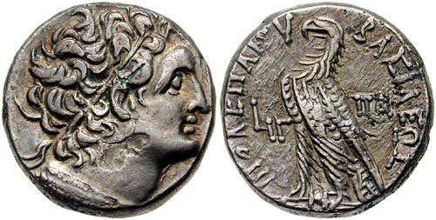

Svoronos 1860

Coin of Cleopatra, with distinctive hairstyle and hooked nose
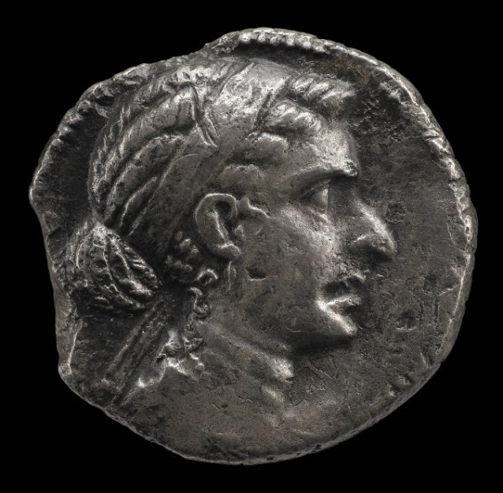

British Museum 1875,1102.3

Head of Cleopatra as a young woman

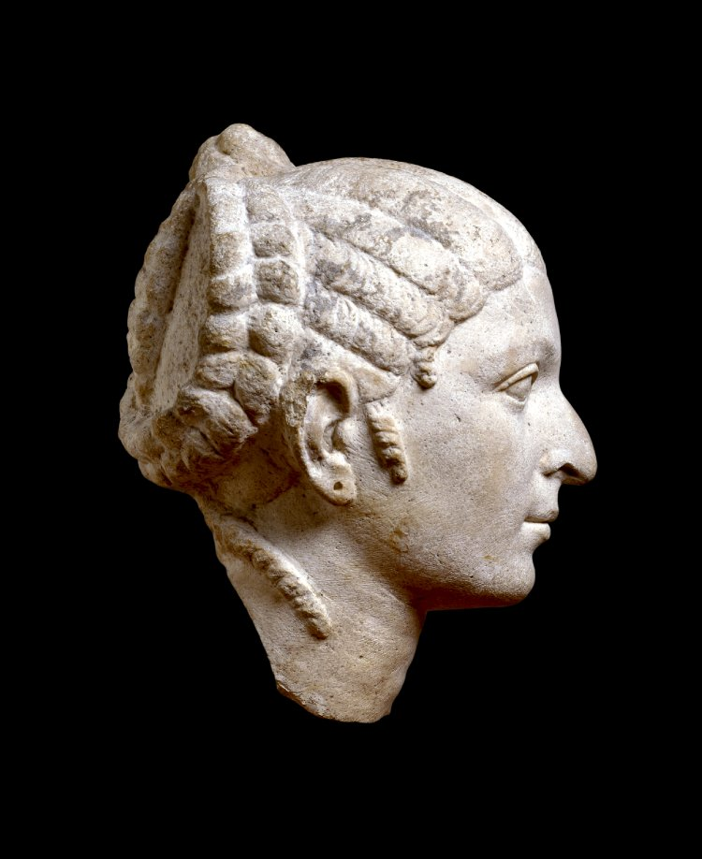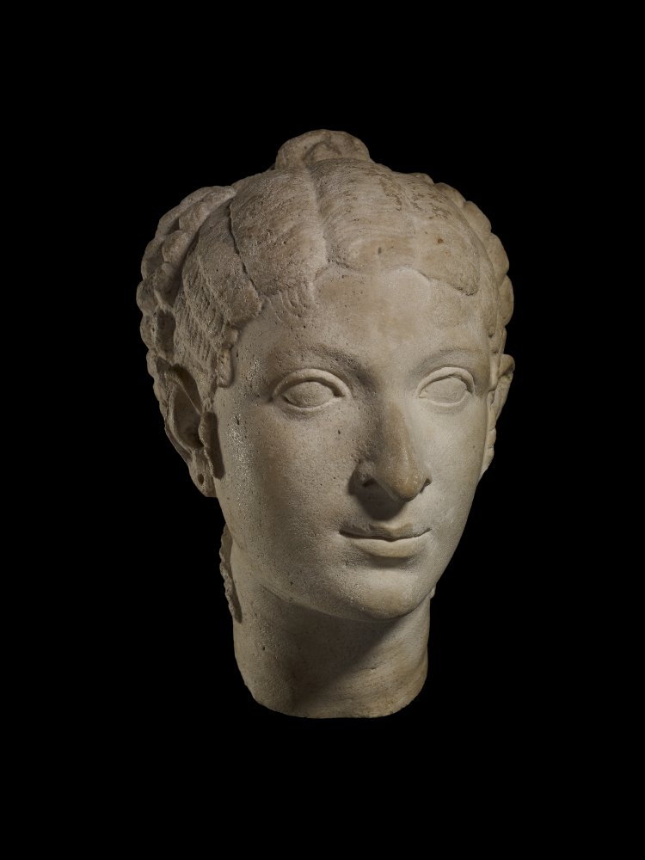

British Museum 1879,0712.15

Coin of Cleopatra and Caesarion minted in Cyprus

Front of coin |  | Back of coin
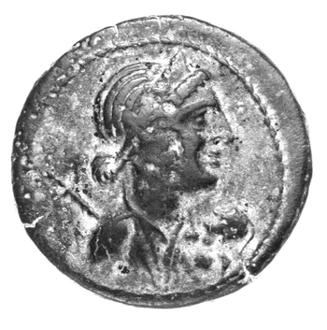 |  | 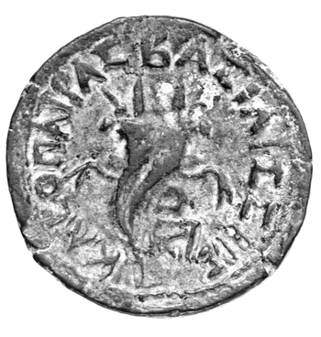
(Front of coin) Bust of Cleopatra facing right, wearing a ‘stephane’ (crown), holding her son Ptolemy XV Caesarion
(Back of coin) Double cornucopia
RPC.1.3901, Sv.1874

Silver denarius of Antony and Cleopatra minted in 32 BC

Front of coin |  | Back of coin
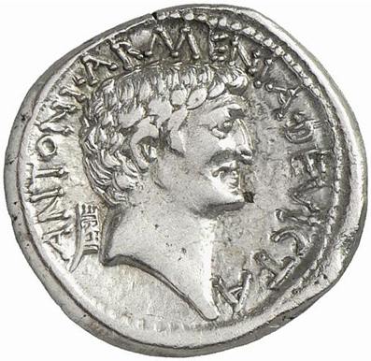 |  | 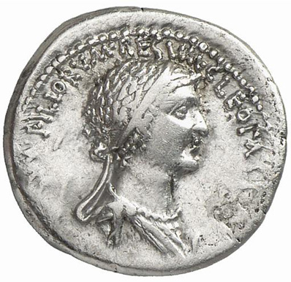
Description  Head of Mark Antony right; behind, Armenian tiara; around, inscription. Border of dots  Inscription reads:  ANTONI·ARMENIA·DEVICTA  For Antony, Armenia having been conquered |  | Description  Bust of Cleopatra right, draped and wearing diadem; before, prow; around, inscription. Border of dots.  Inscription reads:  CLEOPATRAE·REGINAE·REGVM·FILIORVM·REGVM  For Cleopatra, Queen of Kings and of her sons who are Kings
Babelon (Antonia) 95; Crawford 543/2; CRI 345. Sydenham 1210

Relief portraits of Cleopatra and Caesarion from Dendera

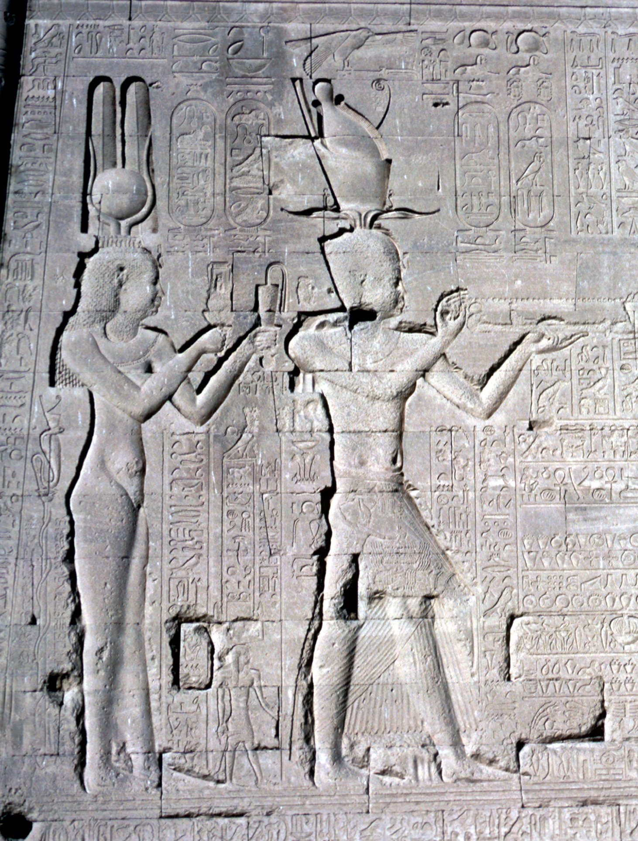

Copyright Information:

Copyright for all the literary translations are held by OCR.
Relief portraits of Cleopatra and Caesarion from Dendera: © Heritage Image Partnership/Alamy. com,
Coin of Cleopatra and Caesarion minted in Cyprus: © American Numismatic Society - reproduced under the terms of the Creative Commons Attribution-NonCommercial 4.0 International License.
Silver denarius of Antony and Cleopatra minted in 32 BC: © Classical Numismatic Group, Inc. www.cngcoins.com - reproduced under the terms of the Creative Commons Attribution-Share Alike 3.0 Unported license.
Coin of Ptolemy Auletes: www.wildwinds.com, Wildwinds. With permission of wildwinds.com and cngcoins.com
Coin of Cleopatra, with distinctive hairstyle and hooked nose: © The Trustees of the British Museum used with permission
Head of Cleopatra as a young woman: © The Trustees of the British Museum used with permission

OCR is committed to seeking permission to reproduce all third-party content that it uses in the assessment materials. OCR has attempted to identify and contact all copyright holders whose work is used in this paper. To avoid the issue of disclosure of answer-related information to candidates, all copyright acknowledgements are reproduced in the OCR Copyright Acknowledgements booklet. This is produced for each series of examinations and is freely available to download from our public website (www.ocr.org.uk) after the live examination series.

If OCR has unwittingly failed to correctly acknowledge or clear any third-party content in this assessment material, OCR will be happy to correct its mistake at the earliest possible opportunity.

For queries or further information please contact the Copyright Team, First Floor, 9 Hills Road, Cambridge CB2 1GE.

OCR is part of the Cambridge Assessment Group; Cambridge Assessment is the brand name of University of Cambridge Local Examinations
Syndicate (UCLES), which is itself a department of the University of Cambridge.

